On 11/6/17 through 11/10/17 I went to a number of sites in the Mojave Desert area to locate new places to go on field trips. I consulted other rock club website, old magazine articles and general internet research. I found about a dozen likely prospects. I decided to start out on the eastern edge of the Mojave and work my back to my base in Barstow.
You are not in Kansas anymore Paul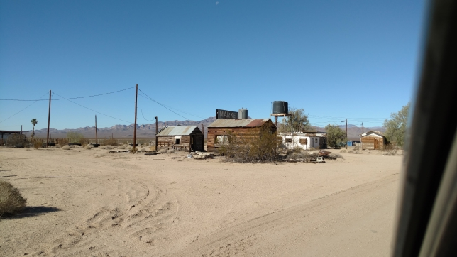
Having not gotten stuck on my previous excursions I decided to go to even more remote places. The first stop on 11/9/17 was the Ship Mountains. Today I had an added bonus to deal with, flash floods in the previous months had washed out some bridges and as the County road crews were only too happy to tell me, San Bernardino County did not have the money to fix them rapidly. Not only did I have to deal with going to places most people did not want to go to (they were smarter than me), but I would have to take the “long way” to get there. My trusty Pilot did not let me down. The above are some abandoned buildings from when this was a railroad stop.
The road goes on and on and on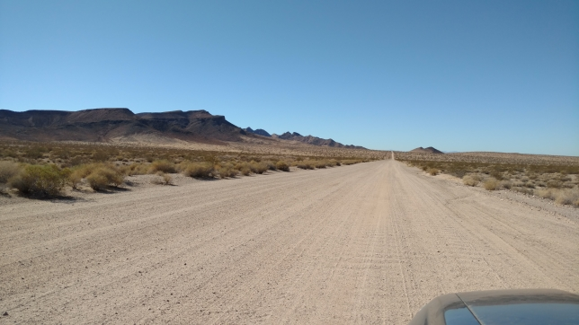
The roads to Ship Mountain were surprisingly well maintained. Supposedly there was more opalite in sand dunes in this area. By the time I reached the dunes I was 10-15 miles from civilization. It got a bit lonely.
There is sand, but is there opalite?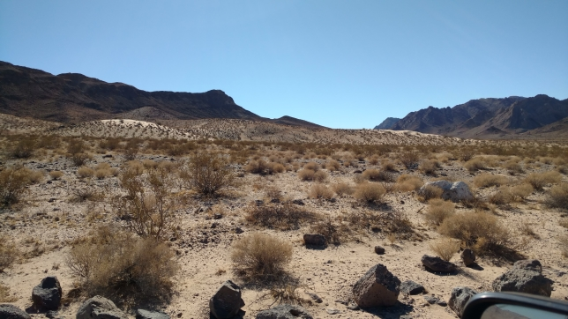
Abandoned mine workings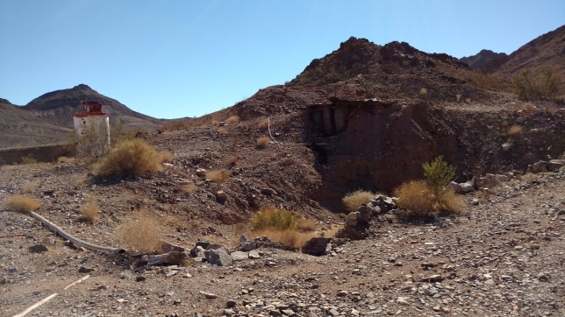
On my way to the sand dunes I came across some abandoned mine workings. I figured if other people found cool rocks in this location it was worth a look.
Abandoned mine workings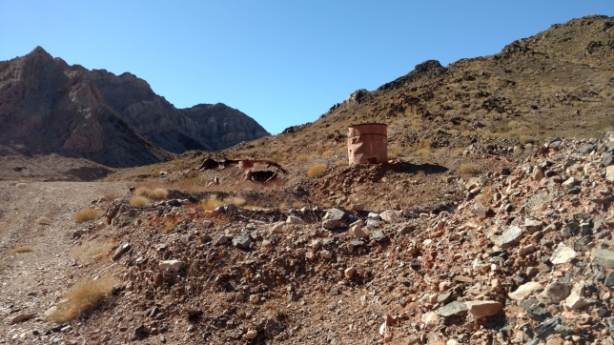
Epidote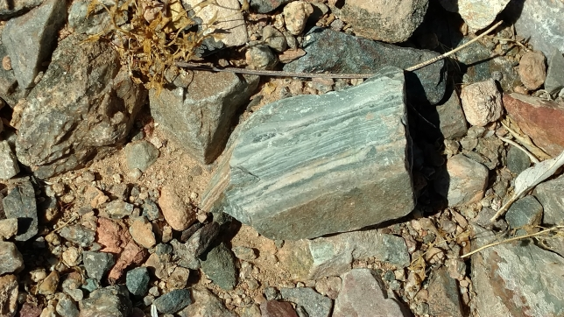

Copper stained crystals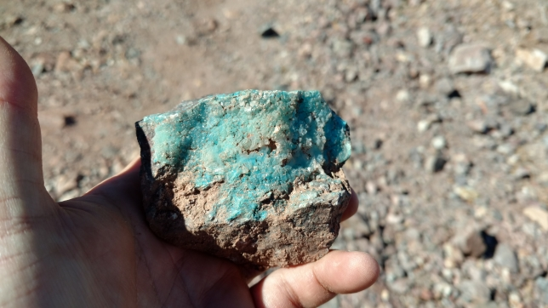
Cuprite & chrysocolla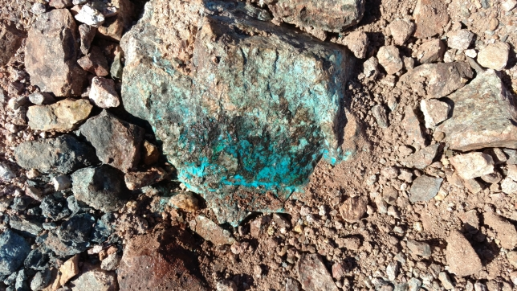
Given the number of copper minerals I found in this area I assumed they were mining copper here. I never did find a road going close to the sand dunes, so I did not find any opalite. Given the remoteness of this site I kind of doubt it was mined out. While the copper minerals were not plentiful, if you looked around and did a little light digging you found some. I have not had a chance to play with any of the specimens I found at this location yet.
On the road again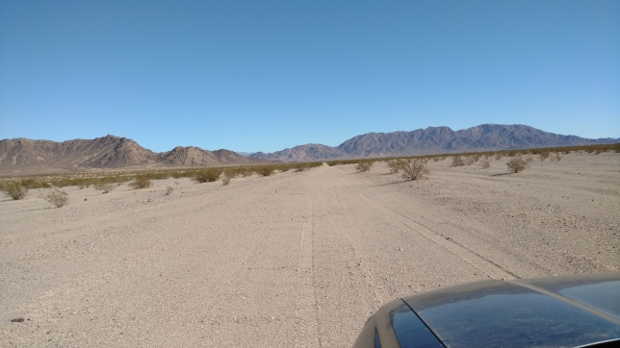
Next stop was the Trilobite Wilderness. The folks in the BLM Office I spoke with said there is some legitimate private property in the Wilderness, that it is marked, and the owners are very particular about people trespassing. The road got worse after the above picture, high clearance vehicles to get over the rocks.
Where the good stuff probably is (beyond the no trespassing sign)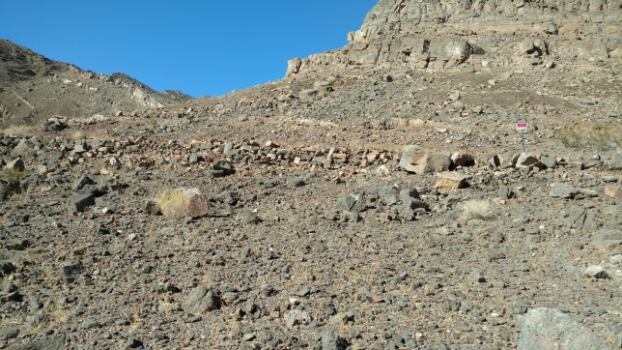
I only stayed here a little while as these trips were “proof of concept” adventures. Either I found something relatively quickly (making it a good spot to take the club), or not. I collected some promising looking chunks of fossilized black mud but have not had time to split them open yet.
Closed general store in Chambless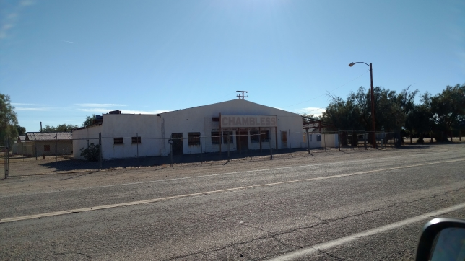
Abandoned restaurant outside Chambless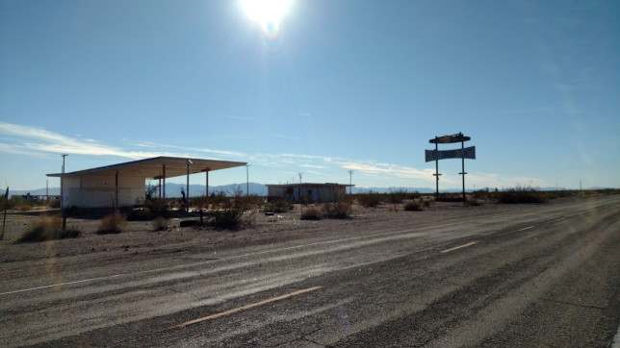
Chambless is another almost dead railroad town. It was kind of sad seeing these towns slowly suffocating. Some of that was caused when Route 66 was replaced by I-40 and all of the traffic moved a few miles to the north. The dirt road to the Chambless rock collecting area had been hit hard by the flash floods. As I recall it would have been a number of miles crawling along at 1-2 mph, so I decided it was not worth the effort and called it a day.
Sunset on the road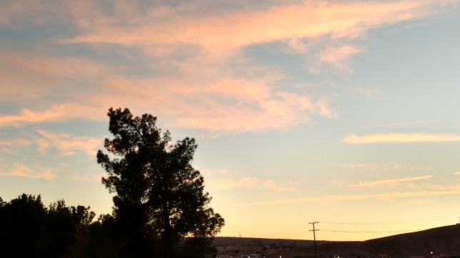
Even better back at the hotel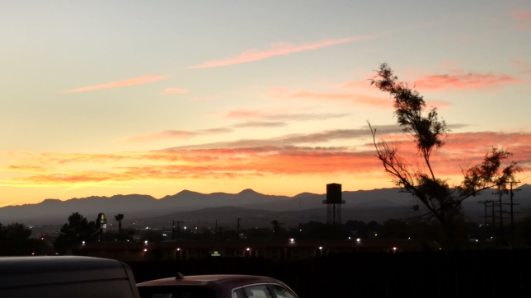
Since the 10th was a travel day back home I wanted to stay close to Barstow. I knew that there are a number of cool rocks that are found in the hills around the Calico Ghost Town. Gravity is very reliable, and water always flows downhill. I put the two of these things together with some topographical maps of the area to figure where the cool rocks would be collecting. I then bounced these locations against some satellite images and looked for piles of rocks that happened to be near roads. The Mojave River bed looked like the best site. I thought I would find rocks I saw in the hills, but instead I found rocks I had not seen before.
Rocks along the road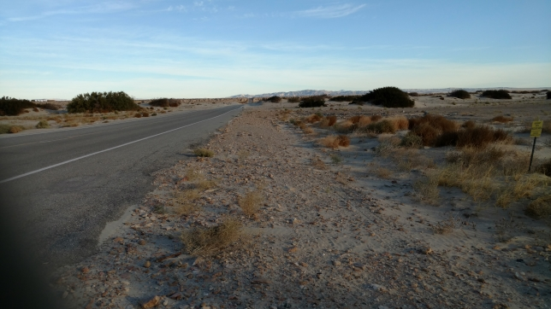
Mojave Paint stone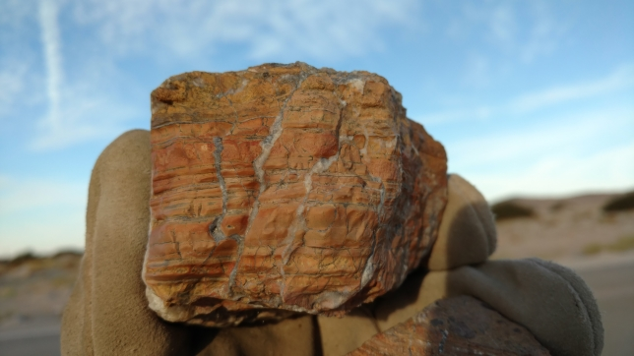
The first thing I found was a lot of a red, orange and yellow stone with dendrites and sometimes quartz stringers. It looks like a mudstone or a siltstone, so my first impression was that it would not take a mirror finish. It reminded me of Indian Paint Stone, so I dubbed it Mojave Paint Stone. Below are my two test pieces. The left one does not have quartz in it and it took a satin finish, the right one with quartz took a much nicer finish.
Mojave Paint Stone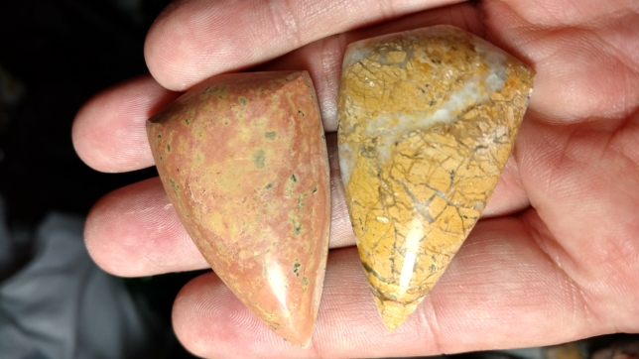
Another cinder cone by Amboy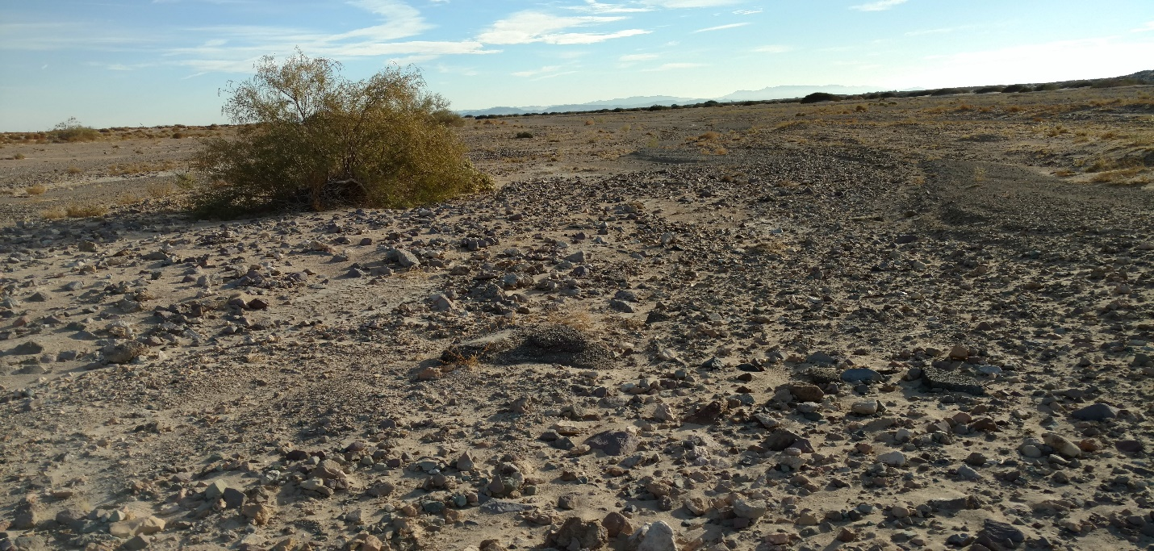
I went to a second location along the Mojave River and found more Mojave Paint Stone and some chalcedony that reminds me of the nearby Hector Rd material.
Amboy’s single café, gas station and hotel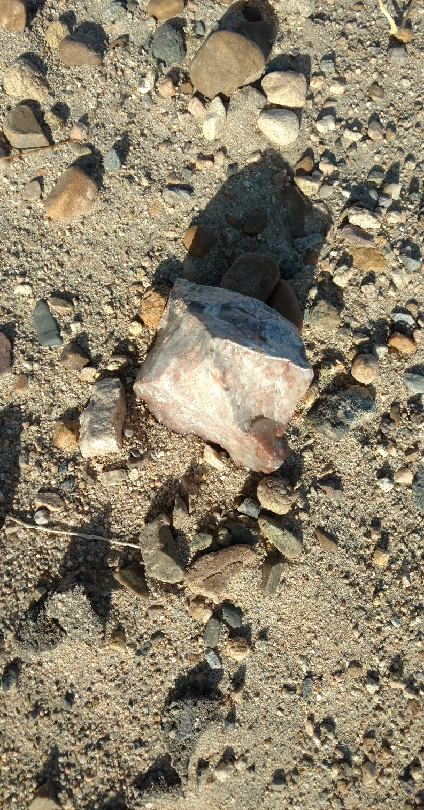
My last stop was the washes around the Calico Early Man site. This is supposed to be a good place to look for material washing out of the hills above Calico. It did not disappoint.
Wash by Early Man area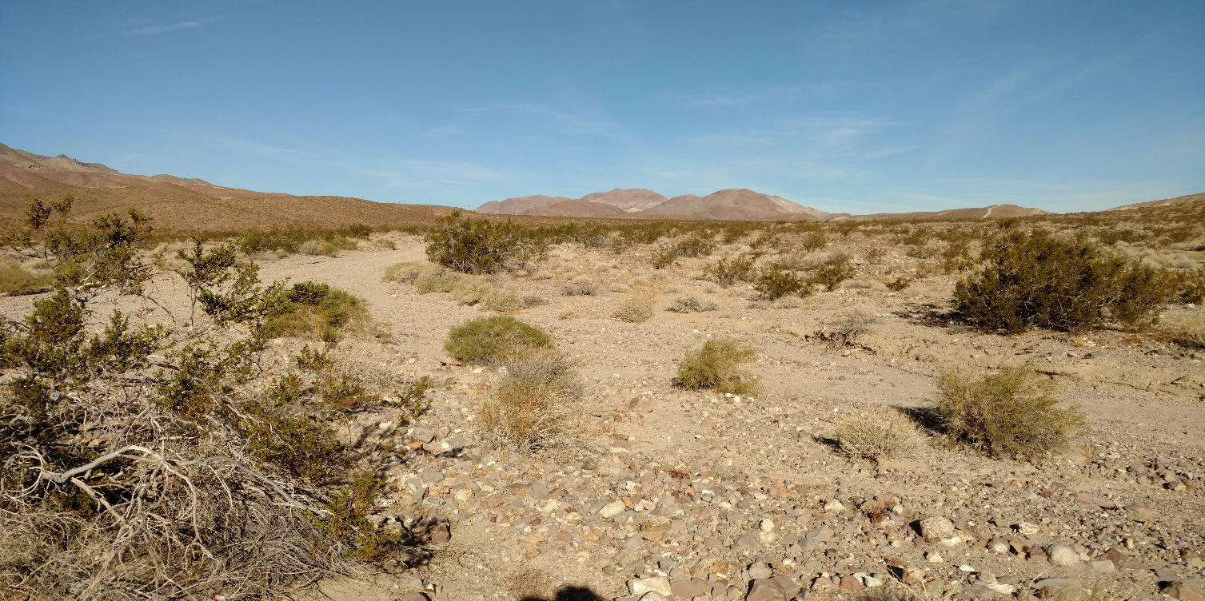
Chalcedony with pink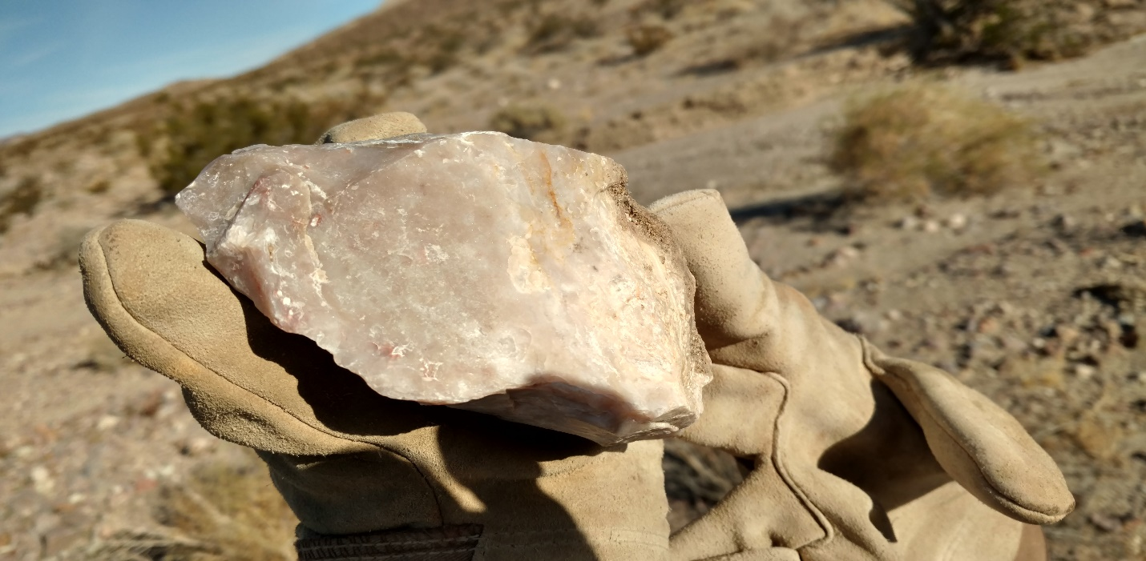
Chalcedony with red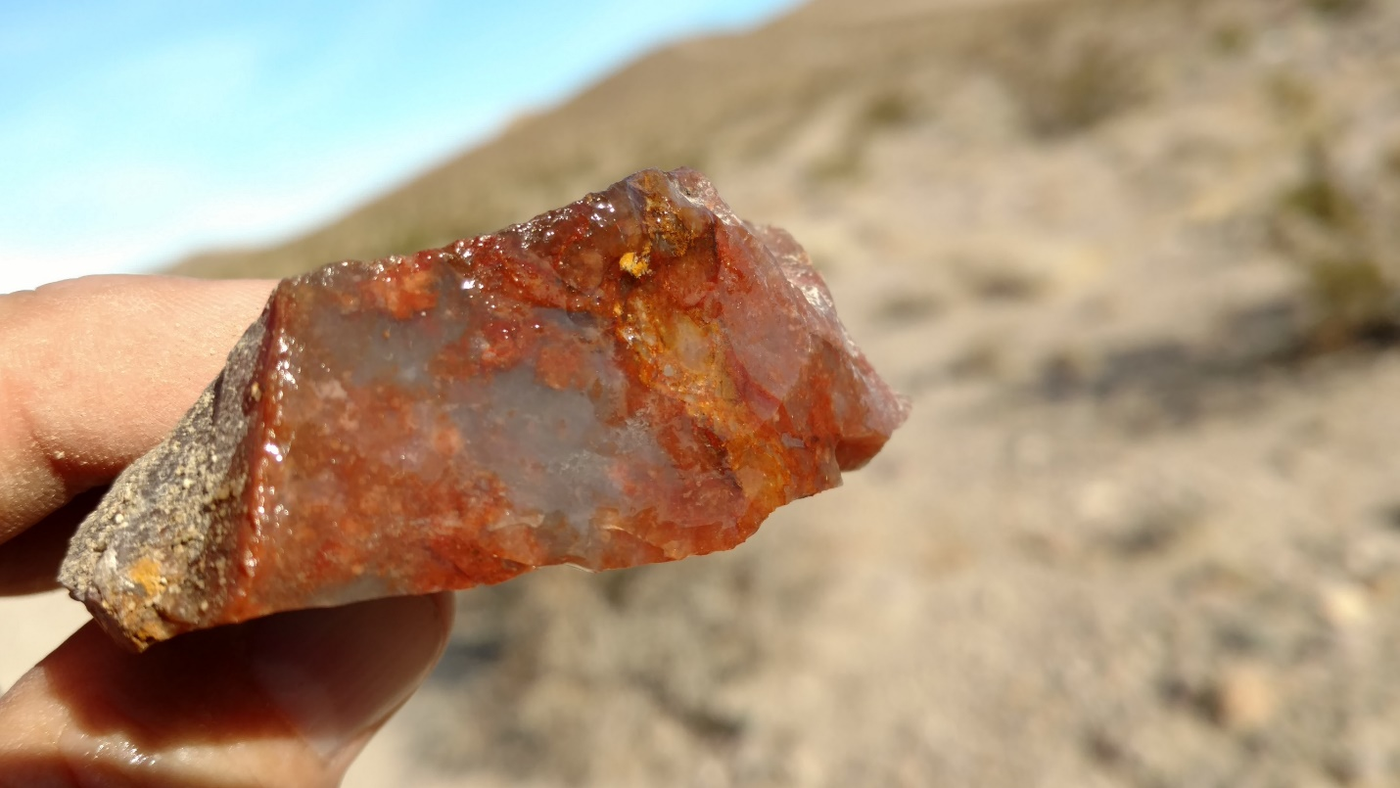
Chalcedony can be boring, but some of the pieces I picked up in this area had red and pink designs in them which have the potential to make nice pieces. I found a couple small pieces of bright red material which may be fire opal. I think was too fractured to do anything, but when I dig it out of the piles of rocks in my garage we will see. I only spent about 30 minutes here and found a few good pieces, so it is worth investigating further.

Fire opal?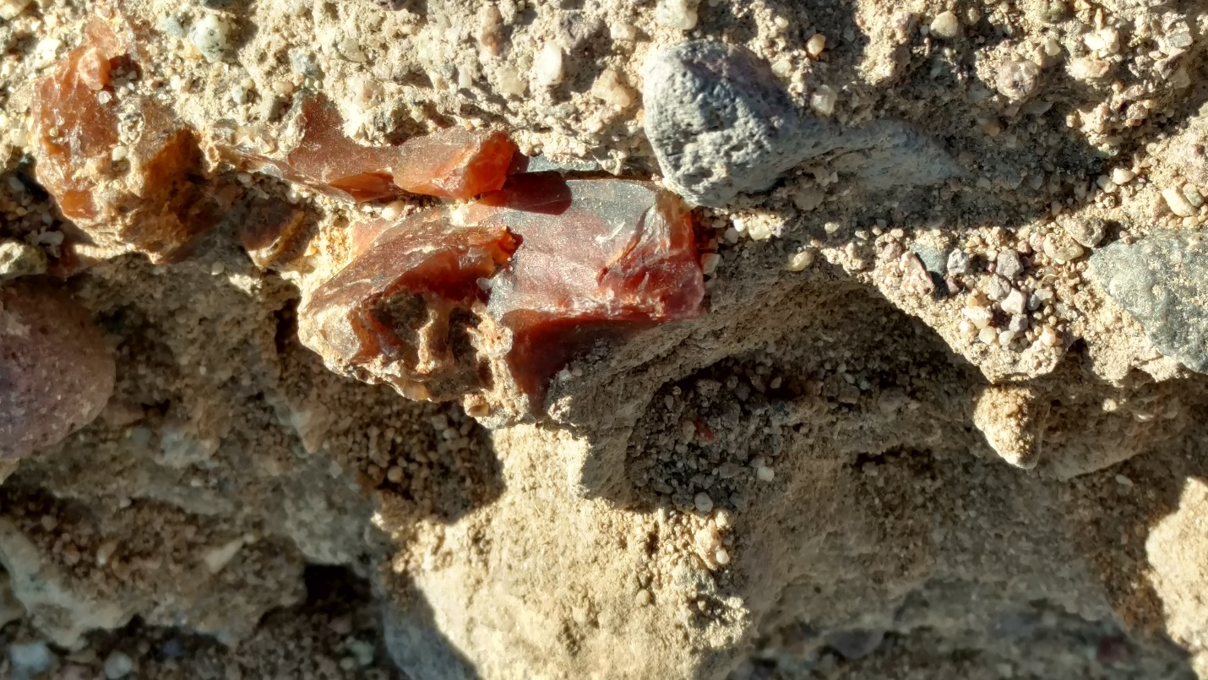

The End

