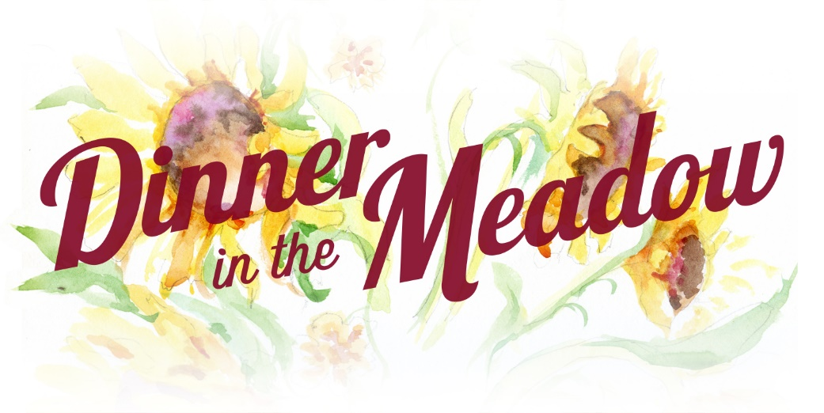
Opportunity
For Small Farmers In North Carolina
To Receive Grant
Funding For Projects
At Least $5,000

2018 Grant Application Cycle Open Now Thru July 6, 2018
APPLICATION
DEADLINE JULY 6, 2018
The Leonard-Mobley Small Farm Fund was established to support and cultivate small farms in North Carolina. Founded in 2014 in honor and in memory of Franklin County farmers Marjorie Leonard and Steve Mobley of Meadow Lane Farm in Louisburg NC, the fund aids in development and long-term sustainability of small farms through an annual grants program, with proceeds raised during a dinner at the farm and through community donations and sponsorships.
Is My Farm Eligible?
To apply, farms must be located in one of eleven counties: Franklin, Granville, Person, Durham, Vance, Warren, Wake, Nash, Halifax, Chatham, and Wilson.
Farms eligible for this grant can be the enterprise of one person or family or a small group of farmers. The farm business must have been operational for at least two years in North Carolina by July 1 of the year of the grant. You may own or rent the land. Farmer’s who generate at least 50% of his/her personal income from the farm operation during the previous calendar year will be given preference. Previous winners are not eligible.

The Grant is expected to improve the infrastructure or equipment for continuation and long-term success of the farm operation and to promote small farm sustainability in the region. Applications for labor, training or marketing will not be considered.
The funding is project driven. The amount of the grant is up to $5,000. It will be awarded on Sunday, September 9, 2018 at the annual Dinner in the Meadow. The awardee or a representative must attend to receive the grant and be prepared to describe his/her project during the event (and at subsequent Dinners). The grant should be spent within 1 year of the award.
Grant applications should be emailed to lmsmallfarmfund@gmail.com or mailed to LMSFF – Grant Application, 571 Leonard Farm Road, Louisburg NC, 27549. The deadline for the grant proposal is July 6, 2018. The application must be completed and all information included or the application will be rejected. An interview at the qualifying farms will be scheduled during July-August. The farm visit is required. Email any questions to lmsmallfarmfund@gmail.com. You may also call 919-495-1305 for more information.
Mailed application must be postmarked on or before July 6, 2018. All applicants will be notified of their status by September 1, 2018.

2018 LMSFF GRANT APPLICATION
(Early submissions are encouraged.)
Name of Farm:
Name of Farmer(s):
Address of Farm(s) (street, city, county):
Phone Number please give a home phone and two cell phone numbers for contacts:
Primary Contact Email:
Web Address (if existing):
Approximate date applicant(s) began market production on this farm(s):
Source of Farm Income (crops, livestock, flowers etc.):
The Farm generates more than half the income for the farmer(s): (Y/N)
Total Gross Receipts from farm revenue in 2017:
Description of Project:
- Clearly define what you want to do with the grant funds if awarded.
- Tell us why this is important to the success and the benefit of the farm(s).
- Be as specific as possible with timeframe for implementation and how the project fits in with your operations now. Will it support operations? Will it help you diversify? Will it add to what exists?
- Tell us about your farm and who you are and why these funds can help you. If possible please tell us about the entire scope of the overall farming venture. Please tell us anything unique about your farm or team or situation that we should know as we consider your application.
Funding Requested:
- Clearly define the total cost of the project.
- Give a financial/budget breakdown of project costs to the best of your ability. List each item and cost.
- Please indicate if your project is funded by any other outside sources or if you are using your money or if the LMSFF grant will fully fund your project.
- Define exactly how the grant funds are significant to achieve your project and farm goals.
- Please share future (LT) expectations for growth of the farm. Include any cost savings you will realize because of your abilities/skills or contacts to realize better economies of scale or sharing of resources with other farmers.

Early applications encouraged. Grant applications should be emailed to lmsmallfarmfund@gmail.com or they may be mailed to LMSFF – Grant Application, 571 Leonard Farm Road, Louisburg NC, 27549 by the
Deadline: July 6, 2018. Applications are reviewed as they are received. All applicants and the awardee will be notified by September 1, 2018.

Thank you for your application. We value the efforts of every farmer and your work in farming and contribution to agriculture in our region.
Please visit our website https://www.dinnerinthemeadow.org/grant-application.html, and follow our efforts to assure the success of small farmers in North Carolina.

