Blue Ridge Fire Department NOTICE FROM THE BLUE RIDGE FIRE DEPARTMENT AUXILIARY
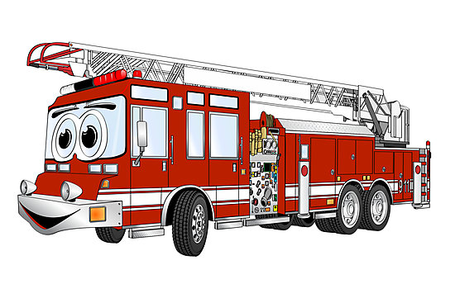
The September 5th Labor Day
Auxiliary Sale has been cancelled.
We will however have the following activities:
August 22nd: A Red-Hot Mama’s mini Craft Sale will be held at the Auxiliary Shed behind the Blue Ridge Fire Station.

September 12th: A Red-Hot Mama’s mini Craft Sale will be held at the Auxiliary Shed behind the Blue Ridge Fire Station.

September 5th, 1:30 PM: The annual Quilt Raffle will be held at the Blue Ridge Fire Station. To view this year’s quilt online go to brfdaz.org/Auxiliary.
Raffle Tickets can be purchased at the Auxiliary Shed on Wednesdays from 9 to 11AM or by contacting any Auxiliary Member.

