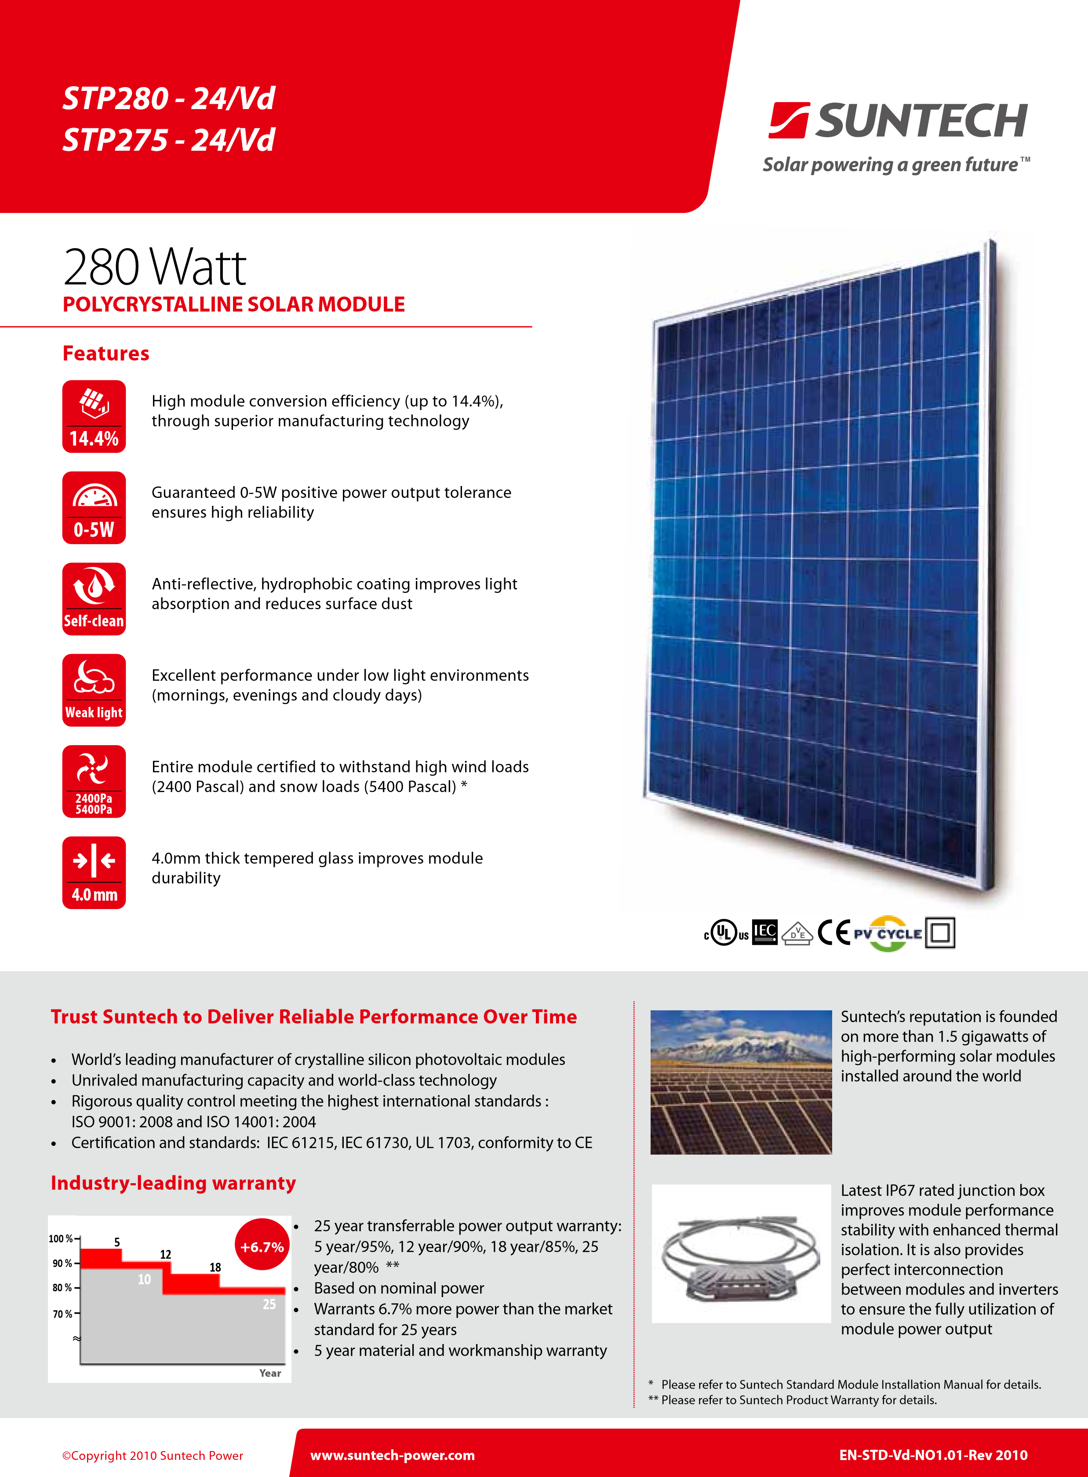
NOCT | STP280-24/Vd | STP275-24/Vd
Maximum Power (W) | 204 W | 201 W
Maximum Power Voltage (V) | 32.0 V | 31.9 V
Maximum Power Current (A) | 6.39 A | 6.29 A
Open Circuit Voltage (Voc) | 40.8 V | 40.7 V
Short Circuit Current (Isc) | 6.74 A | 6.68 A
Efficiency Reduction  (from 1000 W/m² to 200 W/m²) | <4.5% | <4.5%
Solar Cell | Polycrystalline 156 × 156 mm (6 inches)
No. of Cells | 72 (6 × 12)
Dimensions | 1956 × 992 × 50 mm (77.0 × 39.1 × 2.0 inches)
Weight | 27 kgs (59.5 lbs.)
Front Glass | 4.0 mm (0.16 inches) tempered glass
Frame | Anodized aluminium alloy
Junction Box | IP67 rated
Output Cables | H+S RADOX® SMART cable 4.0 mm² (0.006 inches²), symmetrical lengths (-) 1100 mm (39.4 inches) and (+) 1100 mm (39.4 inches), RADOX® SOLAR integrated twist locking connectors
1000 W/m² | 800 W/m² 600 W/m² | 400 W/m² | 200 W/m²
Nominal Operating Cell Temperature (NOCT) | 45±2°C
Temperature Coefficient of Pmax | -0.47 %/°C
Temperature Coefficient of Voc | -0.34 %/°C
Temperature Coefficient of Isc | 0.045 %/°C
Current-Voltage & Power-Voltage Curve (280-24)
9
8

7
6
5
4
3
2
1
0
300
250
200
150
100
50
0
Current (A)
Power (W)
Voltage (V)
0
10 20 30 40
NOCT: Irradiance 800 W/m², ambient temperature 20 °C, wind speed 1 m/s
Mechanical Characteristics
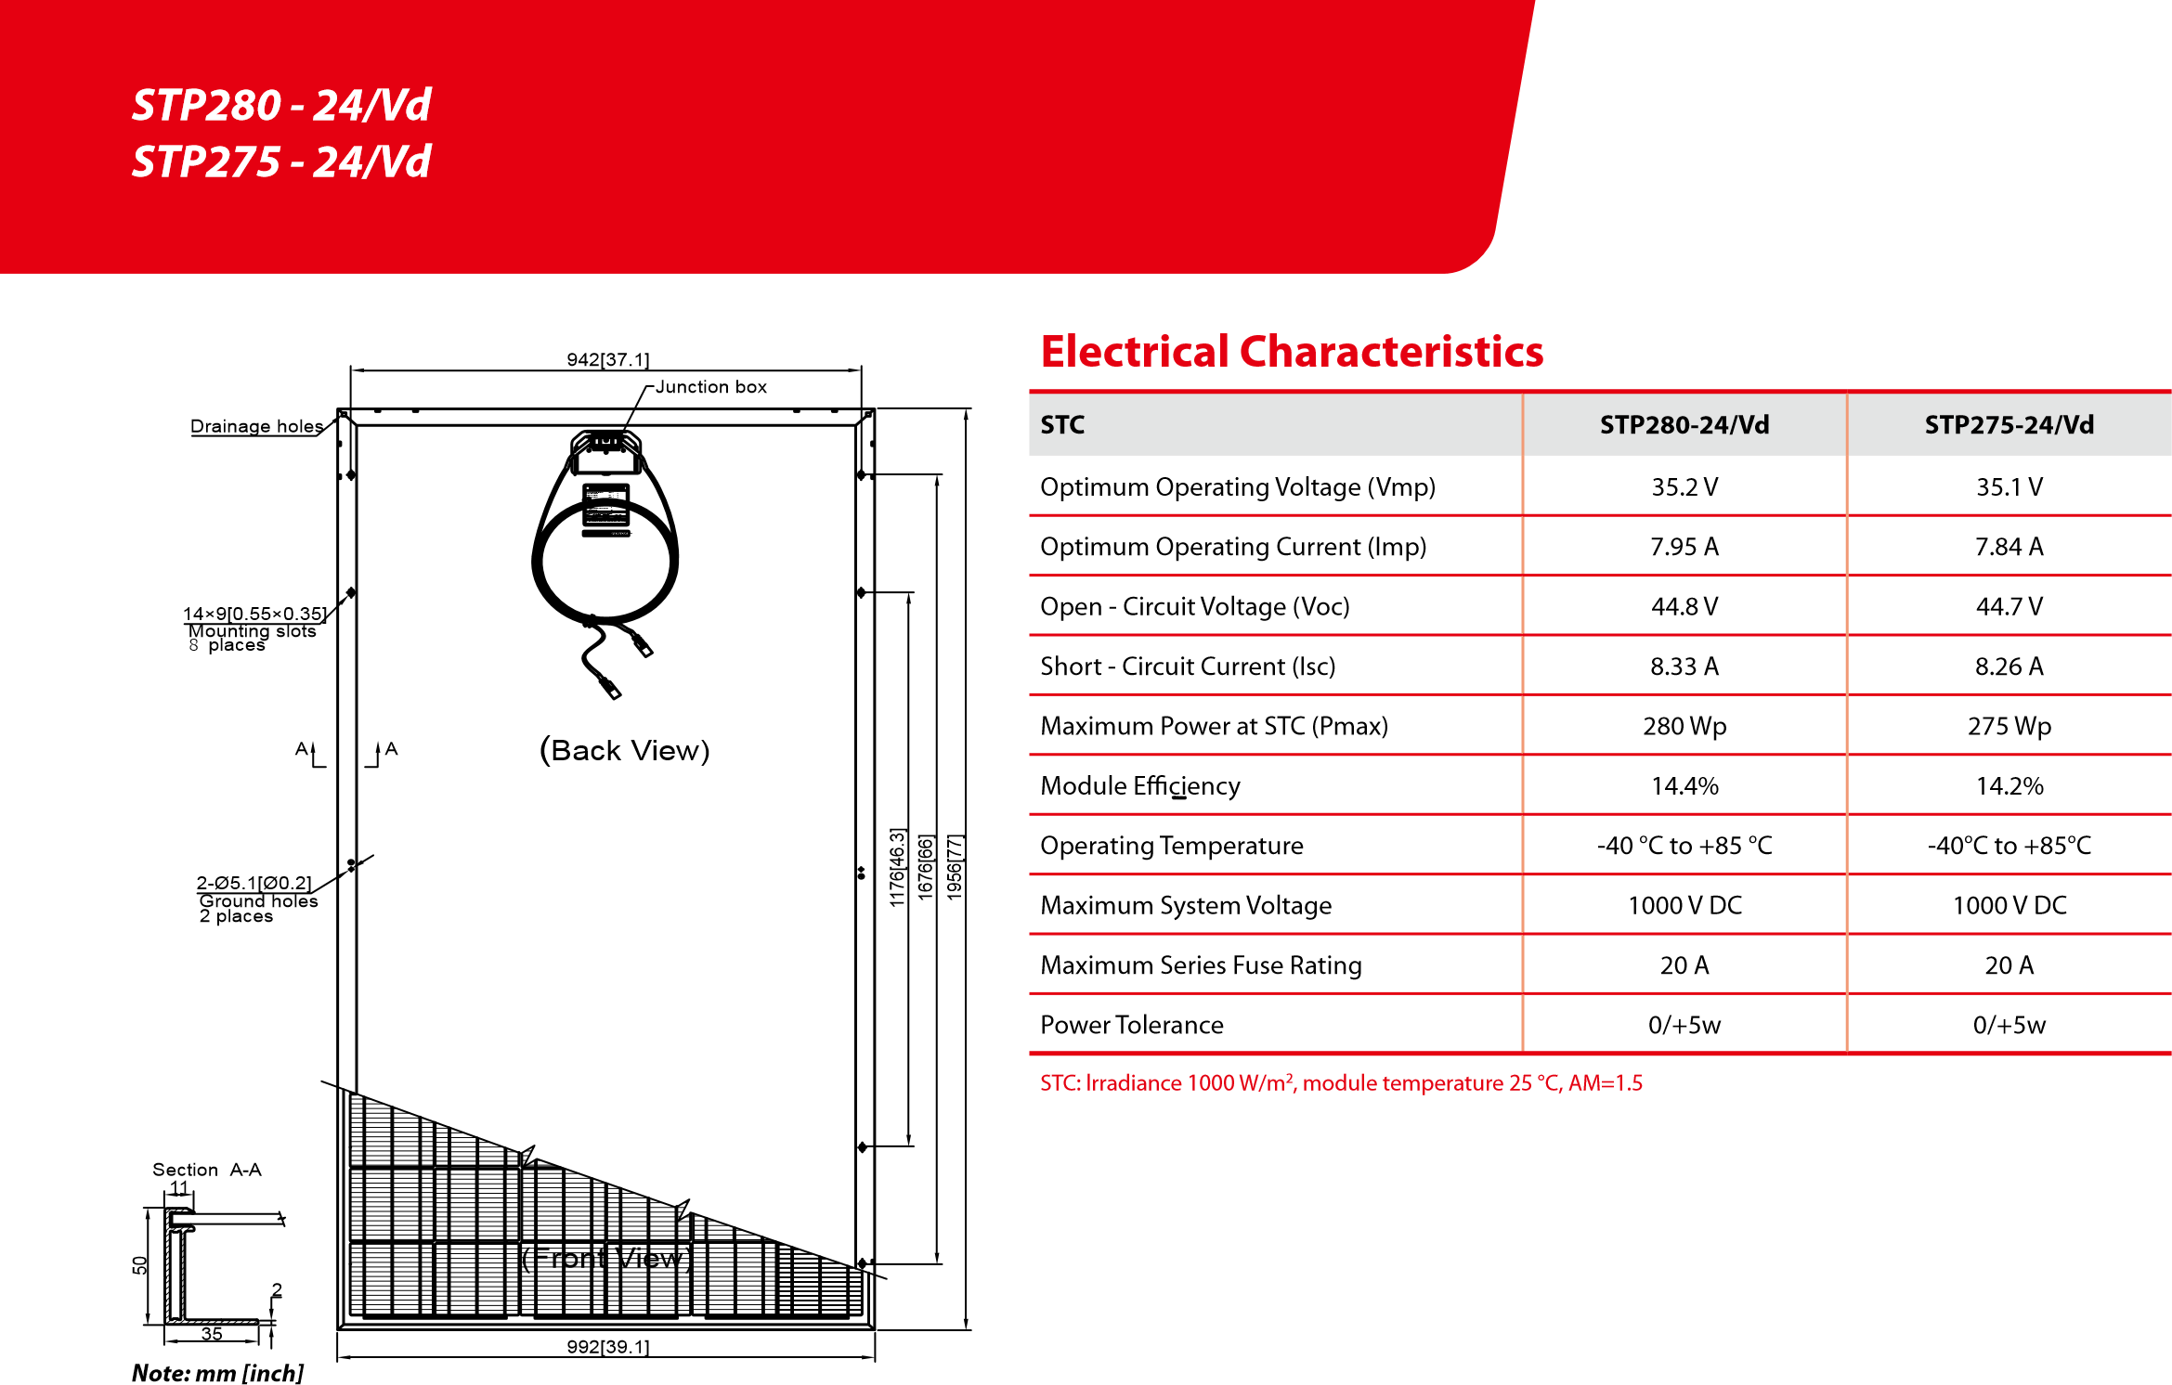
Temperature Characteristics
EN-STD-Vd-NO1.01-Rev 2010
www.suntech-power.com |
E-mail: sales@suntech-power.com
Dealer information box
Container | 20’ GP | 40’ GP | 40’ HC
Pieces per pallet | 21 | 21 | 21
Pallets per container | 6 | 12 | 24
Pieces per container | 126 | 252 | 504
Packing Configuration
Specifications are subject to change without further notification

