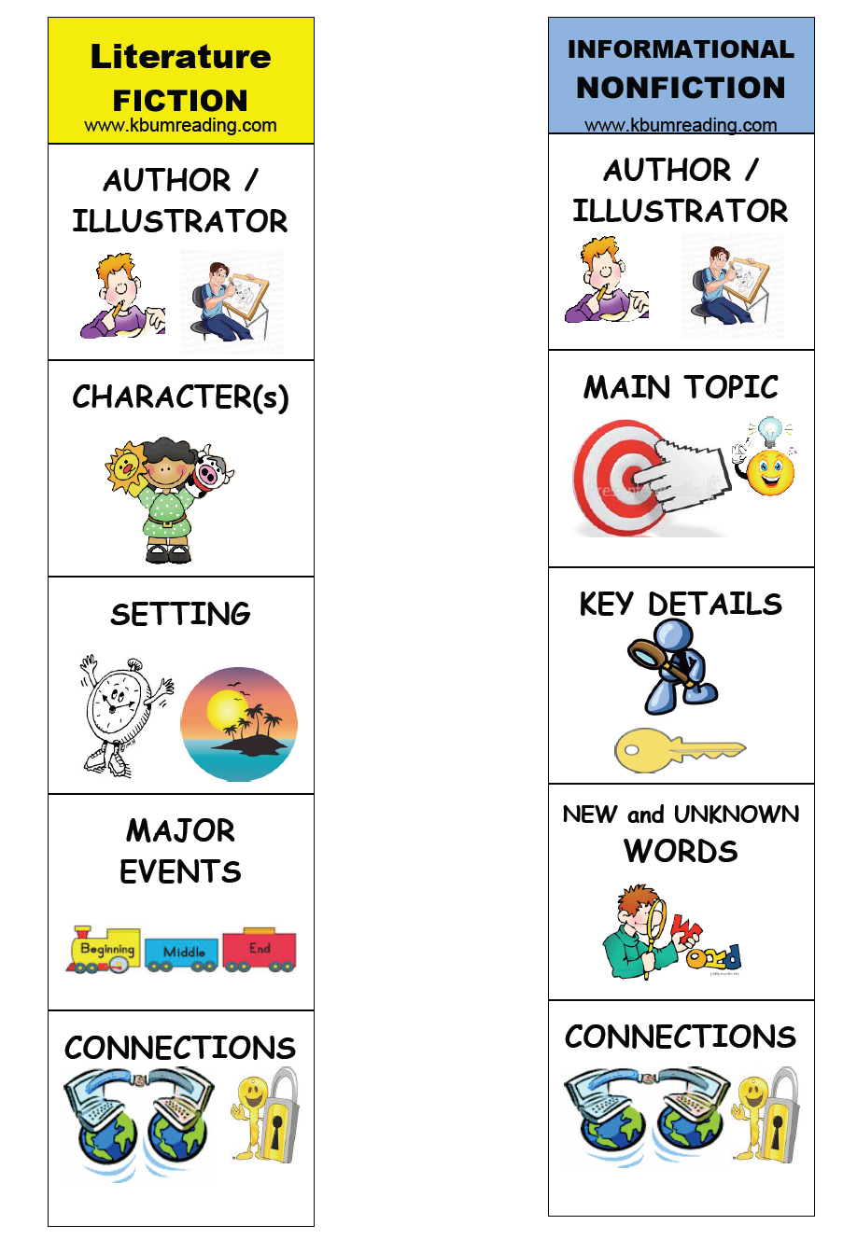
PreK-K Retell Genre ThinkMarks

