***EBENEZER UNITED METHODIST CHURCH***

***Welcome and Announcements -- Jeanne Axtell***

Announcement – please read and pin a copy to the refrigerator.

Welcome The Light of Christ

*Praise Songs ***“ King of kings”, “The River is Here”***

Children’s Time Kristina Armbruster

Offering

*Doxology ***“Praise God from Whom all Blessings Flow”*** # 95

Joys and Concerns

Morning Prayer

*Praise Song ***“Build My Life”***

Scripture

Message  **“Who is John Wesley?”** Pastor Loretta

*Praise Song ***“How Great is Our God”***

*Benediction

*Please stand as you are able.

**THE LORD’S PRAYER**

*Our Father, who Art in Heaven, hallowed be Thy name. Thy Kingdom come, Thy will be done on earth as it is in Heaven. Give us this day our daily bread and forgive us our trespasses as we forgive those who trespass against us. And lead us not into temptation but deliver us from evil. For Thine is the Kingdom, the power, and the glory forever. Amen*

***We extend a very warm welcome to all who are worshiping with us today.***

**ATTENDANCE: May 5th = 50, 12th = 61, 19th = 42**

**Calendar**

**Trinity Sunday, Memorial Day Weekend, and Aldersgate Sunday**

June 9th – Worship Committee – brief meeting following worship

**Thank you, Kristina Armbruster, and Shirley Wease**

**for your help in today’s service!**

Amanda, Beth, Kristina, Luca, Everly, James, Maddie, and Eliza, packaged kits and cleaned out the closet in the children’s classroom.

Thank you!

**Last week the children collected $362.98 to help with the Conference kits.**

**Thank you, to all who participated in this mission project.**

**Pastor Loretta will take some time with her son Robert, daughter-in-law Julie, and grandsons, Jonathan and Gavin. They will be in Williamsburg June1-June 8th. Pastor will visit with them June 3-5.**

**Bible Study – The Chosen**

What: The topic–Jesus and His Disciples as portrayed in the film series

of THE CHOSEN.

When: It will be twice a month on Sunday afternoons – 4:00 PM

**Starting June 9th and June 23rd.**

Where: Warsaw United Methodist Church

Who: All are invited, families are welcome

Participating: Warsaw, Carmel, and Ebenezer United Methodist churches.

Content: Starting with Season 1, episode 1 we will watch an episode,

do a brief study on what we have viewed.

Homework will be assigned – such as reading, the scripture

which will identify the episode we will watch.

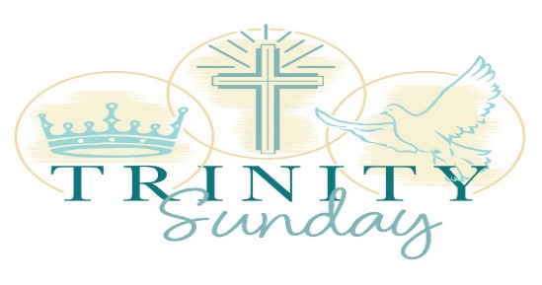

**PRAYER LIST**

*I have not stopped giving thanks for you, remembering* you in my prayers.

Ephesians 1:16 (NIV)

Prayers for Ginny & Lina Hahn (Cindy’s niece & great niece), Jennifer Clarke, Rachel Nice & Daphne, Linda & Ralph Fallin, Joan Balderson, Kacky Sanford, Kathy Davis, Betty Bailey, David Allison, Ian Duprey in the Coast Guard; for those battling cancer; for those battling sickness. Israel & Gaza, Russia & Ukraine; for the healing of the nations! For our country and its leaders, our Church, and the United Methodist Church.

We always thank God for all of you when we mention you constantly in our prayers

**Please** review the Prayer List and let us know of any people whose prayers have been answered. We will glean the list and start again on the first Sunday of every month. If you would like to keep a loved one on please advise pastor Loretta.

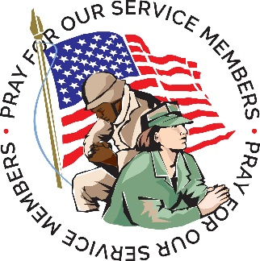

**Ebenezer United Methodist Church**

144 Ebenezer Church Road

P. O. Box 70

Oldhams, Virginia 22529

***Website:*** [*www.eumcoldhams.org*](http://www.eumcoldhams.org)

Reverend Loretta Benninghove

Pastor

Office (804) 472-4642; Cell (434) 480-9992

**Email:** [pastorlorettaumc@gmail.com](mailto:pastorlorettaumc@gmail.com) {preferred email}

[lorettabenninghove@vaumc.org](mailto:lorettabenninghove@vaumc.org)

**May 26, 2024**