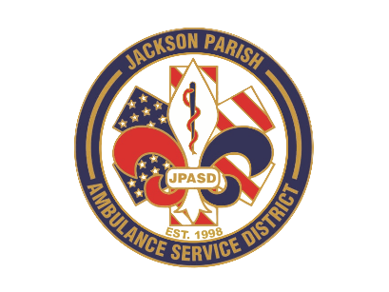
Aaron K. Johnson, Jr - EMS Director

Paula Parkerson, MD - Medical Director

Governing Board
Allen Lindsay, Conchita Doyle, Joe Vail, Alma Williams, Deidre Hollis
Jackson Parish Ambulance Service District
115 Watts Street
Jonesboro, LA 71251
Office: (318) 259-2877
Fax: (318) 259-2099

jacksonparishambulance@jpasd.com

Notice Posted: Wednesday, August 12, 2025 @ 12 noon

NOTICE OF PUBLIC MEETING
A public meeting will be held as follows:
DATE: August 14, 2025
TIME: 12:00 PM
PLACE OF MEETING: Jackson Parish Ambulance Service District
115 Watts Street, Jonesboro, LA 71251
Public Meeting AGENDA
1. Call to Order
2. Roll Call
3. Invocation
4. Pledge of Allegiance
5. Recognition of Guests/Public Comments
6. Approval of Minutes from July 10, 2025
7. Approval of Financials and payment of bills July 2025
8. EMS Director’s Report
9. Old Business
10. New Business
A) Approve access to Commercial Direct Deposit (CDD) for vendors.
B) Approve Vehicle Maintenance Policy update
C) Approve District use of updated Protocols by Medical Director
D) Approve MVR Policy update
11. Adjournment
Reminder: Next Meeting: September 11, 2025 @ 12 Noon
In accordance with the Americans with Disabilities Act, if you need special assistance, please contact Aaron Johnson, EMS Director at 318-259-2891 describing the assistance that is necessary. Due to the Covid-19 virus visitors are asked to not present to the meeting with fever, cough, diarrhea, or general weakness. Masks will be provided for visitors.

{ } Newspaper
{ } Minutes

