**WAG A TAIL PAWSITTING**

Pet Sitting Service Agreement Form

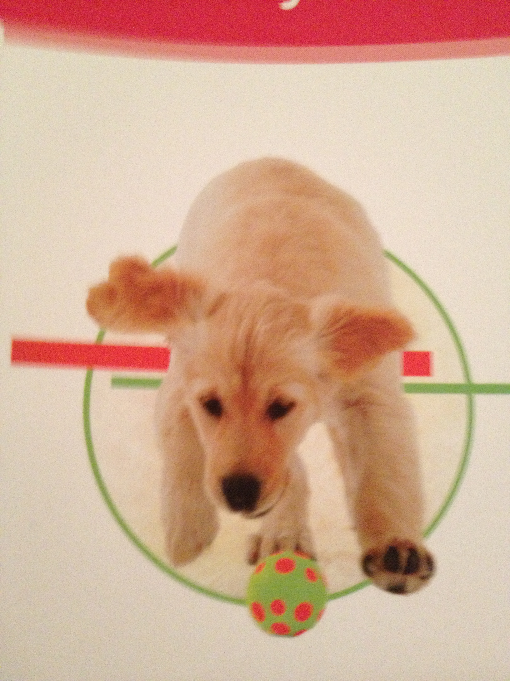

Name/s:

Address:

Home Phone: (____) ________________

Work Phone: (____) ________ ________

Cell Phone: (____) _______ _________

Email:

Emergency Contact:

Location of Extra Key:

Alarm deactivation Code:

Alarm activation Code:

Alarm company Name:

Alarm company Phone:

I agree that I have requested that pet sitter take care of my pet. I agree to pay the charges accrued for the services provided as outlined in this agreement.

Charge per visit: $

**I understand that 50% of payment is due at or prior to the time of the first visit and the balance paid in full upon the day of your return.**

Owner's Signature: Date:_________________________

Owner's Name (please print):___________________

**PET SITTING ASSIGNMENT INFORMATION**

Date of first visit:

Date of last visit:

Number of visits per day:

Total number of visits:

Overnight:

Daily visits:

Additional duties (please circle those you would like to request):

Bring in mail/papers

Water plants

Put out trash cans/recycling

Other

Where can we reach you?

Address:

Phone:

Email:

Do you want us to verify you have returned on time and continue to visit if we do not hear from you?

YES / NO

Would you like us to contact you regularly during the visit?

YES / NO

If yes, please indicate by what method and when/how often:

Additional Notes:

|  |  |
| --- | --- |
|  |  |
|  |  |
|  |  |