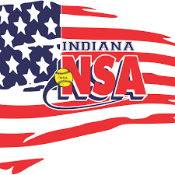
Indiana NSA Commitment

The mission of Indiana NSA is to advance and elevate the sport of softball within Indiana. We are committed to fostering a sense of family, skill development, and sportsmanship. Indiana NSA seeks to provide a platform for individuals and teams to thrive in the dynamic world of softball. Our mission includes organizing and facilitating affordable and competitive tournaments that cater to the diverse needs and aspirations of the softball community across the state. Our goal is to complete every event, while keeping player safety as the upmost importance. We embrace the values of fairness, respect, and collaboration. Indiana NSA is dedicated to creating an inclusive and supportive environment where players, coaches, umpires, and fans can engage passionately. Join us as we champion the spirit of softball and contribute to the overall growth and enjoyment of the game of softball throughout the Hoosier state.

