.
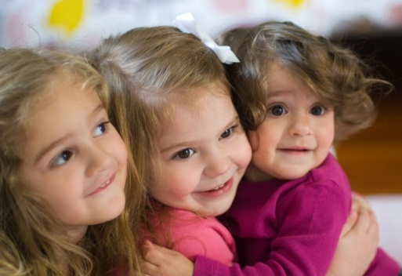 | December 2022
Sun. | Mon. | Tue. | Wed. | Thu. | Fri. | Sat.
 |  |  |  | 1 | 2 | 3
4 | 5 | 6 | 7 | 8 | 9 |  | 10
To replace tip text with your own, just click it and start typing. |  |  |  | Apostle Oliver’s  Jamaica’s  Birthday Party  7:00 PM to 8:00 PM
11 | 12 | 13 | 14 | 15 | 16 | 17
 | Fast  6:00 AM –  6:00 PM | Fast  6:00 AM –  6:00 PM | Fast  6:00 AM –  6:00 PM | Fast  6:00 AM –  6:00 PM | Fast  6:00 AM  6:00 PM
18 | 19 | 20 | 21 | 22 | 23 | 24
 | Fast  6:00 AM –  6:00 PM | Fast  6:00 AM –  6:00 PM | Fast  6:00 AM –  6:00 PM | Fast  6:00 AM –  6:00 PM | Fast  6:00 AM  6:00 PM
25 | 26 | 27 | 28 | 29 | 30 | 31
Christmas | Fast  6:00 AM –  6:00 PM | Prophetic  Proclamation  7:00 PM – 8:00 PM

Notes | View and edit this document in Word on your computer, tablet, or phone. You can edit text; easily insert content such as pictures, shapes, and tables; and seamlessly save the document to the cloud from Word on your Windows, Mac, Android, or iOS device.

