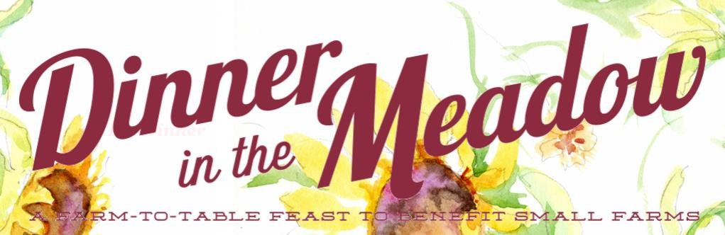

Sunflower | $5000 | 8 Tickets (1 Table)  Table Top Signage Logo in Program  Recognition on Social Media and at Event
Rose | $2500 | 8 Tickets (1 Table) Table Top Signage Logo in Program  Recognition on Social Media
Zinnia | $1000 | 8 Tickets (1 Table) Table Top Signage Logo in Program
Marigold | $500 | 4 Tickets and Name in Program
Geranium | $250 | 2 Tickets and Name in Program

Please make checks payable to: The Leonard-Mobley Small Farm Fund and mail with form below to: 571 Leonard Farm Road, Louisburg, NC 27596. Questions: Martha Mobley at 919-495-1305.

ORGANIZATION NAME WEBSITE SPONSORSHIP CONTACT NAME ADDRESS

EMAIL PHONE
Thank you for supporting our small farms!

