
RICK A SHACKET
DO, MD(H)
Main Office:

Scottsdale Vein & Proctology Center
8752 E Via De Commercio #2
Scottsdale, Arizona 85258
Office: (602) 492-9919 | Mobile: (602) 920-1023

Name: _______________________________________ DOB: ___________ Date: ___________

PRESCRIPTION
Sinecatechins Ointment 15%.

Applied topically, 0.5 cm per lesion, three times a day for up to four months.
Dispense: 15 % (1 tube, 30 g)

___________________________________
Rick A. Shacket, DO, MD (H), BS9262611
Diplomate American Osteopathic Board of Proctology

LOCATIONS
Scottsdale Vein Center 8752 E Via De Commercio, Suite 2, Scottsdale, Arizona 85258, 602.492.9919
Dr. Rick Shacket PLLC 3543 N. 7th Street, Phoenix AZ 85014, 602.492.9919
Rick Shacket, DO, MD(H) 81 W. Guadalupe Road, Suite 111, Gilbert, AZ 85233, 602.492.9919



Log onto https://www.veregen.com and click “SAVE ON TREATMENT” to activate your personalized savings program. Valid only for those with commercial non-federal funded health plans.



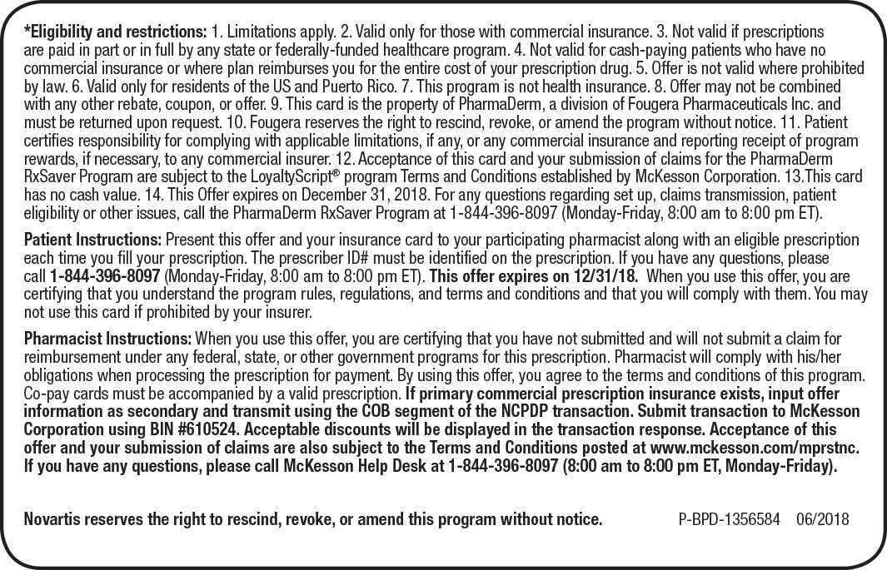

What is sinecatechins?
Sinecatechins is an herbal product made from green tea leaves.
Sinecatechins topical (for the skin) is used to treat genital and anal warts in adults. This medicine is for use only on warts outside the genitals and around the outside of the anus. Sinecatechins topical is not for use inside the vagina, cervix, rectum, or urethra (the tube for passing urine out of your bladder).
Sinecatechins will not cure genital or anal warts and you may develop new warts during or after treatment. Sinecatechins will not keep you from spreading genital or anal warts to other people through sexual intercourse or skin-to-skin contact.

How should I use sinecatechins?
Sinecatechins is usually applied 3 times per day. Follow all directions on your prescription label. Do not use this medicine in larger or smaller amounts or for longer than recommended.
Do not take this medicine by mouth. Sinecatechins topical is for use only on the skin. Do not use on open wounds.
Wash your hands before and after applying the ointment.
Apply only a small amount of ointment to each wart. Dab on the ointment, leaving a thin layer over each wart. Do not rub in completely.
Do not cover the warts with bandages, sanitary napkins, or other protective covering. Wear loose-fitting clothing over treated skin areas.
Do not wash off the ointment before applying your next dose. Reapply the ointment after you swim, bathe, or shower.
You should wash off the ointment before inserting a tampon into the vagina to avoid accidentally getting the medicine inside your vagina. Reapply the ointment after tampon insertion.
Men using the ointment on an uncircumcised penis should wash underneath the foreskin each day.
Keep using this medicine until your warts have completely cleared.
Discontinue using if no improvement is seen within a few weeks. Do not use this medicine for longer than 16 weeks. Call your doctor if your warts do not clear up, or if they go away and then come back after treatment.
Sinecatechins topical ointment can stain light-colored clothing or bed sheets. Avoid getting the ointment on these surfaces. Wear dark-colored clothing to prevent unwanted staining.
Store at room temperature away from moisture and heat. Keep the tube tightly closed when not in use. You may also store the ointment in the refrigerator. Do not freeze.

