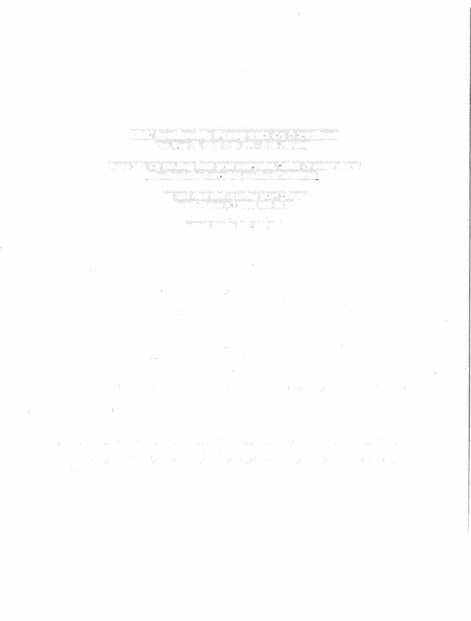
RSAI Leadership Meeting Minutes September 18, 2018
2:00 PM

Agenda:

- Margaret Buckton called the meeting to order at 2:00 p.m. via GoToMeeting.
- Recorded votes submitted electronically on the following motions:
  - August 15 Meeting: McClain moves approval of the minutes of August 15 RSAI Leadership Meeting. Olson Seconded. Those voting yes: McClain, Olson, Noll, Croghan, Smith. Those voting no: none. Motion carries.
  - Financial Report:McClain moves approval of financial report including amount due to ISFIS for 85% of FY 2018 dues less ISFIS discount (total
$48,025 -$400 = $47,625) and additional regional meeting cost reimbursement, postage, brochure printing, for a total of $49,512.61 of which $1,887.61 was approved at the August Leadership Group meeting, for a balance of $47,625. Olson seconded. Those voting yes: McClain, Olson, Noll, Croghan, Smith. Those voting no: none. Motion carries.
  - Motion 3: McClain moves approval of the RSAI priorities for the 2019
Legislative Session, including request for Iowa's Medicaid plan to cover telehealth services for students with mental health needs in the RSAI mental health priority for the 2019 legislative Session. Olson seconded. Those voting yes: McClain, Olson, Noll, Croghan, Smith. Those voting no: none.
Motion carries.

No further business
- Meeting adjourned at 2:06 p.m.

