KGB

Killer Grape Baetis

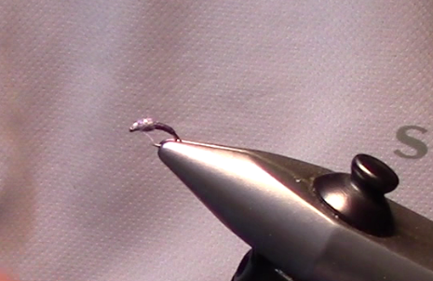

Kiley’s Nymph Skinz are available in many different colors from Hareline Dubbin. This fly is just a variation of John Barr’s emerger using a different tail material and Kiley’s Nymph Skinz in purple for the body

The video for this step by step can be found at:

**KGB Recipe**

**Hook:** TMC2487 Sizes 18 to 22

**Thread:** Veevus 16/0 Grey

**Tails:** Coq De Leon Dark Pardo

**Body:** Kiley’s Nymph Skinz – Purple

**Wing case and legs:** Microlon – Light Purple

**Thorax:** Super Fine Adams Grey

1. Start by attaching the thread to the hook at the 50% point using a jam knot.

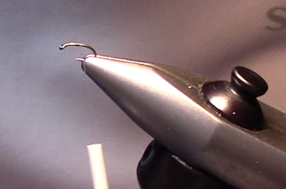

1. Select around 6-8 Coq De Leon Fibers for the tail. Tie the tails in and wrap over the hook bend and then wrap back to the tie in point and trim the butt ends.

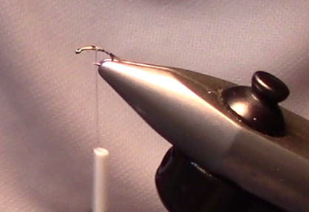

1. Attach Kiley’s Nymph Skinz.

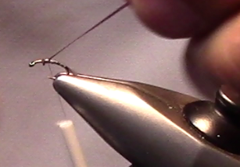

1. Stretching the nymph skin wrap down the hook bend and then back to the tie in point. Tie down the Nymph Skinz and trim.

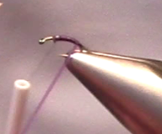 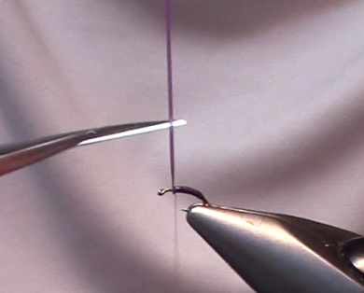

1. Tie in 4 pieces of Microlon for the wing case and legs.

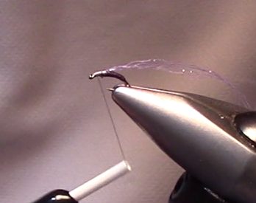

1. Dub the thorax with Grey Superfine. Leave room at the hook eye to tie in the wing case.

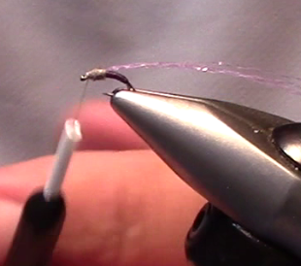

1. Fold the Microlon over the Thorax to form the wing case.

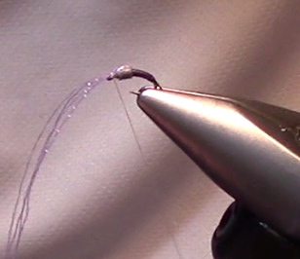

1. Next separate the Micolon into two bundles. Fold these back on each side of the thorax to form the legs.

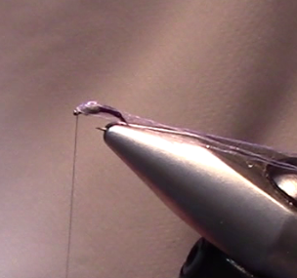

1. Whip Finish.

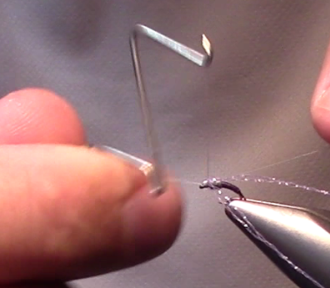

1. Trim the legs. I like to trim them at the back of the thorax.

