Leyland Historical Society News

Issue 86 Summer 2017 5th June 2017

Meetings

**Meetings held in the Shield Room, Banqueting Suite, Civic Centre, West Paddock at 7.30 pm**

**All meetings marked * are free to members though visitors have to pay £10.00 rather than usual visitors entrance fee of £5.00.**

**The membership fee of £15.00 per year includes all 10 meetings and the Lailand Chronicle at a discount price of only £1.00, usual price £3.00.**

----------------------------------------------------------------------------------

Monday 4th September 2017

**“Leyland in 1968 – The Town Peter Barrow Recorded”**

Peter Houghton

Monday 2nd October*

**“In At The Deep End” – The Story of the R.N.L.I**

Mikron Theatre Company

Monday 6th November*

**“The Rise of Personal Heritage in the 21st Century”**

**Family History & Local History**

Dr Nick Barrett

Monday 4th December

**“The Diary of Samuel Pepys”**

Lizzie Jones

Monday 8th January 2018 (2nd Monday)

**“Industrial Archaeology - The Latest Past”**

Chris Wild

Monday 5th February

**“Cracks from the Cobblers Seat”**

Sid Calderbank

Monday 5th March

**“Development of Late Victorian and Edwardian Gardens”**

Colin Dickinson

Monday 9th April (2nd Monday)

**“The Story of Heraldry”**

Thomas Woodcock, Garter King of Arms

Monday 7th May

**13th Annual Historical Society Trip**

Saturday 19th May*

**Leyland Historical Society at Home**

Monday 4th June*

**“World War II Codebreakers”**

Dr Mark Baldwin

Monday 2nd July*

**“The Monarchy”**

Dr David Starkey

Our 50th Anniversary Season

To start our 50th Season in September we will look back to see how Leyland looked round about 1968 when the Society was formed. As we discovered last year the pictorial journey with pictures collected by our late member, Peter Barrow was extensive and tonight we will take an historic walk around town with him as our guide.

This year’s Mikron Theatre production in October tells the story of the Royal National Lifeboats Institution. Skipwick RNLI is all at sea. Crew members are hard to come by and Coxswain Darren’s management style isn’t helping. So when seventeen year old Shannon volunteers, it’s all hands on deck – particularly for Darren’s teenage son, Billy.

Can the station survive in this ‘me first’ age? Will eccentric fundraiser Hazel’s ideas ever turn a profit? And can Darren and Billy chart the choppy emotional waters closer to home?

With marvellous maritime music and fathoms of fun, join Mikron as we dive into two hundred years of saving lives at sea!

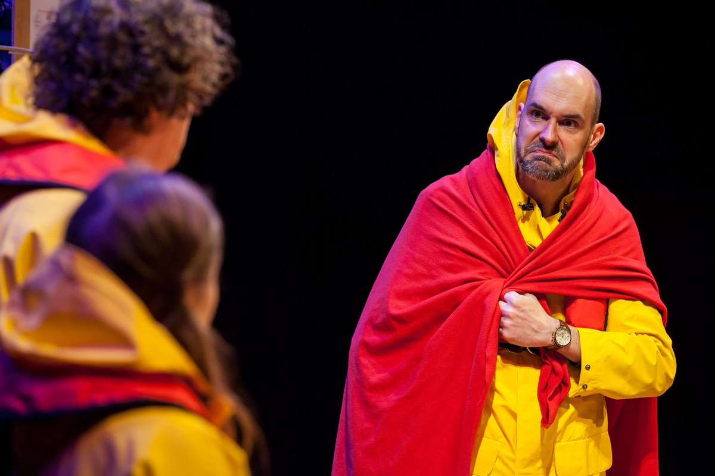

In November we are having a special event as when we were presented with the Website of the Year Award for 2016, the presenter, Dr. Nick Barrett commented on how much he liked our site. I then took that opportunity to invite him to speak to our members. Nick was the person behind the first few series of “Who Do You Think You Are” and wrote the original books of the series. His talk will show how the combination of family history and local history has been aided and promoted in the 21st Century.

For her presentation this year in December, in a show entitled "The Diary of Samuel Pepys", Lizzie Jones will dramatize the diary in her own style.

Samuel Pepys (23rd February 1633 – 26th May 1703) was an administrator of the navy of England and [Member of Parliament](https://en.wikipedia.org/wiki/Member_of_Parliament_(UK)) who is most famous for the [diary](https://en.wikipedia.org/wiki/Diary) that he kept for a decade while still a relatively young man. Pepys had no maritime experience, but he rose to be the Chief [Secretary to the Admiralty](https://en.wikipedia.org/wiki/Secretary_to_the_Admiralty) under both [King Charles II](https://en.wikipedia.org/wiki/Charles_II_of_England) and [King James II](https://en.wikipedia.org/wiki/James_II_of_England) through patronage, hard work, and his talent for administration. His influence and reforms at the Admiralty were important in the early professionalisation of the Royal Navy.The detailed private diary that Pepys kept from 1660 until 1669 was first published in the 19th century and is one of the most important primary sources for the English Restoration period. It provides a combination of personal revelation and eyewitness accounts of great events, such as the Great Plague of London, the Second Dutch War and the Great Fire of London.

On 8th May, there will be the 13th Annual Historical Society Trip, details of which will be given at the November meeting.

Friday 18th May will see the opening of the Leyland Heritage Centre on Hough Lane to help celebrate the 50th Anniversary of the Leyland Historical Society. The intention is to rent shop premises for a period of eight weeks to show the Societies work over the past 50 years with displays, answering queries, obtaining information and photographs. The Societies Sales stand will also be there selling chronicles and books.

Saturday 19th May will see the Leyland Historical Society at Home as we invite members of the other Historical Societies in Lancashire to join us for a morning of talks at the Civic Centre and visits around Leyland in the afternoon. Speakers include Elizabeth Shorrock, Sid Calderbank, Colin Dickinson and Peter Houghton.

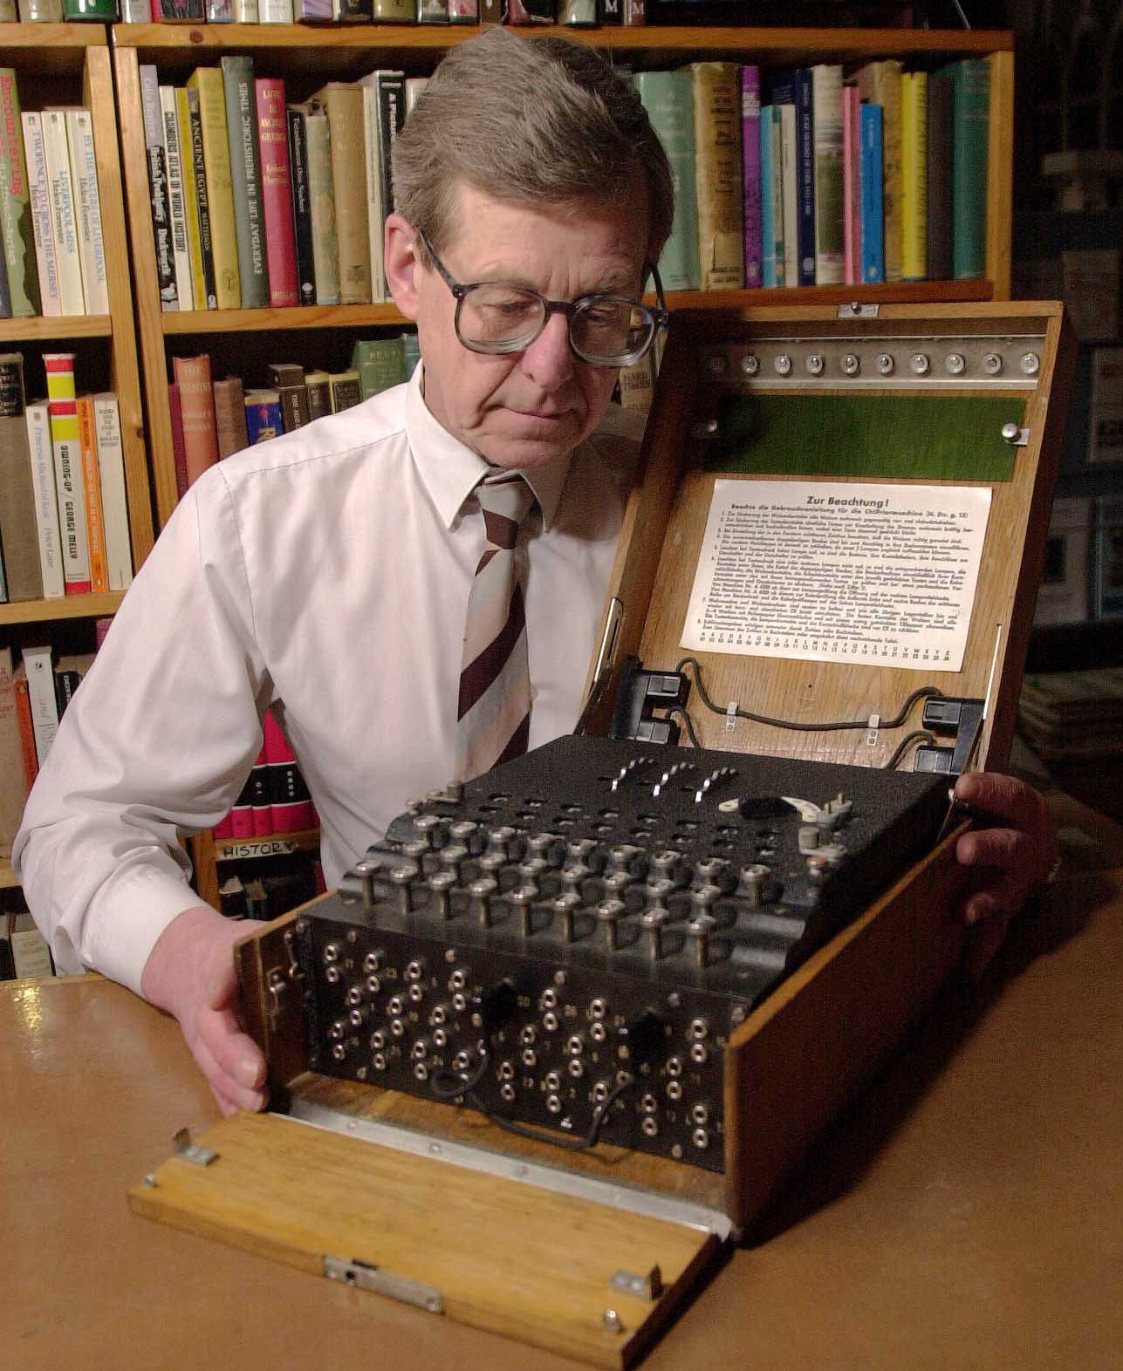

As it is now ten years since we first heard Dr. Mark Baldwin’s story of the WWII Codebreakers and much more has come to light, not forgetting the film “The Imitation Game” where his Enigma machine had a starring role and will be appearing at our June meeting again, Mark will be updating and expanding an already wonderful story.

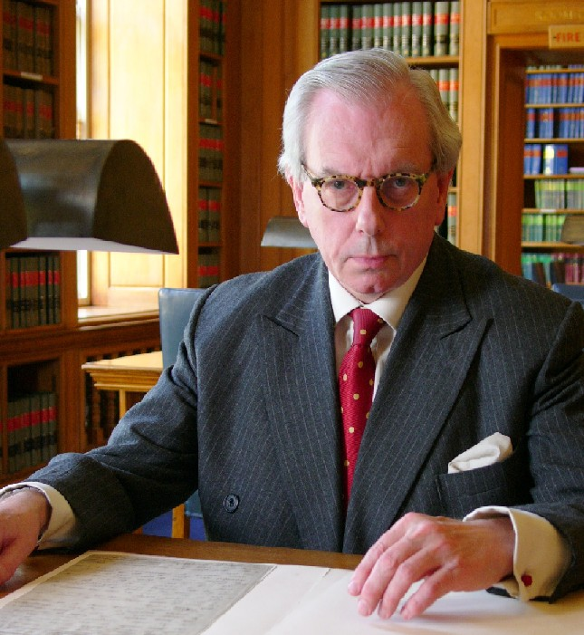

Our final meeting of the season on Monday 2nd July will feature the return of Dr. David Starkey who will give us his latest discoveries on the Monarchy as the Society celebrates its actual 50th Anniversary.

Peter Houghton

For our first talk of 2018 on the Second Monday in January (8th) we will again be entertained by Chris Wild who will be discussing his latest work with the Archeology unit in the University of Salford which include the fire recording of Wythenshawe Hall, Stephenson’s 1830 railway viaduct over the River Irwell (pictured below), Salford Twist Mill and Caernarvon Castle, to name a few diverse highlights.

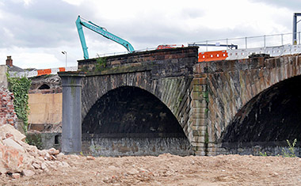

For the February meeting Sid Calderbank will be performing "Cracks from a Cobblers Seat. This is a real local book, as the stories and songs are based around Euxton and Leyland, including a double act which Sid hopes to recreate.

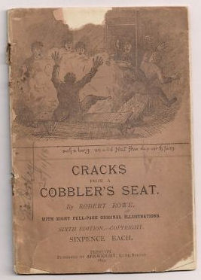

Our old favourite Colin Dickinson will be returning in March with the story behind the “Development of Late Victorian and Edwardian Gardens.  
For the meeting on 9th April (2nd Monday because of Easter) we are welcoming back our member, Thomas Woodcock, Garter King of Arms who will continue the Story of Heraldry.

