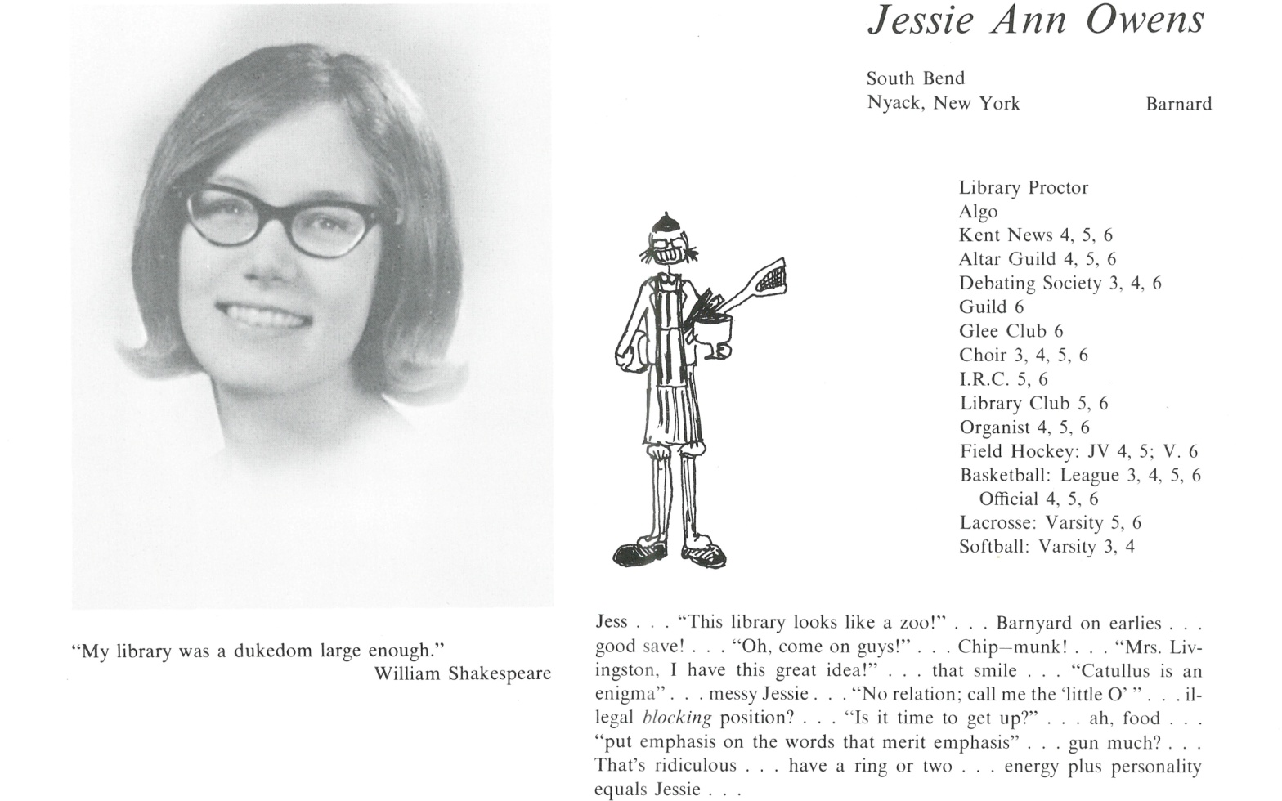

Jessie Ann Owens

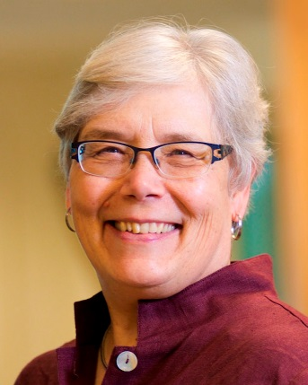Well, I guess it was predictable from Kent days (library and music) that I would become a musicologist. After Kent I went to Barnard, majoring in Latin, and then, after a Fulbright year in Italy, to Princeton for a Ph.D. in musicology. My field is Renaissance music, and I study compositional process (how composers wrote music) and the history of theory. I’m a lapsed organist but enjoy singing whenever I get a chance.

My academic career took me to Columbia (as a Mellon Fellow), then the Eastman School of Music in Rochester, and then Brandeis University in Waltham, MA, where I also served as dean. In 2006 I moved to California to be dean and professor of music at UC Davis.

I have been in two long-term relationships in the days before gay people could marry but am now a single gal.

I retire this June and look forward to being a full-time musicologist and gardener. I will be in Venice in the fall on a research grant, and have two book projects in the works.



______________________________________________________________

______________________________________________________________ ______________________________________________________________ ______________________________________________________________ ______________________________________________________________ ______________________________________________________________ ______________________________________________________________ ______________________________________________________________ ______________________________________________________________

Attach Picture in .jpg Format

______________________________________________________________

______________________________________________________________

___________________________________________________________________________________ _________________________________________________________________________________________________________________________________________________________________________________________________________________________________________________________________________________________________________________________________________________________________________________________________________________________________________________________________________________________________________________________________________________________________________________________________________________________________________________________________________________________________________________________________________________________________________________________________________________________________________________________________________________________________________________________________________________________________________________________________________________________________________________________________________________________________________________________________________________________________________________________________________________________________________________________________________________________________________________________________________________________________________________________________________________________________________________________________________________________________________________________________________________________________________________________________________________________________________