***ASHLAND SCHOOL OF DANCE***

**2025 – 2026 DANCE SEASON**

Classes begin Sunday, September 7, 2025 and run through April TBD, 2026

**ONLINE REGISTRATION:** <https://dancestudio-pro.com/online/asod> 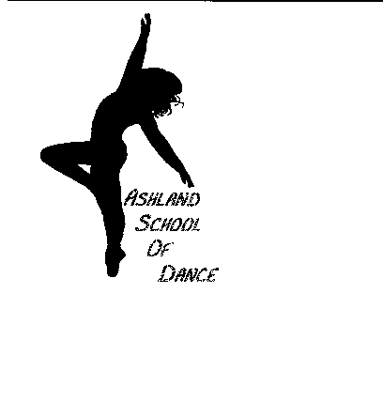

**WINTER SHOWCASE PERFORMANCE:** January 2026

**SPRING DANCE RECITAL:** April 2026

**Sunday**

12:30 – 1:15 Mini Competition Team

1:25 – 2:10 Petite Competition Team

2:20 – 3:20 Jr Company

3:25 – 4:55 Sr Company

5:05 – 6:05 Junior Competition Team

**Monday**

4:00 – 4:30 Creative Movement (Ages 3-4)

4:35 – 5:05 PrePoms/Jazz (Ages 4-5)

5:10 – 5:55 Level I Hip Hop (Ages 7 & up)

6:00 – 7:00 Jr Co Hip Hop

7:05 – 7:50 Adult Hip Hop (class Sept-January)

7:55 – 8:55 Sr Co Hip Hop

**Tuesday**

4:00 – 4:45 PreJazz/Funk (Ages 5-6)

4:50 – 5:20 Creative Movement (Ages 3-4)

5:25 – 6:10 PreBallet/Tiny Tap (Ages 5-6)

6:15 – 7:00 Poms (Ages 6-8)

7:05 – 7:50 Poms (Ages 8 & up)

7:55 – 8:40 Contemporary (Ages 8-12)

**Wednesday**

4:00 – 4:45 Level II Lyrical/Jazz

4:50 – 5:50 Level III Lyrical/Jazz

5:55 – 6:55 Teen Competition Team

7:00 – 8:00 Jr Company

8:05 – 9:05 Sr Company

**Thursday**

4:00 – 4:45 Level I Lyrical/Jazz (Ages 7 & up)

4:50 – 5:35 Level I Jazz/Tap (Ages 7 & up)

5:40 – 6:25 Level II Hip Hop

6:30 – 7:15 Level III Hip Hop

**Friday**

4:00 – 5:00 Int Tap

4:40 – 5:40 Adv Tap

**Saturday (September – January) – 2025 Fall/Winter Session**

9:00 – 9:30 Creative Movement (Ages 3-4)

9:35 – 10:20 Hip Hop (Ages 5-7)

10:25 – 11:10 Poms (Ages 6-8)

11:15 – 12:00 Lyrical (Ages 8-10)