V. We invite you to stand as you are able.

OFFERING PRAYER
V. Let us pray,
God of glory,
great are your wonders among us
and many are the blessings you bestow.
Use us and these your gifts for the needs of the world,
that all the ends of the earth may rejoice in your saving grace,
through Christ our Savior.
C. Amen.

GREAT THANKSGIVING
V. The Lord be with you.
C. And also with you.

V. Lift up your hearts.
C. We lift them to the Lord.

V. Let us give thanks to the Lord our God.
C. It is right to give him thanks and praise.

V. It is indeed right and salutary that we should at all times and in all places offer
thanks and praise to you, O Lord, holy Father, through Christ our Lord; who rose
beyond the bounds of death and, as he promised, poured out your Spirit of life
and power upon the chosen disciples. At this the whole earth exults in boundless
joy. And so, with the Church on earth and the hosts of heaven, we praise your
name and join their unending hymn:

SANCTUS
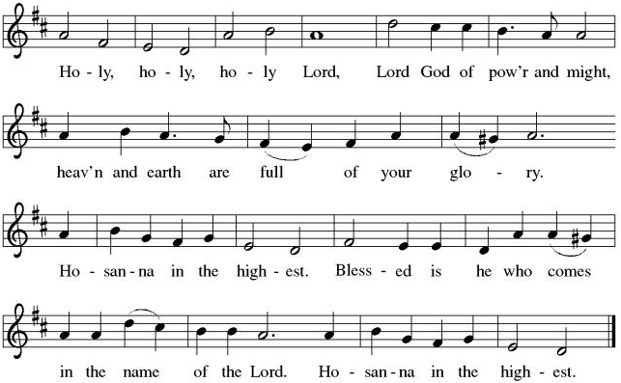

THE EUCHARISTIC PRAYER
V. Blessed are you, Lord of heaven and earth, in mercy for our fallen world you gave
your only Son, that all those who believe in Him should not perish, but have
eternal life. We give thanks to you for the salvation you have prepared for us
through Jesus Christ. Send now your Holy Spirit into our hearts that we may
receive our Lord with a living faith as He comes to us in His holy supper.
C. Amen. Come, Lord Jesus.

V. In the night in which he was betrayed our Lord Jesus took bread,
he gave thanks; broke it, and gave it to his disciples, saying:
Take and eat; this is my body, given for you.
Do this for the remembrance of me.

V. Again, after supper, He took the cup, he gave thanks,
and gave it for all to drink, saying:
This cup is the new covenant in my blood,
shed for you and for all people for the forgiveness of sin.
Do this for the remembrance of me.

THE LORD’S PRAYER
(We ring the bell throughout the Lord’s Prayer at all services to
invite those in the community to join in praying the Lord’s Prayer.)
V. May we now join with one another and pray together as Jesus has taught us.
C. Our Father, who art in heaven, hallowed be thy name, thy kingdom come,
thy will be done, on earth as it is in heaven. Give us this day our daily
bread; and forgive us our trespasses, as we forgive those who trespass
against us; and lead us not into temptation, but deliver us from evil. For
thine is the kingdom, and the power, and the glory, forever and ever.
Amen.

LAMB OF GOD

(We invite you to be seated.)

HOLY COMMUNION
V. Communion here is pretty simple, and all who are baptized and believe in Jesus
Christ are welcome at the table.

OFFERING SONG
(We invite you to sing along.)
Worship & Praise
156—What Have We to Offer?
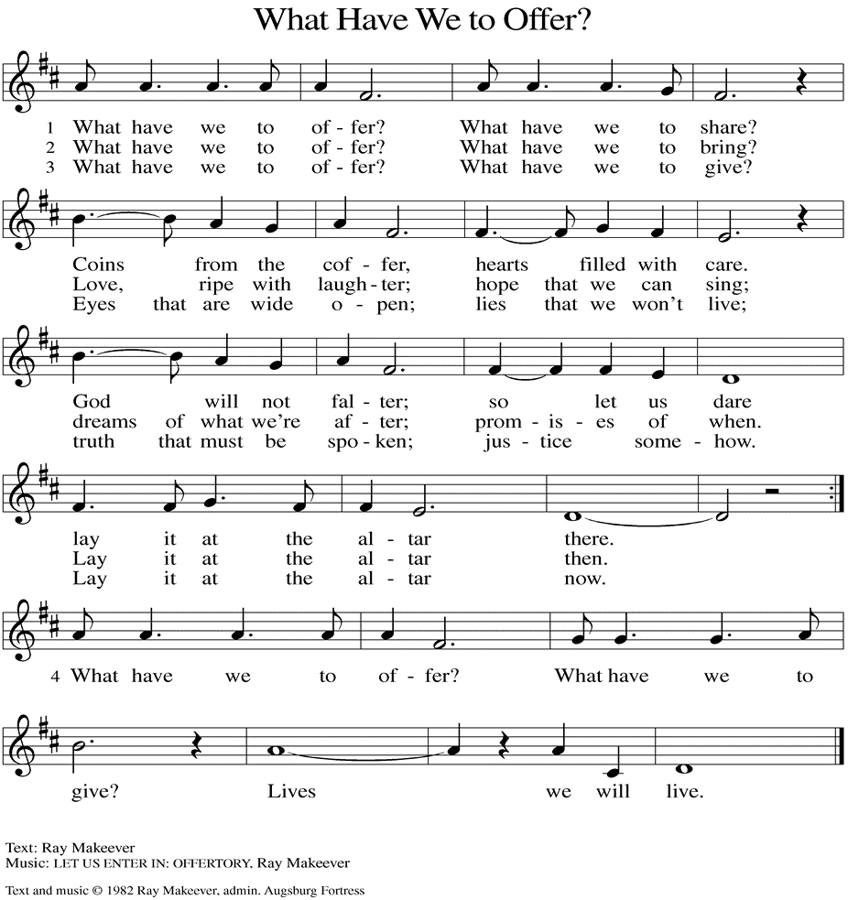
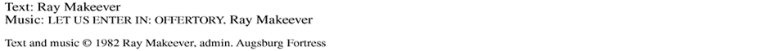

(Usher(s) brings the Tithes and Offerings up front to the Assistant.)

V. Watch over all of us who are worried and suffering, and especially those whose
names we now say aloud or hold within our hearts (pause). Hear us, O God.
C. Your mercy is great.

V. With the joy of Christ’s birth in our hearts, we commend our prayers to you, O
God, trusting in your boundless mercy and eternal love; through Jesus Christ our
Savior.
C. Amen.

SHARING OF THE PEACE
V. May the peace of the Lord be with you always.
C. And also with you.
V. Now, let us share God’s Peace with one another.



(Please respect your neighbor if they desire to still only offer a peace sign or wave.)

(Following the Sharing of the Peace, we invite you to be seated.)

OFFERING
V. We now worship God with our tithes and offerings, wine and bread for use in holy
communion, and monetary gifts to support our ministry for service in God’s name.
Our Ushers will be around to your pews to pass the Offering Plates.

(Ushers come forward to get the Offering Plates from the Assistant.)

(Vicar and Assistant prepare the Altar for Communion.)

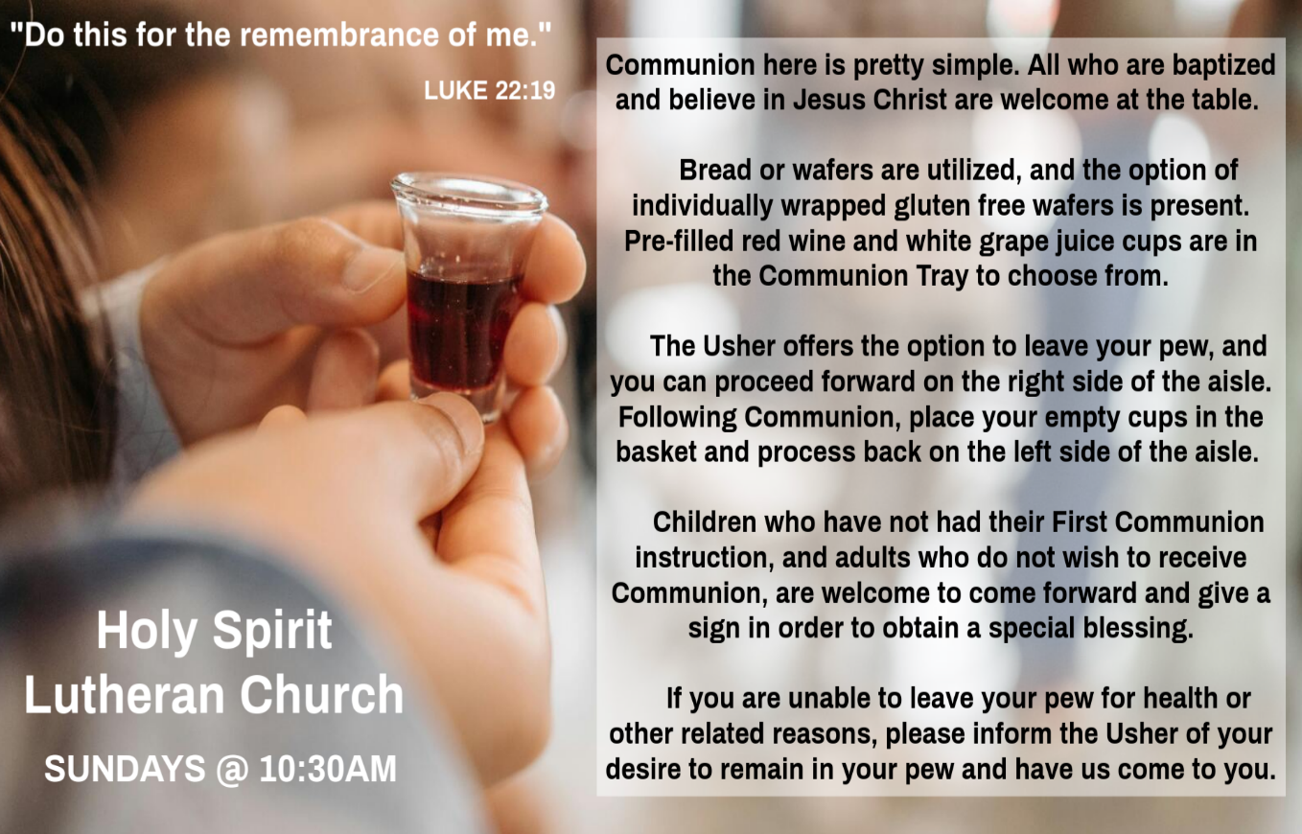

INVITATION TO COMMUNION
V. God is now in flesh appearing.
Come to the feast of joy!
C. Amen.

(Distribution of Holy Communion)

COMMUNION HYMN
(Please enjoy various music offered by our Organist during your
quiet time, prayer, and reflection following Holy Communion.)

(Vicar and Assistant remove Communion Vessels from the Altar.)

V. We invite you to stand as you are able.
POST COMMUNION BLESSING
V. May the body and blood of our Lord Jesus Christ strengthen us and keep us
always in His grace.
C. Amen.

POST COMMUNION CANTICLE
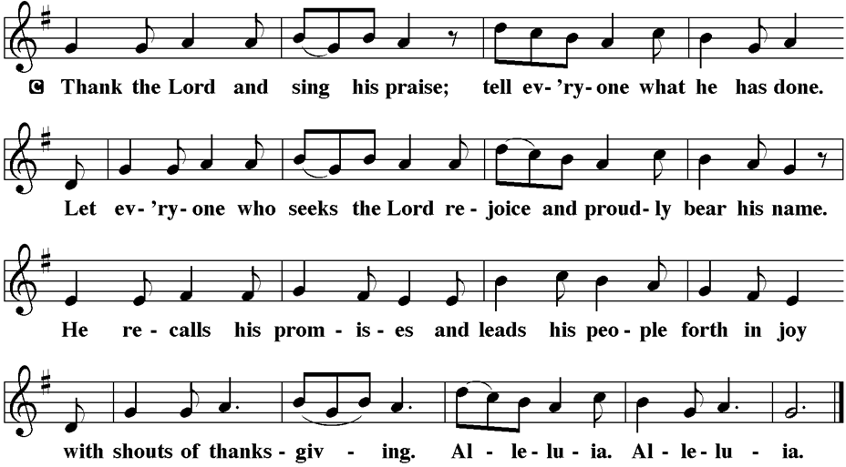

PRAYER AFTER COMMUNION
A. Let us pray,
Incarnate God, you are among us at this table.
May we treasure this gift and ponder in our hearts
the mystery of your presence.
Move us to discover the wonders of your love
in the everyday moments of our lives,
through Christ born in us.
C. Amen.

BLESSING
V. The triune God, glorious Mystery,
holy Incarnate One, abiding Comforter,
☩ bless you with endless grace, peace, and joy.
C. Amen.
Tom M (Philomena Noak's Family)
William T Hodgetts (Pastor William Hodgetts’ Family)
Paul Bowker (Church Member)
BettyAnn & Bill Whitman (Mary Melnicoff's Friends)
Bob Poole (Kathy Poehler's Family)
David Smith (Heather & Vicar Vince Piekarski’s Family)
Joe Smith (Heather & Vicar Vince Piekarski's Family)
Barbara Hoitink (Lucas & Sabrina Munson's Family)
Kathy Raynor (Philomena Noak & Mary Melnicoff’s Friend)
Ed Cox (Church Family)
Audrey Knott (Judy Brannan’s Family)
Jordan (Carol Amundsen's Friend)
Myrna (Brookdale Resident)
Jeremy Pochatko (Vicar Vince Piekarski's Friend)
Ann Wieckouski (Theresa & Kim McGinley's Family)
Rich (Kim McGinley's Friend)
Gloria Sutton (Church Member)
Elizabeth McCafferty (Mary Melnicoff's Friend)
Amy Johnson (Ted Bell's Sister)
Jerry & Marlana (Carol Amundsen's Friend)
Theresa Dolan (Joan Kilcoyne's Family)
Sandy Bloomberg (Judy Brannan's Family)
Simon (Carol Amundsen's Family)
(Additional Names Added Prior to the Worship Service.)
A. Hear us, O God.
C. Your mercy is great.

A. God of compassion, you nurture children as the apple of your eye. As you
sheltered your son Jesus from Herod’s grasp, shelter all children in danger. As
you comforted Rachel, comfort all who have lost children to violence. Hear us, O
God.
C. Your mercy is great.

A. God of love, you console those who weep for lost beloved ones (especially). Even
as we mourn, we offer thanks for those who have gone before us, trusting in your
comfort and protection. Hear us, O God.
C. Your mercy is great.

(Here other intercessions may be offered.)

Christina McNasby (Fran Green’s Family)
The Kinkson Family (Judy Brannan's Friends)
Mark Stephen Dennis (Diana DeNote's Family)
Bill Lodge (Skip & Bonnie Millard's Friend)
Ron Anderson (Bill Kelly's Friend)
Bud Brearey (Judy Brannan & Mary Melnicoff's Friend)
Mary Skain (Kathy Poehler's Friend)
Robert Chaplin (Mary Melnicoff's Friend)
Jack Wieckouski (Theresa & Kim McGinley's Family)
Carolyn Santarpio (Bob Fritsch's Friend)
Harry (Judy Brannan's Friend)
Janet K (Philomena Noak's Friend)
Michael Hart (Diana DeNote's Friend)
Rocco Leonard DeNote (Diana DeNote's Family)
Al Singer & Family (Frank Ford's Friends)
Sherri Lynn (Bob Fritsch's Friend)
John Bannco (Bob Fritsch's Friend)
Nancy Pazarinie (Bob Fritsch's Family)
Jane & Paul Eiben (Rose Lang's Friend)
Joe DiMassimo (Judy Brannan & Mary Melnicoff's Friend)
Tommy Stanford (Sue Waltz's Family)
Audrey McAlister (Sue Waltz's Family)
Joe Waltz (Sue Waltz's Family)
Denny Papst (Rose Lang’s Friend)
Mike & Alice Rhoades (Rose Lang’s Friends)
Chris (Judy Brannan's Friend)
Helen Ehlers (Judy Brannan's Friend)
Leanne Bueth (Joan Kilcoyne's Family)
Janett MacFarlane (Carol Amundsen's Friend)
Patrick Davenport (Sue Waltz's Friend)
Thish Kelly (Theresa & Kim McGinley's Family)
Edward Chapleski (Allison Call's Family)
Scott Levin (Rose Lang's Friend)
Alice Ann Dennis (Diana DeNote's Family)
Nancy Taylor (Ted & Diane Bell's Family)
Santa Isabel Lutheran Church (Elizabeth, NJ)
Messiah Lutheran Church (Oakland, NJ)
Carol Brand (Skip & Bonnie Millard’s Friend)
Joyce Thompson (TDPWC Member)
Barbara Paynter (Leon Stitt’s Family)
Ruth (Anthony & Vincent Bruno's Family)
SENDING HYMN
(We invite you to sing along.)
Lutheran Book of Worship—Green Book
70—Go Tell It on the Mountain

(Assistant extinguishes the Altar Candles half way through the Sending Hymn.)

(Vicar processes out once the Altar Candles have been extinguished.)

(We invite you to be seated.)

BIRTHDAYS, ANNIVERSARIES, & ANNOUNCEMENTS
(Offered by Assistant and Congregation.)

BIRTHDAYS & ANNIVERSARIES
None

DISMISSAL
A. Glory to God in the highest!
C. And peace to God’s people on earth!
A. Go in joy. Embody God’s redeeming grace.
C. Thanks be to God.

POSTLUDE
(Music offered by our Organist as we depart following our Worship Service.)
While Shepherds Watched Their Flocks

LICENSES & EXPIRATION DATES
Worship Service Content is used via permission through Augsburg Fortress Liturgies Annual License #SB144368. The next Subscription Renewal Date is 2/28/2026.
Our Hymns and Worship Music are used via permission through CCLI One
License #11327166. The next Subscription Renewal Date is 1/31/2026.


TITHES, OFFERINGS, & ENVELOPES
2026 Offering Envelopes are available in the back of the church. We worship God with our tithes and offerings. We hear in scripture, “Each of you must give as you have made up your mind, not reluctantly or under compulsion, for God loves a cheerful giver.” (2 Corinthians 9:7) Envelopes can be dropped in the offering plate, mailed to the church, or dropped in the locked mailbox. Thanks for your support in the mission of our church, its ministries, the New Jersey Synod, and other needs!

WORSHIP MINISTRY
The most important thing we do each week is gather together as God's people to Worship. God is the center and focus of everything we do. Participating in Worship is active, as Liturgy means the work and actions of the people gathered. Everything we do during the week to prepare for Worship, and everything we do as we Assist in leading Worship is important. We are thankful for all the wonderful work being done. If you have questions, or are interested in any position, reach out to Vicar Vince.
Sign-up sheets are located on the bulletin board between the church offices.

FOOD PANTRY
Open every Thursday, and the last Saturday of every month, from 10AM to 1PM. 134 people were served in November and 868 people have been served in 2025. Donations can be dropped in the outdoor drop-box, in the money jug in the back of the Church, mailed into the Church Office, or placed in the Offering Plate. Volunteers are needed. Sign-up sheets are located on the bulletin board between the church offices. If you have questions or need training see Heather, Vicar Vince, or Bonnie.
A special thank you goes out to all who donate, pray, and help in any way!

Thursday, 1/1 | Saturday, 1/8 | Thursday, 1/15
Tori & Vicar Vince | Garnet & Joe | Tori, Garnet, & Joe

(A brief silence.)

A. God of grace, you show us mercy not according to our worthiness, but according
to the abundance of your steadfast love. Grant us the courage to go into the
world and do likewise. Hear us, O God.
C. Your mercy is great.

A. God of abundance, the sun and moon praise you and the shining stars sing of
your love. Where we have desecrated your creation, make us into a healing balm
for what we have broken. Hear us, O God.
C. Your mercy is great.

A. God of righteousness, when leaders fail to fulfill their calls to enact justice, you
suffer alongside us. Propel those in power to see you reflected in the faces of all
they serve. Hear us, O God.
C. Your mercy is great.

A. God of life, you claim us as your own and care for us as Christ’s siblings. Pour out
your compassion in every place your people suffer, and protect them in the palm
of your hand. We pray especially for . . .
BettyAnn Rich-White (Church Member)
Chip & Marie Hand (Church Members)
Lynn Bargstadt (Church Member)
Frank Ford (Church Member)
Carol Amundsen (Church Member)
Kim McGinley (Church Member)
Anthony DeLuca (Church Member)
Frank Brunner (Church Member)
Joan Sommerman (Church Family)
Arleen Kinka (Church Family)
Rick Lang (Church Family)
Suzie Clark (Rose Lang's Friend)
Francis Clock (Dianna DeNote’s Family)
Andrew Hudak (Rose Lang’s Friend)
Viena Murtha (Bob Fritsch’s Friend)
Sharon Waicus (Skip & Bonnie Millard's Friend)
Karen O'Brien (Paul Bowker's Friend)
Dustin Irizzary (Mary Melnicoff's Family)
The Bryan Family (Wanda Bryan's Family)
Craig Brearey (Judy Brannan & Mary Melnicoff's Friend)
Sarah Dutton (Frank Ford's Family)
SERMON
(Delivered by Vicar Vince Piekarski.)

(Following the Sermon, we invite you to stand as you are able.)

HYMN OF THE DAY
(We invite you to sing along.)
Lutheran Book of Worship—Green Book
55—Good Christian Friends, Rejoice

APOSTLES’ CREED
V. God has made us his people through our Baptism into Christ. Living together in
trust and hope let us confess our faith together using the Apostles’ Creed.
C. I believe in God, the Father almighty,
creator of heaven and earth.

I believe in Jesus Christ, God’s only Son, our Lord,
who was conceived by the Holy Spirit,
born of the Virgin Mary,
suffered under Pontius Pilate,
was crucified, died, and was buried;
he descended to the dead.
On the third day he rose again;
he ascended into heaven,
he is seated at the right hand of the Father,
and he will come to judge the living and the dead.

I believe in the Holy Spirit,
the holy catholic church,
the communion of saints,
the forgiveness of sins,
the resurrection of the body
and the life everlasting.
Amen.

PRAYERS OF INTERCESSION
(The prayers are prepared locally for each occasion.)
V. Empowered by the news of Christ’s birth, let us pray boldly for the church,
creation, and all who are in need.

COMMUNITY FOOD DONATIONS, DELIVERIES, & MORE
Our local North Cape May Acme provides us with Expiring Soon, Recently Expired, and Slightly Damaged Food and Items weekly. Kathy helps those in need by delivering items each Saturday in the community, brings leftover items to the Church for church members in need, and those who visit the food pantry during the week. Additional items are taken over to the Branches Outreach in Rio Grande on Monday.

BULLETIN ENTRY DEADLINE
The Bulletin is printed on Thursdays during Church Office Hours. Changes need to be submitted to Vicar Vince no later than Thursday by 4PM. Thank you!

CHURCH OFFICE HOURS
Open Thursdays from 6PM to 8PM. It is open to serve the Congregation, the Community, and to handle the business of the Church. Feel free to stop in to talk, pick-up or drop off something, pray in the Sanctuary, or for whatever reason.

DONATION STATION
Get on the train and place all purchased items in the specified project donation bins located on the counter by the front doors. See Heather for more information.


CONFIRMATION & SUNDAY SCHOOL
“Here We Stand” allows our young folks to go through a 2-year process while focusing on the Bible and Luther’s Small Catechism. Studies for year two of our program have resumed. We meet on Sundays from 9-10AM. Classes Resume following Christmas and New Years on Sunday, January 4th, 2026.

BIBLE STUDY & FAITH DISCUSSIONS
Bible Study & Faith Discussions was started in order to focus on various readings,
books, Bible verses, people of faith, and other general topics. Group Members offer
various points of view while reviewing the Bible and various aspects of faith while
being respectful and supportive of each other. We are on break at this time until the new year. Come on out and join us on Tuesday, January 6th at 6PM.

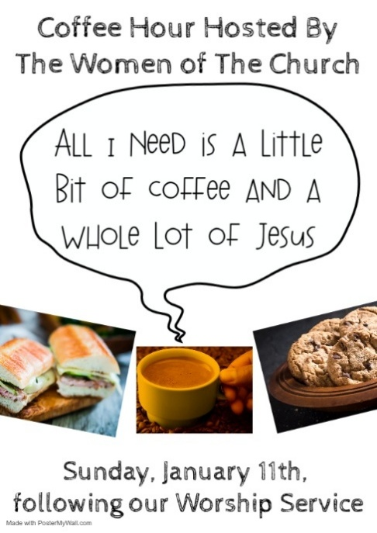

EXECUTIVE COUNCIL MEETING
We will be meeting at Bonnie & Skip’s Residence on Wednesday, January 14th, at 10AM to review our budget for the upcoming year and to handle other business leading up to our Annual Congregational Meeting. Please keep us in prayer.



PREACHING AT BROOKDALE
Vicar Vince preaches again at Brookdale Senior Living in Cape May Court House, on Sunday, January 18th, at 1PM. Holy Communion will follow the service.
GOSPEL READING
In a dream, Joseph is warned to flee to Egypt to protect the infant Jesus from the
jealousy of Herod.

V. The Holy Gospel According to Matthew, the 2nd Chapter (Verses 13-23).
C. Glory to you, O Lord.

V. 13 Now after [the magi] had left, an angel of the Lord appeared to Joseph in a
dream and said, “Get up, take the child and his mother, and flee to Egypt, and
remain there until I tell you, for Herod is about to search for the child, to destroy
him.” 14 Then Joseph got up, took the child and his mother by night, and went to
Egypt 15 and remained there until the death of Herod. This was to fulfill what had
been spoken by the Lord through the prophet, “Out of Egypt I have called my
son.”

16 When Herod saw that he had been tricked by the magi, he was infuriated, and
he sent and killed all the children in and around Bethlehem who were two years
old or under, according to the time that he had learned from the magi. 17 Then
what had been spoken through the prophet Jeremiah was fulfilled:
18 “A voice was heard in Ramah,
wailing and loud lamentation,
Rachel weeping for her children;
she refused to be consoled, because they are no more.”

19 When Herod died, an angel of the Lord suddenly appeared in a dream to
Joseph in Egypt and said, 20 “Get up, take the child and his mother, and go to the
land of Israel, for those who were seeking the child’s life are dead.” 21 Then
Joseph got up, took the child and his mother, and went to the land of Israel.
22 But when he heard that Archelaus was ruling Judea in place of his father
Herod, he was afraid to go there. And after being warned in a dream, he went
away to the district of Galilee. 23 There he made his home in a town called
Nazareth, so that what had been spoken through the prophets might be fulfilled,
“He will be called a Nazarene.”

V. This is the Gospel of the Lord,
C. Praise to you, O Christ.

(We invite you to be seated.)

SECOND READING
Through Jesus’ suffering and death, the trail to eternal salvation has been blazed
for us. We do not fear death, because he has conquered the power of death.
Thus Christ, our merciful and faithful high priest, has the final say over the destiny
of our lives.

R. Our Second Reading is from the 2nd Chapter of Hebrews (Verses 10-18).

R. 10 It was fitting that God, for whom and through whom all things exist, in bringing
many children to glory, should make the pioneer of their salvation perfect through
sufferings. 11 For the one who sanctifies and those who are sanctified all have
one Father. For this reason Jesus is not ashamed to call them brothers and
sisters, 12 saying,
“I will proclaim your name to my brothers and sisters;
in the midst of the congregation I will praise you.”
13 And again,
“I will put my trust in him.”
And again,
“Here am I and the children whom God has given me.”

14 Since, therefore, the children share flesh and blood, he himself likewise
shared the same things, so that through death he might destroy the one who has
the power of death, that is, the devil, 15 and free those who all their lives were
held in slavery by the fear of death. 16 For it is clear that he did not come to help
angels but the descendants of Abraham. 17 Therefore he had to become like his
brothers and sisters in every respect, so that he might become a merciful and
faithful high priest in the service of God, to make a sacrifice of atonement for the
sins of the people. 18 Because he himself was tested by what he suffered, he is
able to help those who are being tested.

R. This is the Word of the Lord.
C. Thanks be to God.

V. I invite you to stand as you are able, and I invite you to announce the Gospel
Acclamation with me.

GOSPEL ACCLAMATION
C. Alleluia. Let the peace of Christ rule in your hearts, and let the word of
Christ dwell in you richly. Alleluia. (Col. 3:15, 16)

CHURCH COUNCIL
Share your comments, concerns, questions, or joys with one of our Church Council Members who can bring them back to our meetings. Visitors are always welcome to attend and listen to what is going on in and around the church. Join us In- Person or on our Conference Call at our next Meeting on Tuesday, January 20th, at 6PM.

ANNUAL CONGREGATIONAL MEETING
As 2025 winds down we will be wrapping up the books and reports in preparation for a new year. 2026 will bring about several new things and changes I am sure, but one thing is for certain, we will be meeting as a Congregation for our Annual Meeting. We will discuss and review things, as well as vote on a new budget. I know it is rather early to think about things, but please start compiling your committee reports and make sure Sunday, February 8th is on your calendars, in your planners, or in your phones to meet after our Worship Service together.

CHURCH DIRECTORY
The 2025 Church Directory is by the Church Office on the bookshelves. We continue keeping it updated, but we undoubtedly miss a few changes or have made a few errors. The printed church directories have spaces for changes in info, new people’s info, notes, and your favorite Bible verses. If you have changes or updates, please inform the Church Office to keep us up to date. Our 2026 Church Directory will be made available to you the week following our Annual Congregational Meeting.

WOMEN OF THE CHURCH
They will be on Winter Break and will Resume Meetings on Monday, March 2nd, at 6PM. New members are always welcome to attend! Contact Judy for more info.

NEWSLETTER
Collect information, stories, pictures, and reports for our next publication. Everything needs submitted to Vicar Vince in-person or via email at vpie8282@gmail.com.

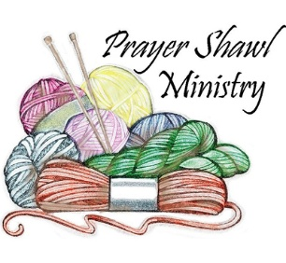
Prayer Shawls, Lap Quilts, Scarves, and other items have been made with love. Blessed items are located in the Narthex, and are free for anyone. Members of the group continue working at home on new stitches and patterns. We are blessed to be able to continue collecting new items. We have a donation station of yarn and other items located in the Narthex. You can find some new supplies for your next creation!
PRAYER LIST
Our Prayer List continues to lengthen and we realize the important need for prayers and healing. Sometimes the unfortunate result is that someone has passed away, and the words “The Family & Friends of” appear before someone’s name. However, sometimes we forget names are still on the list and their health has improved or the they are no longer struggling, and they can be removed. Please share the good and bad stories as we continue to pray for strength and healing. Names can be added or removed from the list on the clipboard in the Narthex prior to the Worship Service, by calling the church office, or addressing it on the Conference Call. Please let us know the relation to the person(s) you listed so we can be more mindful with our prayers. Names will stay on the list until removed by the person(s) who requested prayer.

HOME COMMUNION MINISTRY
A Minister is available if you have a loved one, or if you desire services. We look forward in sharing the Word and Holy Communion! Please inform Vicar Vince, Kathy, or the Church Office so plans can be made for visits.

SPACE AVAILABLE
​​​​​Do you know anyone interested in utilizing our Fellowship Hall for a Party or Event?
It is a suggested $50 refundable security deposit, and $250 for facility use. There is no alcohol or games of chance permitted due to ELCA policy. Please contact Vicar Vince or the Church Office with questions, for info, or to reserve a date and time.

ED GREEN CAPITAL IMPROVEMENT FUND
We continue raising money for unforeseen costs or repairs. Kathy has been selling Wawa Tickets for $6, but we have learned the program will end in 2025. Please use your tickets that you have purchased before the end of the year. We will seek out a new fundraiser. We still have the donation bin in the back of the church and our Church Rummage Sale. Thanks for your continued donations, prayers, and support!

LIBRARY
New books are added to our library from time to time. Several are borrowed and read and exchanged. Who knows, you might find one particularly interesting and share that with someone as well. Reading is a great way to pass spare time, learn, and explore. You may find some fresh ideas for prayer, ways to grow more spiritually, ways to grow closer to God, or some opportunities to understand our faith more. We also have an extended library located in Vicar Vince’s office. There are Bibles of various translations, books from his personal collection, books inherited from Pastor Leah, movies, past Bible Study Curriculums, and more. Visit the library between the church offices, or just ask to be able to check things out.
PSALM
R. Our Responsorial Psalm is from the 148th Psalm.
C. The splendor of the Lord is over earth and heaven. (Ps. 148:13)

R. 1 Hallelujah! Praise the Lord from the heavens;
praise God in the heights.
2 Praise the Lord, all you angels;
sing praise, all you hosts of heaven.
3 Praise the Lord, sun and moon;
sing praise, all you shining stars.
4 Praise the Lord, heaven of heavens,
and you waters above the heavens.
5 Let them praise the name of the Lord,
who commanded, and they were created,
6 who made them stand fast forever and ever,
giving them a law that shall not pass away.
C. The splendor of the Lord is over earth and heaven. (Ps. 148:13)

R. 7 Praise the Lord from the earth,
you sea monsters and all deeps;
8 fire and hail, snow and fog,
tempestuous wind, doing God’s will;
9 mountains and all hills,
fruit trees and all cedars;
10 wild beasts and all cattle,
creeping things and flying birds;
11 sovereigns of the earth and all peoples,
princes and all rulers of the world;
12 young men and maidens,
old and young together.
C. The splendor of the Lord is over earth and heaven. (Ps. 148:13)

R. 13 Let them praise the name of the Lord,
whose name only is exalted, whose splendor is over earth and heaven.
14 The Lord has raised up strength for the people and praise for all faithful
servants,
the children of Israel, a people who are near the Lord. Hallelujah!
C. The splendor of the Lord is over earth and heaven. (Ps. 148:13)

PRAYER OF THE DAY
V. The Lord be with you.
C. And also with you.

V. Let us pray,
O Lord God, you know that we cannot place our trust in our own powers. As you
protected the infant Jesus, so defend us and all the needy from harm and
adversity, through Jesus Christ, our Savior and Lord, who lives and reigns with
you and the Holy Spirit, one God, now and forever.
C. Amen.

(We invite you to be seated for our Readings and Psalm.)

FIRST READING
God does not delegate divine intervention to a messenger or angel. God’s own
presence brings salvation. The prophet and all who read these words join in
celebrating God’s gracious deeds. God trusts that God’s people will not act
falsely.

R. Our First Reading is from the 63rd Chapter of Isaiah (Verses 7-9).

R. 7 I will recount the gracious deeds of the Lord,
the praiseworthy acts of the Lord,
because of all that the Lord has done for us
and the great favor to the house of Israel
that he has shown them according to his mercy,
according to the abundance of his steadfast love.
8 For he said, “Surely they are my people,
children who will not act deceitfully,”
and he became their savior
9 in all their distress.
It was no messenger or angel
but his presence that saved them;
in his love and pity it was he who redeemed them;
he lifted them up and carried them all the days of old.

R. This is the Word of the Lord.
C. Thanks be to God.

INTERESTED IN BECOMING A NEW MEMBER
Have you been attending our church for a while? Have you just recently returned to church after being away for a bit? Maybe you transitioned from another church,
or just started to recently attend our church. We are glad to have you, and would love to have you as a member of our Congregation. See Vicar Vince for more info.

BAPTISM
We are a church whose unity is in Jesus Christ, who gathers us around word and water, wine and bread. Baptism is a significant part of our faith journey as we come from the baptismal waters to live a new life as children of God. Our baptism sets us out on a lifelong journey that is characterized by our relationship to God, our relationship to our faith community, our relationships in our community and the wider world. Living our baptismal covenant means living a life of growth in the faith practices of discipleship. Please see Vicar Vince for more information.

FIRST COMMUNION
Although no particular age for first communion is prescribed by The Use of the Means of Grace, one guideline is offered. Because admission to the Sacrament is by invitation of the Lord to the baptized, "baptized children begin to commune on a regular basis at a time determined through mutual conversation that includes the pastor/vicar, the child, and the parents or sponsors involved, within the accepted practices of the congregation.” Each congregation is encouraged to ask the question of readiness for first communion, establish their own policies regarding age and practice, and accompany that practice with catechesis appropriate to the age of the communicant. If anyone has questions, please see Vicar Vince.

FAVORITE HYMNS
Carol is willing to play some of your favorite hymns for the Prelude & Postlude each Sunday during our Worship Service. Feel free to let her know of your suggestions.

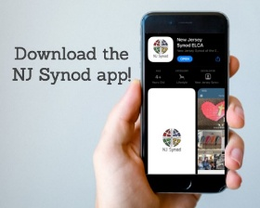
There is a weekly e-newsletter connecting our synod together with weekly prayer, upcoming events, synod and churchwide activities, mission stories, congregational activities, & more. Sign up at www.njsynod.org/stay-connected or download the app.
VICAR APPOINTMENT ON MARCH 19TH, 2023
A Memorandum of Understanding on the Matter of Pastoral Appointment
In Theological Education for Emerging Ministries (TEEM) Candidacy
TO: Congregation Council, Holy Spirit Lutheran Church, Villas
FROM: The Rev. Tracie L. Bartholomew, Bishop, New Jersey Synod

Dear Brother and Sisters in Christ,
This memorandum is in support of your discussions with Vincent Piekarski as pastor of Holy Spirit, Villas. Because this is not the usual pattern for completing the educational and candidacy requirements for ordination, it is my hope that this memorandum will both provide guidelines and engage in conversation with those who are invested in this process.

I would say at the outset that because Vincent is an outstanding candidate for the Ministry of Word and Sacrament, we will all want to do whatever is necessary to assure that his placement serves the mission of the church in the best possible fashion.

The following notes reflect my own understanding of this matter:
(1) The appointment for Vincent will begin on April 1, 2023. At this time, Vincent
will assume all responsibilities of a regularly called pastor, including presiding at
the Sacrament of Holy Communion and Baptism at Holy Spirit, Villas.
(2) A pastoral appointment in the TEEM process is an option for completing
seminary educational requirements and the steps of the candidacy process.
Upon completion of the candidacy process and seminary education, the
candidate may receive and accept a call to ordained ministry from the
congregation where the appointment is being served.
(3) This appointment is jointly supervised by the Office of the Bishop and the TEEM
pastor’s seminary. A mentoring relationship with a local pastor is required for the
length of this appointment.
(4) The synod of candidacy origin will be responsible for the approval process.
(5) Upon approval for ordination, the congregation would be expected to extend a
call to the pastoral appointee.
(6) Compensation for the TEEM pastor will be according to the guidelines of the New
Jersey Synod. All normal forms of compensation should be in place for the term
of the appointment, including stipulation that base salary and housing shall be in
accord with synod guidelines for first call at time of ordination.
(7) The ELCA Portico benefit plan for lay persons in full-time church service should
be used for the pastoral appointee up to the time of ordination, whereupon the
benefit package is to be converted to the plan for ELCA clergy.

HYMN OF PRAISE
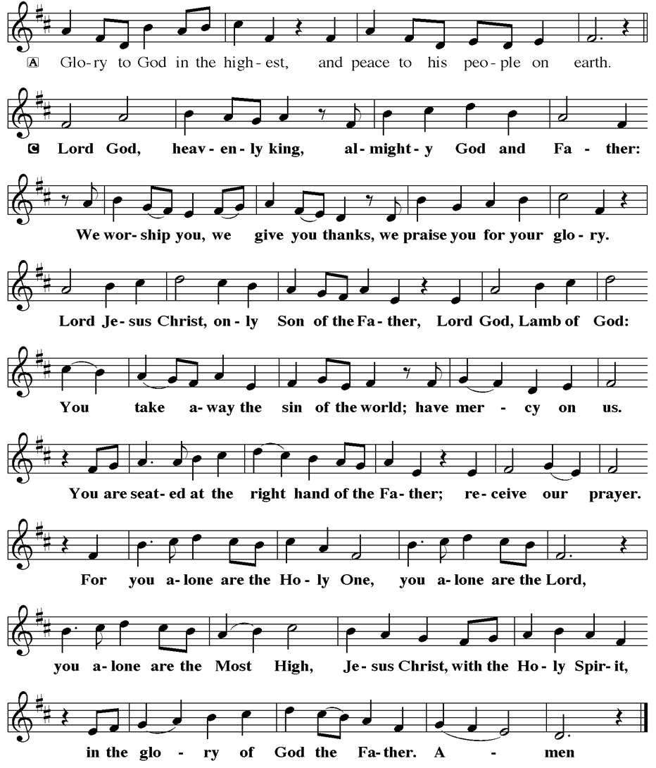
our participation in violent systems that harm your innocent ones;
our reluctance to embody your good news.

Be born in us today
and teach us to sing the joyful song of your salvation.
Amen.

V. God’s grace upon grace flows over you.
☩ Christ’s presence redeems the whole creation.
Your sins are forgiven. Let the earth rejoice and be glad!
C. Amen.

GATHERING HYMN
(We invite you to sing along.)
Lutheran Book of Worship—Green Book
40—What Child Is This

APOSTOLIC GREETING
V. May the grace of our Lord Jesus Christ, the love of God,
and the communion of the Holy Spirit be with you all.
C. And also with you.

KYRIE
V. In peace, let us pray to the Lord.
C. Lord, have mercy.

V. For the peace from above, and for our salvation, let us pray to the Lord.
C. Lord, have mercy.

V. For the peace of the whole world, for the well-being of the church of God,
and for the unity of all, let us pray to the Lord.
C. Lord, have mercy.

V. For this holy house, and for all who offer here their worship and praise,
let us pray to the Lord.
C. Lord, have mercy.

V. Help, save, comfort, and defend us, gracious Lord.
C. Amen.

(8) A decision for Pastoral Appointment is made with the agreement of a synod and
its candidacy committee, and the ELCA, normally represented by the regional
staff person of each in consultation with the seminary and its Director for
Contextual Education.
(9) Pastoral Appointment in a TEEM Candidacy is an option that is to serve the
mission of the Church in a particular and vital way and is not to be viewed or
used as a means to circumvent the normal candidacy process and/or first call
placement process.

In the specific case of Vincent, the New Jersey Synod remains responsible for the candidacy and approval process, and has agreed to this proposal for Appointment at Holy Spirit, Villas.

Continued blessings to both Holy Spirit and Vincent Piekarski as you embark on this journey of mutual ministry. As partners in ministry, we walk with you and rejoice in this new relationship.


VICAR VINCE’S DAY OF REST
A day of rest can have physical, mental, and spiritual benefits. “Mittwoch,” German for mid-week, or Wednesday, is the day that Vicar Vince will use to recharge and do some other things. Please do not hesitate to reach out if there is an emergency!

VICE PASTOR UPDATE
Pastor William Hodgetts continues to attend our Church Council Meetings
and provides Supervision and Support to Vicar Vince.

TRUE DELIVERANCE PRAISE & WORSHIP CENTER
Reverend Maria Brooks and True Deliverance Praise & Worship Center utilize our facilities from 1-4PM on Sundays. TDPWC hosts or assists with other events throughout the year. TDPWC hosts a Prayer Line on Mondays, Wednesdays, & Fridays at 5PM on the Conference Call 1-657-390-7957; & Bible Study on Thursdays at 6:30PM on Zoom. See Rev. Brooks for more information.

ADDITIONAL OFFERINGS FROM OUR FRIENDS & NEIGHBORS
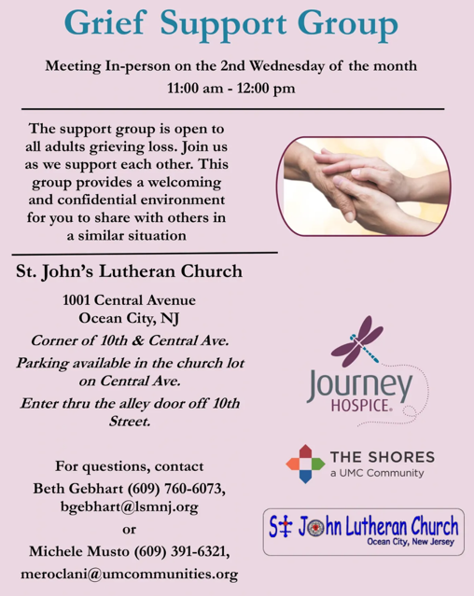

JUST FRIENDS
Promotes a spirit of fellowship among adults 50 years and older. Bring your own lunch to enjoy, beverages and deserts are provided. Everyone is welcome regardless of faith or parish affiliation. The group meets in Our Lady Star of The Sea Parish Hall on the last Wednesday of the month from 12Noon to 2PM from September through May. For more info call Martine Simonis 609-884-5312 x 110.
CONFERENCE CALL CHECK-IN, WELCOME, & ANNOUNCEMENTS
(Vicar (V), Assistant (A), Reader (R), and Congregation (C).)

INTRODUCTION
A. As we celebrate the Twelve Days of Christmas, our gospel today confronts us
with the death of innocent children at the hands of Herod. The birth of Christ does
not remove the power of evil from our world, but its light gives us hope as we
walk with all the “holy innocents” of past generations and today who have
suffered unjustly. In our gathering around word and meal, God continues to
redeem us, lift us up, and carry us as in days of old.

PRELUDE
(Music offered by our Organist at the start of our Worship Service.)
I Heard The Bells on Christmas Day

CHIMES
(Music offered by our Organist at the start of our Worship Service.)
O Little Town of Bethlehem

V. We invite you to stand as you are able.

CONFESSION & FORGIVENESS
(All may make the sign of the cross, the sign that is marked at baptism.)
V. Blessed be the holy Trinity, ☩ one God,
Wonderful Counselor, Mighty Savior, Prince of Peace.
C. Amen.

V. Trusting in God’s steadfast love and faithfulness, let us confess our sin.

(Silence is kept for reflection.)

V. Reconciling God,
C. we yearn for your presence to transform our grief, pain, and despair.
We confess that we have not always prepared
room in our hearts for your love;
we have not always recognized your presence among us;
we have not always embraced your message of peace.

We cry out, weary with the burden of violence, oppression, and fear.
We confess our failure to make room for those seeking refuge;

We, the Evangelical Lutheran Church of the Holy Spirit, are People of God, who
are called by the Holy Spirit to pray, worship, joyfully proclaim Jesus Christ,
and compassionately witness and serve others in Christian Love.


We are glad that you joined us for Worship today! Thank you for enriching our time together! We would like to get to know you better, and for you to get to know us better too. Brochures, welcome gifts, prayer shawls, Bibles, and other items are available throughout the church. We would be happy to show you around and share about our ministries. Please do not hesitate to speak up and ask questions.
Also, please make sure you sign-in on our clipboard on the podium in the lobby.


Our Worship Services are conducted in coordination with our Conference Call.
Join us at 657-390-7423 or 701-802-5170, with access code 8221190#.
You may need to dial 1 first depending on your phone plan. After logging in please announce your name and feel free to talk with others until we get started.

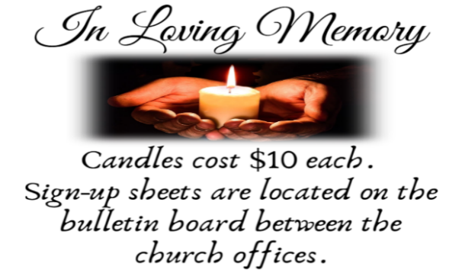
SANCTUARY CANDLE FOR DECEMBER
Given to the Glory of God & In Memory of JOHN KIROW
by Rose Lang, Vicar Vince & Heather Piekarski.
ALTAR CANDLES FOR DECEMBER
Given to the Glory of God & In Memory of WALT MILLER
by Jean, Phil, & Bob Zimmerman.
ST. BARNABAS CARES THRIFT STORE
Are you a person who enjoys staying active, interacting with others, likes the flexibility of working an hour or two per month and would like to support a good cause? If so, then St. Barnabas Cares Thrift Store is looking for you! The store in the Villas is looking for friendly, outgoing people to volunteer and sell clothing. There is no heavy lifting, but instead you would be arranging clothing attractively for sale. The Thrift Store is open 11-3 Monday through Saturday so even volunteering a few hours a month will help. If interested, please call Maureen Kersch 609-425-1317.

WHAT IS THE EVANGELICAL LUTHERAN CHURCH IN AMERICA?
The ELCA was formed in 1987 by the merger of three Lutheran Church bodies –
the ALC (American Lutheran Church), the LCA (Lutheran Church in America), and the AELC (Association of Evangelical Lutheran Churches). Learn more at elca.org.

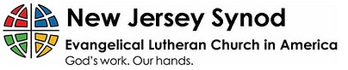
WHAT IS THE NEW JERSEY SYNOD?
The New Jersey Synod is a geographical grouping of Evangelical Lutheran Church in America (ELCA) congregations that share the mission and ministry of the Church on the New Jersey territory. It is one of 65 synods in the ELCA. The NJ Synod is comprised of 143 congregations, which include over 45,000 baptized members.

2025 FINANCIAL STANDING
NOVEMBER INCOME | $6,310.00
NOVEMBER SPENDING | $10,833.05
NOVEMBER GAIN OR (LOSS) | ($4,523.05)
2025 INCOME | $71,202.38
2025 SPENDING | $76,475.25
2025 GAIN OR (LOSS) | ($5,272.87)
ED GREEN CAPITAL IMPROVEMENT FUND | $1,658.55
FOOD PANTRY FUND (SOCIAL MINISTRY) | $11,918.19
CD | $26,245.92

CHURCH STAFF & VOLUNTEERS
VICAR
Vicar Vince Piekarski
VICE PASTOR
Pastor William Hodgetts
ORGANIST & PIANIST
Carol Amundsen
CHURCH OFFICE, SUNDAY SCHOOL, & FOOD PANTRY
Heather Piekarski
CHURCH COUNCIL PRESIDENT
Mary Melnicoff
CHURCH COUNCIL VICE PRESIDENT
Judy Brannan
CHURCH COUNCIL TREASURER
Bonnie Millard
CHURCH COUNCIL SECRETARY
Vicki Rinier
CHURCH PROPERTY
Wayne Rand

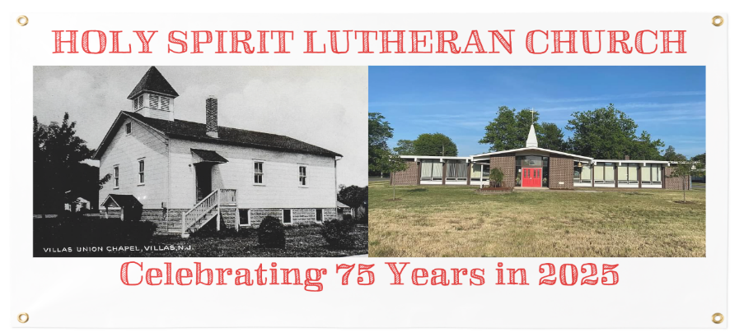

WELCOME TO
HOLY SPIRIT LUTHERAN CHURCH
A Member of the Evangelical Lutheran Church in America, New Jersey Synod
1220 Bayshore Rd., Villas, NJ 08251, 609-886-2414,
holyspiritlutheran@comcast.net, holyspiritvillas.com, facebook.com/holyspiritvillas
Vicar Vince Piekarski can be contacted at any time for conversation or prayer through call or text at 412-225-0287, or through email at vpie8282@gmail.com.
SUNDAY, DECEMBER 28TH, 2025
FIRST SUNDAY OF CHRISTMAS
10:30AM WORSHIP SERVICE WITH HOLY COMMUNION


