Sons of the American Revolution
The Mississippi Society

For Immediate Release – December 18, 2022

Wreath Laying Ceremony Honors Fallen Heroes

The third Saturday of December is National Wreaths Across America Day, a time for people all across the country to pay respects to those who lost their lives fighting for freedom. The movement encourages placing a wreath on the grave of a veteran as a way to pay tribute to their sacrifice this holiday season.

This year the Chief Red Jacket Chapter, National Society Daughters of the American Revolution produced and conducted services at Old Brandon Cemetery in Brandon with representatives from the Mississippi Society Sons of the American Revolution Society Color Guard in period uniforms.

After posting the colors, Mrs. Lindsey Simon, Chair of the MS DAR Wreaths Across America Committee gave a brief presentation. Color Guard members acted as Honor Guard for the family of each service member as a wreath stand was placed at each of the five graves. It is tradition to say the name of the fallen soldier out loud during the presentation of the wreath.

The tenets of Wreaths Across America Day are to “remember, honor and teach.” The aim is to remember the lives lost while honoring their memories and sharing their stories with a younger generation in order to keep their legacies alive and the cost of freedoms they experience every day.

Presenting the colors and providing honor guard services were Jerry Lilly as the Marquis de Lafayette, Ron Humphrey, John McBride, Erik Norman, John Taylor, Rex Allan Jones as General George Washington, John Price as General Thaddeus Kosciuszko, Color Guard Commander Dr. Bryant Boswell of Star, and Detail.

###

The Sons of the American Revolution and Daughters of the American Revolution are national patriotic, historical and educational societies whose members perpetuate the memory and sacrifices of their ancestors who fought or aided in the American Revolution.

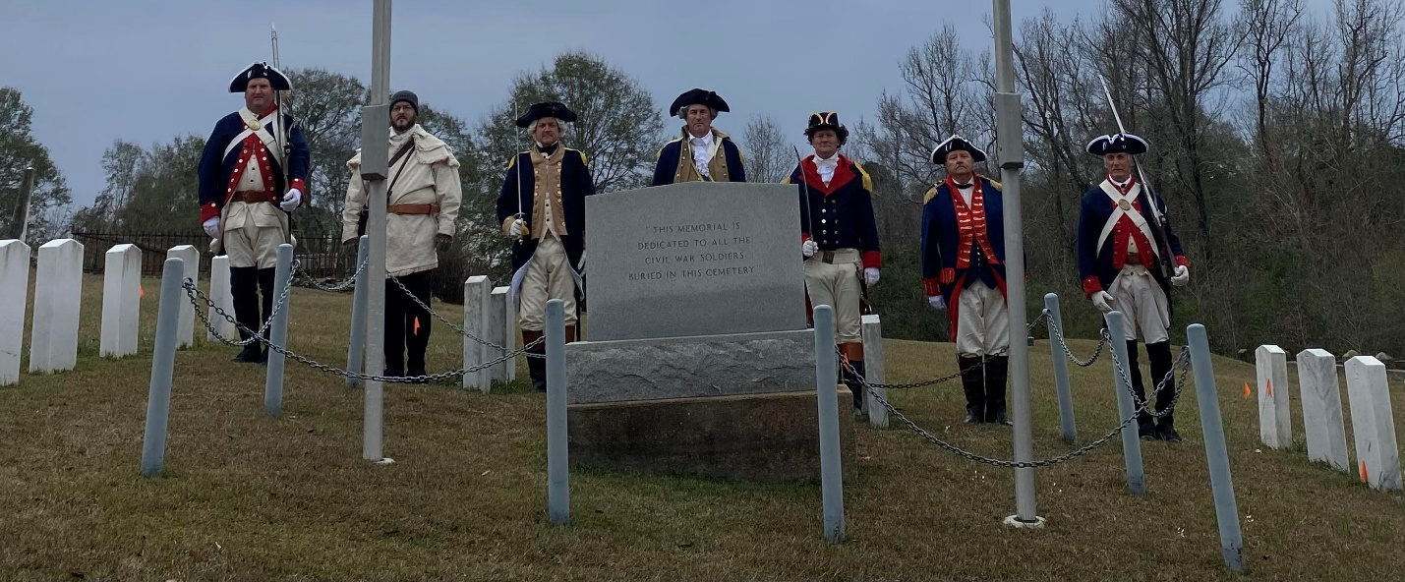

Figure 1 (Left): Erik Norman, Ron Humphrey, Jerry Lilly, Rex Allan Jones, John Price, John Taylor, Bryant Boswell

