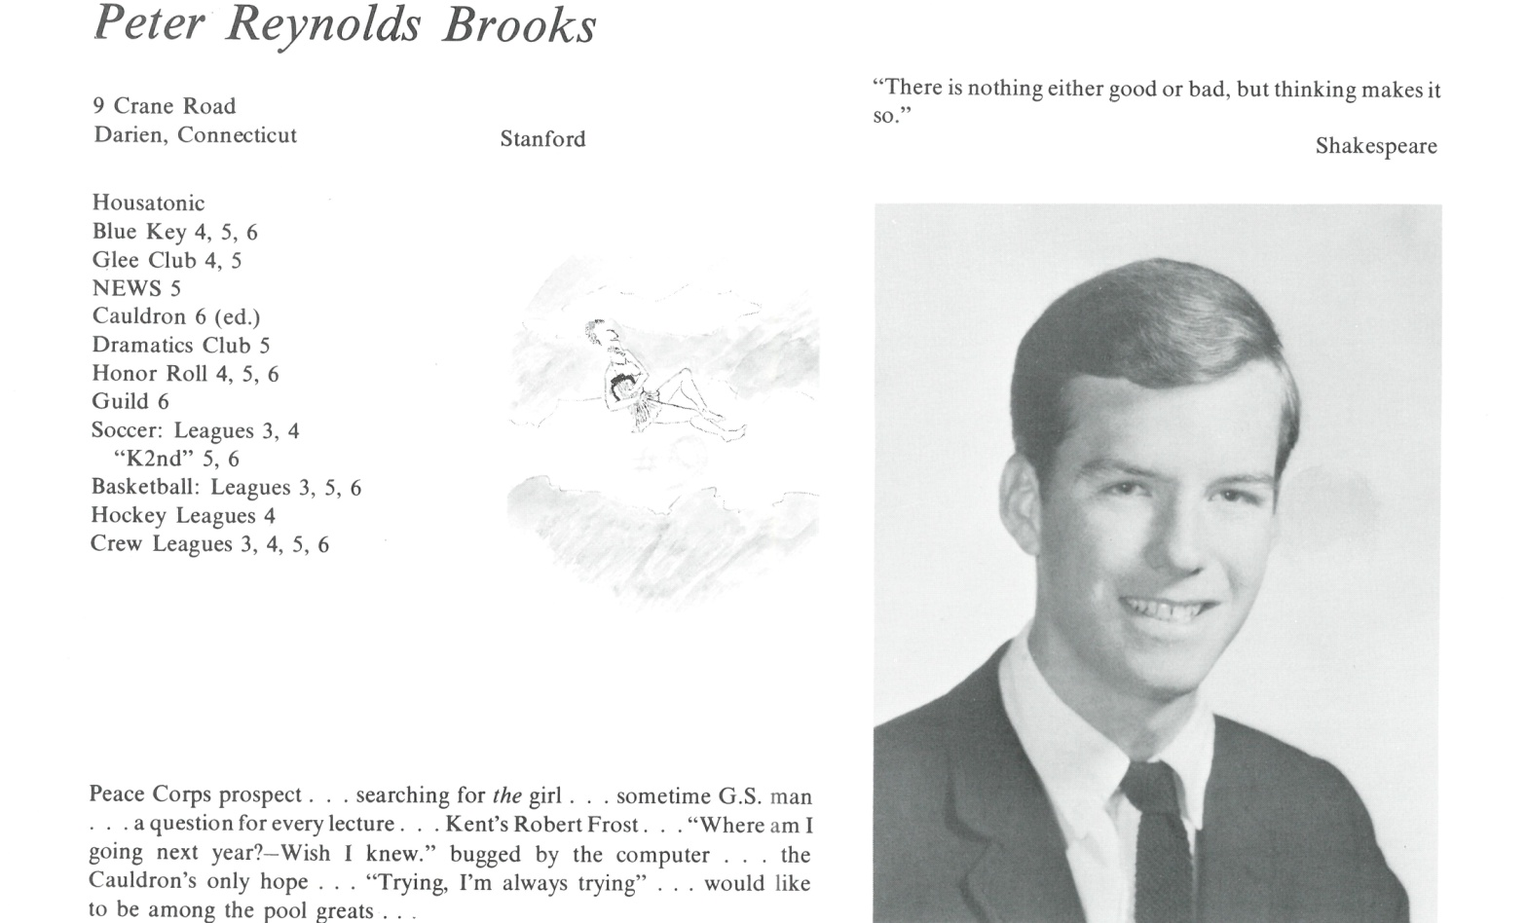

Peter R. Brooks

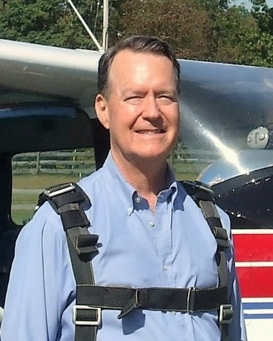“Life After Kent” - well, as is true for all of us, it’s a long story.

Stroked the heavyweight freshman crew at Stanford, studied at Stanford in Germany, then left before graduation, and took my own path. Managed to stay out of Vietnam, but still mourn friends not as fortunate. A few years later, Cornell for natural resources; Audubon teaching naturalist; Penn for planning & landscape architecture; NYS DEC forester; then Merrill Lynch investment advisor for 33 years. Now my older son is my business partner, and I can slow down. Married for 25 years; now single for 17. Somehow produced three wonderful kids, who somehow married a few more wonderful kids. So, the way I look at it, I now have five grown children and five grandchildren, with number six on the way! Still writing poetry through the years; as an expression of life, rather than a hiding place from it.

The future - well, I hope that will be another long story. Bought the remnant of a 200-year-old farm a few years ago, and am steadily resurrecting it. Built stone walls, dug ponds, thinned the woodlot, cleared overgrown fields, completely rebuilt the 1815 hand hewn timber frame barn. Planted about 500 Christmas trees every year for the last 6 years; another 2,000 to go, and we’ll be open for business in the 2020 Christmas season. (Boulderbrookfarm.com). Finally in a position to do some things I want to do; working the farm, sailing a restored Ericson 35; taking river cruises in Europe; listening to Beethoven as well as Flatt & Scruggs; serving on the board of our local land trust, and the NYS Christmas Tree Farmers Assn. This spring just started construction on a replica Greek Revival farmhouse on the farm, just outside Saratoga Springs, NY.

I intend to be an outstanding grandfather, teaching the next generation to appreciate the astounding beauty and complexities of nature; the fulfilling satisfaction of dirty hands and sore muscles; and the blessings and obligations of belonging to a family. The plan is to go to 100 with all systems functioning!



______________________________________________________________

______________________________________________________________ ______________________________________________________________ ______________________________________________________________ ______________________________________________________________ ______________________________________________________________ ______________________________________________________________ ______________________________________________________________ ______________________________________________________________

Attach Picture in .jpg Format

______________________________________________________________

______________________________________________________________

___________________________________________________________________________________ _________________________________________________________________________________________________________________________________________________________________________________________________________________________________________________________________________________________________________________________________________________________________________________________________________________________________________________________________________________________________________________________________________________________________________________________________________________________________________________________________________________________________________________________________________________________________________________________________________________________________________________________________________________________________________________________________________________________________________________________________________________________________________________________________________________________________________________________________________________________________________________________________________________________________________________________________________________________________________________________________________________________________________________________________________________________________________________________________________________________________________________________________________________________________________________________________________________________________________

___________________________________________________________________________________