**Reminder: Annual Dues**

Annual dues are just around the corner.All homeowners should have received the annual letter by now. They are due July 1st, are still 120 dollars and can be sent to FARM AT CREEKSIDE HOA 1067 SO. HOVER ST., UNIT E-131 LONGMONT, CO 80501

**Tree Trimming**

Please keep an eye on your tree branches over the sidewalks. There are quite a few that too low. Longmont City requires branches have at least 8 feet of clearance over sidewalks.

Also please check your tree branches along the perimeter fencing. The latest snowfall was quite heavy and has brought down branches.

**Dumpster Rental**

The dumpster rental has been pushed back to July. The board will keep everyone updated on when it is coming. More details should come in the next newsletter

**Yard-of-the-Month Winner for May**

The HOA is sponsoring a friendly yard of the month competition. Yard landscaping visible from the street should be neat, well-maintained, and have “curb appeal”. Preference will be given to those who did not win last year.

The Yard-of-the-Month winner for May was 2226 Eagleview Circle, belonging to Sandy and Larry Strauss. Their landscaping is highlighted by great use of different sized rocks and plants of varied heights. The yard is neat and well maintained. To the right of the driveway, the angled sidewalk to the front door is bordered by a variety of evergreens as well deep red Barberry bushes, varieties of Daylilies, creeping Phlox and Speedwells. The thick grass looks lush after years of work addressing problem spots. Rocks form a border between the plants to the right of the sidewalk that leads to the front door and the lawn, as well as the lawn and the sidewalk in front of the house. A deciduous Hawthorne tree is circled by Forest Violets, small Pontentilla bushes, Lamb’s Ears and Poppies. A flagstone path at the south rear of the yard is bordered by Pampas Grass, Maiden Grasses, Japanese Silver Grass, Scott's Broom and a Dwarf Korean Lilac Bush. In the smaller area to the left of the driveway are Aspens and Black Chokeberry bushes surrounded by Pontentilla and Spirea bushes bordered by Creeping Phlox, Lamb’s Ears and Yellow Daylilies. Sandy says that her “wish is that people walking past our yard find a moment of quiet comfort and inner peace.”

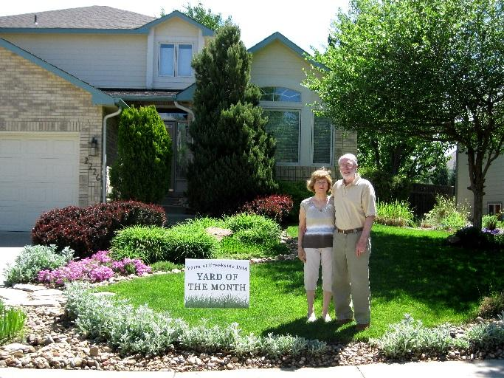

**July 4 Neighborhood Parade**

The 4th of July neighborhood parade will start at 9:30 a.m. at the Eagleview Circle Island. Kids can ride their bikes, walk, or be pulled in wagons by doting parents. A light breakfast will follow. The parade route will be a loop around Eagleview Circle and Bluebird Drive. Drivers should watch for bicyclists and pedestrians in the street.