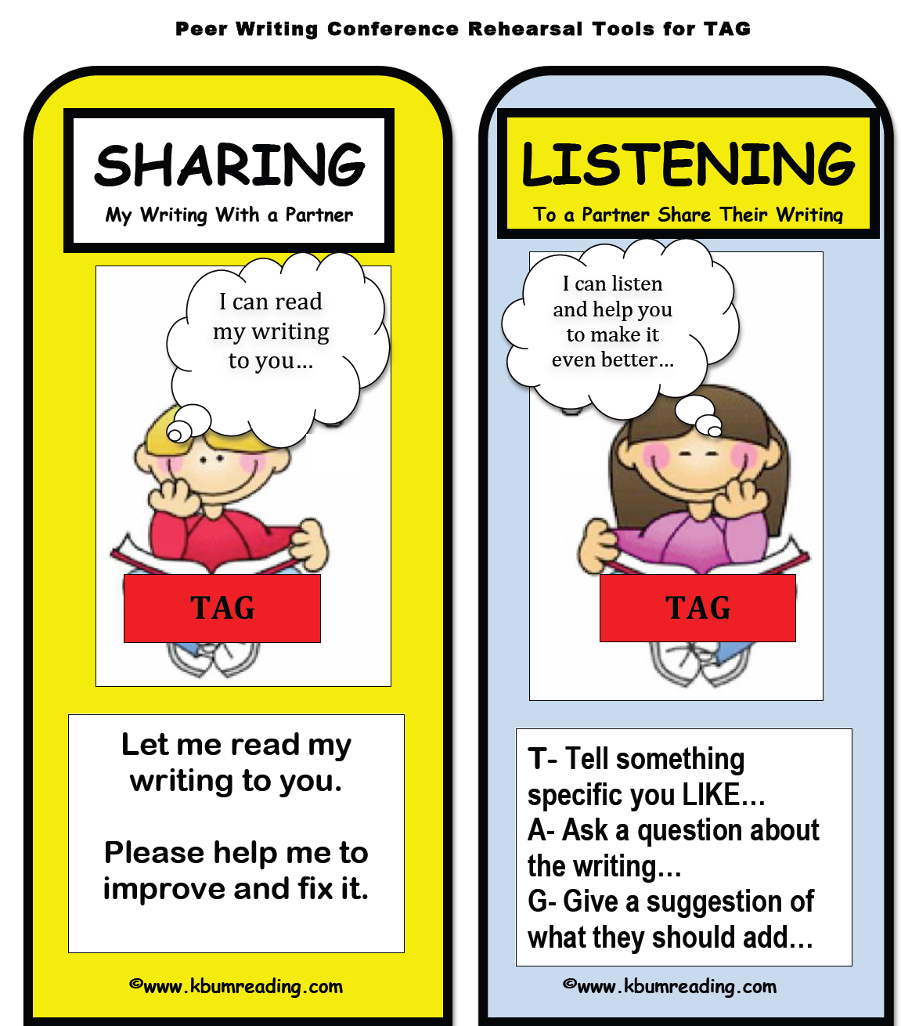

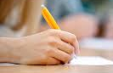


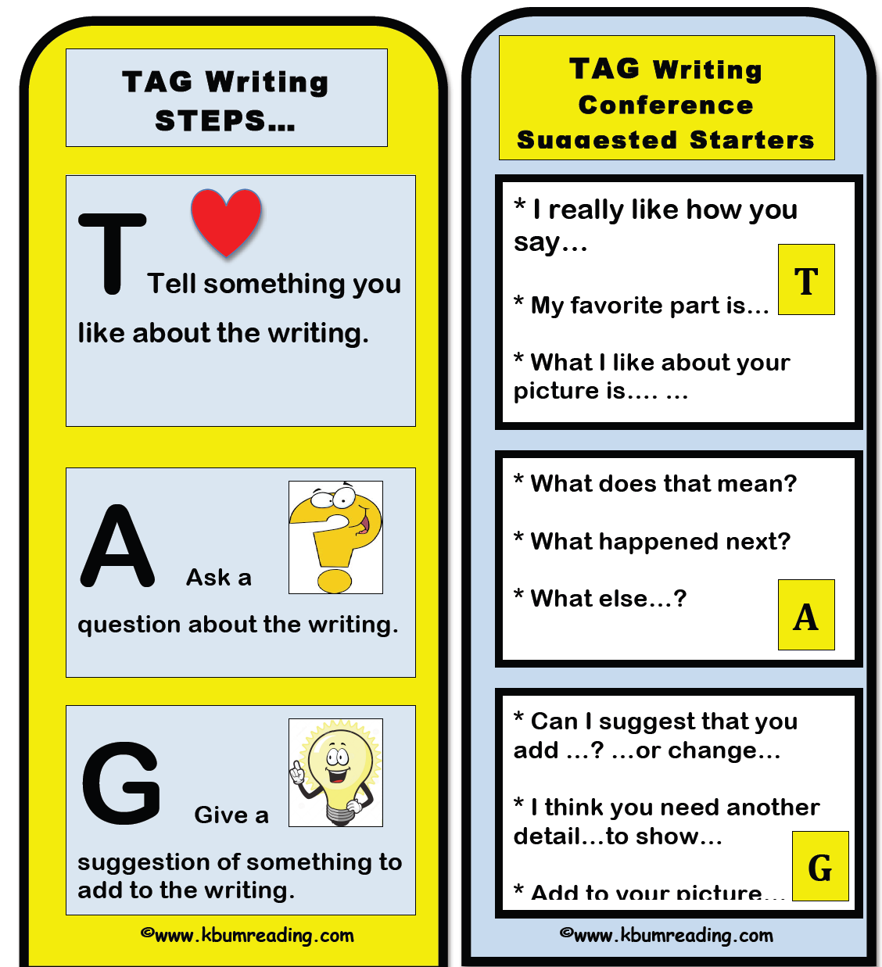
Give
Give a suggestion about what you think they can make better.

*Can I give you a suggestion that you can add ______.
*I think you should fix ____.
*You should add those details / facts _______.

LISTEN to their writing:
Tell
Tell the writer something you liked about their writing.

*I really like how you …
*My favorite part is …
*The best thing about your writing is…

Ask
Ask the writer a question
about their writing.

*What happened after that?
*How were you feeling here?
*Who is this in the picture? Can you label that?

TAG STEP by STEP
for
Student Sharing:
TAG STEP by STEP
for
Student Listening:
3 Revise and / or Edit your writing.
2 Listen to their compliment and answer their question.
- Read your writing to your TAG Partner.

