***Pleasant Township Board of Trustees Meeting***

**Date _October 22, 2024______________ Next Resolution No._ 72—10-22-2024_ _**

* **Call to Order -- The meeting tonight will also be on WebEx.**
* **Please stand for a moment of silence. --Pledge of Allegiance--Roll Call**
* **Visitors –**
* ***Hanna Poling*** with the Southwest Messenger via WebEx.
* **Minutes to approve**- No minutes
* **Financial Reports** – Motion to pay expenditures. Paula gave a list of expenditure amounts since last meeting.
* ***Department Reports***
* **Franklin County Sheriff’s Dept-Community Liaison, Deputy Adkins, 1120- Cell: 614-809-5843**
* Deputy Adkins gave a report. He has been out of the office and apologized that he did not have a list of stats.
* 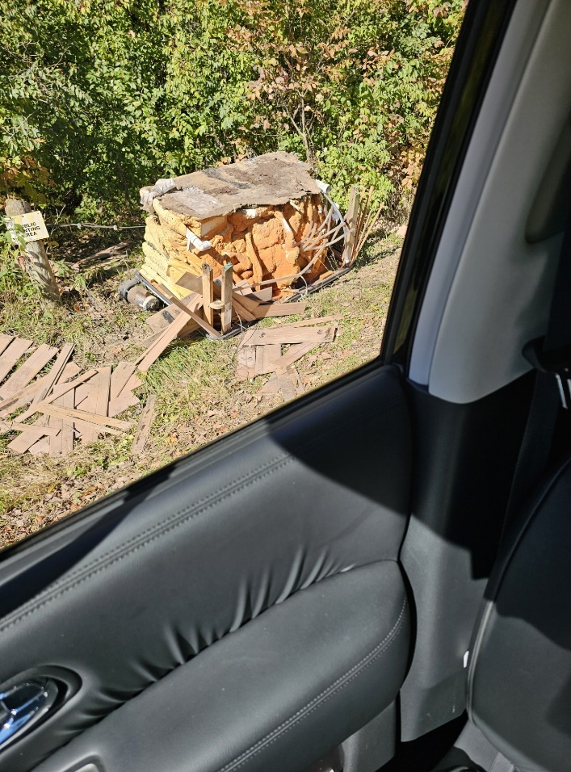**Road Department****- Robert Bausch, Superintendent**
* Gay Rd. ditch- while working on the ditch came across shallow buried phone lines. Made a few phone calls and the phone company will come out to move the lines before they can continue.
* Truck 21 hydraulic tank
* Ditch mowing
* Cemetery mowing

A hot tub was dumped on Graessle Rd.

* **Fire Dept. – Chief Whiting via WebEx**
* Apparatus
* M-231 at Brawn.
* Personnel
* Equipment
* E-231 had front tires replaced.
* Tanker 231 had an airline rupture, had to be flat bedded back to station.
* Training
* The training fire yesterday was a success. The homeowners were happy. We had participation from Prairie, Tri-County and Jackson Twp.
* Station
* Billing
* Currently working on reporting that is required by the Feds.
* **Old Business-**
* Sign the SWACO papers authorizing Eastham & Smith to represent us in the bidding process for trash hauling contract. Resolution __72__to use Eastham & Smith for the trash hauling contract.
* **New Business –**
* Nancy will be attending Big Darby Accord Jurisdictions Workshop Thursday, October 24, 2004, from 9am-12pm.
* Ed has been contacted by a Trustee Jeff Marshall from Fairfield Twp asking for our support in opposition of the Biodigester. Resolution _73_ opposing the biodigester in Fairfield Twp.
* *Set date for Trick or Treat for the Township*--The recommended trick-or-treat date for 2024 by MORPC is Thursday, Oct. 31, 6:00 pm to 8:00 pm. Resolution _74_ for Trick or Treat

Residents are encouraged to check their community’s website to verify the date and time of activities. For several years, our local government members have supported a suggested, unified trick-or-treat date for the region. When Halloween, October 31, falls on a Friday, Saturday, or Sunday, Trick or Treat is held the Thursday prior to October 31. When October 31 falls on a Monday, Tuesday, Wednesday, or Thursday, Trick or Treat is held on October 31. Local communities make the decision to change or keep their trick-or-treat date and time.

Inclement weather: In the event of inclement weather, the recommended date will not change. Parents/guardians are encouraged to exercise good judgment in allowing children to participate.

* The Franklin County Engineer cordially invites you to be our guest at the annual meeting of the Township and County authorities on Thursday, November 21, 2024. This year’s meeting will be held at: Villa Milano Banquet & Conference Center 1630 Schrock Road Columbus, Ohio 43229 Pursuant to Section 5543.06 of the Ohio Revised Code, the Franklin County Engineer is required to meet with Township and County authorities concerning maintenance of roads and bridges in Franklin County, Ohio. Registration starts at 5:15 p.m. Dinner and Program will begin at 6:00 p.m. Presentation and updates from the Engineer’s Office and FCTA Special Guest: Linda S. Bailiff, Director of the Ohio Public Works Commission (OPWC) We invite and encourage you as our special guest to attend this event. Please R.S.V.P. no later than Friday, November 15, 2024, to: Terri Pritchard tpritchard@franklincountyengineer.org Phone at 614-525-3905
* Resolution_75_ to approve the lighting district for Darbydale for 2024/2025.
* **Announcements-**
* The Alkire Road over Hellbranch Run closing was postpone and will be closing Monday, October 28th for approximately 21 days**A close up of a notice

  Description automatically generated**

**Clerk Updates- Paula**



* Miscellaneous correspondence
* Update on the HSA? – Update as of 5:00 p.m. today.
* **Speaker Sheets-** (come to the podium to be heard on WebEx)
* Ken Yarnell
* Alicia Gieger
* **Adjourn**