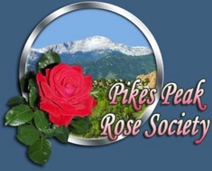
Pikes Peak Rose Society (PPRS) Membership January 1, 2025 - December 31, 2025
www.PikesPeakRoseSociety.org
(719) 357-6736 (leave msg)
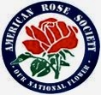
The Pikes Peak Rose Society is a nonprofit organization formed in 1996 and is an affiliate of the American Rose Society (ARS). The PPRS’s purpose is to promote interest in the ROSE plant through education, demonstration, and cultural and social events that further the aims and objectives of the ARS.
Meetings are held monthly from February through November. There is an Annual Rose Show, garden tours of member gardens and a Holiday Party (November or December). Members receive the monthly newsletter “The Rose Companion” and discounts on various rose-related materials.
PLEASE PRINT
NAME(S)________________________________________________________
ADDRESS________________________________________________________
CITY______________________________STATE______ZIP CODE_________
PHONE NUMBER(S) _________________________________________________
EMAIL ADDRESS(ES) _________________________________________________
BIRTHDAY (DAY AND MONTH ONLY) ____________________________________

Individual e-newsletter membership Dues - $20 $____________________
Family e-newsletter membership Dues - $25 $____________________

NAME TAG(S) (Optional) @ $15 each $_____________________
________________________________________

SHINGLES-CERTIFIED ROSARIANS (Optional) @ $10 each $____________________

________________________________________

Circle one: Cash Check #________
Total Submitted: $___________________
Are you a member of the American Rose Society?
Yes No
Send Membership form and check payable to Pikes Peak Rose Society to:
Barb Valenti 6305 Sandray Ct Colorado Springs, CO 80919 barb.mellenti@gmail.com

