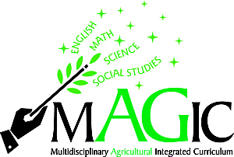
Ag in the Classroom
mAGic kits are developed to meet learning standards in English, Math, Science, and Social Studies for grades fourth through eighth. Kits include lesson plans and supplies for activities and lesson plans. Kits can be checked out or arrangements can be made to have lessons presented to your class. Contact Diane Cleland at wbfbaitc@winnebagoboonefarmbureau.org or Call 815-962-0653 for more information.

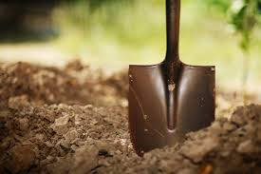
SOIL mAGic

Soils are alive, as students will discover through the lesson in this kit. Students will learn to conduct experiments in soil pH, create soil profiles, and understand the components of soils. They will also unveil the history of crop rotation and dig into the Dust Bowl!

PLANT mAGic
This kit offers problem-solving activities in plant propagation, production, and processing. Students will conduct experiments to learn about plant differences and plant ecosystems. They’ll also sequence plant products, research the discoveries of George Washington Carver, and look at the impact of crops on the national economy.

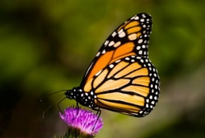
INSECT mAGic
Students will learn about the impact of insects on crop production through a variety of lessons and activities. Mapping exercises let students follow butterflies on migration patterns. Students track a day in the life of an insect and learn about wingspan, life cycles, anatomy, and social hierarchy patterns of common insects.


ILLINOIS mAGic
Prairies, Ronald Reagan, Chicago, John Deere, and the Big Blue Stem: This kit covers everything Illinois. The lessons in this kit highlight the six geographic regions of the state. Therefore, students can explore the geographical diversity of Illinois.

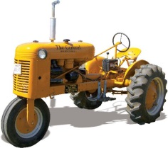
MACHINE mAGic
Students will learn about the history of farm machinery and the impact of modern farming techniques on families and communities. They’ll also learn how inventors John Deere and Cyrus McCormick helped shape modern agriculture. Hands-on exercises let students identify machinery parts and estimate cost.

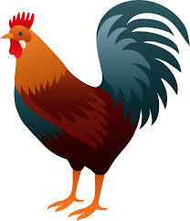
POULTRY mAGic
Students will uncover interesting facts about U.S. poultry production through exercises and hands-on experiments. They’ll learn about the anatomy and nutritional value of an egg. Students will also learn about the history of egg production and find out how poultry dishes are prepared around the world.

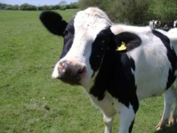
DAIRY mAGic
Hands-on exercises let students explore the processes of using milk, acids, enzymes, and bacteria to make cottage cheese, yogurt, and ice cream. Students will find out how much milk a cow produces in a lifetime, learn about the issues of supply and demand in the dairy industry, and dive into dairy.

