10/29/2016 Quiet Signs for Our Times from YaHuWaH Elohim

Because YaHuWaH Elohim is Sovereign over His creation, He has the ability to influence the timing of events on every level, personal and public. He can time the events of our personal lives in a way that lets us know that He is in control of those things that personally affect us. He can also control the workings of national governments in a way that lets His people know that He is Sovereign over world events.

Why Watch?

We are commanded by Messiah YAHUSHUA to watch.

Matthew 24:42 "Watch therefore: for ye know not what hour your Lord doth come."

We need to be watchful regarding current events so that we can be alerted ahead of time and prepare for the coming judgment.

Gideon's 300 Watchers

My wife and I read through sections of the bible regularly. On October 19, 2016, (the very ancient 2nd Hebrew month, 17th day, early aviv barley, Hebrew year 5777) we happened to be reading Judges chapter 7. Noah's flood began on the 17th day of the 2nd month.

Judges 7:4 And YaHuWaH said unto Gideon, The people are yet too many; bring them down unto the water, and I will try them for thee there: and it shall be, that of whom I say unto thee, This shall go with thee, the same shall go with thee; and of whomsoever I say unto thee, This shall not go with thee, the same shall not go.
5 So he brought down the people unto the water: and YaHuWaH said unto Gideon, Every one that lappeth of the water with his tongue, as a dog lappeth, him shalt thou set by himself; likewise every one that boweth down upon his knees to drink.
6 And the number of them that lapped, putting their hand to their mouth, were three hundred men: but all the rest of the people bowed down upon their knees to drink water.
7 And YaHuWaH said unto Gideon, By the three hundred men that lapped will I save you, and deliver the Midianites into thine hand: and let all the other people go every man unto his place.
The 300 men who were chosen were watching for the enemy as they drank. The other approximately 32,000 men present were sent home, they would not participate in overcoming the enemy.

The Gift of the Iron Rods

On the afternoon of October 19th, 2016, my wife and I were in our yard and I was raking pine needles. We have 50 pine trees and 8 leaf trees in our large yard. My wife picked something up from the ground and asked what it was. I looked at it and said "It's an iron rod". It was about a foot long. I told her to throw it on the ground, which she did. We left it there and kept on working.

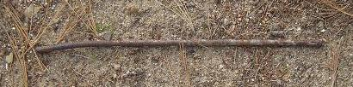
The iron rod discovered by my wife near our water well on the 17th day of the 2nd month, Hebrew year 5777.

Four days later while removing ashes from our pit where we burn the pine needles and leaves from our 58 trees, another iron rod came up out of the pit in a shovel full of ashes.

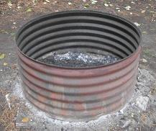
Our burn pit where we burn pine needles and leaves.

I took the iron rod in my hand and threw it to the earth. I've been unable to find it since.

The Wooden Rod of Moshe and the Iron Rod of Messiah

We recall the account of Moshe at the burning bush, and how that YaHuWaH Elohim commanded Moshes to take the wooden rod in his hand and throw it to the ground. When Moshe cast his wooden rod to the ground it became a living serpent, a supernatural sign. The sign from YaHuWaH Elohim would be presented to Pharaoh by Moshe.

Exodus 4:2 And YaHuWaH said unto him, What is that in thine hand? And he said, A rod.
3 And He said, Cast it on the ground. And he cast it on the ground, and it became a serpent; and Moses fled from before it.

In the book of Revelation we're told that the person who overcomes will rule the nations with a rod of iron.

Revelation 2:18 And unto the angel of the church in Thyatira write; These things saith the Son of YaHuWaH, who hath his eyes like unto a flame of fire, and his feet are like fine brass;
19 I know thy works, and charity, and service, and faith, and thy patience, and thy works; and the last to be more than the first.
20 Notwithstanding I have a few things against thee, because thou sufferest that woman Jezebel, which calleth herself a prophetess, to teach and to seduce my servants to commit fornication, and to eat things sacrificed unto idols.
21 And I gave her space to repent of her fornication; and she repented not.
22 Behold, I will cast her into a bed, and them that commit adultery with her into great tribulation, except they repent of their deeds.
23 And I will kill her children with death; and all the churches shall know that I am he which searcheth the reins and hearts: and I will give unto every one of you according to your works.
24 But unto you I say, and unto the rest in Thyatira, as many as have not this doctrine, and which have not known the depths of Satan, as they speak; I will put upon you none other burden.
25 But that which ye have already hold fast till I come.
26 And he that overcometh, and keepeth my works unto the end, to him will I give power over the nations:
27 And he shall rule them with a rod of iron; as the vessels of a potter shall they be broken to shivers: even as I received of my Father.
28 And I will give him the morning star.
Further, the sign of the birth of the man child will appear in the heavens next year on September 23, 2017, exactly two years to the day after Pope Francis met with President Obama in the White House on the Hebrew Day of Atonement, September 23, 2015. Babylon has a two year space for repentance before judgment is rendered by angelic beings (Watchers). Revelation 18:8 - Double unto her double...

The man child will be a righteous government administered to the peoples of the earth by YaHuWaH Elohim. We need it!

The sign of the birth of the man child in 2017 is available at this link: http://www.joybysurprise.com/The_Sun_Clothed_Woman.html

The Angelic Watchers Who Came to Earth

We're told in Genesis chapter 6, the Book of Enoch, and the Book of Jubilees that angelic beings came to earth and cohabited with earthly women, producing Nephilim (Giants). We also understand that 200 angelic watchers sinned with women, but many others did not.

Daniel chapter 4 tells us of holy Watchers who passed judgment on the King of Babylon, decreeing that he would become insane for 7 years, living in the field with the beasts.

Daniel 4:16 Let his heart be changed from man’s, and let a beast’s heart be given unto him; and let seven times pass over him.
17 This matter is by the decree of the Watchers (Aramaic - Irin), and the demand by the word of the set apart ones: to the intent that the living may know that the most High ruleth in the kingdom of men, and giveth it to whomsoever he will, and setteth up over it the basest of men.

This rarely mentioned account of the judgment in Daniel chapter 4 concerning the King of Babylon has modern day end of the age prophetic implications which have gone largely ignored by modern "prophecy" teachers.

Be aware that the term "Watchers" in Daniel chapter 4 is the word "Irin" in Aramaic, a close relative of the word Aryan, hence Iron, and the nation of Iran.

Holy Angelic Watchers, the Irin of Daniel chapter 4, may very well be a "Rod of Iron" in the hand of the overcomer of Revelation 2:27 above.

Indeed, the judgments mentioned in the book of Revelation are administered by angelic beings.

Will the overcomer of Revelation chapter 2 demand that the wicked, corrupt, openly criminal and perverse, government of Babylon the Great be destroyed by angelic beings?

Christians: Note that the overcomer turns from eating meat sacrificed to idols (pork, etc.) in verse 2:20. A word to the wise.

The Angelic Watchers of the Apollo 12 Moon Mission

As the men of Apollo 12 walked on the moon, they noticed something odd in the sky and took this picture.

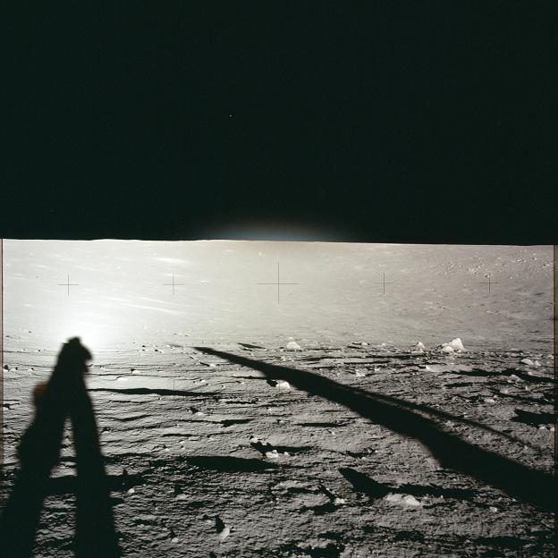
Astronauts of Apollo 12 took this picture of the bright triple dot in the sky, the Watchers of Apollo 12

Here's a close up of the above light in the sky in the picture above that interested the astronauts .
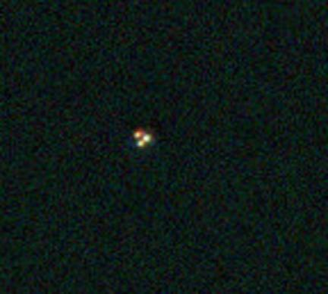

Apollo 12 had a mission to land near the Surveyor III spacecraft and to go examine it. They landed about 1/4 mile from Surveyor III and traveled to it.

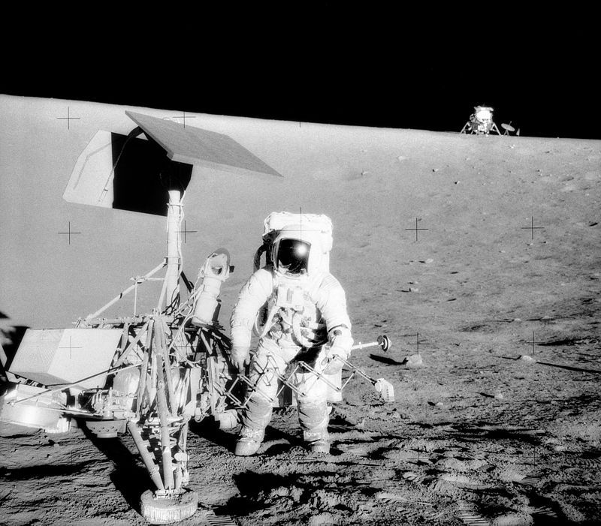
Surveyor III on the moon with the Lunar Lander in the background.

Few know that Surveyor III landed on the moon on the 10th day of the 1st Hebrew month in 1967. The moon is symbolic of the nation of Israel in the bible, the moon reflecting the light of the sun as the nation of Israel is to reflect the spiritual light (Torah) of YaHuWaH Elohim.

The 10th day of the 1st Hebrew month is the only day each year that a lamb was to be chosen for inspection to be the acceptable Passover sacrifice. The Surveyor III spacecraft landed on the moon (symbolic of Israel) on the 10th day of the 1st month to begin inspecting the moon. On the 49th day (7 x 7 days) after the Surveyor III spacecraft landed on the moon, the Israeli army took Jerusalem from Jordan on 6/7/1967 in the Six days War.

Note that the Apollo 12 astronauts inspected the Surveyor III that had inspected the moon, and the astronauts were themselves being inspected (watched) by angelic beings.

Signs Concerning Noah's Flood and the Coming Destruction

The account of Noah's flood in most modern bibles is translated from the Hebrew Masoretic text. The Masoretic text tells us that the flood of Noah began on the 17th day of the 2nd month. The Septuagint, a 1000 year older account, tells us that the flood began on the 27th day of the 2nd month. Why the difference? The answer might reside in Jewish Kabbalism.

Most of the oldest New Testament texts available today date back only to the 4th century. Christianity was paganized (substituting the Feast of Ishtar for the previously observed Hebrew Day of FirstFruits, etc.) in the 4th century AD. There was a great influx of pagan people into the Roman church in the 4th century when Christianity was declared the State Religion of the Roman Empire by Emperor Constantine. The great numbers of pagan people invaded and overwhelmed the church government, voting out the desires of Sabbath keepers. Thus the original New Testament texts from the 1st century may have long ago been destroyed and perverted copies made in order to support the 4th century "paganized Christianity" that we know today as modern Christianity.

Because there may be a degree of uncertainty as to whether the flood of Noah began on the 17th day of the 2nd month or the 27th day of the 2nd month, we should watch on both days to see if anything "out of the ordinary" transpires that may be indicative of a signal from YaHuWaH Elohim to His people.

A Space Probe Impacts Mars on the 17th Day of the 2nd Month

October 19, 2016, was the 17th day of the 2nd month (as months would have been counted in the days of Noah, beginning in the autumn). According to the Masoretic text, and the Karaite early Aviv reckoning back in March 2016, October 19 was the day in 2016 that the flood waters began in Noah's day. So, October 19, 2016, was a special day for us to be watchful for signs that might link our current time with Noah's time.

There was a special event that occurred on October 19, 2016, that received the attention of global media. Few people will be aware that this day may have had biblical implications. Even the great majority of Jewish people who follow the Hillel calendar will count this day as the 17th day of the 1st month, not the 2nd month, and will not be aware of a possible link with the days of Noah and the beginning of the flood.

On October 19, 2016, the Space probe named Schiaparelli accidentally crash landed on Mars.
http://www.bbc.com/news/science-environment-37715202

The planet Mars, the red planet, is known from ancient times to signify "war".

The Schiaparelli probe was built in Italy and is a collaboration of the ESA and Russia.

I'm certain that the European Space Agency (ESA) didn't intentionally plan to land its spacecraft on Mars on the 17th day of the 2nd biblical month. However, YaHuWaH Elohim may have directed that the space mission be planned this way in order to give a "head's up" to a very few of His people, alerting them to the impending danger of war. Not just a war, but a war on the level of Noah's flood that destroyed almost all life on earth. In Matthew chapter 24 YAHUSHUA Messiah tells us that a time of trouble is coming in our future when almost all life on earth will be destroyed. He said it will be like the days of Noah.

Two Planes Catch Fire in the United States on the 27th Day of the 2nd Month

After sunset Jerusalem time on 10/28/2016 (10/29/2016, the Hebrew day begins at sunset, 10/29/2016 is the 2nd month 27th day in Noah's time) at 16:35 GMT a plane caught fire on the runway at O'Hare airport in Chicago. Later a FedEx plane caught fire on the runway at Ft. Lauderdale airport in Florida.

http://www.foxnews.com/us/2016/10/28/plane-blows-tire-catches-fire-at-ohare-passengers-safe.html

http://www.foxnews.com/us/2016/10/28/fedex-plane-catches-fire-at-florida-airport.html

According to the earlier Septuagint text, Noah's flood began on the 27th day of the 2nd month.

We can watch for further events as we go through the day, October 29, 2016. And we are assuredly being watched by higher angelic beings, some of whom have our best interests in mind and some of whom have our utter destruction as their objective.

In the book of Revelation we're told that Satan will be cast to the earth, as Moshe cast his wooden rod to the earth and it became a living serpent. The sign of the iron rods being found and cast to the earth by my wife and I as mentioned above are symbolic of angelic beings (Irin) being cast to the earth by Michael the Archangel in order to render judgments and wreak havoc upon unrepentant mankind.

Those having the seal of YaHuWaH Elohim will not be harmed.

Revelation 9:1 And the fifth angel sounded, and I saw a star fall from heaven unto the earth: and to him was given the key of the bottomless pit.
2 And he opened the bottomless pit; and there arose a smoke out of the pit, as the smoke of a great furnace; and the sun and the air were darkened by reason of the smoke of the pit.
3 And there came out of the smoke locusts upon the earth: and unto them was given power, as the scorpions of the earth have power.
4 And it was commanded them that they should not hurt the grass of the earth, neither any green thing, neither any tree; but only those men which have not the seal of YaHuWaH in their foreheads.

