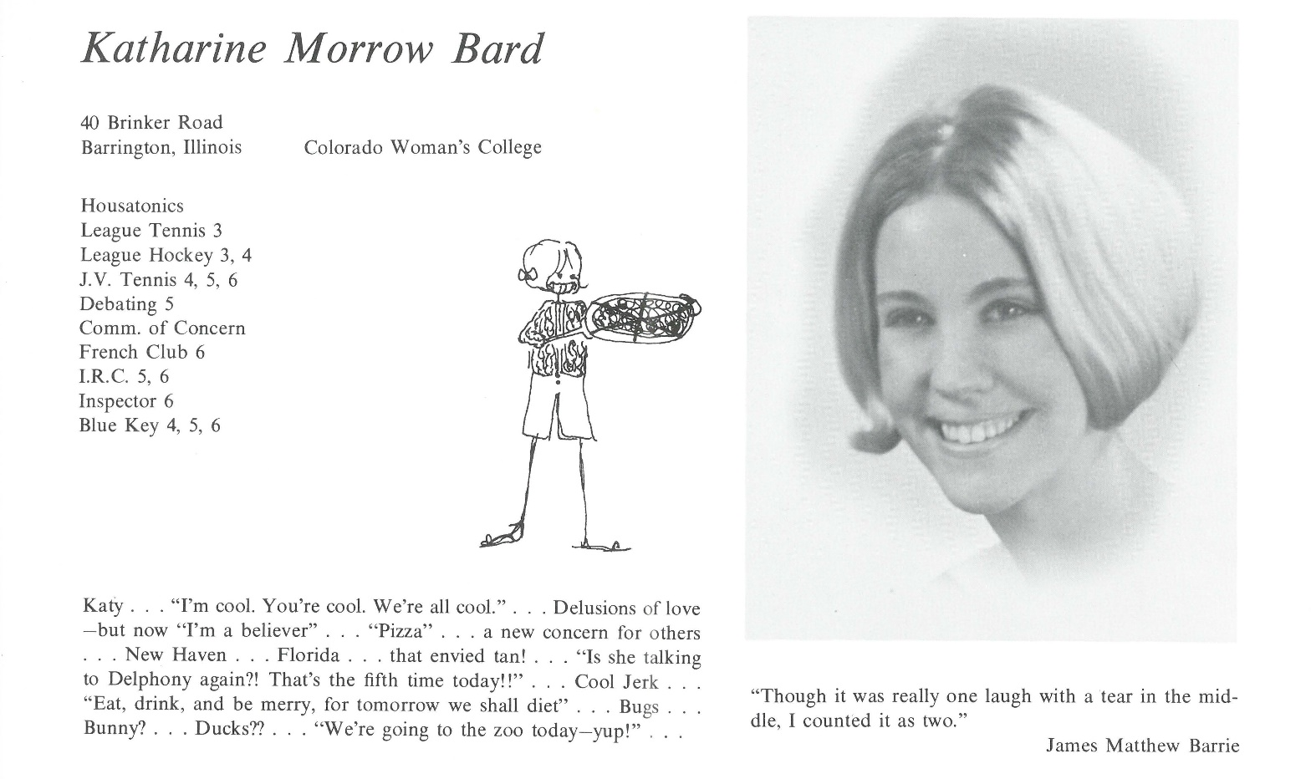

Katharine M. Bard Dickson

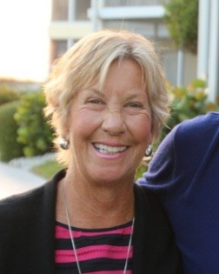50 years, yikes! Scary thought! I am a Mother of two, a Grandmother, a Step-Grandmother, a Gardner, a Volunteer and an Artist. I am also married to a wonderful artist who actually makes a living at it! We have two 12 year old basset hounds, a large garden in Colorado and believe it or not, I still drive the same car that I had in college. This is a great place to live and enjoy the surroundings! When the cold gets us, we still love Florida in the winter.

Highlights of my life have been working on art projects with kids for large fundraisers. Also, worked in the peace movement in the mid 70’s and 80’s. I was able to attend a conference in Russia with the international Physicians for the Prevention of Nuclear War. Three separate trips to East Africa and South Africa have been the highlights of my life. Now, our kids and grandkids are #1 as life starts to slow down. So far, it’s all been pretty great and I have been blessed with good health.



______________________________________________________________

______________________________________________________________ ______________________________________________________________ ______________________________________________________________ ______________________________________________________________ ______________________________________________________________ ______________________________________________________________ ______________________________________________________________ ______________________________________________________________

Attach Picture in .jpg Format

______________________________________________________________

______________________________________________________________

___________________________________________________________________________________ _________________________________________________________________________________________________________________________________________________________________________________________________________________________________________________________________________________________________________________________________________________________________________________________________________________________________________________________________________________________________________________________________________________________________________________________________________________________________________________________________________________________________________________________________________________________________________________________________________________________________________________________________________________________________________________________________________________________________________________________________________________________________________________________________________________________________________________________________________________________________________________________________________________________________________________________________________________________________________________________________________________________________________________________________________________________________________________________________________________________________________________________________________________________________________________________________________________________________________

___________________________________________________________________________________