February 2023 Member Meeting & Program
DATE: February 13, 2023
6:00 pm – Networking
6:30 pm – Short Meeting
6:45 pm – Program
PROGRAM NAME: Rocky Mountain National Parks Updates

WHERE: Via Zoom
Rocky Mountain Guides is inviting you to a scheduled Zoom meeting.
Time: Feb 13, 2023 06:00 PM Mountain Time (US and Canada)

Join Zoom Meeting -- https://us06web.zoom.us/j/83668661251
Meeting ID: 836 6866 1251
One tap mobile -- +17207072699,,83668661251# US (Denver)
PROGRAM: Join us February 13 for an update from Rocky Mountain National Park including major park projects, visitor use management planning and responsible recreation efforts!
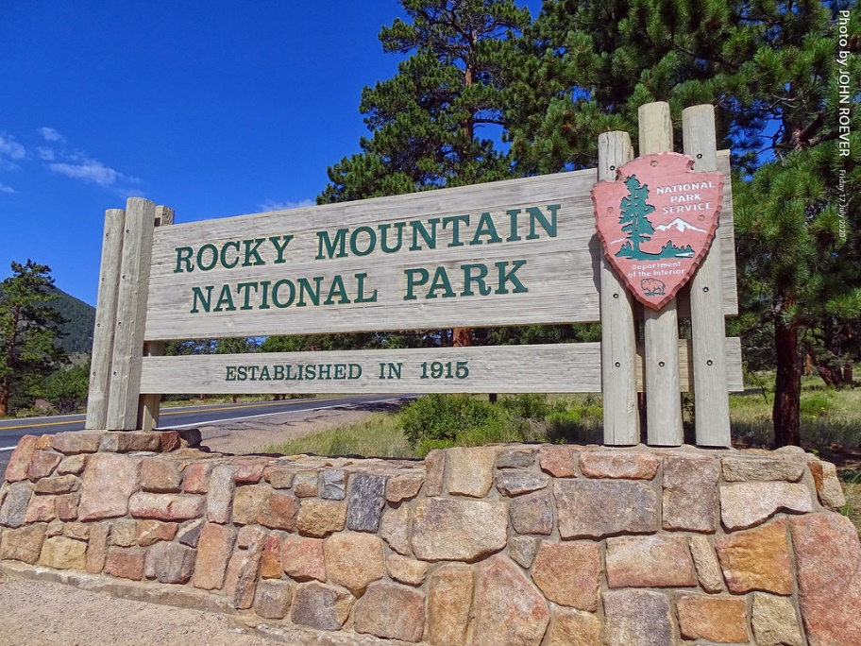
Kyle Patterson is the Management Specialist/Public Affairs Officer at Rocky Mountain National Park. Her main duties include media relations, community outreach and overseeing the park's digital media presence including the website and social media channels. As a member of the park's Leadership Team, she is engaged in a number of park efforts. She has been at Rocky in this position since 2001. Prior to this she was the Public Information Officer at Mount Rushmore National Memorial.

GUESTS: Members are encouraged to invite potential members as guests to meeting.

MEETING NIGHT CONTACT: Mark Blaising at Blaising303@gmail.com or by text 303-263-8647; Zoom issues: Tom Jensen 303-968-0515

