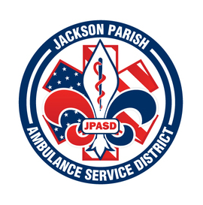

**JACKSON PARISH AMBULANCE SERVICE DISTRICT**

**115 Watts Street**

**Jonesboro, LA 71251**

**Office: (318)-259-2877 Fax: (318)-259-2099**

**jacksonparishambulance@jpasd.com**

**Aaron Johnson BOARD MEMBERS**

**EMS Director [ ] Newspaper** Allen Lindsay, Chairman

**Paula Parkerson , MD** [ ] **Minutes** Conchita Doyle, Vice-Chairman

Medical Director Joe Vail

Alma Williams

Deidre Hollis

**Notice Posted: Tuesday, December 10, 2024 @ 1:00 pm**

**NOTICE OF PUBLIC MEETING**

**A public meeting will be held as follows:**

**DATE:** December 12, 2024

**TIME:**  12:00 PM (Immediately following Public Hearing)

**PLACE OF MEETING:** Jackson Parish Ambulance Service District

115 Watts Street, Jonesboro, LA 71251

Public Meeting AGENDA

1. Call to Order

2. Roll Call

3. Invocation

4. Pledge of Allegiance

5. Recognition of Guests/Public Comments

6. Approval of Minutes from November 14, 2024

7. Approval of Financials and payment of bills November 2024

8. EMS Director’s Report

9. Old Business

A) Accept the 2025 Financial Budget

10. New Business

A) Surplus and Auction Ambulances VIN# 6095 (T8) and 2378 (T10)

B) Resolution to Earmark Funds for specialized purposes

C) Approval of proposed 2025 Regular Scheduled Meeting dates

D) Election of Officers

11. Adjournment

***Reminder: Next Meeting: January 9, 2025 @ 12 Noon***

In accordance with the Americans with Disabilities Act, if you need special assistance, please contact Aaron Johnson, EMS Director at 318-259-2891 describing the assistance that is necessary. Due to the Covid-19 virus visitors are asked to not present to the meeting with fever, cough, diarrhea, or general weakness. Masks will be provided for visitors.