Here's some information added to this page on the joybysurprise.com website: http://www.joybysurprise.com/Sign_of_Messiah_s_Return.html

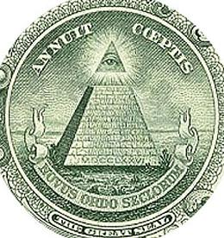
The Roman writing on the base of the pyramid in the graphic above, MDCCLXXVI, is numerically equal to 1776.
MDCCLXXVI also equals MDC CLX XVI
600 60 6 = 666

Revelation 13:18 Here is wisdom. Let him that hath understanding count the number of the beast: for it is the number of a man; and his number is Six hundred threescore and six.
The establishment of the United States of America in the year 1776 is encoded with the value 666 as indicated above. This is one witness that the United States is the mystery "beast" mentioned in the book of Revelation.
The construction of One World Trade Center in New York City, the tower of modern Mystery Babylon the Great, was topped out at 1776 ft and then dedicated on 5/10/2013. Please note that the height of One World Trade Center is also secretly encoded with the value 666 (Roman numerals MDCCLXXVI, 1776), the number of the beast of the book of Revelation. This is a second witness to the identity of the "beast" of Revelation chapter 13.

John Chapter 21 and the 153 Fish in the Net Revisited

There will be an eclipse of the sun on 3/20/2015. When I first discovered this solar eclipse in 4/2009 I wept from time to time for three days, sometimes uncontrollably. When I saw it I knew that the eclipse meant that millions of people would die. The King of Israel was returning.

On the small PDF image of the solar eclipse of 3/20/2015 that I found online in 2009, there was a dotted line that passed through Sicily and the boot of Italy. The PDF image of the solar eclipse was a graphic presentation of the coming of the Son of man described in Daniel chapter 2. It indicated a rock (Sicily) falling on the toes of a foot (Italy). In Daniel chapter 2 a Rock from heaven falls upon the toes of an idol and smashes the idol to pieces. The idol is annihilated and crushed to dust by the Rock from the sky. The feet and toes of the idol are composed of iron and clay. The iron is symbolic of the Roman Empire. The clay is symbolic of Arab nations. In the Hebrew text of Daniel chapter 2 the word pronounced "arab" is present and translated as "mingled" or "mixed" in the English bibles. The clay is "arab" or mixed with the iron, but the two materials don't adhere to each other.

In 2009 I searched through hundreds of years of solar eclipse plates and could find nothing similar to the one of 3/20/2015. This special solar eclipse falls in the middle of a string of four lunar eclipses (called a lunar tetrad) that fall on YaHuWaH 's Feast days in 2014 and 2015. It will be over 500 years before a similar string of lunar eclipses on YaHuWaH 's Feast Days of Passover and Sukkot occurs again. Not only is the lunar tetrad significant, the solar eclipse falling in the center of the tetrad is super significant.

Here's the path of the 3/20/2015 solar eclipse:

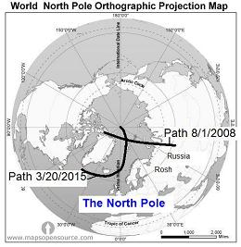

The path of the total solar eclipse ends precisely at the North Pole. I've been unable to find any eclipse that ends precisely at the North Pole for hundreds of years in either direction.

Here's what the solar eclipse will look like to an observer standing at the North Pole on 3/20/2015:

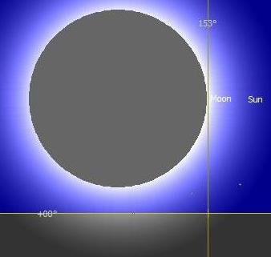

The eclipse appears to be entirely above the horizon because of atmospheric refraction, but it isn't.

The eclipse in reality is mostly below the horizon as pictured below:
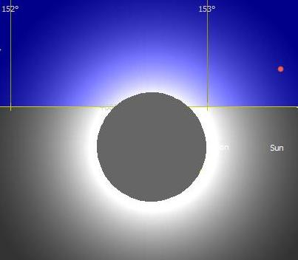

In the previous graphic the sun is just emerging from below the horizon after being below the horizon for the past 6 months. The North Pole has been in complete darkness for 6 months prior to this time.

This solar eclipse is relevant to John chapter 21 and the 153 fish as described in a previous email and on this page: http://www.joybysurprise.com/The_Four_Tavs.html

This solar eclipse ends precisely at the 153 degree marker in the constellation of Pisces the Fish.

Here's a graphic that pertains to John chapter 21 and the 153 fish:

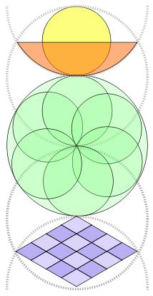

An explanation of the above graphic is available here: http://www.log24.com/log07/saved/070701-Fish.html

Quote from the log24.com website above: "The resulting diagram is mentioned in pre-Christian Pythagorean works, and is mentioned briefly in Plato's Timaeus; supposedly the upper portion, resembling depictions of emergence such as the sun emerging from the horizon, represented to the Pythagoreans the realm of the gods, while the central portion represented humanity, and the lower portion represented the shifting world of manifestation."

The yellow circle above is a symbol of Peter. He's in the boat which is the orange half circle.

The green circles are the disciples who are there.

The blue grid is the fish net.
The mention of the number 153 in the Greek culture 2000 years ago would immediately bring to the mind of the educated person the square root of 3, which was commonly approximated by the ratio 153:265.

Consider this:
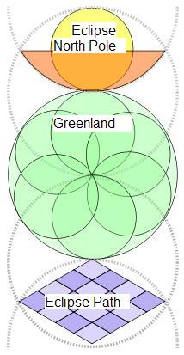

Greenland is in the "Net" in the eclipse map near the top of this page. The solar eclipse is emerging from the horizon in the third graphic from the top of this page.

Consider this:
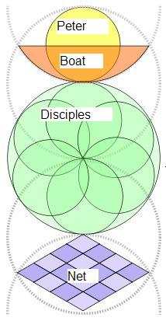

Here's the interpretation:

Peter in the diagram above is Pope Francis (Peter the Roman, Petrus Romanus) who sits in Peter's seat in the Vatican.

According to the Jewish Sages, a solar eclipse pertains to the goyim (gentile nations) and is a sign of coming danger or catastrophe.

It would appear that Peter the Roman and Pauline Benjamite Christianity may be doomed. Perhaps Rahab will be placed outside the walls of Jericho by Joshua for her safety.

I had wondered and prayed about this solar eclipse since finding it about 5 years ago. Mr. Armstrong identified Iceland and Norway as being settled by people of the tribe of Benjamin. Whether that's true or not I don't know, but this eclipse cuts right through Benjamite territory as identified by Mr. Armstrong. I had years ago considered that it might mean the end of Benjamite (Paul's) Christianity. The discovery of the above diagrams just this last week relating to the fish in the net tends to confirm that finding.

There is a lamb with two horns mentioned in prophetic scripture. Now for the first time in history two Popes are serving concurrently.

This solar eclipse event of 3/20/2015 may confirm the prophecy of Saint Malachy from centuries ago that Rome will burn at the time of this current Pope.

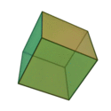
A model of the universe.

The diagonal of a cube is described as one of the sides multiplied by the square root of three, 153:265.

Isaiah 13:5 They come from a far country, from the end of heaven, even YaHuWaH , and the weapons of His indignation, to destroy the whole land.

The Sun Clothed Woman Revisited

Pope Francis is scheduled to appear before the Congress of the United States for the first time in history on September 24, 2015. Two years later on September 23, 2017, a special sign appears in the heavens. It's the sign of the sun clothed woman giving birth to a manchild. The time of Great Tribulation mentioned in the bible is likened to a woman giving birth. You need to be aware that 8 days after giving birth to a male, according to the Torah the child is taken to the Temple for circumcision. In Revelation chapter 12 the manchild is caught up to heaven. If the woman gives birth on September 23, 2017, the manchild will be taken by force on October 1, 2017, which will probably be the Karaite Day of Atonement. If the birth is delayed, his removal for circumcision will be delayed. Whoever this manchild is, whether a person or a group of people, they will be taken inter-dimensionally through prison walls if need be.

There is nothing like this sun clothed woman sign on September 23, 2017, for thousands of years in either direction, past or future.

If this sign is true, a major comet or something like that ( the sign of the Great Red Dragon, Revelation 13) should appear in the heavens near the constellation Virgo in September 2017.

The Sign of the Sun Clothed Woman link: http://www.joybysurprise.com/The_Sun_Clothed_Woman.html

