Pleasant Township Board of Trustees Meeting Highlights
Date __December 14, 2021 Next Resolution No.__ 79---12-14-21_______

- Call to Order

- Please stand for moment of silence----Pledge of Allegiance-----Roll Call (Nancy attending virtually due to having close Covid contact)
UPDATED 7-13-21--SPECIAL NOTE: THE GOVENOR’S REQUIREMENTS FOR COVID RESTRICTIONS HAS BEEN LIFTED, WE WILL CONTINUE TO CONDUCT A VIRTUAL MEETING FOR THE PUBLIC TO JOIN USING WEBX, IF THEY CHOOSE, ALL BOARD MEMBERS ARE REQUIRED TO ATTEND IN PERSON.
- Minutes to approve- no minutes

- Financial Reports – Motion to pay expenditures.

- Visitors – (Hannah Poling with the Messenger via WebX)

  - Anyone else in attendance via WebX

- Swearing in ceremony for Tyler Burleson. Congratulations to our newly hired firefighter.
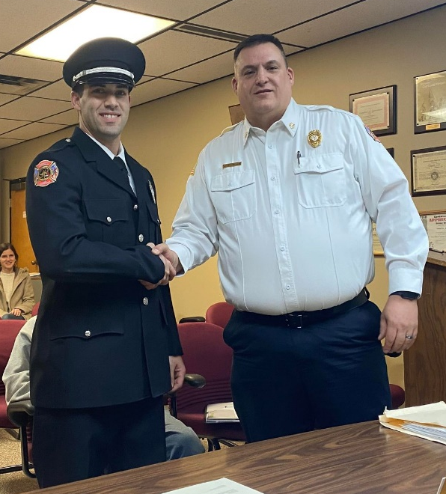
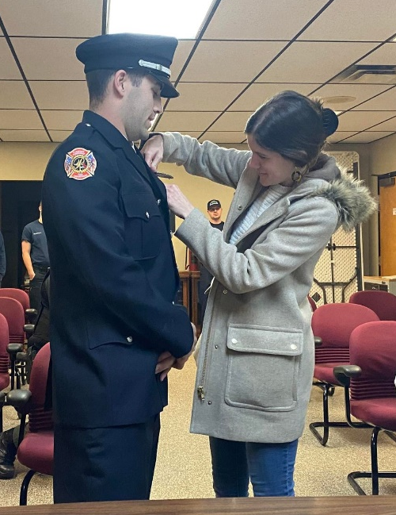
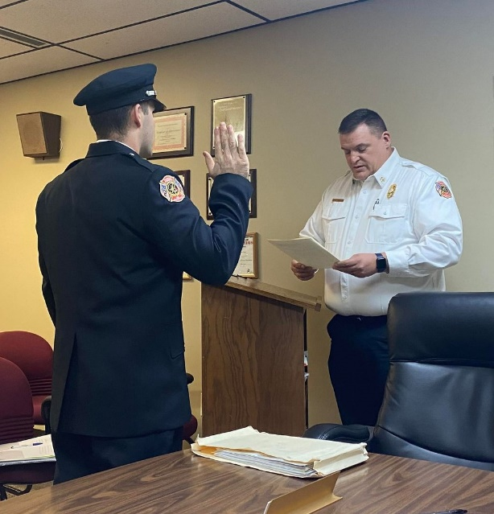

- Department Reports

- Franklin County Sheriff’s Report- Deputy Hamilton
- 136 calls the last two weeks.
- Will notify the environmental officer about a large amount of trash dumped on Lambert Rd.
- Road Department- Robert Bausch off for surgery, Greg Gieger attending

- Thornhill Update- located the tile
- New Door Hangers for nuisance properties
- Converting garage & equipment for snow
- Steve has filled out his paperwork
- Repaired signs on Denton Rd. and Johnson Rd.
- One light has been fixed on Infinity, the other one has problems underground and will take longer to repair.
Fire Dept. – Chief Taylor

- Run Stats
  - 82 runs for November, 1124 for 2021
  - 61 runs for December to date
- Apparatus Maintenance
  - E-231
    - Rust Preventative spray completed
  - E-232
    - Rust preventative spray completed
  - T-231
    - Returned from All American
    - Minor issues while pump testing - repaired
  - GF231
    - Rust preventative completed
  - M-231
  - M-232
    - Getting Tires and Exhaust Tip work completed
    - Rust preventative completed
  - CH-231
  - U-231
  - Boat-231
- Station Projects
  - Crews decorated for Christmas
  - Crews began painting interior of living quarters
  - Physio Control was in to PM all monitors and Lucas Devices
  - Completed a foster home inspection
  - SWCSD Fire Academy Students here for several days.
For Your Information
- Burleson Swearing in Ceremony
Requests
- Resolution___79___ to order Electro-Hydraulic Extrication tools, airbags and other components from MES/Warren Fire Equipment at the cost of $57,548.55.
  - 95% of the cost of this equipment will be paid for by the Assistance to Firefighters Grant, with 5% of the cost ($2,877.00) coming from township funds.
- Resolution__80____ to declare the items on list attached as surplus and no longer of use to the township and place them on Gov Deals for public auction. Items not sold on Gov Deals will be disposed of accordingly as they have no value to the township.

- Old Business-

- New Business –
Email from James Weaver, Local Waste--- Attached (they are following) are the 2022 service guidelines for your review. Once approved, we will include these as well as the attached recycling flyer with the January Statements. Also, Nicole has been promoted to a Sales Admin role and is working in that space now but will still be handling any requests for special events, roll-off containers, or any municipal container concerns.
As a result, I wanted to take this opportunity to introduce you to our new Customer Service Manager, Devarel Pickens.
Please continue to use the info@localwasteservices.com email for all residential billing or service inquiries, but feel free to escalate anything to Dev and myself as needed.
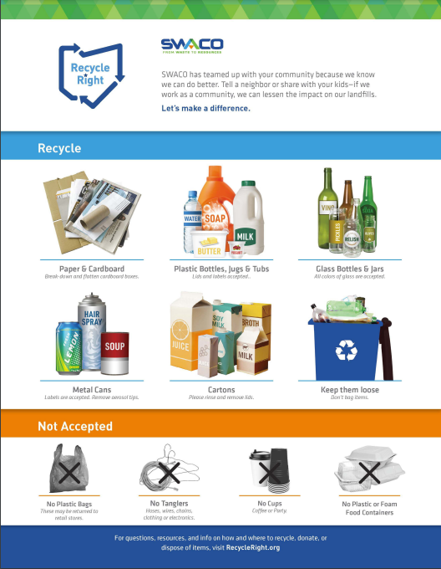
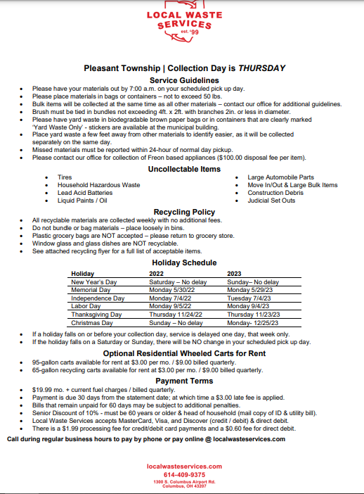
Resolution__81__to approve the 2022 Local Waste Guidelines as presented by James Weaver of Local Waste.
- Clerk Updates- Paula
- Resolution ____82____ to transfer $10,000 from General Fund to HRA Account.

- Speaker Sheets-

- Adjourn

