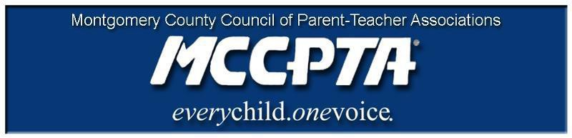

DELEGATES’ ASSEMBLY MEETING AGENDA
Tuesday, September 28, 2021
Meeting Held on Zoom

7:00 pm WELCOME

- Approve Agenda; Approve April 27, 2021 minutes

7:05 pm INFORMATIONAL UPDATES

- Gender Equity/Office of Legislative Oversight
- MCPS School Renaming Process
- National/Free State Update
- Compliance Documents/Training Resources

7:35 pm OLD BUSINESS

- Vote to fill MCCPTA Board Secretary Position

7:40 pm OFFICER REPORTS

- Cynthia Simonson, President
- Rodney Peele, Vice President- Educational Issues
- Rochelle Fink, Vice President- Administration
- Charisse Scott, Vice President- Programs
- Laura Mitchell, Vice President- Advocacy
- Francesco Paganini, Treasurer
- All Reports - https://mccpta-my.sharepoint.com/:f:/g/personal/office_mccpta_org/ErdAHlXG_KtPkephqFD0c54BswtmvWGlB7-3BWAuY9PBQA?e=oz62mU

8:10 pm COMMITTEE REPORTS

- Committee calls for representatives from each school
- All Reports, including all work plans – https://mccpta-my.sharepoint.com/:f:/g/personal/office_mccpta_org/EqrswSssoZNKmDkT7cm5zUsBWr2jCTyep6swTFxihgD89g?e=2y53h6

8:20 pm NEW BUSINESS

- Approve MCCPTA 2021/2022 Budget

8:55 pm ANNOUNCEMENTS & ADJOURNMENT

DATES:

- October 12, 2021 – 7 pm, BOE with Poolesville Cluster (tentative)
- October 13, 2021 – 7 pm, BOD Meeting on Zoom
- October 18, 2021 – 7 pm, BOE with Blake Cluster (tentative)
- October 26, 2021 – 7 pm, DA Meeting on Zoom

