Eco Orca Class OCTOBER 2025 Old Growth Forest
SUNDAY |  |  | MONDAY | TUESDAY | WEDNESDAY | THURSDAY | FRIDAY | SATURDAY
 |  | 28 | 29 | 30 | 1 | 2 | 3 | 4
 |  |  |  |  | Francis king Forest Walk | Aylard  Farm | Gorge  Park
 | 5 |  | 6 | 7 | 8 | 9 | 10 | 11
 |  |  | Highlands Park | Roche Cove Forest Trail | Cook St  Park | Tower Point Beach | Layritz  Park | 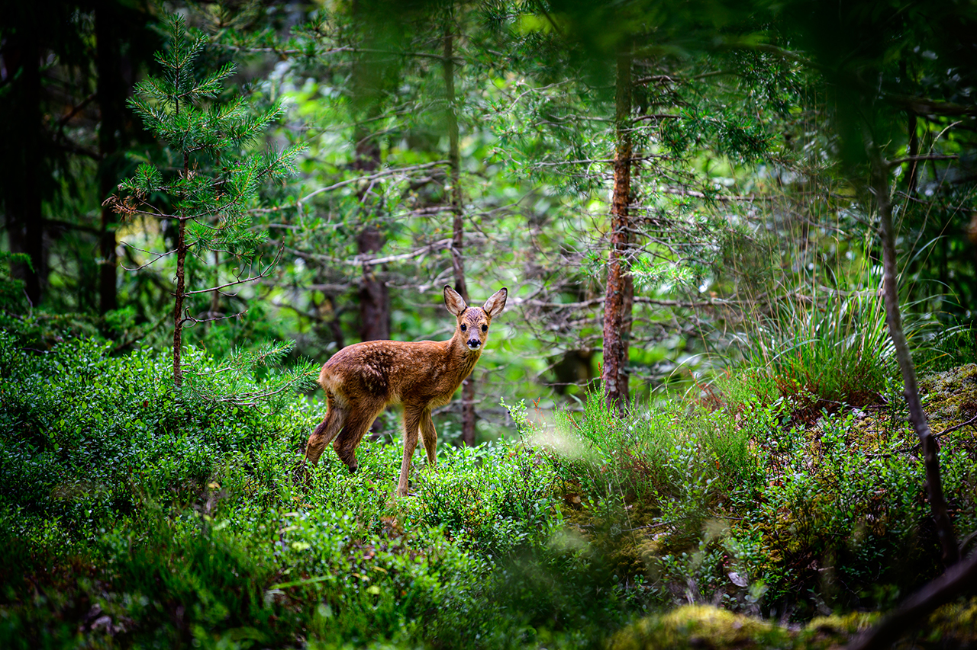
 | 12 |  | 13 | 14 | 15 | 16 | 17 | 18
 |  |  | Closed  Thanksgiving Day | Humpback Park | Mt Doug Beach Park | Ruby Creek Forest Trail | Beacon Hill Moss Lady
 | 19 |  | 20 | 21 | 22 | 23 | 24 | 25
 |  |  | Westhills  Park | Island View Beach | View Royal Garden Park | Mitchell’s Farm Pumpkin Patch $5 | Pro Day  No Class
 | 26 |  | 27 | 28 | 29 | 30 | 31 | 1
 |  |  | Ed McGregor Docks  Sooke | Central Saanich Park and Farms | Devonian Beach Trails | Beckwith  Park | Halloween Costume Party  Halloween

