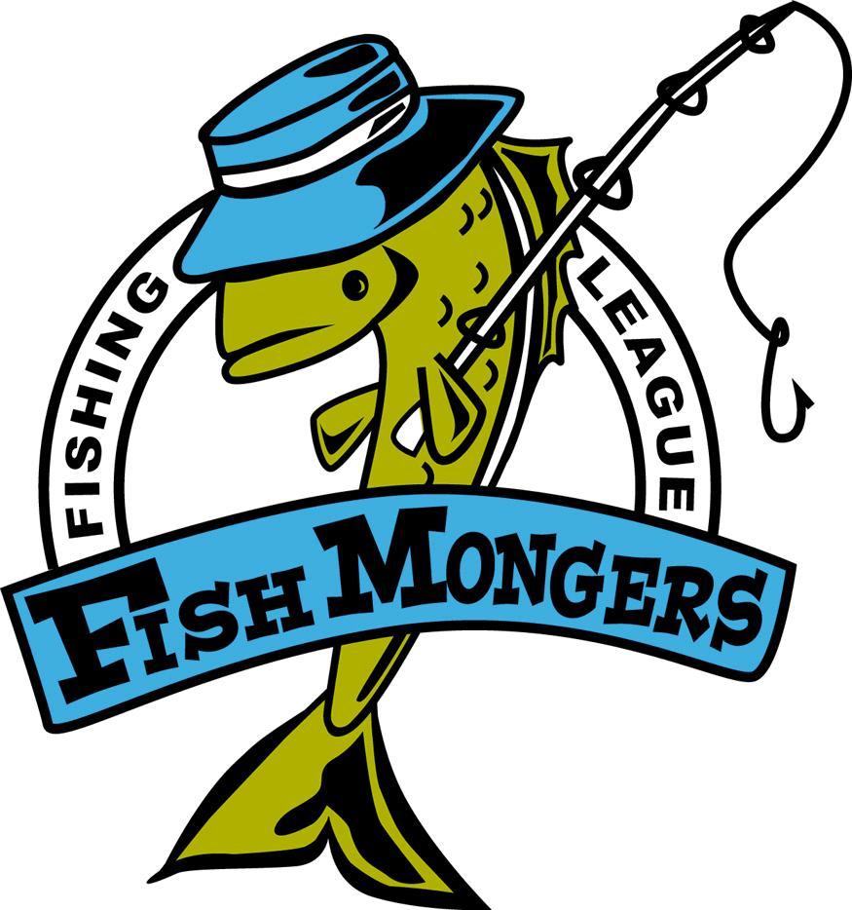
Final 09/10/2004
Team | Skunk | Walleye  26 Gull Leo | Northern  35 WF  Dave P | Black Bass  19 Pel  Dave P | Rock Bass  11 Cul Todd | Weekly Points | Total Points
Robertson/ Sundquist |  |  | 27.5 | 13.25,13.5 | 11 | 9 | 39
Peterson/  Rud |  | 14 |  | 14,16 |  | 8 | 34
Sauer/  Lundberg 1 |  | 17 | 26.5 | 14.75 | Mini slam +3 | 11 | 31
Bryan Raguse/ Andy Kratochvil |  |  |  | 15.25 |  | 2 | 30
Johnson/ Lueck |  | 16.25 | 33.25 |  |  | 6 | 30
Weinkauf/ Nelson |  |  |  | 11 |  | 0 | 29
Anderholm/  Nelson |  |  |  |  |  | 0 | 22
Todd Greatens/  Scott Stahl 1 |  | 15.25 |  |  |  | 2 | 17
Ford 1 |  |  |  |  |  | 0 | 16
Leo Grabowski |  |  |  |  |  | 0 | 14
Goll/Jacobsen 1 | NS |  |  |  |  | 0 | 5
Dave Saatoff/ Mike Worden 1 | NS |  |  |  |  | 0 | 4
Winners paid $400/300/200. New reels to Peterson x2 and Leo. Rockies were a tie –new zebcos are on the way.
If after the reels are paid for I have money left I will split it between the wieners.
Dave

