12/19/2016

Confirmation of the Sign of the Woman Travailing in Birth on 9/23/2017

For reference purposes, previous articles from the past two years can be found on this page: http://www.joybysurprise.com/Articles.html

The article of 12/17/2016 concerned the heavenly sign of the woman clothed with the sun mentioned in Revelation chapter 12. The woman is travailing, giving birth to the man child who will rule all nations with a rod of iron. The passage is a reference to YAHUSHUA Messiah.

We can verify that the special sign on 9/23/2017 is in fact concerning Messiah YAHUSHUA because of it's relationship with the life and ministry of YAHUSHUA nearly 2,000 years ago.

The Bar Mitzvah

When a Jewish boy is 13 years old he reads publicly from the Torah for the first time in a ceremony known as a Bar Mitzvah. The 13th anniversary of the boy's birth is actually the 1st day of his 14th year.

The Bar Mitzvah date for a boy born on 9/23/2017, the day the Woman Clothed with the Sun is travailing in birth, is 9/30/2030. That particular day, 9/30/2030, is the Karaite Day of Trumpets in 2030.

Here's a link to a Bar Mitzvah date calculator: http://www.chabad.org/calendar/bar-bat-mitzvah_cdo/aid/6227/jewish/BarBat-Mitzvah.htm

Also, because the crucifixion of Messiah was probably on Passover in 30 AD, Passover in 2030 would be the 2,000th anniversary of the crucifixion and the first day of the 3rd thousand year day.

Below is a graphic that illustrates these events.

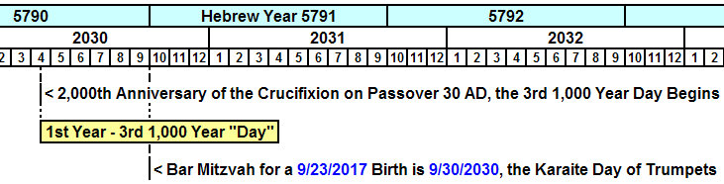

Because the Bar Mitzvah date for a male child born on 9/23/2017 falls precisely on the Karaite Day of Trumpets in 2030, we can identify this event timing as a confirmation of the heavenly sign of the Woman Clothed with the Sun travailing in birth on 9/23/2017 as being from YaHuWaH Elohim.

The special days called "Feasts" in the bible are known as "moedim" in Hebrew. Moedim means an "appointed" day, not just a "feast" day. When events happen on the appointed days of YaHuWaH Elohim, we are instructed to take notice. The moedim are special days that YaHuWaH Elohim has reserved unto Himself to use as "signals" to us that He is in control and working in His creation.

And because the 3rd one thousand year "day" from the crucifixion begins on Passover 2030, just 6 months prior to the Bar Mitzvah of the Man Child in 2030, we may regard that as another confirmation that the sign of the Woman Clothed with the Sun is from our Creator Elohim and valid.

Our Messiah spoke of doing many things on the 3rd day, like building a Temple and being perfected.

The Tav at the End of 6,000 Years

There was a sign in the sky in 4/1996 and 4/1997 generated by two comets that crossed each other and marked an ancient Hebrew "Tav", an "X", directly on the decapitated forehead of the "Medusa" or Satan (Arab Al Ghoul). The article is labeled "12/05/2016 –

The Tav at the End of 6,000 Years" and is available on this page: http://www.joybysurprise.com/Articles.html

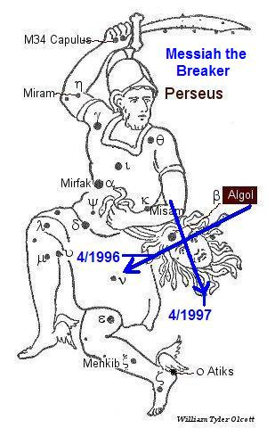

In the 50th year from the completion of that special "Tav" in the sky in 1997 from our Creator Elohim in the graphic above, we find the midpoint date from 4/11/2046 to 4/11/2047 to be 10/10/2046.

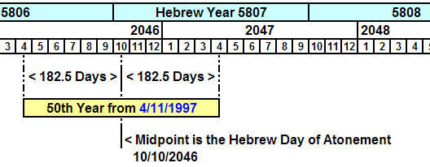

October 10, 2046 is the Hebrew Day of Atonement.

We also note that the Tav above on the forehead of the decapitated Satan in 1996 and 1997 marks the precise end of 2,000 years from the birth of Messiah in 4 BC. That Tav in the sky placed on "Satan's decapitated head" by YaHuWaH Elohim marks the beginning of the 3rd one thousand year "day" from YAHUSHUA's birth in 4 BC.

Entry into Ministry at 30 Years of Age

Luke 3:21 Now when all the people were baptized, it came to pass, that YAHUSHUA also being baptized, and praying, the heaven was opened,
22 And the Holy Ghost descended in a bodily shape like a dove upon Him, and a voice came from heaven, which said, Thou art My beloved Son; in Thee I am well pleased.
23 And YAHUSHUA Himself began to be about thirty years of age, being (as was supposed) the son of Joseph, which was the son of Heli,

I published an article on 3/27/2016 titled "The 30 AD Calendars". The article can be found at this link: http://www.joybysurprise.com/Articles.html

Many people have settled on 30 AD as the year of Messiah's crucifixion after extensive research. Part of the reason for selecting 30 AD is that 4-3BC has been widely accepted for the birth of Messiah. A Priest in Israel would be qualified to enter into service in the Temple when he was 30 years old. When we add 33 years to 4 BC we arrive at 30 AD for Messiah's crucifixion.

In actuality, the 30 year qualification for service would begin at the person's 29th birthday. His 29th birthday would be the 1st day of his 30th year of life. This is known as inclusive numbering, and it's the way that years were counted in ancient Israel.

The Feast of Sukkot (Tabernacles) began on October 7, 4 BC. Many scholars believe that Messiah was born during the Feast of Sukkot, since a requirement for observing the Feast of Sukkot is to dwell in a temporary shelter made specifically of tree branches during the Feast. Messiah was Elohim who came to temporarily dwell among us in a human body.

The time period from 10/07/04 BC (birth of Messiah, begin Sukkot) to the 4/27 AD baptism by John is 29 years and 6 months.

Below is a graphic showing some historic events concerning the nation of Israel, the 30th year from 9/23/2017, and the 50th year from 1997.

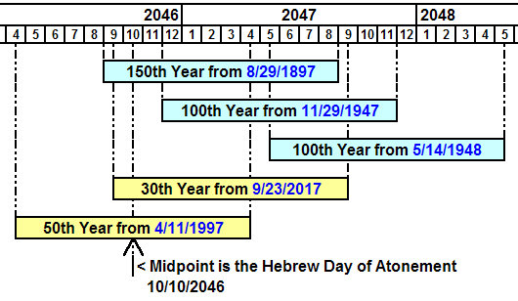
As you can see in the above graphic, a priest born on 9/23/2017 would enter into ministry during his 30th year (29 years old). His ministry would agree in timely fashion with historical events concerning the nation of Israel. We might regard this as another confirmation that sign of the Woman Clothed with the Sun and travailing in birth on 9/23/2017 is valid.

So we have signs tending to confirm Messiah's birth in 4 BC ( the comets of 1996 & 1997) and signs confirming His birth in 2017 (the Woman Clothed with the Sun travailing in birth).

Questions:

Is the sign of 9/23/2017 a woman giving birth to a mature Messiah?

Is it a sign of the beginning of the Great Tribulation period?

Is it a sign of Messiah's birth 2,000 years ago?

Is it a sign of a human woman actually giving birth in 2017 to an incarnation of Elohim in a human body who will mature to enter ministry 30 years later at the approach of the centenary of Israel's statehood in 2046?

Is it the sign of the birthing of 144,000 over comers who will rule the earth with a rod of iron along with Messiah?

We might wonder what all of this means. I hope we can begin to grasp it all. The people mentioned in Acts 2:4 weren't expecting what came to them. We need to pray and prepare ourselves.

Please don't assume that because the years 2046 to 2048 are indicated in the graphics above that Messiah won't come until then. The purpose of all these timelines might be just to confirm to some of us who doubt that there is a Creator who is in control of everything.

Summary

There's more to the universe than meets the eye. YaHuWaH Elohim is a usually invisible supernatural being with abilities beyond human comprehension, coordinating astronomical events to coincide with the affairs of human governments. He created us.

We have feelings and emotions, so He must have feelings also, probably to a greater extent than what we can imagine. Most people treat Him with indifference and ignore Him and His instructions. He's looking for someone to be His friend. It's something to think about. Just tell Him each day that you'll be His friend. You'll be glad you did, and so will He.

