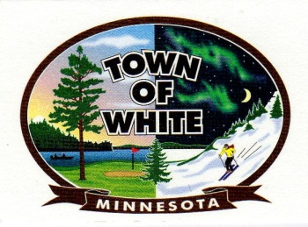 | Town of White  P.O. Box 146  Aurora, MN 55705  (218)229-2813  townofwhite@yahoo.com

STRATEGIC PLAN
2013-2015
Mission: To be a responsible steward of all resources and to provide quality municipal services that will help to maintain and improve the manner in which our citizens live, work, and play.
Category #1 – Facilities Management Strategy
Goal #1 – To sell the Aurora Garage and determine new storage needs
Goal #2 – To reduce operating expenses at the Loon Lake Community Center including a reduction in personnel due to attrition
Goal #3 – To increase revenue by increasing recreation/usage at our facilities
Goal #4 – To improve the footprint of the township by modifying the landscape at our main facilities (parking lots, removal of dead trees, entrances etc.) and increasing options
Goal #5 – Improve/Upgrade Shooting Range Facilities to continue to attract national venues
Category #2 - Organizational Development (Core Services) Strategy
Goal #1 – Determine adequate personnel needs to meet increasing demand & services
Goal #2 – Develop attrition strategy for Transfer of knowledge of retiring employees
Goal #3 – Continue to expand shared services and partnerships where possible for reduction of operating expenses & increased services
Goal #4 – Continue to invest in training for employees with a continuous improvement focus
Goal #5 – Continue to invest in technology to improve communication & efficiency & increase marketing & awareness of the township’s assets
Goal #6 – Continue to seek grant opportunities to reduce operating expenses & increase municipal services

Category #4 - Operations/Infrastructure Strategy

Goal #1 – Develop a roadway improvement schedule & ensure adequate funds are reserved for this process

Goal #2 – Continue to invest in water/wastewater services including maintenance of current services

Goal #3 – Purchase new equipment to improve operations efficiency & reduce maintenance costs

Category #5 - Fiscal Sustainability Strategy

Goal #1 – Increase the amount of unrestricted unassigned funds from 45% to 50% in the next three years

Goal #2 - Increase investments of the township

