

The Village of Innsbrook

1835 Highway F – Innsbrook, MO 63390

636-745-8844 * 636-745-7755

**Survey Summary**

2025 Comprehensive Plan Update

*May 30, 2025*

**BACKGROUND**

A critical component of the planning process used in the development of the Village’s 2025 Comprehensive Plan Update was the citizen survey. The survey was mailed to every resident and linked to the Village’s Website and made available at Village Hall. Between January 25th and May 1st, 2025, the citizen survey received 176 responses from Village residents, households and families, a sample size comprising 28% of Innsbrook’s total resident population. The survey's ten (10) questions were intended to help identify the core values of the citizens and the critical issues facing the Village of Innsbrook. The survey responses do not represent the views of the consultant or the elected and appointed officials from the Village, or Innsbrook Corporation. The following is a summary of the survey findings.

**STRENGTHS**

The citizens were asked to rank the Village of Innsbrook’s top assets, from 1 to 5, one (1) being the most important.. The top three (3) highest-ranked assets related to the area’s natural environment, as follows.

**Figure 1: Natural Setting Survey Rankings**

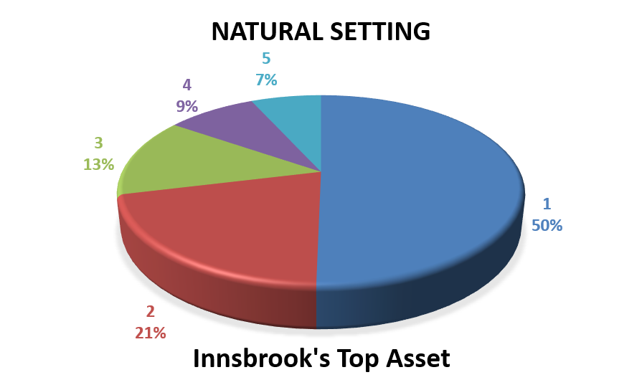

1. Natural Setting
2. Peace & Quiet
3. Lakes
4. The Resort
5. The Resident Population

When asked to choose Innsbrook’s greatest asset, 50% of respondents ranked Innsbrook's natural setting as the Village’s greatest asset, with a rating of 3.99 out of 5, being the greatest, see Figure 1.

**WEAKNESSES**

**Figure 2: Nearby Businesses Survey Rankings** Businesses

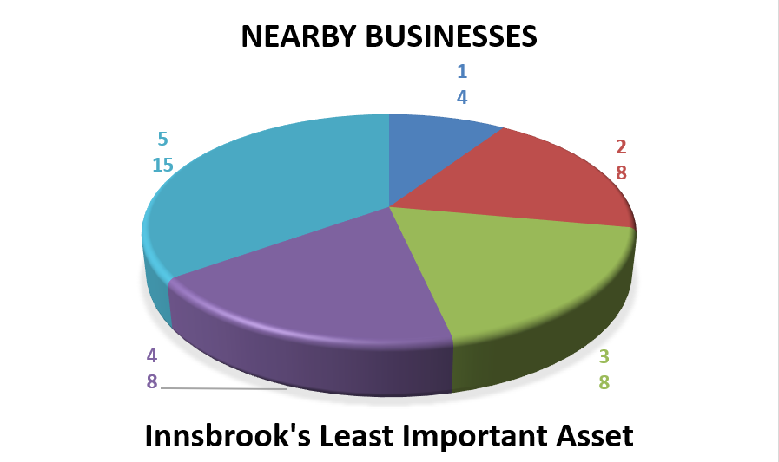

On the other hand, survey respondents ranked “Nearby Businesses” and “Dollar General” as the least important assets, given that commercial development encroaches on the natural environment.

Nearby Businesses were the lowest valued asset with a rating of 2.49 out of 5. Only four (4) respondents ranked Innsbrook’s Businesses as the Village’s most important asset, see Figure 2.

|  |  |  |  |  |  |  |  |
| --- | --- | --- | --- | --- | --- | --- | --- |
| **Table 1: The Village of Innsbrook’s Top Assets** | | | | | | | |
| ***Top Community Assets*** *(in order of rating)* | **Least Important** | |  | | | **Most Important** | |
| **1** | **2** | | **3** | ***4*** | | ***5*** |
| ***Rating*** | | | | | | |
| 1. Natural Setting | **3.99** | | | | | | |
| 1. Peace & Quiet | **3.85** | | | | | | |
| 1. Lakes | **3.55** | | | | | | |
| 1. The Resort | **3.54** | | | | | | |
| 1. Resident Population (the People of IBK) | **3.39** | | | | | | |
| 1. Location | **3.23** | | | | | | |
| 1. Vacation/Recreational Atmosphere | **3.22** | | | | | | |
| 1. Cultural/Arts/Entertainment | **2.97** | | | | | | |
| 1. Housing | **2.85** | | | | | | |
| 1. Dollar General | **2.71** | | | | | | |
| 1. Nearby Businesses | **2.49** | | | | | | |
| *Source: 2025 Innsbrook Comprehensive Plan Update Survey* | | | | | | | |

**OPPORTUNITIES**

The citizens were asked to rank the Village of Innsbrook’s top five (5) issues it will face in the next 5-10 years. The top five (5) highest-rated issues are also related to the Village’s natural setting, its peace and quiet, and how population and commercial growth can undermine these integral assets. “Preserving Natural Areas” is by far the more urgent issue according to residents.

1. Preserving Natural Areas
2. Property Maintenance/Aesthetics
3. VRBO / AirB&B
4. Weekend Population Increase
5. Crime & Safety Issues

**Figure 3: Innsbrook’s Most Urgent Issue**

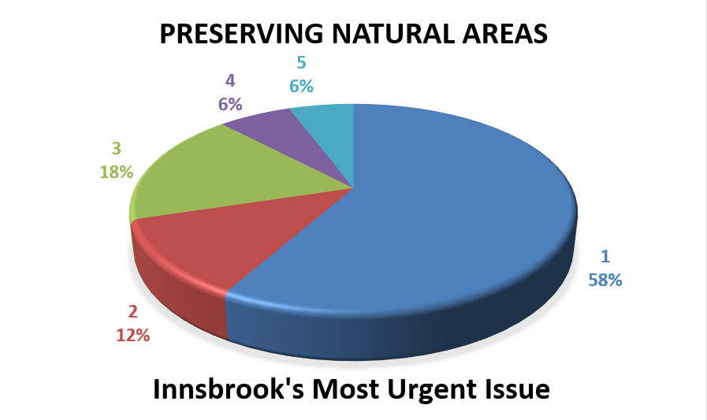

Preserving Innsbrook’s natural areas is the top issue according to 58% of respondents who ranked preserving natural areas a 1 out of 5, one (1) being the most important.

|  |  |  |  |  |  |  |  |
| --- | --- | --- | --- | --- | --- | --- | --- |
| **Table 2: The Village of Innsbrook’s Top Issues** | | | | | | | |
| ***Most Urgent Issues*** *(in order of rating)* | **Least Urgent** | |  | | | **Most Urgent** | |
| **1** | **2** | | **3** | ***4*** | | ***5*** |
| ***Rating*** | | | | | | |
| 1. Preserving Natural Areas | **4.11** | | | | | | |
| 1. Property Maintenance/Aesthetics | **3.56** | | | | | | |
| 1. VRBO / AirB&B | **3.39** | | | | | | |
| 1. Weekend Population Increase | **3.37** | | | | | | |
| 1. Crime and Safety Issues | **3.35** | | | | | | |
| 1. Traffic Congestion or Speeding | **3.34** | | | | | | |
| 1. Recreation Activities for All Age Groups | **3.30** | | | | | | |
| 1. Farmland Preservation | **3.21** | | | | | | |
| 1. Population Growth | **3.14** | | | | | | |
| 1. Access to Quality Shopping & Dining | **2.85** | | | | | | |
| 1. Outdoor Storage | **2.71** | | | | | | |
| 1. Expanding the Village’s Limits (Annex) | **2.62** | | | | | | |
| *Source: 2025 Innsbrook Comprehensive Plan Update Survey* | | | | | | | |

The citizens were asked what improvements were needed to make the Village of Innsbrook a better place to live and visit. The top responses included the following, in order of popularity:

1. Limit short-term rentals
2. Improve trash and snow removal
3. Control the deer populations
4. Add a pool and more hiking and biking trails
5. More strictly enforce speed limits
6. Add a lane for the main entrance gate
7. Improve water and sewage utilities
8. Maintain gravel roads and fix the closed bridge
9. Increase access to mail and emergency services
10. Enforce quiet hours and dark skies
11. Reduce lake pollution
12. Increase government transparency

**POPULATION AND COMMERCIAL** **GROWTH**

The citizens were asked whether the Village of Innsbrook should encourage, maintain, or discourage population growth, and where any future residential and commercial developments should be located. The vast majority of survey respondents supported maintaining the current population and recommended that any additional growth should be well-planned.

The common consensus is that the Village must retain its unique identity and original vision which was inspired by the Village's founder Ed Boyce. The Village must not deviate in either the direction of another exurb of the Greater Saint Louis MSA, like O'Fallon, MO, or another overly trafficked vacation destination, like the Lake of the Ozarks. The Village must retain its peaceful, quiet, and stylistically Alpine rural atmosphere.

The respondents are open to limited residential growth, but no rental growth. On the other hand, residents are very weary of commercial growth, even concerning the proposed developments surrounding Highways F and M. Locally owned, mom-and-pop stores will take precedence according to the respondents. Large commercial franchise development and uses that are destructive to our youth and/or active, healthy image, such as liquor stores and smoke shops, were strongly discouraged by respondents. Most residents are willing to drive to Wright City or Warrenton for gas, groceries, etc. However, there is still a desire among many residents for increased access to emergency services and the extension and improvement of public utilities like water, sewage, and roads. However, survey respondents acknowledge that these improvements require the capital gained from commercial growth.

Later in the survey, residents were asked what kinds of stores, services, restaurants, or entertainment uses they would like to see and where. Many respondents did not want to answer this question given their stance on discouraging any new commercial development. For many residents, the clubhouse, the country store, the pool bar, and the Dollar General are adequate. However, most respondents made it clear that limited commercial development is acceptable but that most of it must be restricted to the area surrounding the Highway F and M intersection and should stay away from the Resort. Those who support commercial growth requested to pay more attention to improving the existing clubhouse and keeping it open longer, building a new gas station and car wash, and opening more uses akin to Lavender Farm.

The last question regarding growth asked survey respondents how the Village could attract visitors, tourists, and other outsiders to Innsbrook. Once again, many respondents declined to directly answer the question as they disagreed with the premise of attracting more growth to the quaint Village. Those who entertained the question support the creation of a farmer's market, horse shows / rodeos, and continued concerts while demoting the overly loud and crowded events surrounding Sky Wars and even the Fourth of July fireworks show.

**PUBLIC SERVICES**

**Most Important:** The citizens were asked to rank the Village of Innsbrook’s most important public services. The top three (3) ranking public services were the most basic public services that pertain to the survival and safety needs of residents (fire, utilities and P&Z):

1. Fire Protection

2. Utilities (Water, Sewer)

3. Planning & Zoning

4. Streets

5. Police/Security

The most important public service according to 44% of survey respondents is Fire Protection with a rating of 3.77 out of 5 followed very closely by Utilities (Water and Sewer) with a rating of 3.71.

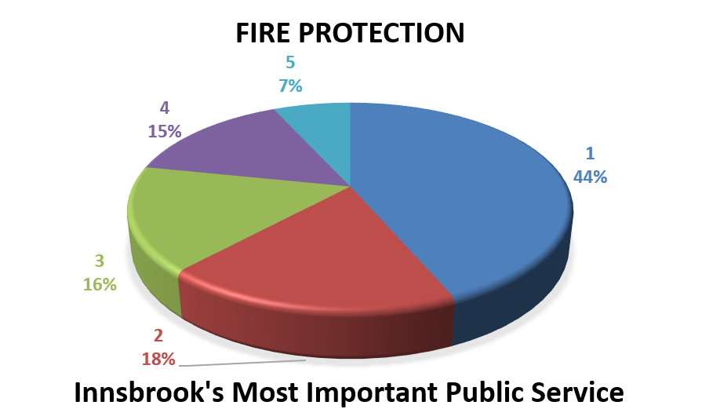

**Figure 4: Innsbrook’s Most Important Services**

**Least Important:** The least important public services were “Animal Control”, “Leaf Collection & Recycling” and “Winter Maintenance (Snow Removal) which are not services the Village currently provides.

|  |  |  |  |  |  |  |  |
| --- | --- | --- | --- | --- | --- | --- | --- |
| **Table 3: The Village of Innsbrook’s Most Important Public Services** | | | | | | | |
| ***Most* Important Services** *(in order of rating)* | **Least Important** | |  | | | **Most Important** | |
| **1** | **2** | | **3** | ***4*** | | ***5*** |
| ***Rating*** | | | | | | |
| 1. Fire Protection | **3.77** | | | | | | |
| 1. Utilities (Water, Sewer) | **3.71** | | | | | | |
| 1. Planning & Zoning | **3.58** | | | | | | |
| 1. Streets | **3.50** | | | | | | |
| 1. Police/Security | **3.47** | | | | | | |
| 1. Parks & Recreation | **3.28** | | | | | | |
| 1. Winter Maintenance (Snow Removal) | **3.26** | | | | | | |
| 1. Leaf Collection & Recycling | **3.02** | | | | | | |
| 1. Animal Control | **2.79** | | | | | | |
| *Source: 2025 Innsbrook Comprehensive Plan Update Survey* | | | | | | | |

**GENERAL**

Based on resident ratings of the below statements, the Village of Innsbrook is a great place to live, especially for retirees, so there is little need for change unless the Village wants to bring in more your families and grow the populatiion.

|  |  |  |  |  |  |  |  |
| --- | --- | --- | --- | --- | --- | --- | --- |
| **Table 4: Quality of Life in Innsbrook, MO** | | | | | | | |
| ***Statements*** *(in order of rating)* | **Disagree** | |  | | | **Agree** | |
| **1** | **2** | | **3** | ***4*** | | ***5*** |
| ***Rating*** | | | | | | |
| The Village is a great place to live | **4.39** | | | | | | |
| The Village of Innsbrook is a great place to retire | **4.20** | | | | | | |
| I am proud to live in the Village of Innsbrook | **4.19** | | | | | | |
| The Village is a great place to raise children | **2.99** | | | | | | |
| The Village should grow in size and population | **2.19** | | | | | | |
| *Source: 2025 Innsbrook Comprehensive Plan Update Survey* | | | | | | | |

Residents are mostly satisfied with their housing options, public utilities, recreational programs, and other assets. The only additional development that most residents want in the Village is parks. Most residents want to discourage future rental and non-residential development, unless they reduce the tax burden on residents. Many residents support local organizations like Wags and Whiskers, and limited commercial development by the intersection of Highways F and M, but the natural environment and its peace and quiet take precedence.

|  |  |  |  |  |  |  |  |  |
| --- | --- | --- | --- | --- | --- | --- | --- | --- |
| **Table 5: Resident Satisfaction with Living Standards in Innsbrook, MO** | | | | | | | | |
| ***Statements*** *(in order of rating)* | **Disagree** | |  | | | **Agree** | | |
| **1** | **2** | | **3** | **4** | | **5** | |
| ***Rating*** | | | | | | | |
| 1. There are sufficient housing options in the Village | | | | | | | | **3.91** |
| 1. I am generally pleased with the Village's utilities | | | | | | | | **3.77** |
| 1. The Village should have more parks and walking areas | | | | | | | | **3.40** |
| 1. There are sufficient recreation programs for youth in the Village of Innsbrook | | | | | | | | **3.37** |
| 1. There are sufficient recreation programs for seniors in the Village of Innsbrook | | | | | | | | **3.34** |
| 1. I support restricting side-by-side to those registered prior to April 2024 and banning the use of side-by-sides by 2029 | | | | | | | | **3.31** |
| 1. Traffic is a problem | | | | | | | | **2.91** |
| 1. A gas station/convenience store and restaurant should go at F & M | | | | | | | | **2.81** |
| 1. The Village should provide funding to local organizations (i.e. Wags & Whiskers) | | | | | | | | **2.65** |
| 1. The Village should do more to assist local organizations and businesses | | | | | | | | **2.59** |
| 1. The Village should annex land for home/chalets & more recreation/open space | | | | | | | | **2.58** |
| 1. Innsbrook should have more stores, restaurants and commercial services | | | | | | | | **2.50** |
| 1. I would support a tax to fund road improvements | | | | | | | | **2.26** |
| 1. I would support a sales tax to fund future development & improvements | | | | | | | | **2.16** |
| 1. The Village of Innsbrook should provide incentives to bring new business to town | | | | | | | | **2.13** |
| *Source: 2025 Innsbrook Comprehensive Plan Update Survey* | | | | | | | | |