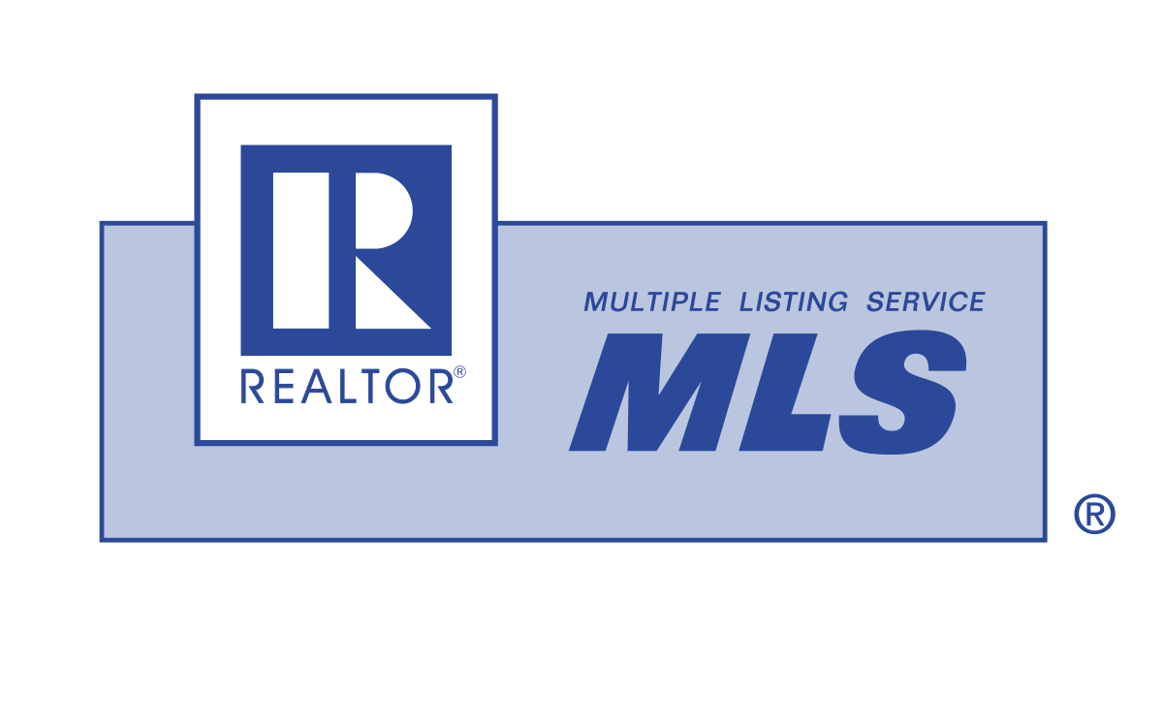
Home Wish List

Name/Phone/Email: Date:

Property | Comments | Exterior | Comments
Resale/New Construction |  | Deck/Patio
Move-In Ready or Some Improvements Needed |  | Swimming Pool
Year Built |  | Garage
Number of Stories |  | Other Structures (shed, RV gate)
Lot Size |  | Landscaping (grass, desert, trees)
View (city, mountain, golf view) |  | Location | Comments
Square Footage |  | Close to Shopping
Interior | Comments | Close to Schools
Number of Bedrooms |  | Close to Work
Number of Bathrooms |  | Nearby Recreational Facilities
Living Room |  | Desired Location
Kitchen Style (countertops finish, island, appliances) |  | Homeowners Association  (Yes/No, fees)
Breakfast Area |  | Community Features (55+, gated, pool, trails)
Dining Room |  | General | Comments
Family Room |  | Moving Timeframe
Other (den, office) |  | Price Range
Fireplace(s) |  | Lender Pre-approved
Flooring (ceramic, carpet, wood) |  | Contingencies
Openness of Home |  | Relocating?

Name/Phone/Email: Date:

Top five features your home must have:
1.
2.
3.
4.
5.
Add one feature to make this your dream home:
Additional Comments:

