Puckety Presbyterian Church
1009 Puckety Church Road Lower Burrell, PA 15068
(Return Service Requested)
REMINDER:  Sunday Worship: 10:00 a.m.  Zoom/video at pucketychurch.org | 
Puckety Church
We are determined to be the heart, voice, and hands of God, making a lasting difference in your life, our community, and the world!





Puckety Presbyterian Church
At Puckety we personally and collectively Honor God, Grow in Faith,
and Improve our Community and World.
October 2025

Pastor’s Corner

I can’t remember the last time I was “pulled” in so many directions to comment on things happening around us. As I write this – 2 weeks after Charlie Kirk’s assassination – I wonder if the Spirit is calling me to speak into the turmoil, with words about the power of faith, the importance of free speech in our society, and the ultimate centrality of witnessing to Christ. It would fill 10 pages. Like I’ve learned with trying to text someone about a delicate matter – the ‘written word’ has limits. Much of what’s in my heart (a lot of our hearts) is best addressed either one-to-one, or in small groups, where we can discuss and prevent misunderstanding. This is one of the reasons why I’ve been trying so hard to help Puckety enhance its small group ministry. We’ve had an average of 85-90 people in church the last 3 Sundays (at least 100 different people minimum) – and yet we only received 27 small group surveys back. Of those 27 surveys, 21 are already currently in a small group (or have been in the last year). I’m very grateful for the enthusiasm of our “veteran” participants to try something new. Nevertheless, the purpose of the relaunch was to get our other folks not in a small group (b/n 60 and 70 people) to get plugged into one. Maybe I’ll just give a personal, concrete example, instead to trying to convince you of the and biblical pattern & precedent… I need a small group. With the anxiety I have felt in the past 8 weeks – losing a beloved pet (and recently getting a new one we’ve discovered has significant health issues), repeated discussions – albeit important ones – about policies affecting our relationship with our neighboring schools, the political tension I feel coming at me from friends on both sides of the WIDE spectrum, various folks needing to back away from various ministries (often for good reasons, but still creating a vacuum of leadership & volunteers), I need to remember I’m not alone. A small group is a blessed place where some of that pressure finds a “relief valve.”
Don’t misunderstand me – a small group is way more than a place to “vent.” It is a place where you find sisters and brothers to listen to you, to “carry each other’s burdens” (Galatians 6:2), to share God’s perspective and counsel from his Word, speak truth, give encouragement and exhortation, and be prayed for. Let me be clear: this absolutely essential aspect of the Church cannot be accomplished in a weekly worship service or private devotional time. When our Reformed heritage includes as one of the 6 great ends of the church, the “shelter, nurture, and cross-shaped fellowship of the children of God,” this kind of regular, spiritual fellowship is what it means (Book of Order F-1.0304). It’s right out of Acts 2 by the way. So, if you’re “anxious” like I am, if you feel like you don’t have enough time to do all the things you need to do, if you feel sometimes like people don’t understand you or what you’re going through … you know what I’m going to say. God has something in mind for that. My friends, reach out, and form a group today where you can support one another, particularly in your discipleship, in better following Jesus, in knowing him, and the power of his resurrection.
Peace to you - Pastor Brian

Remember to check Puckety's website and social media!
Website: www.pucketychurch.org Like and Follow on Facebook: Puckety Presbyterian Church
Follow us on Instagram: Puckety Church Follow us on X (formerly Twitter): @churchpuckety


There are different ways to give to the mission of the church. If you choose to give electronically, click the button on our website or you can also make it even easier by using the Vanco Faith App! (search Vanco App in the App Store or Google Play). When you search for our church, put in "Puckety Presbyterian Church" For more information on how to use Vanco Faith click the link on pucketychurch.org. ​Thank you for your generosity!


The Puckety Praise Band is looking to extend an invitation to any drummers, guitarists, vocalists, or other musicians who want to dedicate their talents to the Lord for Sunday morning services and Thursday evening rehearsals! Come join us Thursday evening at 6:00pm in the Sanctuary if you or someone you know might be interested THEY DO NOT HAVE TO BE MEMBERS - please see Pastor Brian, Jesse Oddis, or any member of the Puckety Praise Team for more info.

A Devotional for You - Please read Philippians 4:4-9
God knew exactly what he was doing. A couple months back when I was led to do a series on Philippians for end of summer / start of fall, I had no idea how much (seriously how MUCH) I would need the Spirit’s words in chapter 4 exactly when I was studying and preparing for the message, including the words about not being anxious, and the secret of contentment in any and every situation. But for this devotional I wanted us to focus on verses 8-9. Virtually every Christian will smile and nod in agreement at the exhortation to think about “whatever is true, whatever his honorable, whatever is pure” – pretty much all Christians say, “absolutely, Amen!” But when we start to get specific and concrete about what those things are – when we start to talk about relationships, sexuality, education, involvement in social justice, what is “true” and “pure” quickly becomes volatile and sensitive subject matter. And yet, CLEARLY, Paul doesn’t want us to just think of these things in our heads and leave them there, because at the end of the next verse he says, “practice these things.”
So, we have to ask ourselves what are the primary virtues, and how should we live them out? I believe our culture, over time, has replaced former primary virtues for quite different ones, particularly the value of “tolerance.” I would like to share a helpful quote from C.S. Lewis – a professor of history – who gives a timely perspective to guide us: “For about 60 years (over 100 years for us), we have so concentrated on one of the virtues – “kindness” – that most us of do not feel anything except kindness to be really good or anything but cruelty to be really bad. And if one virtue must be cultivated at the expense of all the rest – though obviously Christ and his Apostles call for more – none may have a higher claim than “mercy.” In many places, indeed, there still isn’t enough mercy. But the current idea of kindness is not the same – it is much closer to the idea of tolerance. So, the trouble becomes that ‘kindness’ is a quality fatally easy to attribute to ourselves on inadequate grounds. A person easily comes to console himself for his other vices by a conviction that ‘his heart’s in the right place,’ though he has never made a costly sacrifice for a fellow creature. Biblical love – which is a sacrifice of self - is not the same as tolerance. I believe we have given too much ground by lowering temperance, chastity, and particularly courage, from the primary virtues – for they are better at framing love.
If you are ever tempted to think that we modern Western people cannot ‘really be so very bad’ because we are comparatively speaking, ‘humane,’ or ‘tolerant’ – if in other words you think God might be content with us on that ground – ask yourself whether you think God ought to be content with the cruelty of cruel ages because they excelled in courage or chastity. You will see, if you look fairly, that this is an impossibility. From considering how the ‘cruelty’ of our ancestors looks to us, you may get some inkling how our softness, worldliness, and timidity, would have looked to them, and hence how both look to God!” [C.S. Lewis, The Problem of Pain, italics mine]. Someone reading Lewis may think him rigid or ‘harsh,’ but what I find interesting is the deep objectivity of his insights. What this means is that we should continually be doing a “self-check” on what we think is “true and honorable and pure…” by again and again seeing how God defines those concepts, and to not be afraid of examining what the earliest generations of believers thought of as “pure,” “honorable,” and “admirable.” If we practice these things, as Paul writes, we will at least face resistance, and in some cases, Jesus warned us, persecution. If you delve into the Gospels and Epistles, you’ll be surprised how ‘love’ particularly is exemplified and defined by the Lord and his representatives – I know I have been, time and again. But it’s worth it. Love is worth it. Jesus is worth it. And it’s what the Kingdom looks like. God bless you all, and may he fill you with His Spirit, so that his fruit grows abundantly in your life (Galatians 5:22ff.) Pastor Brian



05 Vince Appleman

12 Jennifer McKay

19 Michelle Gordon

26 Maria Schafer
Your Session:
Deb Artman – Clerk
Jolene Kostelansky
Mick Dober
Kelly Kapelewski
Marilyn Crumley
Alice Knopfel
Maria Schafer
Sandy Schafer
Chuck West
Matt Wehrle

Your Deacons:
Sandra Ankney
Pat Fish
John McAllister
Cecil McCutcheon
Donna Jeffries
Mira Whalen
Kim Soulcheck
Sandy Appleman
Fran Kapelewski
Nita Serene
Bruce Sproull
Vicky Eckman
Corporate Officers:
President: Chuck West
Vice-Pres.: Maria Schafer
Secretary: Debra Artman
Treasurer: Jolene Kostelansky


Do you have a key to the church that you do not use or only use once a year? Perhaps you were given a key for a committee that you are no longer on? If you have one, please turn it into the office. Our key supply has dwindled and instead of having new keys made, we would like to recirculate keys not currently being used. THANK YOU!

Offering Counters:
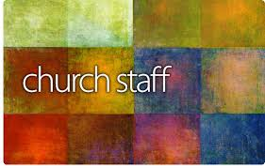


ATTENTION ALL SESSION MEMBERS, DEACONS, AND TEAM LEADERS:

Please be sure to check your mail slots in the metal cabinet at the top of the stairs often. You may receive correspondence or announcements that need your attention in a timely manner!

Pastor:

Reverend Brian Kilbert

Administrative Secretary:
Kelly Kapelewski

Bookkeeper:
Debra Artman

Choir Director:
Lorraine Menk

Music Ministry Specialist:
Jesse Oddis

Housekeeper:
Irene Nelson

Financial Secretary:
Judy West

05: Helen Crissman & Marilyn Crumley
12: Janet Karan & Jolene Kostelansky
19: Chuck & Judy West
26: Jolene Kostelansky & Sophia Earhart
or Matt Wehrle

PRAYER REQUESTS!
If you are not on our prayer chain, please consider signing up for it. It only takes a minute to lift someone who may need your prayers! Call or email the office. We have an email prayer chain as well as a phone call prayer chain.


For those of you that don’t know, we have a lost and found box in the library. There are MANY items in this box. Including a set of keys, beautiful leather bound devotionals and glasses! Check it out if you are missing something.




1 De’Var Lakshmanan
3 Beth Hilbeck
4 Ryan Bargerstock
April Oddis
5 Nita Lundie
Terry Soulcheck
10 Rachel Aungst
Sandy Schafer
12 Joel McCullough
Kwade Kirchartz
16 Doug Marshall
17 Jeff Burtner
18 Mersades Schafer
20 Melissa Sisco
30 Lillian Blandford

The Bible readings are from “Book of Common Worship”

Week of:

October 5:
Lam 1:1-6
Psalm 137
Hab 1:1-4;2:1-4
2 Tim 1:1-14
Luke 17:5-10

October 12:
Jer 29 :1,4-7
Psalm 66 :1-12
2Kings 5 :1-3,7-15c
2 Tim 2 :8-15
Luke 17 :11-19

October 19:
Jer 31:27-34
Psalm 119:97-104
Gen 32:22-31
2Tim 3:14-4:5
Luke 18:1-8

October 26:
Joel 2:23-32
Psalm 65
Jer 14:7-10,19-22
2 Tim 4:6-8,16-18
Luk3 18:9-14



Please consider joining any of our Ministry
Teams here at Puckety Church!
Outreach – Matt Wehrle
Discipleship – Chari Burtner
Praise Team (Band) – Jesse Oddis
Choir – Lorraine Menk
Fellowship and Care – Charlene McKay
Worship – Jennifer McKay
Upkeep – Vince Appleman
AV Team – Wiebke Kilbert
Youth Group Volunteers – Pastor Brian Kilbert
Pulpit Assistants – Kelly Kapelewski

Sunday Women's Bible Study:
We will be meeting on Sunday October 5th and
Sunday October 19th to continue our discussion
on the Solas. Please bring your lunch and questions to discuss.



You see them for a few minutes each Sunday during the Children's Message, but that is just a brief look at the wonderful kids that we have here at Puckety! If you would like to get to know them better and have some fun with the children of our church, please consider signing up to take turns as a teacher or helper for Children’s Church. Our time with the kids is spent doing a lesson or story from the Bible along with crafts or games that help to reinforce the point learned in the lesson. Since we have grown so much, we would like to have a few helpers so we could have 2 adults in each class! If this sounds like something that you would be interested in, please call or text: Brenda McAllister 724-331-6462 or Jolene Kostelansky 724-882-0804.


DONATIONS CURRENTLY BEING ACCEPTED BY ORIGINS:
All items need to be NEW AND UNOPENED!
"Determined to be the heart, voice, and hands of God making a difference in our Community"
Looking for a way to give back to the community? Our one night a month commitment to Origins is a perfect way to give back and support the most vulnerable in our community. We gather at Origins at 5 PM on the second Tuesday of the month and work together as a team to accomplish a task set by the organization. The task is usually sorting baby clothes by size, gender and season. Our work helps to make the bins of donations easy for the families to access and find what they are needing for their young family. Working as a team also allows us to get to know our fellow church members outside of the pews! The hardest part of the evening is remembering to bring your reading glasses for those small tags! Please consider signing up on the big bulletin board and joining us. Rides can be arranged if you don't like to drive at night but want to join us. Please see Wiebke with any questions or call
(724-799-3323)

- Diapers
- Pull-Ups/Training Pants
- Baby Wipes
- Baby Soaps
- Baby Shampoos
- Baby Lotions
- Diaper Rash Ointment
- Formula
- Baby Food
- Toddler Food
- Pedialyte
- Baby and Kids Hygiene Items
- Feminine Hygiene Products
- Breastfeeding Supplies
- Sensitive/Baby Friendly Laundry Detergent

There are many more details about the items listed above on the coat rack in the ramp hallway! Please take a moment to read the list and jot down what you might like to donate so when you shop, you know just what to look for !
Remember you can donate those over the counter no cost Medicare items that you may not need if they are on the list!
If you are not on Medicare, Origins would greatly appreciate any donations of the specific items requested.

Puckety Church is looking for a new “Decorating Director”. This is a volunteer position. You would oversee the seasonal decorating of the Sanctuary and other areas of the church. Please let Jennifer McKay know if you are interested.

Wednesday evening small group (Chosen: The Last Supper) facilitated by Pastor Brian. We usually meet in conference rooms Wed. evenings (6:30-8:00) through mid-November for study and discussion. Episodes can be seen on Amazon Prime or church DVD. All are welcome. Want details, call 724-678-6976.


BONFIRE & BOOS:

A TRUNK OR TREAT EVENT

October 18th 5:00-7:00pm

Puckety Presbyterian Church

1009 Puckety Church Rd Lower Burrell PA

FREE COMMUNITY EVENT

ALL ARE WELCOME!!

Hot dogs, hot chocolate, popcorn, roast your own marshmallows, games with prizes, crafts and

TRUNK OR TREAT!!

(costumes are welcome but not necessary)

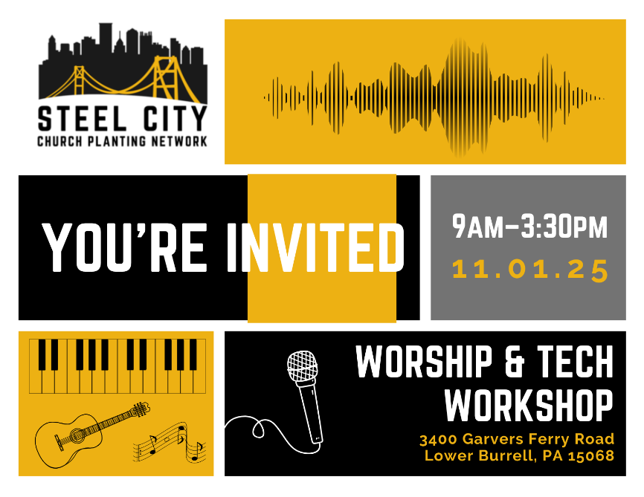
Calling all worship, AV team, and interested members!
Join us for a conference on Saturday, Nov. 1st at Redemption Church – Meals 4 Children partner church - at 3400 Garvers Ferry Rd./ Lower Burrell, PA. There will be interactive breakout sessions, a chance for fellowship, and more!
The cost is $15 per participant, but Puckety will pay your registration if you sign up by Oct. 12th (see Pastor Brian or call the office) and commit to attend half (3 hours) of the conference (first half 9am to Noon is the Worship team focus and the 2nd half from Noon to 3:00 is the Tech Team focus) – see below for some options.
9:15 - 10:15 Main Session – Biblical Worship vs. Cultural Performance
10:30 – 11:30: Breakout Sessions (options)
1. Healthy Teams - A Better Way
What are the foundations for a healthy team? What are the better practices?
2. Sound Basics
Crafting a setlist, flow of service, rehearsal, team management etc.
11:30-12:30: Lunch - Provided
12:30-1:30: Breakout Sessions (Options)
1. Aligning Tech and Worship
Service teams that are unified on their vision and purpose will provide the most worshipful experience for their church. Tech/Worship will be successful when they look beyond the product and prioritize the King and His people.
2. Livestream Basics
Livestreaming basics to start an online presence.
3. Importance of Theology in Song Selection
We will dive into the importance of theology and biblical soundness in the songs we present to our congregation, as well as discuss the harm in the lack of scriptural depth.
1:45-3:00 – Main Ending Session – True Worship Produces Transformation (Matt Cooper, Harvest Church Kittanning)
3:05-3:30- Q&A
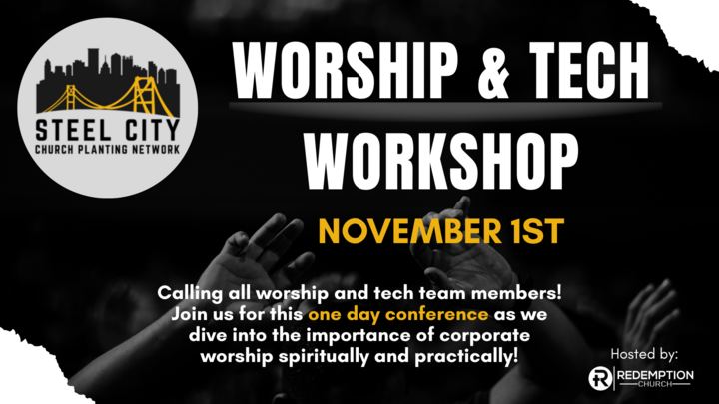

Attic Update
Puckety is a very generous congregation, including donating decorations and items that "maybe" the church can use. This generosity caused a very full and cluttered attic which made it hard to find items and created dangerous tripping hazards. In September a small crew got together to sort through, organize and label the Christmas decorations that are used around the church buildings. They started in the cool of the morning and ended just after noon. There is still more work to be done in the other parts of the attic to make the area safer and easier to find what someone is looking for. As you find an item at home that you think the church may be able to use, please call and ask first before bringing it to the church or putting it up in the attic. Even small items like serving trays or decorations add up and becomes hard to find a safe place to store them. Please know that Puckety is very grateful for your support and generosity. The office can help figure out which committee your item may best suit and get you in contact with the right person to decide if the item can really be used by the church.

YOUTH GROUP: We had a solid start with a great kickoff on September 14th – with lots of water games as summer came to a close (water balloon “tennis” with sheets at the courts, water balloon hot potato, and carrying a “Superman” on your team to transfer water in a relay – a video is worth 1,000 pictures, so check out the church’s Facebook page). We added two brand new students the following week. We have a fall outing planned to the Renshaw Farms Pumpkin Fest on Sun. October 12th – leaving from the church at 2:00 PM and back around 6:00 PM. The church is paying half the admission cost of any 6th-12th grade student who attends at least one regular meeting before then, but the remainder of admission is due to Pastor Brian by October 5th to confirm your spot. More fun is on the horizon so please spread the word that all students 6th to 12th grade are welcome to join us Sundays 6-8pm – please sign up for text alerts for changes to times & activities – 724-678-6976
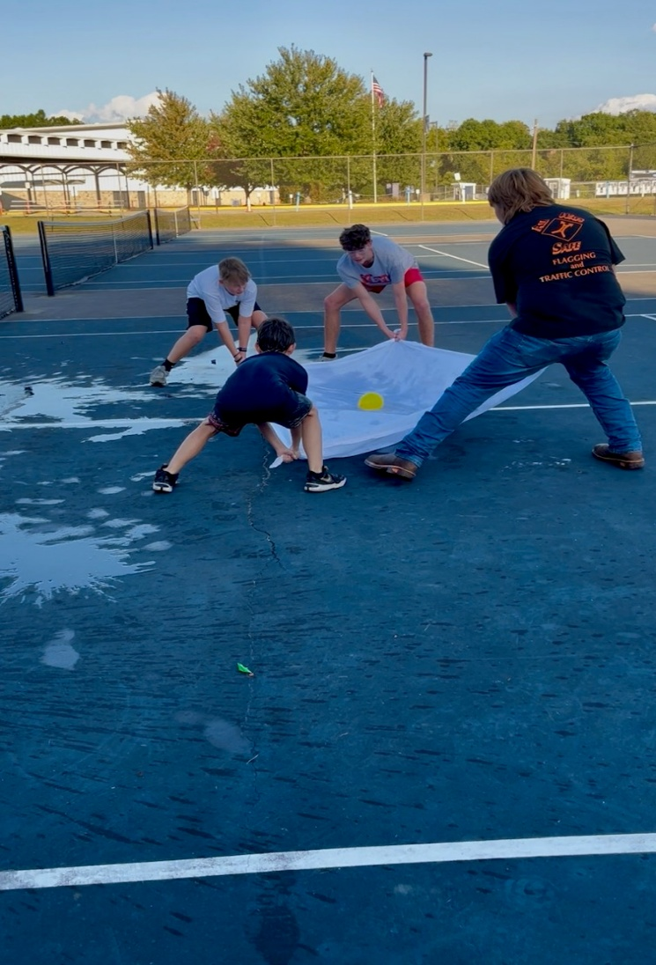
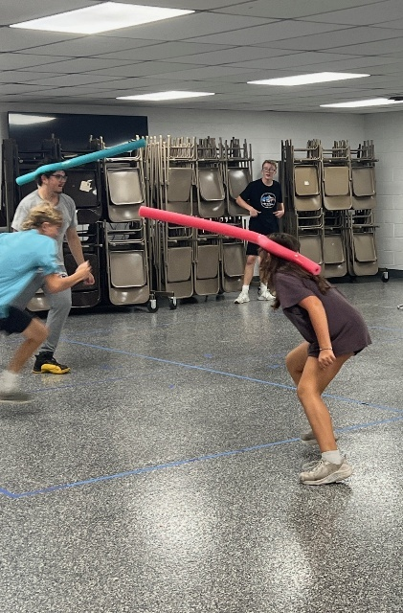
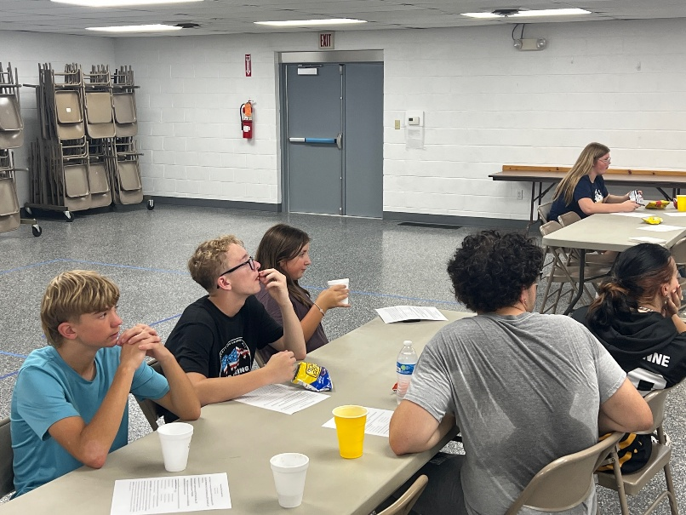
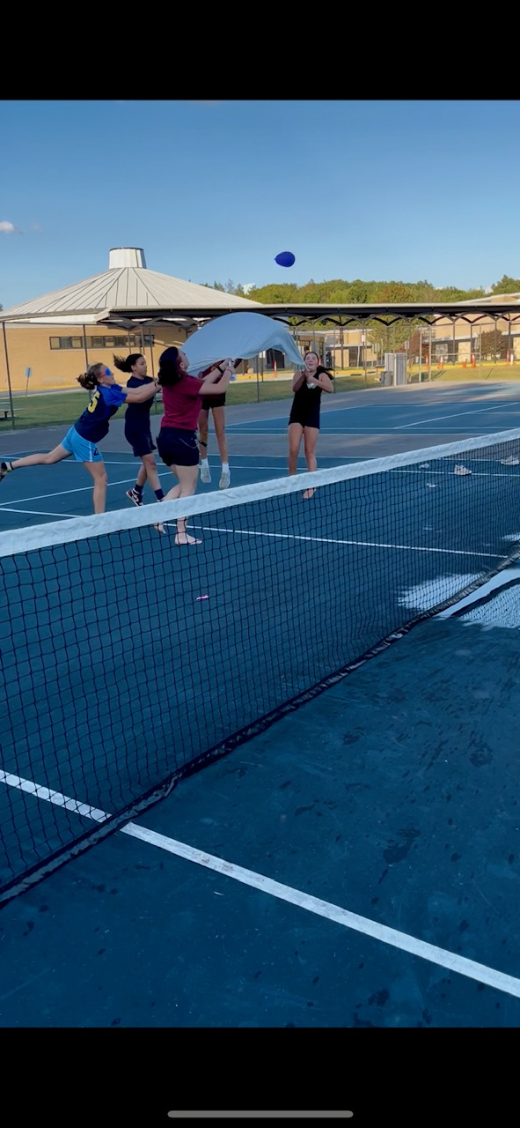
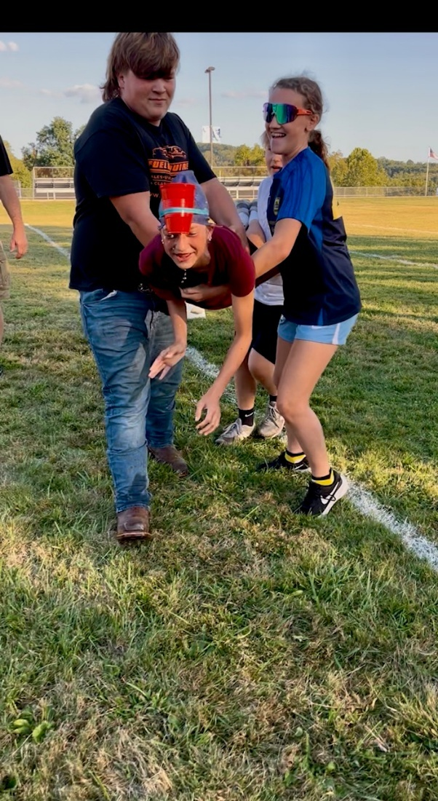
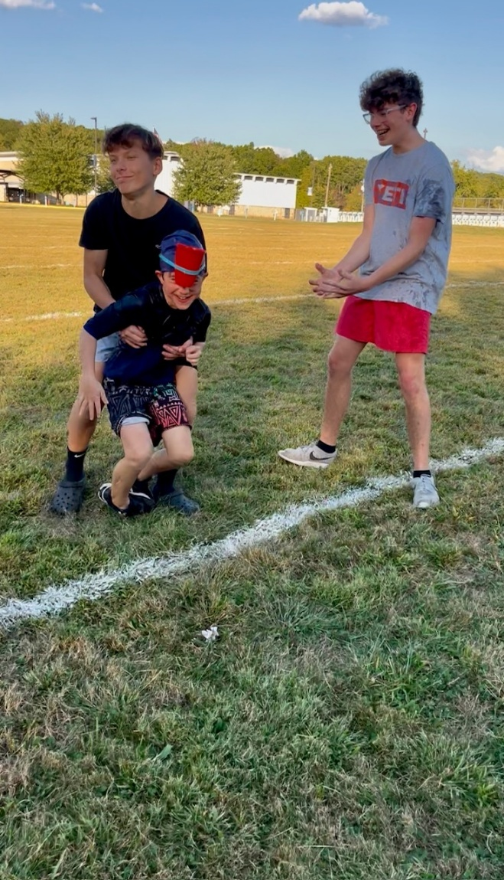

AV Team Opportunity Invitation: Looking for a ministry to plug into once a month? Do you like being behind the scenes? We have a space for you on our AV Team. Specifically we are looking for a few more volunteers to run the sound board. We provide all training and equipment. Please reach out to Pastor Brian or Wiebke Kilbert if you are interested. If you aren't sure we would welcome you to come back and observe the team in action.

Date | Presentation Creation | Presenter | Sound | Zoom host
10/5/25 | Matt | Matt | Nate | Wiebke
10/12/25 | Jenn | Joyce | Rodney | Beth
10/19/25 | Brian | Joyce | Zach | Wiebke
10/26/25 | Denise | Joyce | Nate | Wiebke
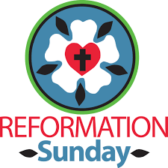
Reformation Sunday - October 26th - wear your tartan, kilt, Martin Luther t-shirt, John Calvin earrings, or any other item that speaks to our Reformed heritage)


Bonfire & "Boo's": A Trunk or Treat Event
Have you noticed how many Trunk or Treat events there are in our community? Since our first Trunk or Treat, each year we have noticed additional events being advertised for the same dates. To help us be a bit different we decided to smoosh our annual bonfire and Trunk or Treat together into one event like a perfectly toasted S'more! Join us on October 18th from 5-7 pm for our Bonfire and Boo's, We will be passing out candy from our car trunks, have games and crafts for the kids and a fire so they can roast a marshmallow and have a tasty hot dog. After 7 pm we will move from our cars to the fire and break out the chocolate and the graham crackers for the traditional church bonfire!

To make this event excellent for the community we need as much help as possible. We need adults to bring their cars and hand out candy. We need volunteers to run the easy games and crafts. We need watchful eyes around the fires to ensure that safety is a priority for everyone at our event. We especially need your help in getting the word out to your friends and families with little ones that would enjoy this family friendly FREE event. Word of mouth is still the best by far. There are flyers available for you to take and pass on. Please see Wiebke or Kelly if you have questions. There are sign-up sheets in the hallway for the cars and the other spots where we need help.


Puckety Church is hosting another free community event!
Monday October 27th from 7:00 to 8:00 PM

Today’s homes present numerous safety challenges!
Join us in the Church Sanctuary to hear from guest speaker Brady Heinlein
He will address the surprising need for fire awareness, along with tips and resources to make our homes safer!
All are welcome. Please RSVP so we can have sufficient materials for all attendees: 724-339-1323, message Puckety’s Facebook page, or email kelly@pucketychurch.org
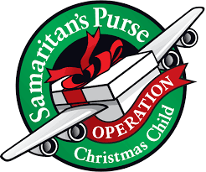
Operation Christmas Child - What is Operation Christmas Child?

The Samaritan's Purse project Operation Christmas Child collects shoebox gifts filled with fun toys, school supplies and hygiene items—and delivers them to children in need around the world to demonstrate God’s love in a tangible way. For many of these children, the gift-filled shoebox is the first gift they have ever received. Children receiving the shoebox are enrolled in 12-lesson discipleship program and given a booklet titled “The Greatest Journey” that will teach them how to follow Christ.


This year, Puckety Church will once again be sponsoring Operation Christmas Child. Starting October 19, 2025, through November 16, 2025, shoeboxes will be at all entrances to the sanctuary. Instructions on how to pack the shoebox and an age category label are included. Please bring your shoebox to Puckety Church by Sunday November 16, 2025.

Shipping cost is $10.00 and ways to pay for shipping are included in the pamphlet.
Shoeboxes will be delivered to the collection site at Grace Community Church starting Monday, November 17, 2025
~~~~~~~~~~~~~~~~~~~~~~~~~~~~~~~~~~~~~~~~~~~~~~~~~~~~~~~~~~~~~~~~~~~~~~~~~~~~~~~~
Samaritan’s Purse – 2025
This year Puckety Church is participating through Samaritan’s Purse to pursue reaching out internationally to provide the gift of hope to victims of war, disaster, poverty, and famine. This organization offers training, education, and humanitarian aid, as well as working with local churches and ministry partners for the purpose of teaching the gospel of Jesus Christ. This year, three categories are being presented to you, the congregation, to prayerfully consider a Samaritan’s Purse gift donation to any of the categories listed below. Please read the descriptions.

- Bring Clean Water to a Community – A Clean Water Project
To disaster-stricken areas – an emergency response – to provide clean water, sanitation such as latrines, and deliver water tanks.

To work with communities facing water scarcity, contaminated water.
Digging wells, installing filtering systems, training to maintain and repair the water system,
teach health and hygiene education, proper food handling and waste disposal.
Spiritual outreach and support.

- Help a Poor Farming Family – A Farm and Garden Project
Drought, infestation, and disaster can ruin a harvest. Samaritan’s Purse will provide seeds, tools, fertilizer, drought resistant plants.
Teaching and training – to diversify crops, provide knowledge and valuable resources to grow their own food, develop sustainable gardening practices in a climate changing world.
Building a greenhouse, teach and train to find a source of water.
Spiritual Outreach and support.

- Send a New Missionary Doctor – New Missionary Doctor Project
There is a desperate need for medical expertise in the developing world and remote hospitals. Doctors who have chosen to become missionary doctors enroll in a 2-year training course called Post-Residency Program. This is a fully funded program where doctors work alongside veteran missionary doctors to develop skills needed to practice medicine in developing countries overseas.

Process includes – Application and selection Training and preparation
Doctor and family serve in the mission field Option to enroll in another assignment

Please make your check to: Puckety Presbyterian Church
Attention: Deacons – Samaritan’s Purse
Same for cash – Attention: Deacons – Samaritan’s Purse

Sunday | Monday | Tuesday | Wednesday | Thursday | Friday | Saturday
28  Youth Group Pickleball Outing  10:00am Worship  11:30am Ladies Lunch | 29  Meals on Wheels  10:00am Men's Group  10:30am Card Ministry  12:00pm AA Meeting | 30  6:30pm Girl Scout Troop 20130  8:00pm N.A. meeting | 1  Meals on Wheels  1:00pm Move It!  6:00pm Deacons Meeting  6:30pm Girl Scout Troop 52527  6:30pm Pastor Brian Small Group | 2  Apple Dumpling Prep  1:00pm Meals 4 Children Food Packing  6:00pm Praise Band Rehearsal  7:00pm Choir Rehearsal | 3  Apple Dumpling Prep  Meals on Wheels  OFFICE CLOSED | 4  8:00am Apple Dumpling Prep  3:00pm Apple Dumpling Pick Up
5  10:00am Worship  11:30am Women's Bible Study  3:00pm Apple Dumpling Pick Up  6:00pm Youth Group   | 6  Meals on Wheels  10:00am Men's Group  12:00pm AA Meeting  6:00pm Schafer Small Group  6:00pm Upkeep Team Meeting | 7  5:30pm Girl Scout Troop 46799  6:00pm Girl Scout Troop 20130  6:30pm Outreach Team Meeting  8:00pm N.A. meeting | 8  Meals on Wheels  1:00pm Move It!  6:30pm Pastor Brian Small Group | 9  6:00pm Praise Band Rehearsal  7:00pm Choir Rehearsal | 10  Meals on Wheels  OFFICE CLOSED | 11  Bracken Birthday Party???
12  Youth Group Meeting or Outing  10:00am Worship | 13   Meals on Wheels  10:00am Men's Group  12:00pm AA Meeting  4:30pm Discipleship Team Meeting  5:30pm MS Group Meeting  7:00pm Seneca Service Unit Leader Meeting | 14  5:00pm Origins Outreach  6:00pm Girl Scout Troop 20834  6:00pm Session Meeting  8:00pm N.A. meeting | 15  Meals on Wheels  1:00pm Move It!  6:30pm Girl Scout Troop 52527  6:30pm Pastor Brian Small Group | 16  1:00pm Meals 4 Children Food Packing  6:00pm Praise Band Rehearsal  7:00pm Choir Rehearsal | 17  Meals on Wheels  OFFICE CLOSED |   18  
19  10:00am Worship  11:00am Prayer Walking  11:30am Women's Bible Study  6:00pm Youth Group | 20  Meals on Wheels  10:00am Men's Group  12:00pm AA Meeting  6:00pm Schafer Small Group | 21  5:30pm Girl Scout Troop 46799  6:00pm Girl Scout Troop 20130  6:00pm Worship Team Meeting  8:00pm N.A. meeting | 22  Meals on Wheels  1:00pm Move It!  6:30pm Pastor Brian Small Group | 23  6:00pm Praise Band Rehearsal  7:00pm Choir Rehearsal | 24  Meals on Wheels  OFFICE CLOSED  12:00pm Menk Scrapbooking Event | 25  9:00am Menk Scrapbooking Event
  26  10:00am Worship  11:30am Ladies Lunch  6:00pm Youth Group Halloween Party | 27  Meals on Wheels  10:00am Men's Group  10:30am Card Ministry  12:00pm AA Meeting  7:00pm 412 Fire Safety Presentation | 28  6:00pm Girl Scout Troop 20834  8:00pm N.A. meeting | 29  Meals on Wheels  1:00pm Move It!  6:30pm Pastor Brian Small Group | 30  6:00pm Praise Band Rehearsal  7:00pm Choir Rehearsal | 31  Meals on Wheels  OFFICE CLOSED   | 1

