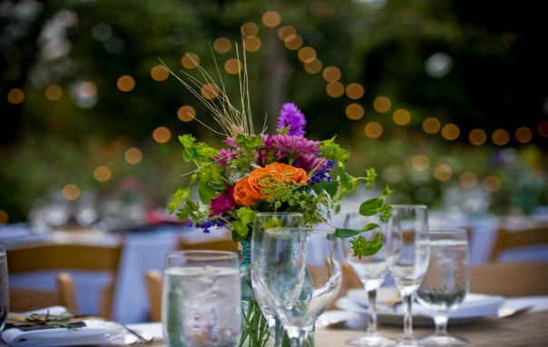

CONGRATULATIONS! YOU’RE GETTING MARRIED!

Name of Bride ______________________________________________________________________

Name of Groom _____________________________________________________________________

Wedding Date ___________________________Time of day________________________________

Ceremony Venue Address___________________________________________________________

Venue Contact person_______________________________________________________________

Reception Venue Address (if different from Ceremony)________________________________

Is their space available at your venue for flower preparation and storage?_____________

Will this space be available the day before as well as the day of your wedding?________

List the approximate number attending the wedding__________________________________

Are you interested in having your friends and bridesmaids help prepare your flowers? _______________. If so, how many helpers will you have?______________________________

Describe the overall wedding style

_______________________________________________________________________________________________________________________________________________________________________________________________________________________________________________________________

Wedding colors_____________________________________________________________________

Bridesmaid dress color_____________________________________________________________

Your style preference-circle or highlight any that apply:

Old fashioned lush or romantic whimsical country simplistic minimalist monochrome limited palette bold colors delicate pastels tightly arranged loosely arranged big flowers small flowers textural I have NO IDEA

List any flowers you do NOT wish to include__________________________________________

_____________________________________________________________________________________

List any flowers you definitely want to include________________________________________

_____________________________________________________________________________________

_____________________________________________________________________________________

Total number of Corsages (moms, grandmothers, helpers)__________________________

Total number of Boutonnieres (dads, grandfathers, groomsmen, ushers)____________

Total number of Bouquets (including the bride)_____________________________________

Bouquet to toss­­­­__________________

Locations for Flowers (indicate number for each):

Tables for dinner____________Tables for cocktails________________________

Bar_________________Bathrooms__________Cake table____________________

Large Arrangements at ceremony_________________Trellis or focal point at ceremony________Chairs or pews___________ Special designations for family seating at ceremony_____________________________________________________

Containers for Arrangements:

Do you have your own? _______________________________________________________________

List any containers you will need to rent from me ___________________________________________________________________________________________________________________________________________________________________________________________________________________________________________________________

_______________________________________________________________________________

Be sure to develop a plan for clean up after the wedding. I will deliver the flowers as arranged (to the venue) but what happens after that is up to you and your helpers. If you have rented any of my containers, you will be responsible for getting them back to me within five days of the event.

List contact person who will return the containers:

Jeanne Domenech 703-909-4717

604 E. Alexandria Ave, Alexandria VA 22301