**St. Luke’s Episcopal Church**

**The Second Sunday of Lent**

**28 February 2021  10:00 A.M.**

**Holy Eucharist**

The Reverend Allison Caudill, *Celebrant*

The Reverend Lisa Tolliver, *Preacher*

**THE WORD OF GOD**

**Prelude “When we are in the utmost need” J. S. Bach**

**[ CONTINUE TO NEXT PAGE ]**

**Processional Hymn “How firm a foundation” Hymnal, 636**

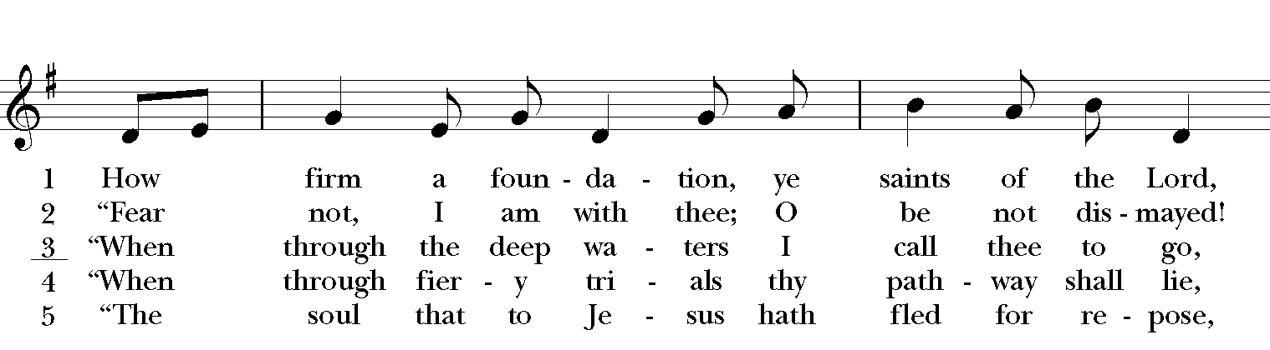

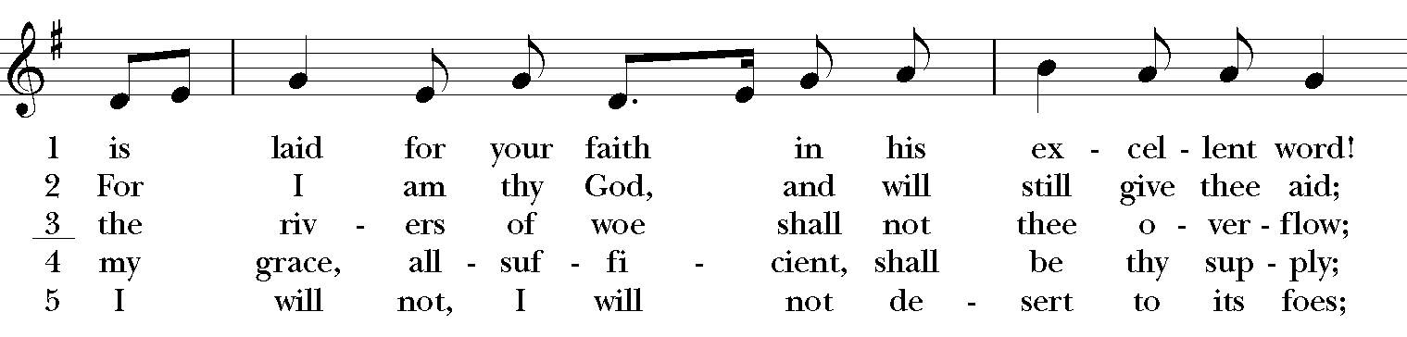

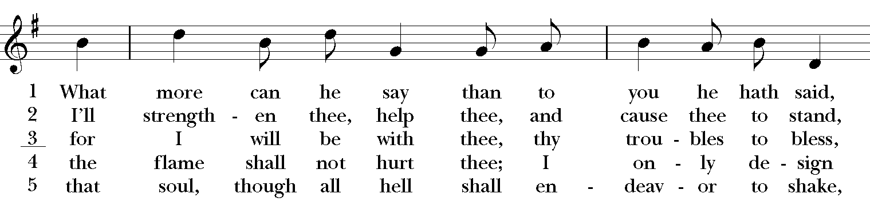

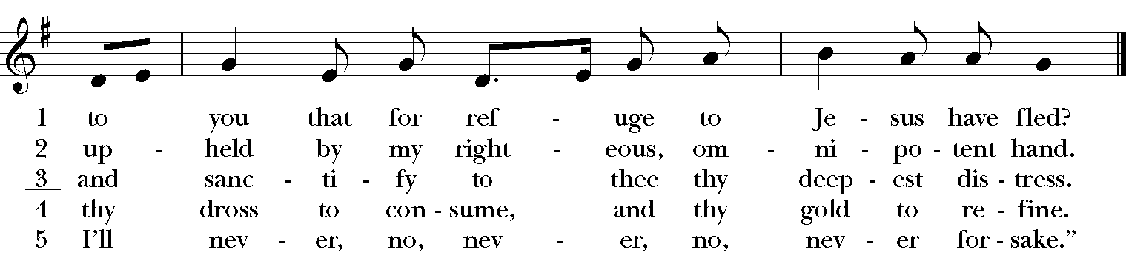

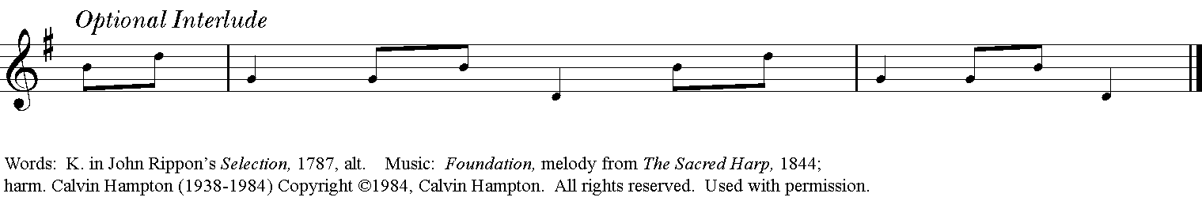

**The Opening Acclamation Page 355**

**Celebrant** Bless the Lord who forgives all our sins.

**People His mercy endures for ever.**

**The Collect of Purity Page 355**

**Kyrie: S 86**

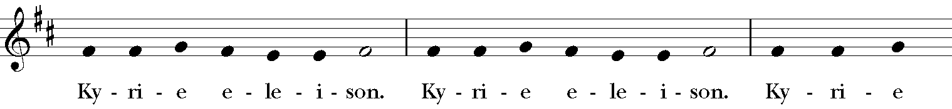

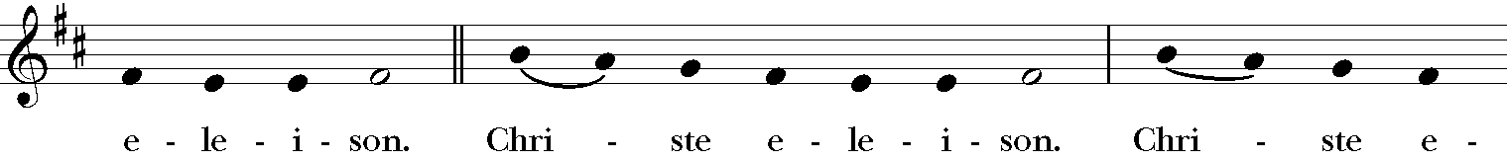

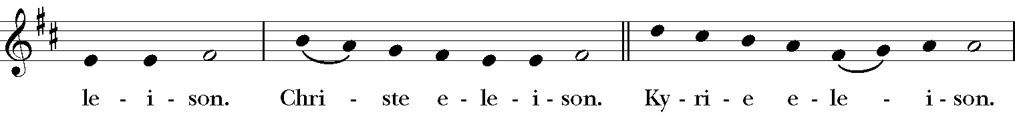

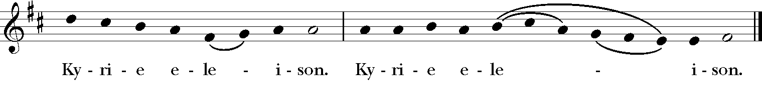

**The Salutation & Collect of the Day Page 357**

***Celebrant*** The Lord be with you.

***People* And also with you.**

***Celebrant*** Let us pray.

O God, whose glory it is always to have mercy: Be gracious to all who have gone astray from your ways, and bring them again with penitent hearts and steadfast faith to embrace and hold fast the unchangeable truth of your Word, Jesus Christ your Son; who with you and the Holy Spirit lives and reigns, one God, for ever and ever. ***Amen.***

**The First Lesson Genesis 17:1-7, 15-16**

When Abram was ninety-nine years old, the LORD appeared to Abram, and said to him, "I am God Almighty; walk before me, and be blameless. And I will make my covenant between me and you, and will make you exceedingly numerous." Then Abram fell on his face; and God said to him, "As for me, this is my covenant with you: You shall be the ancestor of a multitude of nations. No longer shall your name be Abram, but your name shall be Abraham; for I have made you the ancestor of a multitude of nations. I will make you exceedingly fruitful; and I will make nations of you, and kings shall come from you. I will establish my covenant between me and you, and your offspring after you throughout their generations, for an everlasting covenant, to be God to you and to your offspring after you. God said to Abraham, "As for Sarai your wife, you shall not call her Sarai, but Sarah shall be her name. I will bless her, and moreover I will give you a son by her. I will bless her, and she shall give rise to nations; kings of peoples shall come from her."

The Word of the Lord.

***People* Thanks be to God.**

**Psalm 22:22-30 Plainsong**

22 Praise the LORD, you that fear him;  *  
      stand in awe of him, O offspring of Israel; all you of Jacob's line, give glory.

23 For he does not despise nor abhor the poor in their poverty; neither does he hide

his face from them;  *  
      but when they cry to him he hears them.

24 My praise is of him in the great assembly;  *  
      I will perform my vows in the presence of those who worship him.

25 The poor shall eat and be satisfied, and those who seek the LORD shall praise him:  *  
      "May your heart live for ever!"

26 All the ends of the earth shall remember and turn to the LORD,  *  
      and all the families of the nations bow before him.

27 For kingship belongs to the LORD;  *  
      he rules over the nations.

28 To him alone all who sleep in the earth bow down in worship;  *  
      all who go down to the dust fall before him.

29 My soul shall live for him; my descendants shall serve him;  *  
      they shall be known as the LORD'S for ever.

30 They shall come and make known to a people yet unborn  *  
      the saving deeds that he has done.

**The Second Lesson Romans 4:13-25**

For the promise that he would inherit the world did not come to Abraham or to his descendants through the law but through the righteousness of faith. If it is the adherents of the law who are to be the heirs, faith is null and the promise is void. For the law brings wrath; but where there is no law, neither is there violation. For this reason it depends on faith, in order that the promise may rest on grace and be guaranteed to all his descendants, not only to the adherents of the law but also to those who share the faith of Abraham (for he is the father of all of us, as it is written, "I have made you the father of many nations") --in the presence of the God in whom he believed, who gives life to the dead and calls into existence the things that do not exist. Hoping against hope, he believed that he would become "the father of many nations," according to what was said, "So numerous shall your descendants be." He did not weaken in faith when he considered his own body, which was already as good as dead (for he was about a hundred years old), or when he considered the barrenness of Sarah's womb. No distrust made him waver concerning the promise of God, but he grew strong in his faith as he gave glory to God, being fully convinced that God was able to do what he had promised. Therefore his faith "was reckoned to him as righteousness." Now the words, "it was reckoned to him," were written not for his sake alone, but for ours also. It will be reckoned to us who believe in him who raised Jesus our Lord from the dead, who was handed over to death for our trespasses and was raised for our justification.

The Word of the Lord.

***People* Thanks be to God.**

**[ CONTINUE TO NEXT PAGE ]**

**The Sequence “Now let us all with one accord” Hymnal, 147**

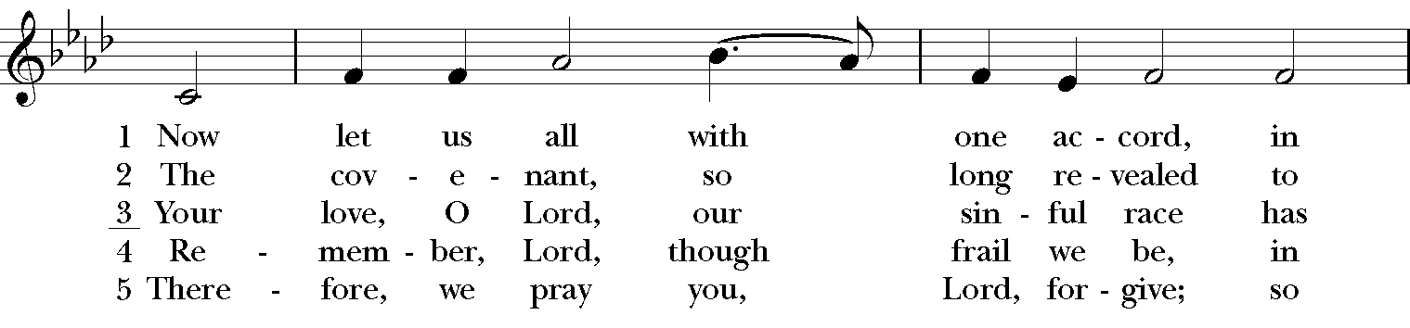

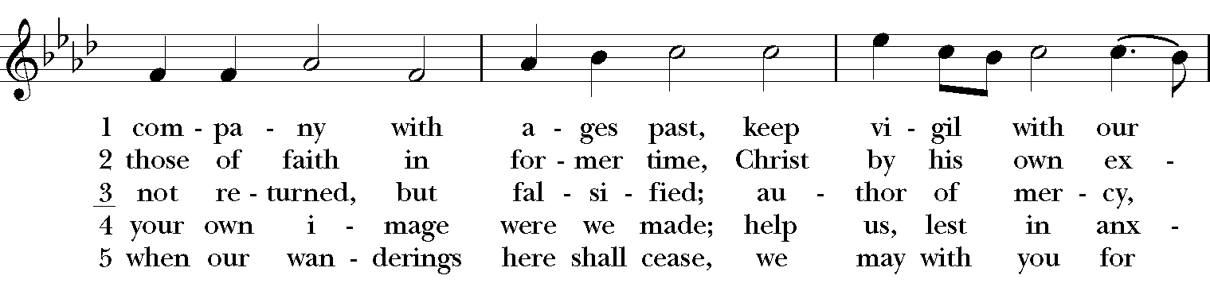

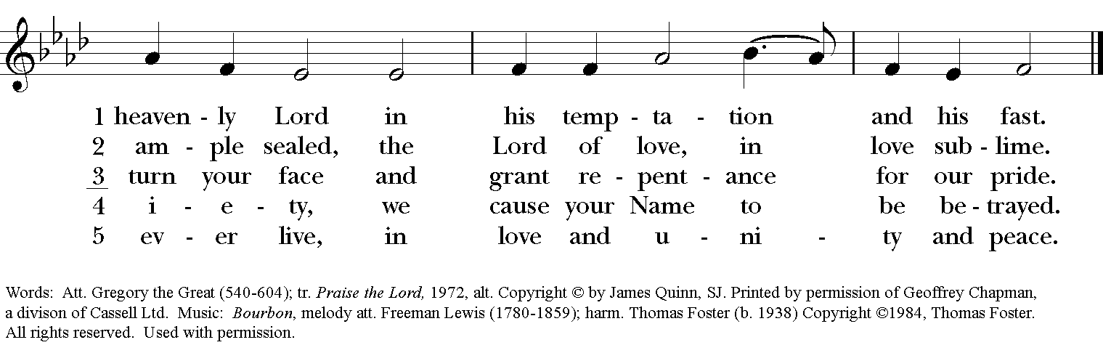

**The Holy Gospel Mark 8:31-38**

***The people remain standing. The Celebrant says***

The Holy Gospel of our Lord Jesus Christ according to Mark.

***People* Glory to you, Lord Christ.**

Then he began to teach them that the Son of Man must undergo great suffering, and be rejected by the elders, the chief priests, and the scribes, and be killed, and after three days rise again. He said all this quite openly. And Peter took him aside and began to rebuke him. But turning and looking at his disciples, he rebuked Peter and said, "Get behind me, Satan! For you are setting your mind not on divine things but on human things." He called the crowd with his disciples, and said to them, "If any want to become my followers, let them deny themselves and take up their cross and follow me. For those who want to save their life will lose it, and those who lose their life for my sake, and for the sake of the gospel, will save it. For what will it profit them to gain the whole world and forfeit their life? Indeed, what can they give in return for their life? Those who are ashamed of me and of my words in this adulterous and sinful generation, of them the Son of Man will also be ashamed when he comes in the glory of his Father with the holy angels."

***After the reading, the Celebrant says***

The Gospel of the Lord.

***People* Praise to you, Lord Christ.**

**The Sermon**

**The Nicene Creed**

*Said by all, standing*

**We believe in one God, the Father, the Almighty, maker of heaven and earth, of all that is, seen and unseen.**

**We believe in one Lord, Jesus Christ, the only Son of God, eternally begotten of the Father, God from God, Light from Light, true God from true God, begotten, not made, of one Being with the Father. Through him all things were made. For us and for our salvation he came down from heaven: by the power of the Holy Spirit he became Incarnate from the Virgin Mary, and was made man. For our sake he was crucified under Pontius Pilate; he suffered death and was buried. On the third day he rose again in accordance with the Scriptures; He ascended into heaven and is seated at the right hand of the Father. He will come again in glory to judge the living and the dead, and his kingdom will have no end.**

**We believe in the Holy Spirit, the Lord, the giver of life, who proceeds from the Father and the Son. With the Father and the Son he is worshiped and glorified. He has spoken through the Prophets. We believe in one holy catholic and apostolic Church. We acknowledge one baptism for the forgiveness of sins. We look for the resurrection of the dead, and the life of the world to come. Amen.**

**Prayers of the People, Form V Page 389**

*Deacon or other leader*

In peace, let us pray to the Lord, saying, “Lord, have mercy”

For the holy Church of God, that it may be filled with truth and love, and be found without fault at the day of your coming, we pray to you, O Lord.

*Here and after every petition the People respond*

***Lord, have mercy****.*

For *Justin*, the Archbishop of Canterbury, For *Michael,* our Presiding Bishop, for *Terry,* our own Bishop, for all bishops, for ***Michael, Allison, Anne, Art, and Jim****,* and other clergy, and for all the holy people of God, we pray to you, O Lord.

For all who fear God and believe in you, Lord Christ, that our divisions may cease, and that all may be one as you and the Father are one, we pray to you, O Lord.

For the mission of the Church, that in faithful witness it may preach the Gospel to the ends of the earth, we pray to you, O Lord.

For those who do not yet believe, and for those who have lost their faith, that they may receive the light of the Gospel, we pray to you, O Lord.

For the peace of the world, that a spirit of respect and forbearance may grow among nations and peoples, we pray to you, O Lord.

For those in positions of public trust especially Joe our President, Andy our Governor, and Neil & Greg our Mayors, that they may serve justice, and promote the dignity and freedom of every person, we pray to you, O Lord.

For all who live and work in this community, we pray to you, O Lord.

For a blessing upon all human labor, and for the right use of the riches of creation, that the world may be freed from poverty, famine, and disaster, we pray to you, O Lord.

For the poor, the persecuted, the sick, and all who suffer; for refugees, prisoners, and all who are in danger; that they may be relieved and protected, we pray to you, O Lord.

For this *congregation,* for those who are present, and for those who are absent, that we may be delivered from hardness of heart, and show forth your glory in all that we do, we pray to you, O Lord.

For our enemies and those who wish us harm; and for all whom we have injured or offended, we pray to you, O Lord.

For all who have commended themselves to our prayers; for our families, friends, and neighbors; that being freed from anxiety, they may live in joy, peace, and health, we pray to you, O Lord.

For **Al, Allen, Amanda, Amy, Ann, Annie, Beecher, Bethann, Beverly, Bill, Braxton, Bud, Calvin Riley, Carol, Charles, Christy, Danny, Dave, David, Diana, Doug, E.J., Eleanor, Elizabeth, Erma, Gene, Hugh, Ira, Jackie, Jen, Jenni, Jerry, Jewell, Jim, Joan, Joe, John, Joyce, Karen, Kelly, Ken, Laura, Lauren, Lee, Linda, Lisette, Liz, London, Lynn, Martha, Marty, Mary, Matt, Meg, Mike, Milo, Monica, Morgan, Nancy, Nina (Nine-ah), Patricia, Rob, Ronald, Rueben, Sandy, Sherrie, Stefanie, Steve, Sue, Susan, Susie, Terry, Tim, Tracy, Trent, Ursula, Vicki, Walt, Whitney, Wynn; for the men and women of our armed forces, especially Alex, Bianca, Casey, Christian, Griffin, Pat, Seth, Sinclair, Steve***,* we pray to you, O Lord.

For all who have died in the communion of your Church, **especially Louise Gensimore Toebbe, Joe Bush**, and those whose faith is known to you alone, that, with all the saints, they may have rest in that place where there is no pain or grief, but life eternal, we pray to you, O Lord.

Rejoicing in the fellowship of the ever‑blessed Virgin Mary, (*blessed Luke*) and all the saints, let us commend ourselves, and one another, and all our life to Christ our God.

*To you, O Lord our God.*

*Silence*

*The Celebrant adds a concluding Collect, or the following Doxology*

For yours is the majesty, O Father, Son, and Holy Spirit; yours is the kingdom and the power and the glory, now and for ever. *Amen.*

**Confession of Sin Page 360**

Celebrant Let us confess our sins against God and our neighbor.

**All Most merciful God, we confess that we have sinned against you in thought, word, and deed, by what we have done, and by what we have left undone. We have not loved you with our whole heart; we have not loved our neighbors as ourselves. We are truly sorry and we humbly repent. For the sake of your Son Jesus Christ, have mercy on us and forgive us; that we may delight in your will, and walk in your ways, to the glory of your Name. Amen.**

**The Absolution**

**The Peace**

***Celebrant*** The peace of the Lord be always with you.

***People* And also with you.**

**THE HOLY COMMUNION**

**Offertory Anthem “An earthly tree a heavenly fruit” William Byrd**

An earthly tree a heavenly fruit it bare.

A case of clay contained a crown immortal,

A crown of crowns, a King, whose cost and care

Whose race before was thrall

To death, to doom, to pains of everlasting.

By His sweet death, scorn, stripes and often fasting.

A Star above the stars, a Sun of light,

Whose blessed beams this wretched earth bespread

With hope of heaven, and of God’s Son the sight

And sinful soul lay dead.

O faith, O hope, O joys renowned forever!

O lively life, that deathless shall persever!

Lydia Lewis, Danielle Armstrong, *sopranos*

**[ CONTINUE TO NEXT PAGE ]**

**The Great Thanksgiving: Eucharistic Prayer A Page 361**

*S120a*

*Celebrant* It is right and a good and joyful thing, always and everywhere to give thanks to you, Father Almighty, Creator of heaven and earth.

*Here the Celebrant adds a Proper Preface*

Therefore we praise you, joining our voices with Angels and Archangels and with all the company of heaven, who for ever sing this hymn to proclaim the glory of your Name.

*Celebrant and people*

**Sanctus: S-124**

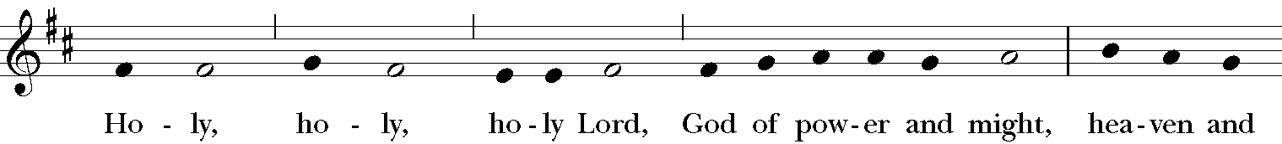

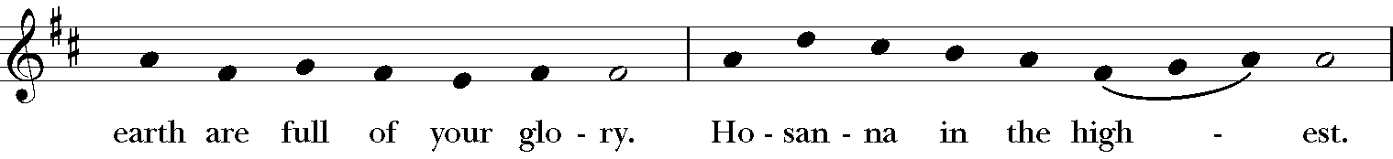

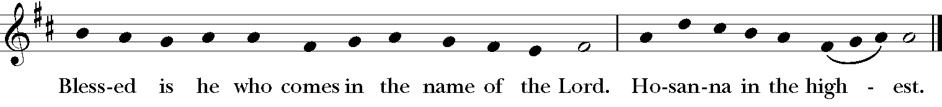

*The Celebrant continues*

Holy and gracious Father: In your infinite love you made us for yourself; and, when we had fallen into sin and become subject to evil and death, you, in your mercy, sent Jesus Christ, your only and eternal Son, to share our human nature, to live and die as one of us, to reconcile us to you, the God and Father of all. He stretched out his arms upon the cross, and offered himself, in obedience to your will, a perfect sacrifice for the whole world.

On the night he was handed over to suffering and death, our Lord Jesus Christ took bread; and when he had given thanks to you, he broke it, and gave it to his disciples, and said, “Take, eat: This is my Body, which is given for you. Do this for the remembrance of me.”

After supper he took the cup of wine; and when he had given thanks, he gave it to them, and said, “Drink this, all of you: This is my Blood of the new Covenant, which is shed for you and for many for the forgiveness of sins. Whenever you drink it, do this for the remembrance of me.”

Therefore we proclaim the mystery of faith:

**People Christ has died.**

**Christ is risen.**

**Christ will come again.**

*The Celebrant continues*

We celebrate the memorial of our redemption, O Father, in this sacrifice of praise and thanksgiving. Recalling his death, resurrection, and ascension, we offer you these gifts.

Sanctify them by your Holy Spirit to be for your people the Body and Blood of your Son, the holy food and drink of new and unending life in him. Sanctify us also that we may faithfully receive this holy Sacrament, and serve you in unity, constancy, and peace; and at the last day, bring us with all your saints into the joy of your eternal kingdom.

All this we ask through your Son Jesus Christ. By him, and with him, and in him, in the unity of the Holy Spirit all honor and glory is yours, Almighty Father, now and for ever. **AMEN**.

**The Lord’s Prayer**

**Our Father, who art in heaven, hallowed be Thy Name. Thy kingdom come, Thy will be done, on Earth as it is in heaven. Give us this day our daily bread, and forgive us our trespasses, as we forgive those who trespass against us, and lead us not into temptation, but deliver us from evil, for thine is the kingdom and the power and the glory, for ever and ever. Amen.**

**Fraction Anthem: Lamb of God : S-161**

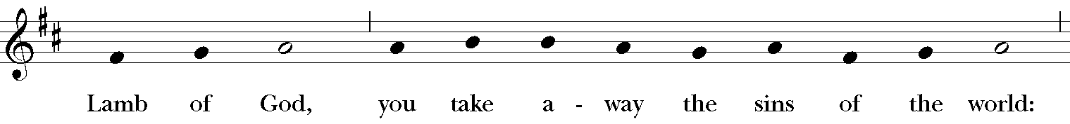

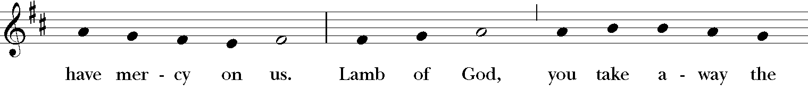

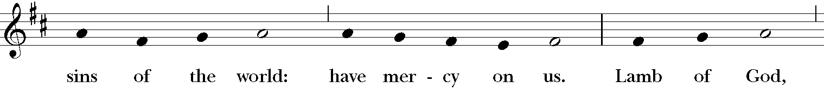

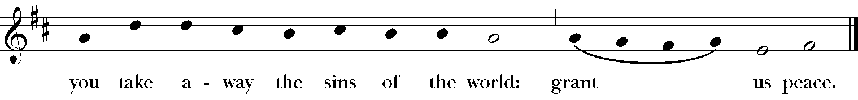

*A spiritual communion is a personal devotional that anyone can pray at any time to express their desire to receive Holy Communion at that moment, but in which circumstances impede them from actually receiving Holy Communion. We invite you to join us in this prayer wherever you are.*

**[ CONTINUE TO NEXT PAGE ]**

**A Prayer from the St. Augustine Prayer Book**

*As the celebrant receives the elements of Communion, the congregation says aloud this prayer*

***All*     Jesus, my Savior, I ask you to come into my heart and fill me with your love.  Although I cannot physically join with others to celebrate the Eucharist today, I desire to offer my thanksgivings and prayers in union with all who worship you, wherever they may be. And although I cannot receive you now sacramentally in the bread and wine of Holy Communion, still I desire to receive your body and blood spiritually and feed on your love, that I may be united with you and with all your people in one communion and fellowship, your mystical body the church, now and ever more.  Amen.**

**Communion Anthem “A prayer of St. Richard of Chichester” L. J. White**

O holy Jesus, most merciful redeemer,

Friend and brother, may I know thee more clearly

Love thee more dearly, and follow thee more nearly.

**The Blessing**

**[ CONTINUE TO NEXT PAGE ]**

**The Final Hymn “The God of Abraham praise” Hymnal, 401**

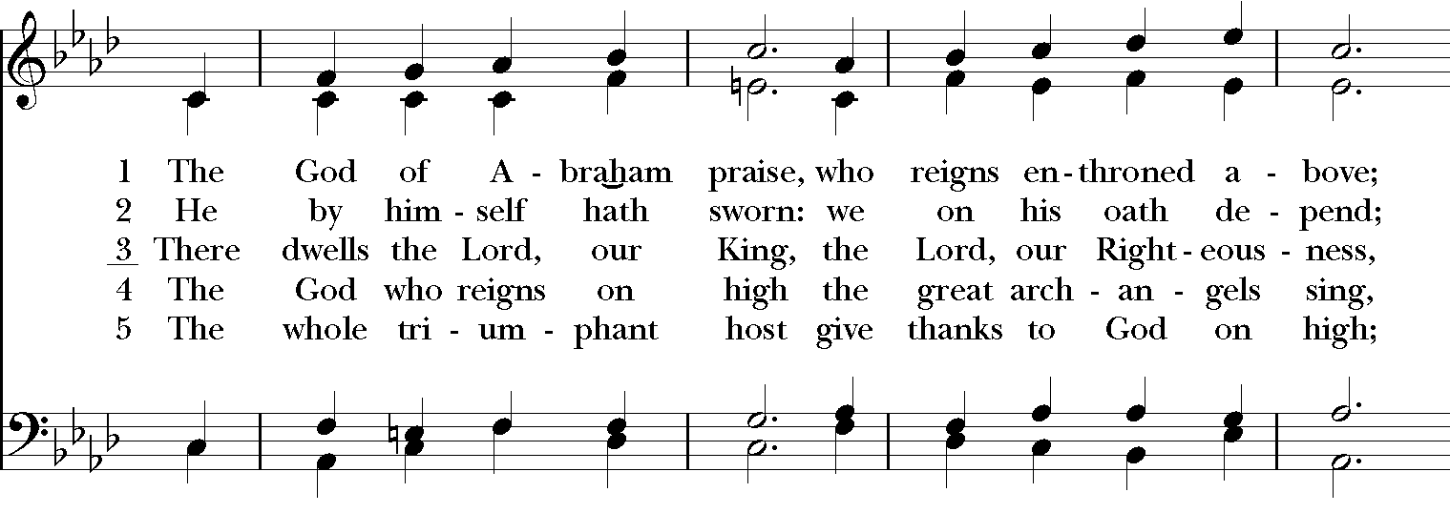

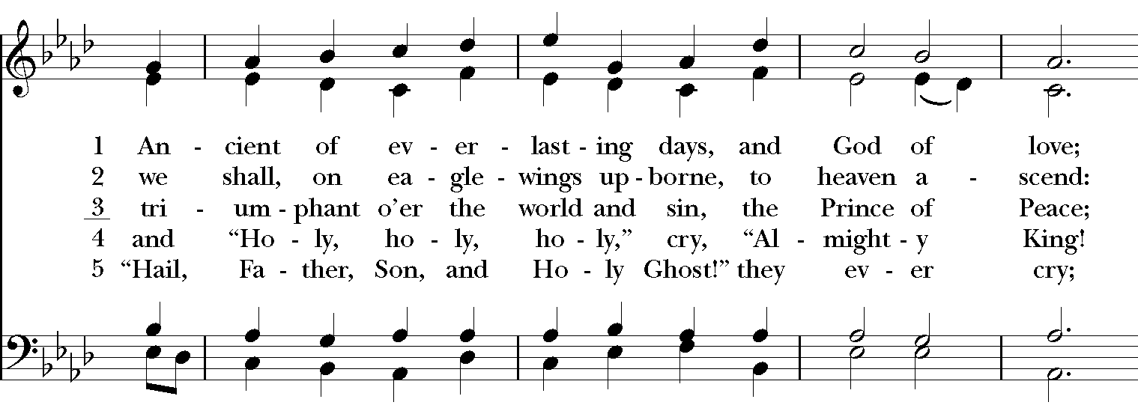

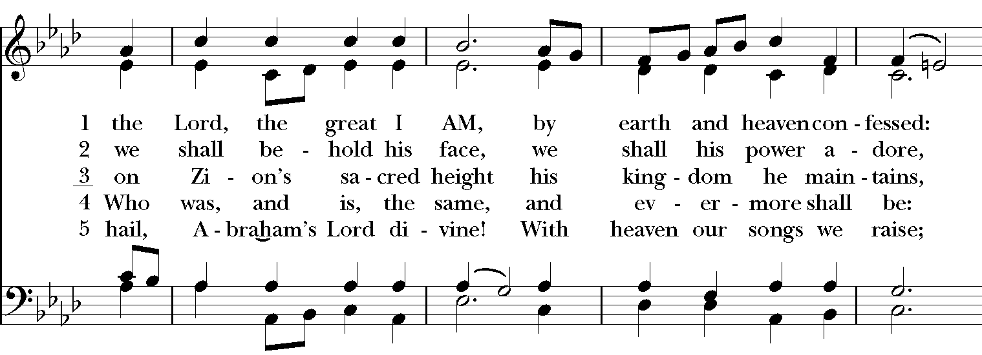

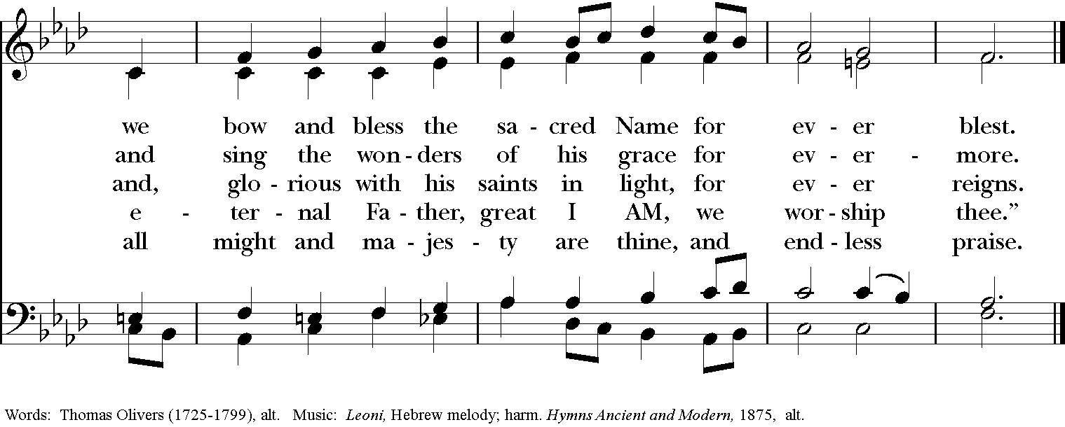

**The Dismissal**

***People* Thanks be to God.**

**Postlude “Choral Prelude: Leoni” Isadore Freed**

Permission to reprint, podcast, and/or stream the music in the service obtained from ONE LICENSE # A-736775. All rights reserved.

Hold Control and hover Left Mouse button

over green button to activate link.

**ANNOUNCEMENTS**

**St. Luke’s Music Series**

On **Sunday March 14 at 3:30 pm** soprano Emily Albrink will present a recital with David George, pianist.  Details forthcoming!

This event is a “virtual” recital, so you can relax and listen in the comfort of your own homes.  Mark your calendars to be sure to listen in!

**2021 Stewardship & Offering Envelopes**It is not too late to submit your pledge (a commitment to a specified amount of financial giving) to the ministry of St Luke’s for 2021! Please be in touch with our bookkeeper, Judy, at [**bookkeeper@stlukesanchorage.org**](mailto:bookkeeper@stlukesanchorage.org) to make or update your pledge for 2021. You have many options for giving, including by mail, by automatic draft from your preferred bank account, and by our online giving portal.  
  
If you would like to make your financial gifts by mail, we need to mail Offering Envelopes out to those who want them.  Please let Dawn know at [**admin@stlukesanchorage.org**](mailto:admin@stlukesanchorage.org), should you want a pack of envelopes for 2021.

**A new Lenten program**

As we continue the safe practice of virtual worship services, we want to offer a special series during the season of Lent.

The Stations of the Cross is a service we usually read on Good Friday just before the service.  It offers a pilgrimage following the 14 Stations of the Cross.

***This year we’re going to offer 2 stations each Sunday in Lent***.  A choral meditation or an organ meditation will follow the short prayer service set for each station.  ***On Palm Sunday, we’ll offer the last 4 stations, ending with the last, Jesus is put in the tomb***.

During Holy Week, you can watch the 14 Stations of the Cross in one viewing, if you prefer.

The inspiration for this series was the amazing set of  improvisations at the Royal Conservatory of Music at Brussels by the French organist, Marcel Dupre on February 13, 1931.  They were later transcribed and published and became Dupre’s crowning compositional achievement.  Lisa Lewis will play five of the fourteen organ pieces over the course of the 6 weeks of Lent. You may also want to explore the poetry of French poet, Paul Claudel, that served as inspiration for Dupre’s improvisations.  The pieces are dramatic and capture the emotion of each station.

**Watch for the Stations 3 and 4 on Lent II, February 28 at 3:00 pm on St. Luke’s Facebook page, https://www.facebook.com/StLukesAnchorage.**

**Wednesday AM Lenten Bible Study!**

Please join us via Zoom every Wednesday during Lent at 9:45 am to discuss a chapter of The Path, a Bible Study published by Forward Movement and much beloved by our Thursday Night group. Because we are not able to hand out books at the church office during this time, we are asking that all those who wish to participate acquire a personal copy of the book. If you need financial assistance, please be in touch with Mother Allison at [associate@stlukesanchorage.org](mailto:associate@stlukesanchorage.org) so that she can assist you in obtaining a copy. You’ll find links below to purchase a copy of the book, so that you can follow along with us in this Lenten practice of studying scripture in community!

The book can be ordered in either paper copy or Kindle format from Amazon via this link: [**https://www.amazon.com/Path-Journey-Through-Bible-English/dp/0880284358/ref=sr_1_1?dchild=1&keywords=the+path+forward+movement&qid=1611780422&sr=8-1**](https://www.amazon.com/Path-Journey-Through-Bible-English/dp/0880284358/ref=sr_1_1?dchild=1&keywords=the+path+forward+movement&qid=1611780422&sr=8-1)

A PDF of the book from the publisher can be found here: [**https://www.forwardmovement.org/promotions/PDF/ThePathPDF.pdf**](https://www.forwardmovement.org/promotions/PDF/ThePathPDF.pdf)

The Zoom link, which will be the same each week, is here: [**https://us02web.zoom.us/j/81267113936**](https://us02web.zoom.us/j/81267113936)

**Thursday Night Bible Study**

The Basics of the Bible Study continues on Thursday evenings with Mother Allison! We are using The Path to guide our study, but all you need is a Bible and access to the internet to join us. We are gathering every Thursday evening from 6:45-7:45 on Zoom to discuss the foundational stories of our faith and to explore how these stories connect to our own journeys. Please follow this link on Thursdays at 6:45 to join us!

**Contemporary Anglican Saints – Sunday 9am Class**

Please join us Sunday mornings, 9:00. The British Isles and the greater Anglican Communion has been the home and origin of many great saints. These saints are people with fascinating stories, and great impact on global Christianity. Please join us as we learn about these saints and discuss their influence and ideas.

For more information, email Dave Kirchinger at [**episcopaliandave@gmail.com**](mailto:episcopaliandave@gmail.com).

The link to the class is: [**https://us02web.zoom.us/j/85144530030**](https://us02web.zoom.us/j/85144530030) / Meeting ID: **851 4453 0030**

If prompted to enter a password, please enter our parish office phone number - 2458827

**Centering Prayer**

Centering Prayer is TWICE a month, every 2nd and 4th Tuesday. Join us on **March 9th and 23rd from 6 – 7pm** on ZOOM until we can all join back in the Lyman Office.

Link to Centering Prayer Group: <https://zoom.us/j/85280543522>

Meeting ID: 852 8054 3522

If prompted to enter a password, please enter our parish office phone number – 2458827

**Birthdays & Anniversaries**

**If you've had a birthday or anniversary over the past several weeks, or have one coming up in the weeks ahead,** please let Dawn know, [admin@stlukesanchorage.org](mailto:admin@stlukesanchorage.org).  Let her know your birthday, or the date of your wedding anniversary and how many years you've been married, and we will offer a blessing over you during our recorded worship.

**In our prayers** ... **for Al, Allen, Amanda, Amy, Ann, Annie, Beecher, Bethann, Beverly, Bill, Braxton, Bud, Calvin Riley, Carol, Charles, Christy, Danny, Dave, David, Diana, Doug, E.J., Eleanor, Elizabeth, Erma, Gene, Hugh, Ira, Jackie, Jen, Jenni, Jerry, Jewell, Jim, Joan, Joe, John, Joyce, Karen, Kelly, Ken, Laura, Lauren, Lee, Linda, Lisette, Liz, London, Lynn, Martha, Marty, Mary, Matt, Meg, Mike, Milo, Monica, Morgan, Nancy, Nina (Nine-ah), Patricia, Rob, Ronald, Rueben, Sandy, Sherrie, Stefanie, Steve, Sue, Susan, Susie, Terry, Tim, Tracy, Trent, Ursula, Vicki, Walt, Whitney, Wynn**; and our men and women serving in our armed forces and their families. We offer prayers of blessing and thanksgiving for all men and women serving in the armed services, especially these persons known to us: **Alex, Bianca, Casey, Christian, Griffin, Pat, Seth, Sinclair, Steve**. We pray that they have safe journeys and know the loving concern of friends and family. May God watch over them and grant them strength and courage to face perils which beset them.

**Readings for:**

**March 7: Exodus 20:1-17; Psalm 19;**

**Third Lent**  **I Corinthians 1:18-25; John 2:13-22.**