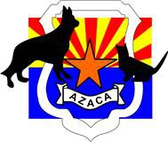

NOMINATION

Arizona Animal Control Officer of the Year 2018
- The recipient of this award shall have been directly involved in the animal control profession for a minimum of three years.
- Recipient shall be a current member of AZACA (individual or agency member).
- Recipient may be nominated for a single outstanding achievement in animal control or long-term exceptional performance in animal control work (agency or association related). Specific details must be provided.

NOMINEE INFORMATION
Name and title:
Address:

Phone number:
E-mail address:

Narrative of accomplishments/performance (following the criteria guidelines, limited to 1,000 words or less, attach additional sheets if needed):

YOUR INFORMATION:
Name and title:
Address:

Phone number:
E-mail address:
Signature:

Nominations must be submitted by February 22, 2019, for consideration. Selection will be made at the AZACA 2019 Training Summit by all present members.

Mail to: Email to: Fax to:
AZACA azacoa@gmail.com 928-527-9380
P.O. Box 5135
Mesa, AZ 85211-5135

