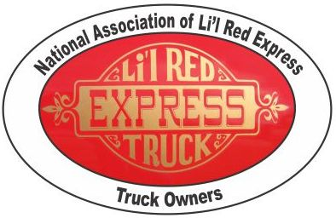
NATIONAL ASSOCIATION of LI’L RED EXPRESS TRUCK OWNERS
NALRETO
This organization was created to provide a qualified sanctioning body to develop standards of quality and to verify authenticity for the Dodge Li’l Red Express Truck. A subset of this capacity is to provide certification of restoration parts.
Our Judging Handbook has been compiled and a wealth of time and attention to detail was invested when compiling the handbook to assure complete accuracy. The guidelines in the handbook will assist fellow restorers when restoring their trucks to factory specifications. It will also assist manufacturers in improving the quality of restoration parts and services they provide for the Li’l Red Express Truck.
The goal of the NALRETO’s certification process is twofold. The first objective is to provide restorers of the Li’l Red Express Trucks with an avenue to obtain quality parts for their vehicle. The second objective is to provide manufacturers and resellers with credibility, recognition and a customer base for their Li’l Red Express parts. This is a winning situation for all parties. Increase demand for you parts and customers are assured that the parts they are purchasing are correct for their application and will be accepted as OEM replacement parts for judging purposes. A list of NALRETO certified parts and their suppliers will be available to any interested parties at no charge.
NALRETO is contacting manufacturers and/or resellers of reproduction parts for the Dodge Li’l Red Express Truck. Parts that meet or exceed original OEM specifications will receive a certification certificate and an “Official NALRETO Certification Number” for each part approved. There is no charge for this certification process. If interested, please follow the certification instructions below.
Certification Instructions:
Send part(s), certification request form for “each” part to:
John C. Roberts
225 Mariner Lane
Rotonda West, FL 33947
941-380-9977
jroberts150@comcast.net

NOTE: Please include return shipping charges if the part is to be returned.
If you have any questions or would like additional information, please contact ofne of us via the above information. Thank you for helping NALRETO improve the standards for the Li’l Red Express Truck.

Best regards,
John C. Roberts, Senior Judge, National Association of Li’l Red Express Truck Owners

