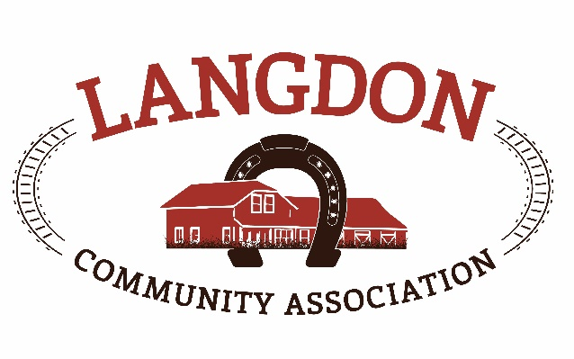
Langdon Community Association
Box 134
Langdon, AB T0J 1X0
www.goodlucktown.ca

LCA Meeting – April 18, 2021
Location: Fieldhouse

In Attendance:
Chrissy Craig – Chair
Jessica Smythe – Vice Chair
Nicole Porquet-Seitz – Director
Crystal Upstone – Events
Brian Ferguson - Treasurer
Corrie Carrobourg – Director
Nicki Black - Secretary
Heather Miller – Fieldhouse
Brand-Lee Mouck – Community Programs
Scott Pike – Parks Lead
Dave Miller- Director
Tony Baker - Director
Georga Fisk- Director
Brian Hogg
Al Schule

Meeting called to order at 1936

- Approval of Agenda:
  - Motion to approve the agenda with additions: Georga & Corrie
- Approval of Minutes:
  - Motion to approve the minutes from March 21, 2021: Nicole & Nicki

- Reports No updated reports
Next LCC meeting – April 25, 2021, zoom 6pm

- Standing Business
  - Tasks review – reviewed and updated
  - Risk Management – included in policies discussion
  - Succession Planning –Please look at document and update as required
  - Education – Online Federation of Calgary Communities resources and education class for new board members or new board positions. Courses have been sent out and free to register.
  - Strategic Planning – Received draft of new policies. Document will be broken down and be send to members to review their allocated section. Chrissy will send to members and asked to be done by next meeting,
  - Langdon Community Campus – Waiting for the license to organize the walk through. Grant for equipment has been received however we need to build the garage for storage before purchasing equipment. Countyinsisting Landform need to build the garage, but this will work out more expensive, so need to review. Storage issues could hinder July 1st opening.
Needs assessment being done on the Rec center, Board members still meeting with developers for funding.

- Discussion
- Ball Diamond Grant – Community and facility grant has been received ($61K which we can match). This will be used to purchase the equipment for the new ball diamonds. Chrissy will be applying for the Langdon Tax Levy to be used towards this too.
- Naming of quads – RV admin wanting to name them Rocky View County Langdon Ball Diamonds, however, have not had any input from the community. Board will be going to RGC to have the diamonds named to what the community votes in. Facebook posts will be done in the next week to get the community voting.
- Town Clean Up – will take place April 24th. Bags and transfer feeds being donated by Rocky View. Tim Hortons will be donating donuts for volunteers. Tahnee Fales will be coordinating people from the Fieldhouse.
- Water line in the Fieldhouse – received the quote from Trust plumbing. Discussion around the different options and what would be most cost effective as this was not in the budget but needs to be done. Decision needs to be made by end of June to have time for the work to be done before the colder weather.
- Soccer – open house with Foothills went well. Will be looking at options to bring U10 & U12 back to Langdon fields (this will reduce fees). Registration has been extended by 2 weeks to allow for the changes. Frequently asked questions / update to go up on FB this week.
- Ball calendar – booking software is in the works to be able to track the schedules for new and old ball diamonds. Will interface with the website.
- Hiring of staff member – 12 resumes received. Interviews will take place this week. Best candidates’ details will be emailed to board for approval. New hire needs to start in 2 weeks (May 1st).
- Fieldhouse is currently open for any events / meetings allowed in Stage 1. Cleaner will be called in as needed.
- Langdon days – all agree that some form of the event still needs to go ahead if possible. Will be moved back to August 21 & 22, Covid dependent.
- Motions
- Approved by email - Motion to approve food trucks in the Fieldhouse parking lot
on Saturday May 1st to coincide with the garage sale day. Motion by Chrissy – all approved.

Motion to approve spending $480 to inspect a Bobcat for use at the ball diamonds. Money to be taken from Campus Fundraising account if not covered in a grant. Motion by Corrie, second Chrissy, all in favour.

Adjourned 2140h

Reports
Events report –
Funds development report –
Communication report –
Parks report –
Program report –
Fieldhouse report –
Capital Projects Report –
Bingo Report –

Future Meeting (calendar invites sent to your goodlucktown.ca emails)
All meetings at 730pm at The Fieldhouse unless noted

Next meeting May 16, 2021

