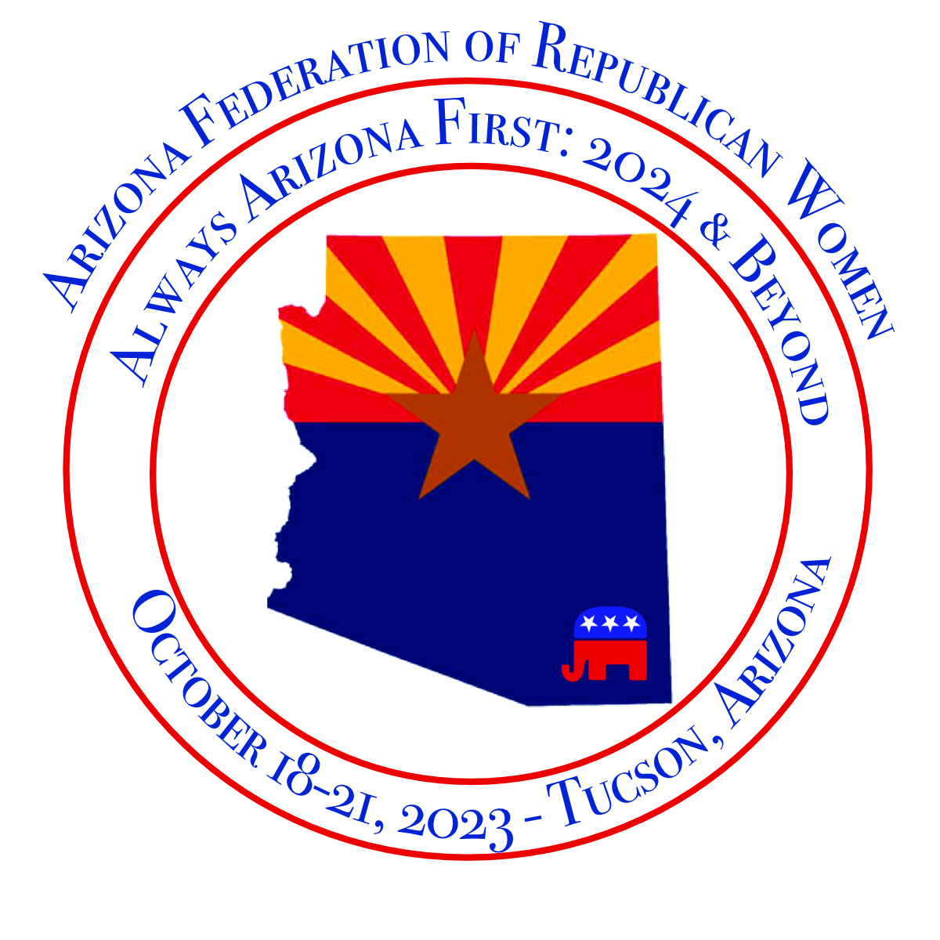
ARIZONA FEDERATION of REPUBLICAN WOMEN
Convention Program and Guide Reports

The AzFRW Official Program and Guide of the AzFRW 2023 Biennial Convention provides an opportunity for the AzFRW Elected Officers, Region Directors, and Committees to provide a report for our membership. All reports are due to the Convention Program Guide Editor by August 30, 2023.

Reports are to be professional in Word format only (no PDF’s please). Please proof carefully and early submissions would be appreciated! Pictures and high-quality graphics are encouraged however not required.

Club Presidents may want to share their club report with a prior President if there were two Presidents during the convention cycle. This is an excellent opportunity to share the accomplishments of your clubs and committees.

REPORTS DEADLINE:
August 1, 2023

AzFRW Elected Officers Report
AzFRW Region Directors Report

AzFRW Standing and Other Committee Reports:
Americanism Club Reports
Arrangements Convention
Awards Legislative
Bylaws Nominating
Campaign Publicity & Public Relations
Convention Rules Committee Convention Resolution Committee

E-mail your report by August 1, 2023
to Convention Program Guide Editor, Joan Lang, wandjlang@gmail.com.

