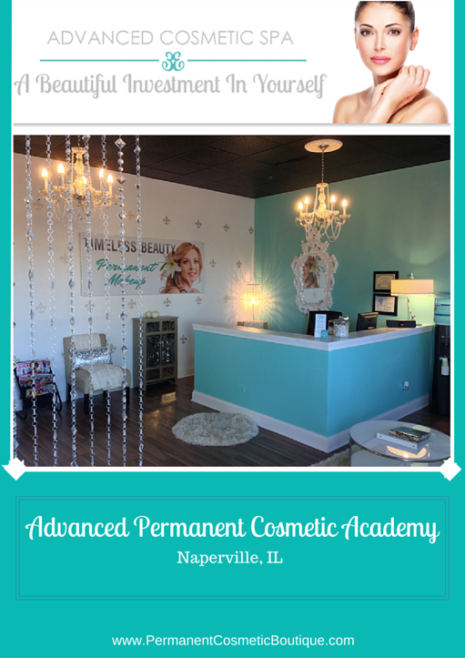
Welcome to Advanced Permanent Cosmetic Academy!
Our company is based on the belief that our students’ needs are of the utmost importance. Our entire team is committed to meeting those needs. We travel around the world to learn the highest standards and the most cutting edge techniques in Permanent Cosmetics. Classes are held at the newly expanded location in the beautiful city of Naperville, Illinois.
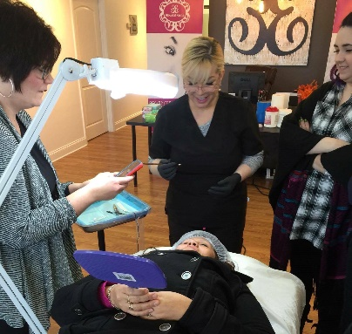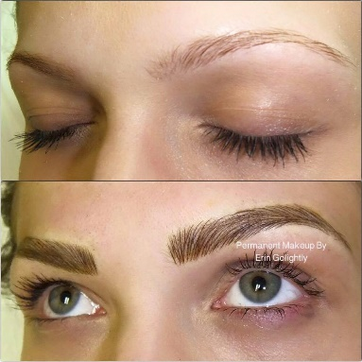

Introduction to Permanent make up offers the foundation to one of the most in-demand and profitable services in today’s image conscious market. This entry level course is designed to teach precise procedural execution using quality machines, pigments and supplies. With the knowledge of color selection, ethical business practices and marketing strategies, we help you develop your professional image. Completion of your classroom hours, home study hours and hands on procedures will give you opportunity for a professional income. Classes are limited in size to allow each student the attention required to achieve professional results. Our Academy is a 100 minimum with at least 65 Hours of Classroom training, 35 hours of home-study for a fundamental class in Permanent Makeup. Each student in addition to class hours will be able to choose a day to observe procedures on live clients. We offer ongoing support for all of our students!
How to Contact Us
Address: 4s100 IL-59 Naperville, IL 60563
Phone: 630-800-8668
Email: info@permanentcosmeticboutique.com
What Will I Learn?
You will learn cutting edge techniques relevant in today’s Permanent Makeup world. These techniques include the 3 Dimensional Hairstroke Eyebrows, Eyeliner, Full Lip and Lip Liner procedures. We will cover topics relevant for your business such as:

- Introduction to Permanent Makeup
- Set-Up Requirements • Client Consultations
- Health Requirements
- Sanitation and Sterilization
- Client Preparation and Artistic Techniques
- Color Theory
- Review of Proper Forms,
- Needles and Client After-Care
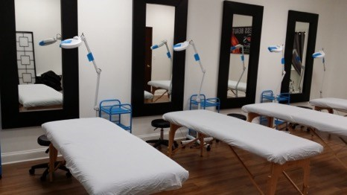

What should I expect?
You will receive a certificate of training for permanent cosmetics after completing the course and demonstrating your skills. You also will receive ongoing support with us which is necessary for success. Classes include a small kit enough for 50 clients, you will be directed where to buy more products in class. You will work on all of our equipment and we will supply everything you need to work in class. Models are also provided for you. If you have a model it is always recommended to see healing results, healing color and to provide the touch-up results on the same person.
About Erin Golightly
Erin is a leader in Permanent Cosmetics serving Naperville and all surrounding communities of Chicago, Illinois. She is a Master Certified Permanent Cosmetics Professional with over
23 years in the beauty industry and 12 years’ experience as a
Permanent Cosmetics. She specializes in natural looking 3 Dimensional Hairstroke Eyebrows, natural finish eyeliner and lip blush color. Erin is Licensed by the Department of Health, a member of the Society of Permanent Cosmetic Professionals, The American Academy of Micropigmentation and the League of Permanent Cosmetics Professionals. Erin attends continuing education around the world and courses yearly for Permanent Cosmetics.

We are a licensed Permanent Cosmetic Facility

How Much Will It Cost?
Permanent Makeup is a very lucrative career requiring only a small investment of your time and money. For our 100 hr Basic training class that includes the 3D Hairstroke eyebrows $4800
Our classes fill very quickly so to reserve your spot, please call JoAnn at 630-800-8668.

School Policies
Non-discrimination ADVANCED PERMANENT COSMETIC ACADEMY does not
discriminate on the basis of age, gender, marital status, national origin, race or religion.
Attendance and Tardiness - To receive a certificate of completion, you must arrive on time for class each day. Classes begin at 9:00 a.m. and end at approximately 7:00 p.m. each day. Students who arrive late or miss class time, will be responsible for additional charges as listed in the Enrollment Agreement. Student's must work on live models and complete required hours to receive certification. It is the instructor's sole discretion whether a student is ready to work on live models. If a student is unable to meet minimum standards as required, there will be no refund of tuition.

Advanced Standing - We do not offer advance standing for previous training or course work.

Student Records - All student records will be kept for a period of 5 years from date of graduation. Records are private and can be accessed only with a written request from the student. Records will only be sent directly to the student.
Satisfactory Progress Policy & Evaluation - Students must maintain satisfactory progress while enrolled in training. Each student is evaluated during each phase of the class. If a student's comprehension or performance falls below the passing level of 75%, reevaluation or additional time will be recommended for practice and study before conclusion of the program. If the student chooses not to bring their skills/understanding up to a level that allows them to safely perform services, no certification will be granted even though they may complete other requirements. Records are kept by the school and are available to the student as required by Illinois law.

Complaint Procedure - Any questions concerning this training program which have not been satisfactorily answered or resolved prior to class should be directed to Erin Golightly 4s100 N Route 59 Naperville, IL 60563 (630) 800.8668.
Filing A Complaint - Go to ibhe.org under consumer information, click ‘online complaint’ system or call 217-557-7359.
Student Conduct - Students are expected to behave maturely. Students displaying disruptive behavior will be terminated from the program. Disruptive behavior includes, but is not limited to: harassing other students, possession or being under the influence of drugs or alcohol, or abusive language. The ethics statement outlines our behavioral expectations. It is expected that all instructors will be familiar with these issues and strive to uphold their essence.

Termination Policies - Students who behave inappropriately will receive a written warning. A second infraction of conduct policy will result in termination from the program.
One year after termination, student may reapply for admissions to an upcoming class.
Admission not guaranteed.

Ethics Statement
As owners, instructors of ADVANCED PERMANENT COSMETIC ACADEMY, it is our
responsibility and privilege to support the physical, mental and spiritual welfare of our students, and to uphold the dignity and integrity of our program. Thus, we agree to abide by the following guidelines:
Relationships with Students - In recognition of the trust placed in us by our students, we agree to: Show only the highest regard for our students' personal beliefs and values; offer our services of teaching to all persons, regardless of sex, race, color, ancestry, religious creed, national origin, physical disability, mental disability, medical condition, age, marital status, political affiliation, or sexual orientation; avoid any action that we know will conflict with the higher interest of our students; avoid taking unfair advantage of students financially, sexually, romantically, or otherwise.
Professional Conduct - In conducting our teachings and practices, we will: Offer only those services that we are competent to provide; be honest, straightforward, fair and conscientious in all business dealing; manage our business finances according to accepted business and accounting practices; in advertising and other descriptions of our services (including verbal), we will make no exaggerated claims as to the benefits of our classes and we will represent our training, qualifications, abilities and affiliations accurately.

Enrollment Agreement
This enrollment agreement is a legally binding instrument acknowledging that you have been given reasonable time to read and understand it, and that you have read a statement of ADVANCED PERMANENT COSMETIC ACADEMY policies regarding tuition, payment,
cancellation, refund, and ethics. Student acknowledges and is aware he/she will be attending the applicable course(s) only under the terms of this agreement. Student acknowledges and is aware that ADVANCED PERMANENT COSMETIC ACADEMY does not certify to perform tattoo removal, scar camouflage and/or para-medical procedures. Student acknowledges that success is dependent on his/her application of practices learned in each course. The student additionally understands that minimum standards must be met to receive a certificate of completion. The school is in no way required to issue a certificate of completion unless the student performs satisfactorily in all aspects of the course(s). The instructor will make every effort to work diligently with each student to ensure successful completion of each course. Each student must complete work on live models, and attend their minimum scheduled classroom hours in addition to studying his/her manual. Class hours vary depending on class and location. Students who are late for class will be charged a fee of $50.00 per hour to make up time with the instructor on a future date.
The student acknowledges that if any equipment belonging to the instructor is dropped, damaged, or otherwise misused in any way, the student will be required to replace the damaged equipment at the current cost of said equipment. Student acknowledges that he/she is responsible for research of his/her local and state laws regarding licensing and operation. ADVANCED PERMANENT COSMETIC ACADEMY nor its instructors are in any way
responsible for legal advice regarding laws that govern the student's state. Student also agrees that it is the instructor's sole discretion when student is ready to perform work on live models. While the school will make every effort to provide live models for students to work on, student acknowledges that no guarantees can possibly be made concerning said models. All supplies for use during training will be provided for students. Student start-up kits and replacement supplies are available for purchase.
Student must remit either a deposit by Visa, Mastercard, Discover, American Express, Cash or Cashiers Check the day they enroll in a class. This deposit will be deducted from tuition, which is due in full no later than ten (30) days prior to your class start date unless payment arrangements have been made and a promissory note signed before a notary public has been received. If balance of tuition is not received within 30 days prior to start date, student forfeits their original deposit, which held that class and will need to reschedule with a new deposit.

Cancellation Policy
A deposit or full tuition payment via cash, cashiers check, Visa, MasterCard, Discover or American Express will reserve space in class. Student will receive a full refund of deposit or tuition if notice of intent to cancel is received within 72 hours after receipt of initial payment. If cancelling class after 72 hrs from payment there is a $500 non-refundable fee. Deposit is deducted from tuition and balance of tuition is due 30 days prior to start of class unless payment arrangements have been made and a promissory note has been signed before a notary public and returned. Deposit, nor tuition, are refundable if student cancels after 72 hours of receipt of payment or if student fails to show up for class. However, if there is a proven emergency, we will offer the student the next available opening dates for two classes in which they can participate at no additional charge. Student must clear their schedule and pick from one of the two classes offered or they forfeit their deposit and/or tuition.
Students must read, understand, and agree to their rights and responsibilities, and acknowledge that the cancellation and refund policies have been clearly explained. This Enrollment Agreement is meant for viewing purposes only and student will receive a printed copy with their deposit or payment when committing to enrollment in a particular class.
Illinois Board of Higher Education
Division of Private Business and Vocational Schools
1N. Old State Capital Plaza Ste 333 Springfield, IL 62901
*Advanced Permanent Cosmetics is approved to operate by the
Private Business and Vocational Schools Division of Illinois Board of Higher Education.
*Advanced Permanent Cosmetics is not accredited by a US Department of Education recognized accrediting body.

