WELCOME TO
HOLY SPIRIT LUTHERAN CHURCH
A Member of the Evangelical Lutheran Church in America, New Jersey Synod
1220 Bayshore Rd., Villas, NJ 08251, 609-886-2414,
holyspiritlutheran@comcast.net, holyspiritvillas.com, facebook.com/holyspiritvillas
Vicar Vince Piekarski can be contacted at any time for conversation or prayer through call or text at 412-225-0287, or through email at vpie8282@gmail.com.
SUNDAY, FEBRUARY 22ND, 2026
FIRST SUNDAY IN LENT
10:30AM WORSHIP SERVICE WITH HOLY COMMUNION
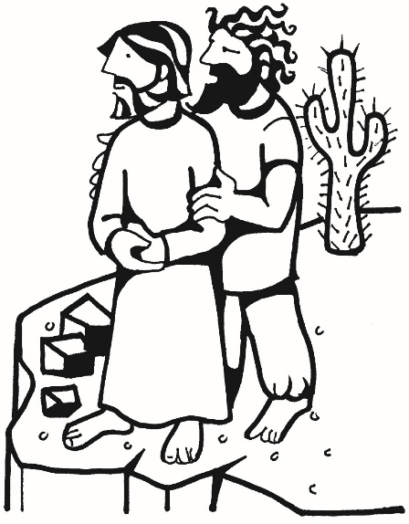

We, the Evangelical Lutheran Church of the Holy Spirit, are People of God, who
are called by the Holy Spirit to pray, worship, joyfully proclaim Jesus Christ,
and compassionately witness and serve others in Christian Love.


We are glad that you joined us for Worship today! Thank you for enriching our time together! We would like to get to know you better, and for you to get to know us better too. Brochures, welcome gifts, prayer shawls, Bibles, and other items are available throughout the church. We would be happy to show you around and share about our ministries. Please do not hesitate to speak up and ask questions.
Also, please make sure you sign-in on our clipboard on the podium in the lobby.


Our Worship Services are conducted in coordination with our Conference Call.
Join us at 657-390-7423 or 701-802-5170, with access code 8221190#.
You may need to dial 1 first depending on your phone plan. After logging in please announce your name and feel free to talk with others until we get started.


SANCTUARY CANDLE FOR FEBRUARY
Given to the Glory of God & In Memory of JAMES P. ROONEY
by Del McKenna & Children.
ALTAR CANDLES FOR FEBRUARY
Given to the Glory of God & In Memory of CLAIRE MILLER
by Jean, Phil, & Bob Zimmerman.
CONFERENCE CALL CHECK-IN, WELCOME, & ANNOUNCEMENTS
(Vicar (V), Assistant (A), Reader (R), and Congregation (C).)

INTRODUCTION
A. Today's gospel tells of Jesus’ temptation in the desert. His forty-day fast becomes
the basis of our Lenten pilgrimage. In the early church, Lent was a time of intense
preparation for those to be baptized at the Easter Vigil. This catechetical focus on
the meaning of faith is at the heart of our Lenten journey to the baptismal waters
of Easter. Hungry for God’s mercy, we receive the bread of life to nourish us for
the days ahead.

PRELUDE
(Music offered by our Organist at the start of our Worship Service.)
What Wondrous Love Is This

CHIMES
(Music offered by our Organist at the start of our Worship Service.)
Stand Up, Stand Up for Jesus

V. We invite you to stand as you are able.

CONFESSION & FORGIVENESS
(All may make the sign of the cross, the sign that is marked at baptism.)
V. Blessed be the holy Trinity, ☩ one God,
who forgives all our sin,
whose mercy endures forever.
C. Amen.

V. Let us confess our sin before God, who removes our guilt
and blots out all offenses.

(Silence is kept for reflection.)

V. Gracious God,
C. have mercy on us according to your steadfast love.
V. For seeking worldly delights that deceive us and dishonor you:
Gracious God,
C. have mercy on us according to your steadfast love.

V. For desiring self-reliance instead of hungering for your word:
Gracious God,
C. have mercy on us according to your steadfast love.
V. For failing to recognize your coming reign,
and for hindering the work of the Spirit: Gracious God,
C. have mercy on us according to your steadfast love.
V. For drawing from the well of self-serving ambition,
and for disdaining the living water Christ offers: Gracious God,
C. have mercy on us according to your steadfast love.
V. For disregarding voices from the margin,
and for distrusting signs of your healing and hope in the world:
Gracious God,
C. have mercy on us according to your steadfast love.
V. For dwelling in tombs of self-pity and discontent,
and for disregarding Christ’s call to come forth to life:
Gracious God,
C. have mercy on us according to your steadfast love.

V. God’s steadfast love, grace, and forgiveness abound.
Through faith, the free gift of God,
you have been clothed in the righteousness of Christ.
In the name of ☩ Jesus Christ, your sins are forgiven.
The Spirit of the One who raised Christ from the dead
dwells in you,
pours God’s love into your hearts,
and gives you life and peace.
C. Amen.

GATHERING HYMN
(We invite you to sing along.)
Lutheran Book of Worship—Green Book
229—A Mighty Fortress Is Our God

APOSTOLIC GREETING
V. May the grace of our Lord Jesus Christ, the love of God,
and the communion of the Holy Spirit be with you all.
C. And also with you.

KYRIE
V. In peace, let us pray to the Lord.
C. Lord, have mercy.

V. For the peace from above, and for our salvation, let us pray to the Lord.
C. Lord, have mercy.

V. For the peace of the whole world, for the well-being of the church of God,
and for the unity of all, let us pray to the Lord.
C. Lord, have mercy.

V. For this holy house, and for all who offer here their worship and praise,
let us pray to the Lord.
C. Lord, have mercy.

V. Help, save, comfort, and defend us, gracious Lord.
C. Amen.

HYMN OF PRAISE
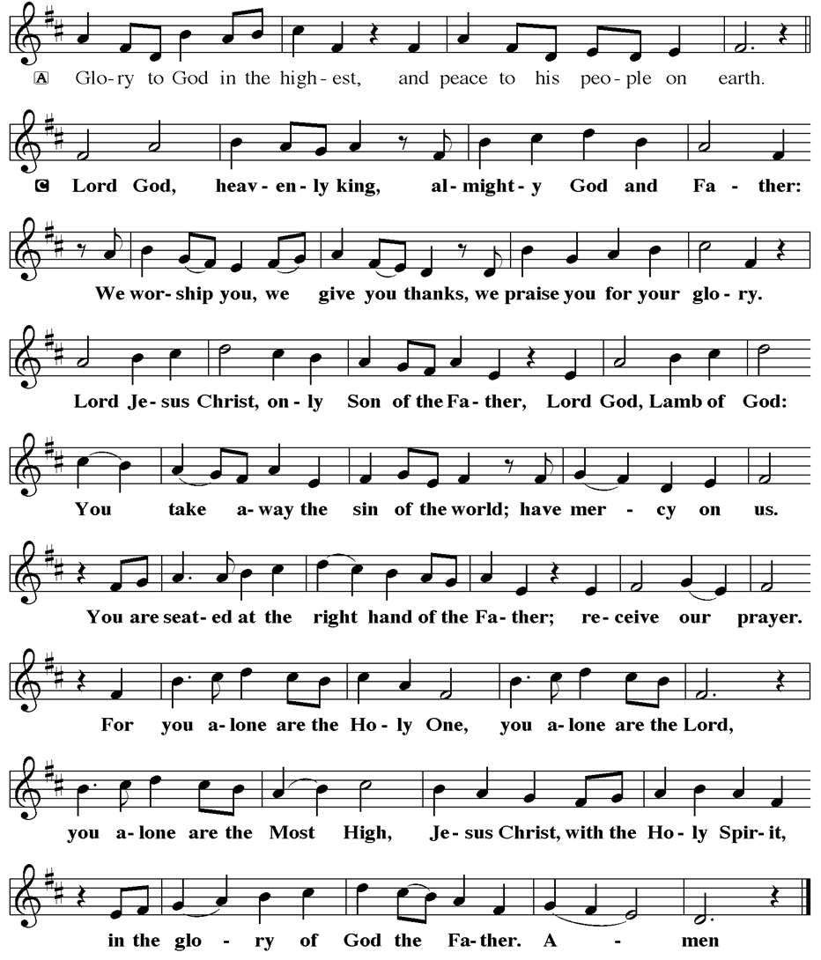
PRAYER OF THE DAY
V. The Lord be with you.
C. And also with you.

V. Let us pray,
Lord God, our strength, the struggle between good and evil rages within and
around us, and the devil and all the forces that defy you tempt us with empty
promises. Keep us steadfast in your word, and when we fall, raise us again and
restore us through your Son, Jesus Christ, our Savior and Lord, who lives and
reigns with you and the Holy Spirit, one God, now and forever.
C. Amen.

(We invite you to be seated for our Readings and Psalm.)

FIRST READING
Human beings were formed with great care, to be in relationship with the creator,
creation, and one another. The serpent’s promise to the first couple that their
eyes would be opened led, ironically, to the discovery only that they were naked.

R. Our First Reading is from the 2nd & 3rd Chapters of Genesis (2:15-17; 3:1-7).

R. 15 The Lord God took the man and put him in the garden of Eden to till it and
keep it. 16 And the Lord God commanded the man, “You may freely eat of every
tree of the garden, 17 but of the tree of the knowledge of good and evil you shall
not eat, for in the day that you eat of it you shall die.”

3:1 Now the serpent was more crafty than any other wild animal that the Lord
God had made. He said to the woman, “Did God say, ‘You shall not eat from any
tree in the garden’?” 2 The woman said to the serpent, “We may eat of the fruit of
the trees in the garden, 3 but God said, ‘You shall not eat of the fruit of the tree
that is in the middle of the garden, nor shall you touch it, or you shall die.’ ” 4 But
the serpent said to the woman, “You will not die, 5 for God knows that when you
eat of it your eyes will be opened, and you will be like God, knowing good and
evil.” 6 So when the woman saw that the tree was good for food and that it was a
delight to the eyes and that the tree was to be desired to make one wise, she
took of its fruit and ate, and she also gave some to her husband, who was with
her, and he ate. 7 Then the eyes of both were opened, and they knew that they
were naked, and they sewed fig leaves together and made loincloths for
themselves.

R. This is the Word of the Lord.
C. Thanks be to God.

PSALM
R. Our Responsorial Psalm is from the 32nd Psalm.
C. Mercy embraces those who trust in the Lord. (Ps. 32:10)

R. 1 Happy are they whose transgressions are forgiven,
and whose sin is put away!
2 Happy are they to whom the Lord imputes no guilt,
and in whose spirit there is no guile!
3 While I held my tongue, my bones withered away,
because of my groaning all day long.
4 For your hand was heavy upon me day and night;
my moisture was dried up as in the heat of summer.
C. Mercy embraces those who trust in the Lord. (Ps. 32:10)

R. 5 Then I acknowledged my sin to you, and did not conceal my guilt.
I said, “I will confess my transgressions to the Lord.”
Then you forgave me the guilt of my sin.
6 Therefore all the faithful will make their prayers to you in time of trouble;
when the great waters overflow, they shall not reach them.
7 You are my hiding-place; you preserve me from trouble;
you surround me with shouts of deliverance.
8 “I will instruct you and teach you in the way that you should go;
I will guide you with my eye.
C. Mercy embraces those who trust in the Lord. (Ps. 32:10)

R. 9 Do not be like horse or mule, which have no understanding;
who must be fitted with bit and bridle, or else they will not stay near you.”
10 Great are the tribulations of the wicked;
but mercy embraces those who trust in the Lord.
11 Be glad, you righteous, and rejoice in the Lord;
shout for joy, all who are true of heart.
C. Mercy embraces those who trust in the Lord. (Ps. 32:10)

SECOND READING
Through Adam’s disobedience, humanity came under bondage to sin and death,
from which we cannot free ourselves. In Christ’s obedient death, God graciously
showers on us the free gift of liberation and life.

R. Our Second Reading is from the 5th Chapter of Romans (Verses 12-19).

R. 12 Just as sin came into the world through one man, and death came through sin,
and so death spread to all because all have sinned 13 for sin was indeed in the
world before the law, but sin is not reckoned when there is no law. 14 Yet death
reigned from Adam to Moses, even over those who did not sin in the likeness of
Adam, who is a pattern of the one who was to come.

15 But the free gift is not like the trespass. For if the many died through the one
man’s trespass, much more surely have the grace of God and the gift in the
grace of the one man, Jesus Christ, abounded for the many. 16 And the gift is not
like the effect of the one man’s sin. For the judgment following one trespass
brought condemnation, but the gift following many trespasses brings justification.
17 If, because of the one man’s trespass, death reigned through that one, much
more surely will those who receive the abundance of grace and the gift of
righteousness reign in life through the one man, Jesus Christ.

18 Therefore just as one man’s trespass led to condemnation for all, so one
man’s act of righteousness leads to justification and life for all. 19 For just as
through the one man’s disobedience the many were made sinners, so through
the one man’s obedience the many will be made righteous.

R. This is the Word of the Lord.
C. Thanks be to God.

V. I invite you to stand as you are able, and I invite you to announce the Gospel
Acclamation with me.

GOSPEL ACCLAMATION
C. One does not live by bread alone, but by every word that comes from the
mouth of God. (Matt. 4:4)

GOSPEL READING
Jesus experiences anew the temptations that Israel faced in the wilderness. As
the Son of God, he endures the testing of the evil one.

V. The Holy Gospel According to Matthew, the 4th Chapter (Verses 1-11).
C. Glory to you, O Lord.

V. 1 Jesus was led up by the Spirit into the wilderness to be tested by the devil. 2 He
fasted forty days and forty nights, and afterward he was famished. 3 The tempter
came and said to him, “If you are the Son of God, command these stones to
become loaves of bread.” 4 But he answered, “It is written,
‘One does not live by bread alone,
but by every word that comes from the mouth of God.’ ”
5 Then the devil took him to the holy city and placed him on the pinnacle of the
temple, 6 saying to him, “If you are the Son of God, throw yourself down, for it is
written,
‘He will command his angels concerning you,’
and ‘On their hands they will bear you up,
so that you will not dash your foot against a stone.’ ”
7 Jesus said to him, “Again it is written, ‘Do not put the Lord your God to the
test.’ ”
8 Again, the devil took him to a very high mountain and showed him all the
kingdoms of the world and their glory, 9 and he said to him, “All these I will give
you, if you will fall down and worship me.” 10 Then Jesus said to him, “Away with
you, Satan! for it is written,
‘Worship the Lord your God,
and serve only him.’ ”
11 Then the devil left him, and suddenly angels came and waited on him.

V. This is the Gospel of the Lord,
C. Praise to you, O Christ.

(We invite you to be seated.)

SERMON
(Delivered by Vicar Vince Piekarski.)

(Following the Sermon, we invite you to stand as you are able.)

HYMN OF THE DAY
(We invite you to sing along.)
Lutheran Book of Worship—Green Book
482—When I Survey the Wondrous Cross

APOSTLES’ CREED
V. God has made us his people through our Baptism into Christ. Living together in
trust and hope let us confess our faith together using the Apostles’ Creed.
C. I believe in God, the Father almighty,
creator of heaven and earth.

I believe in Jesus Christ, God’s only Son, our Lord,
who was conceived by the Holy Spirit,
born of the Virgin Mary,
suffered under Pontius Pilate,
was crucified, died, and was buried;
he descended to the dead.
On the third day he rose again;
he ascended into heaven,
he is seated at the right hand of the Father,
and he will come to judge the living and the dead.

I believe in the Holy Spirit,
the holy catholic church,
the communion of saints,
the forgiveness of sins,
the resurrection of the body
and the life everlasting.
Amen.

PRAYERS OF INTERCESSION
V. Reconciled by God’s mercy and sustained by God’s presence, let us pray for the
world and its needs.

(A brief silence.)

A. God of all grace, grant faith to your church. Give to all the baptized the will to
resist temptation and to worship and serve you alone. Hear us, O God.
C. Your mercy is great.

A. God of all creation, tend this earth. When human greed and disobedience
threaten this planet and the life it contains, lead us by your Spirit into ways of
reverence, awe, and gentleness. Hear us, O God.
C. Your mercy is great.

A. God of all nations, preserve us from trouble. Surround all living in places of
violence with your steadfast love and give resilience to all who work for peace.
Grant courage to those who challenge, especially around issues of racism and
systemic oppression. Hear us, O God.
C. Your mercy is great.

A. God of all healing, mend our wounds. Bring wholeness to all who are sick, give
peace to all who groan in grief, and send companions to all who are lonely or
isolated. Especially we pray for:
BettyAnn Rich-White (Church Member)
Chip & Marie Hand (Church Members)
Lynn Bargstadt (Church Member)
Frank Ford (Church Member)
Carol Amundsen (Church Member)
Kim McGinley (Church Member)
Anthony DeLuca (Church Member)
Frank Brunner (Church Member)
Joan Sommerman (Church Family)
Arleen Kinka (Church Family)
Rick Lang (Church Family)
Suzie Clark (Rose Lang's Friend)
Francis Clock (Dianna DeNote’s Family)
Andrew Hudak (Rose Lang’s Friend)
Viena Murtha (Bob Fritsch’s Friend)
Sharon Waicus (Skip & Bonnie Millard's Friend)
Karen O'Brien (Paul Bowker's Friend)
Dustin Irizzary (Mary Melnicoff's Family)
The Bryan Family (Wanda Bryan's Family)
Craig Brearey (Judy Brannan & Mary Melnicoff's Friend)
Sarah Dutton (Frank Ford's Family)
Christina McNasby (Fran Green’s Family)
Mark Stephen Dennis (Diana DeNote's Family)
Bill Lodge (Skip & Bonnie Millard's Friend)
Ron Anderson (Bill Kelly's Friend)
Bud Brearey (Judy Brannan & Mary Melnicoff's Friend)
Mary Skain (Kathy Poehler's Friend)
Robert Chaplin (Mary Melnicoff's Friend)
Jack Wieckouski (Theresa & Kim McGinley's Family)
Carolyn Santarpio (Bob Fritsch's Friend)
Harry (Judy Brannan's Friend)
Janet K (Philomena Noak's Friend)
Michael Hart (Diana DeNote's Friend)
Rocco Leonard DeNote (Diana DeNote's Family)
Sherri Lynn (Bob Fritsch's Friend)
John Bannco (Bob Fritsch's Friend)
Nancy Pazarinie (Bob Fritsch's Family)
Jane & Paul Eiben (Rose Lang's Friend)
Joe DiMassimo (Judy Brannan & Mary Melnicoff's Friend)
Denny Papst (Rose Lang’s Friend)
Mike & Alice Rhoades (Rose Lang’s Friends)
Chris (Judy Brannan's Friend)
Helen Ehlers (Judy Brannan's Friend)
Leanne Bueth (Joan Kilcoyne's Family)
Janett MacFarlane (Carol Amundsen's Friend)
Thish Kelly (Theresa & Kim McGinley's Family)
Edward Chapleski (Allison Call's Family)
Scott Levin (Rose Lang's Friend)
Alice Ann Dennis (Diana DeNote's Family)
Nancy Taylor (Ted & Diane Bell's Family)
Santa Isabel Lutheran Church (Elizabeth, NJ)
Messiah Lutheran Church (Oakland, NJ)
Joyce Thompson (TDPWC Member)
Barbara Paynter (Leon Stitt’s Family)
Ruth (Anthony & Vincent Bruno's Family)
William T Hodgetts (Pastor William Hodgetts’ Family)
Paul Bowker (Church Member)
BettyAnn & Bill Whitman (Mary Melnicoff's Friends)
Bob Poole (Kathy Poehler's Family)
David Smith (Heather & Vicar Vince Piekarski’s Family)
Barbara Hoitink (Lucas & Sabrina Munson's Family)
Kathy Raynor (Philomena Noak & Mary Melnicoff’s Friend)
Jordan (Carol Amundsen's Friend)
Jeremy Pochatko (Vicar Vince Piekarski's Friend)
Ann Wieckouski (Theresa & Kim McGinley's Family)
Rich (Kim McGinley's Friend)
Amy Johnson (Ted Bell's Sister)
Jerry & Marlana (Carol Amundsen's Friend)
Theresa Dolan (Joan Kilcoyne's Family)
Sandy Bloomberg (Judy Brannan's Family)
Simon (Carol Amundsen's Family)
Bill Ransing & Family (Frank Ford’s Friends)
Barbara Brosius (Philomena Noak's Friend)
Barbara Schmiedel (Bob Fritsch's Family)
Cathy Bell (Ted & Diane Bell's Family)
Doreen Kinzler (Church Member)
Linda Stonelake (Kathy & Butch Poehler's Friend)
Anne Pfaff (Bonnie Millard & Vicki Rinier's Friend)
Tom Keywood (Gloria Sutton's Family)
Celeste (Community Member)
Robin (Community Member)
Anna Perez (Bob Fritsch's Family)
(Additional Names Added Prior to the Worship Service.)
A. Hear us, O God.
C. Your mercy is great.

A. God of all people, provide for our community. For any among us who hunger for
bread, bring nourishment. For any among us who hunger for truth, speak your
life-giving word. Hear us, O God.
C. Your mercy is great.

A. God of all life, bring us to you. We thank you for your free and abounding grace,
and for those who, by that same grace, now rest eternally in you. Hear us, O
God.
C. Your mercy is great.

(Here other intercessions may be offered.)

V. Watch over all of us who are worried and suffering, and especially those whose
names we now say aloud or hold within our hearts (pause). Hear us, O God.
C. Your mercy is great.

V. Receive our prayers, O God, through Jesus Christ, our strength and salvation.
C. Amen.

SHARING OF THE PEACE
V. May the peace of the Lord be with you always.
C. And also with you.
V. Now, let us share God’s Peace with one another.



(Please respect your neighbor if they desire to still only offer a peace sign or wave.)

(Following the Sharing of the Peace, we invite you to be seated.)

OFFERING
V. We now worship God with our tithes and offerings, wine and bread for use in holy
communion, and monetary gifts to support our ministry for service in God’s name.
Our Ushers will be around to your pews to pass the Offering Plates.

(Ushers come forward to get the Offering Plates from the Assistant.)

(Vicar and Assistant prepare the Altar for Communion.)

OFFERING SONG
(We invite you to sing along.)
Worship & Praise
156—What Have We to Offer?
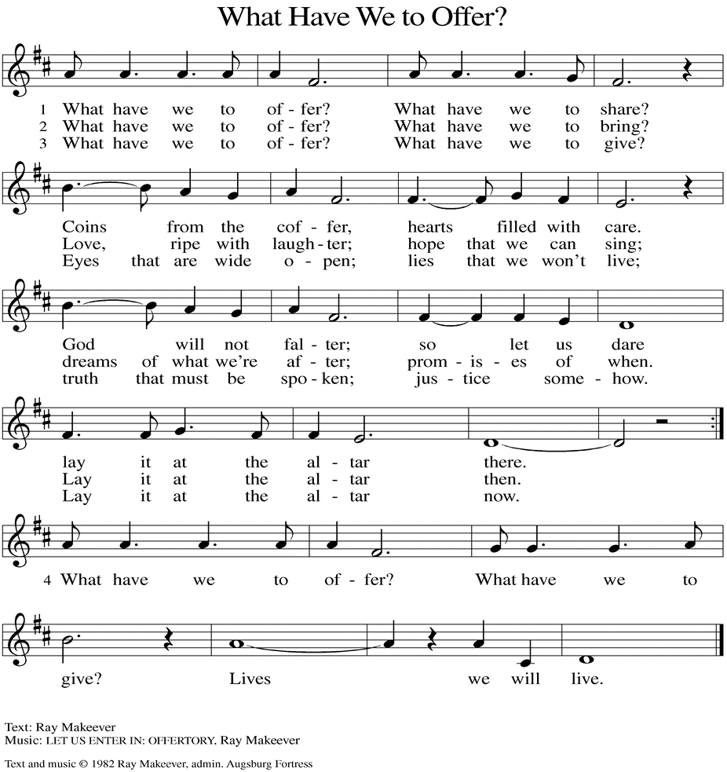
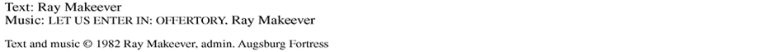

(Usher(s) brings the Tithes and Offerings up front to the Assistant.)
V. We invite you to stand as you are able.

OFFERING PRAYER
V. Let us pray,
O God, maker of heaven and earth,
your steadfast love embraces all creation.
You send rain and sunshine to nourish the earth
and bring forth its bounty.
Through these gifts of bread and wine,
draw us into the death and life of your Son,
who calls us to bear witness to his saving work.
We ask this in Jesus’ name.
C. Amen.

GREAT THANKSGIVING
V. The Lord be with you.
C. And also with you.

V. Lift up your hearts.
C. We lift them to the Lord.

V. Let us give thanks to the Lord our God.
C. It is right to give him thanks and praise.

V. It is indeed right and salutary that we should at all times and in all places offer
thanks and praise to you, O Lord, holy Father, through Christ our Lord; who rose
beyond the bounds of death and, as he promised, poured out your Spirit of life
and power upon the chosen disciples. At this the whole earth exults in boundless
joy. And so, with the Church on earth and the hosts of heaven, we praise your
name and join their unending hymn:

SANCTUS
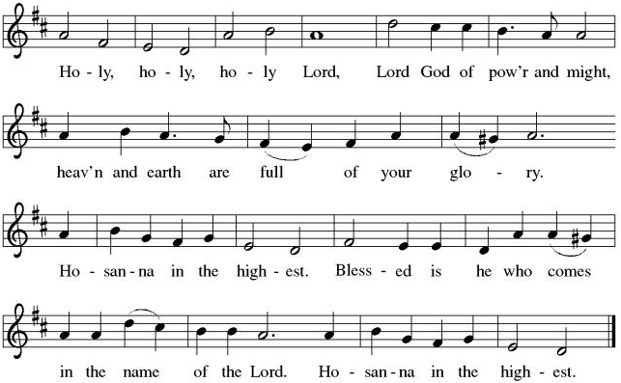

THE EUCHARISTIC PRAYER
V. Blessed are you, Lord of heaven and earth, in mercy for our fallen world you gave
your only Son, that all those who believe in Him should not perish, but have
eternal life. We give thanks to you for the salvation you have prepared for us
through Jesus Christ. Send now your Holy Spirit into our hearts that we may
receive our Lord with a living faith as He comes to us in His holy supper.
C. Amen. Come, Lord Jesus.

V. In the night in which he was betrayed our Lord Jesus took bread,
he gave thanks; broke it, and gave it to his disciples, saying:
Take and eat; this is my body, given for you.
Do this for the remembrance of me.

V. Again, after supper, He took the cup, he gave thanks,
and gave it for all to drink, saying:
This cup is the new covenant in my blood,
shed for you and for all people for the forgiveness of sin.
Do this for the remembrance of me.

THE LORD’S PRAYER
(We ring the bell throughout the Lord’s Prayer at all services to
invite those in the community to join in praying the Lord’s Prayer.)
V. May we now join with one another and pray together as Jesus has taught us.
C. Our Father, who art in heaven, hallowed be thy name, thy kingdom come,
thy will be done, on earth as it is in heaven. Give us this day our daily
bread; and forgive us our trespasses, as we forgive those who trespass
against us; and lead us not into temptation, but deliver us from evil. For
thine is the kingdom, and the power, and the glory, forever and ever.
Amen.

LAMB OF GOD

(We invite you to be seated.)

HOLY COMMUNION
V. Communion here is pretty simple, and all who are baptized and believe in Jesus
Christ are welcome at the table.

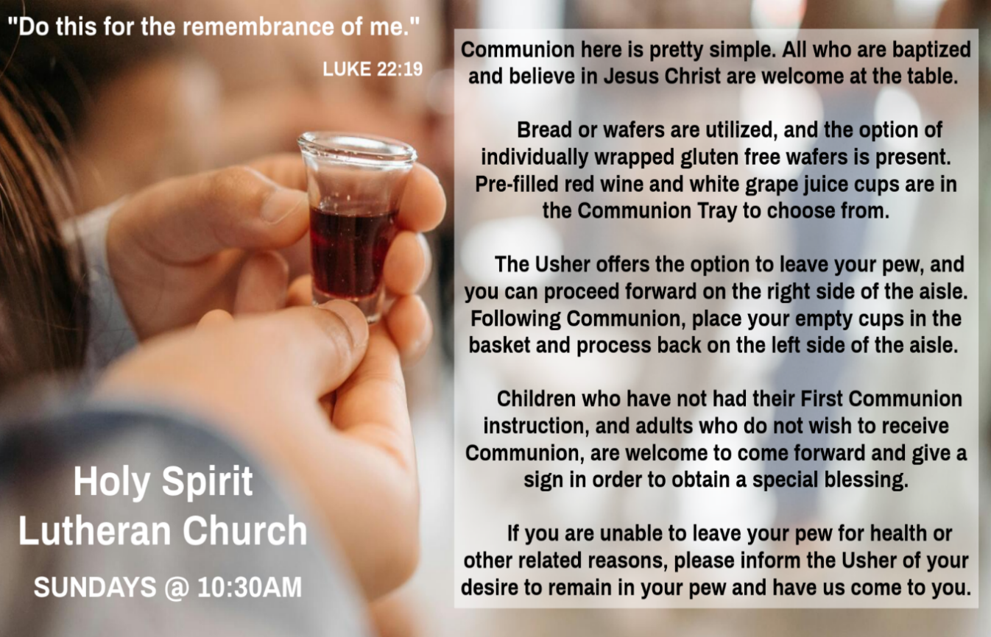

INVITATION TO COMMUNION
V. Come to the table.
Feast on God’s goodness and mercy.
C. Amen.

(Distribution of Holy Communion)

COMMUNION HYMN
(Please enjoy various music offered by our Organist during your
quiet time, prayer, and reflection following Holy Communion.)

(Vicar and Assistant remove Communion Vessels from the Altar.)

V. We invite you to stand as you are able.

POST COMMUNION BLESSING
V. May the body and blood of our Lord Jesus Christ strengthen us and keep us
always in His grace.
C. Amen.
POST COMMUNION CANTICLE
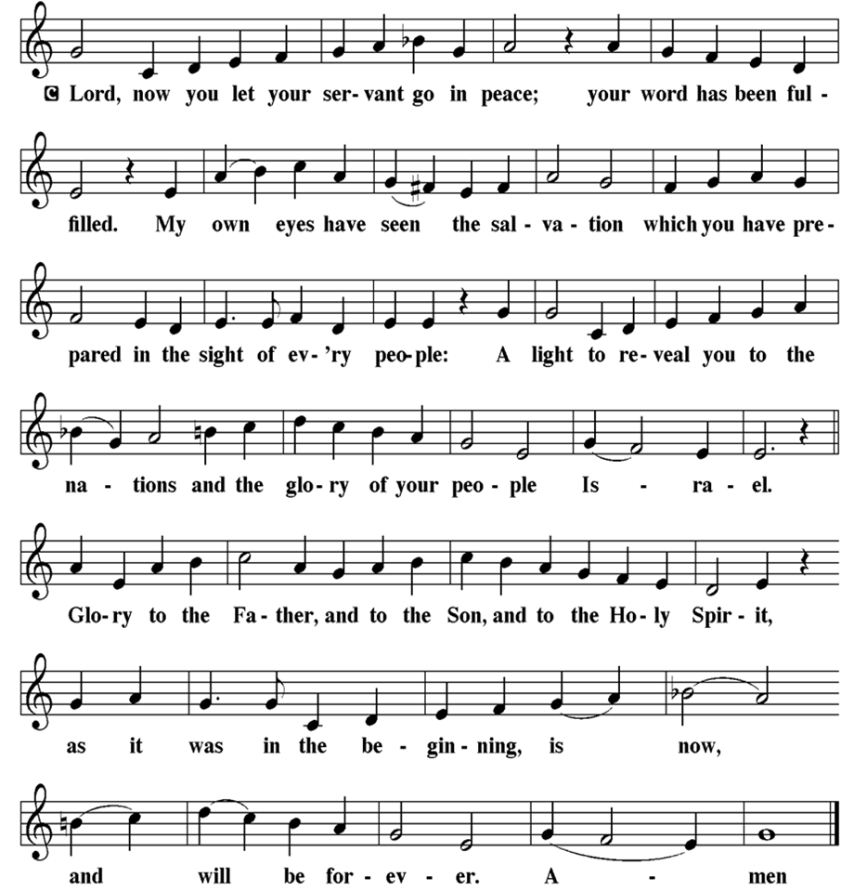

PRAYER AFTER COMMUNION
A. Let us pray,
God of our salvation,
we give you thanks for this meal that restores our souls,
reconciles us to you, and strengthens us for the journey.
Through the body and blood of your Son,
may we become Christ’s body in the world,
bearing witness to your love for all creation,
through Jesus Christ, our Savior and Lord.
C. Amen.

BLESSING
V. Receive the blessing of the holy Trinity:
God, who calls all things into existence,
Jesus Christ, who redeems us,
and the Holy Spirit, whose breath sustains creation,
☩ bless you now and always.
C. Amen.

SENDING HYMN
(We invite you to sing along.)
Lutheran Book of Worship—Green Book
309—Lord Jesus, Think on Me

(Assistant extinguishes the Altar Candles half way through the Sending Hymn.)

(Vicar processes out once the Altar Candles have been extinguished.)

(We invite you to be seated.)

BIRTHDAYS, ANNIVERSARIES, & ANNOUNCEMENTS
(Offered by Assistant and Congregation.)

BIRTHDAYS & ANNIVERSARIES
None

DISMISSAL
A. Go in peace. Believe the good news.
C. Thanks be to God.
POSTLUDE
(Music offered by our Organist as we depart following our Worship Service.)
Love Divine, All Loves Excelling

LICENSES & EXPIRATION DATES
Worship Service Content is used via permission through Augsburg Fortress Liturgies Annual License #SB144368. The next Subscription Renewal Date is 2/28/2026.
Our Hymns and Worship Music are used via permission through CCLI One
License #11327166. The next Subscription Renewal Date is 1/31/2027.



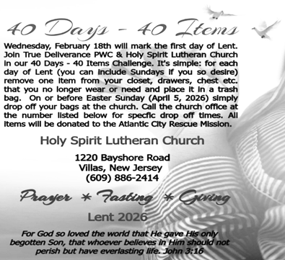

CONFIRMATION & SUNDAY SCHOOL
“Here We Stand” allows our young folks to go through a 2-year process focusing on the Bible and Luther’s Small Catechism. Classes are on Sundays from 9-10AM.

WORSHIP MINISTRY
The most important thing we do each week is gather together as God's people to Worship. God is the center and focus of everything we do. Participating in Worship is active, as Liturgy means the work and actions of the people gathered. Everything we do during the week to prepare for Worship, and everything we do as we Assist in leading Worship is important. We are thankful for all the wonderful work being done. If you have questions, or are interested in any position, reach out to Vicar Vince.
Sign-up sheets are located on the bulletin board between the church offices.

BIBLE STUDY & FAITH DISCUSSIONS
Bible Study & Faith Discussions focuses on various readings, books, Bible verses, people of faith, and other general topics. Group Members offer various points of view while being respectful and supportive of one another. Join us on Tuesdays at 6PM.

FOOD PANTRY
Open every Thursday, and the last Saturday of every month, from 10AM to 1PM. 134 people were served in January and 134 people have been served in 2026. Donations can be dropped in the outdoor drop-box, in the money jug in the back of the Church, mailed into the Church Office, or placed in the Offering Plate. Volunteers are needed. Sign-up sheets are located on the bulletin board between the church offices. If you have questions or need training see Heather, Vicar Vince, or Bonnie.
A special thank you goes out to all who donate, pray, and help in any way!

Thursday, 2/26 | Saturday, 2/28 | Saturday, 3/5
Patti & Bob | Vicki & Bonnie | Garnet & Joe

COMMUNITY FOOD DONATIONS, DELIVERIES, & MORE
North Cape May Acme provides us with Expiring, Recently Expired, and Slightly Damaged Food and Items. Kathy delivers on Saturdays in the community, brings items to church and the food pantry, and to the Branches Outreach in Rio Grande.

BULLETIN ENTRY DEADLINE
The Bulletin is printed on Thursdays during Church Office Hours. Changes need to be submitted to Vicar Vince no later than Thursday by 4PM. Thank you!

CHURCH OFFICE HOURS
Open Thursdays from 6PM to 8PM. It is open to serve the Congregation, the Community, and to handle the business of the Church. Feel free to stop in to talk, pick-up or drop off something, pray in the Sanctuary, or for whatever reason.


2025 Church Directories are by the Church Office on the bookshelves. We continue keeping it updated, but we undoubtedly miss a few changes or have made a few errors. If you have changes or updates, please inform the Church Office to keep us up to date. Our 2026 Directory will be available sometime later in February.

DONATION STATION
Get on the train and place all purchased items in the specified project donation bins located on the counter by the front doors. See Heather for more information.


WOMEN OF THE CHURCH
They will be on Winter Break and will Resume Meetings on Monday, March 2nd, at 6PM. New members are always welcome to attend! Contact Judy for more info.

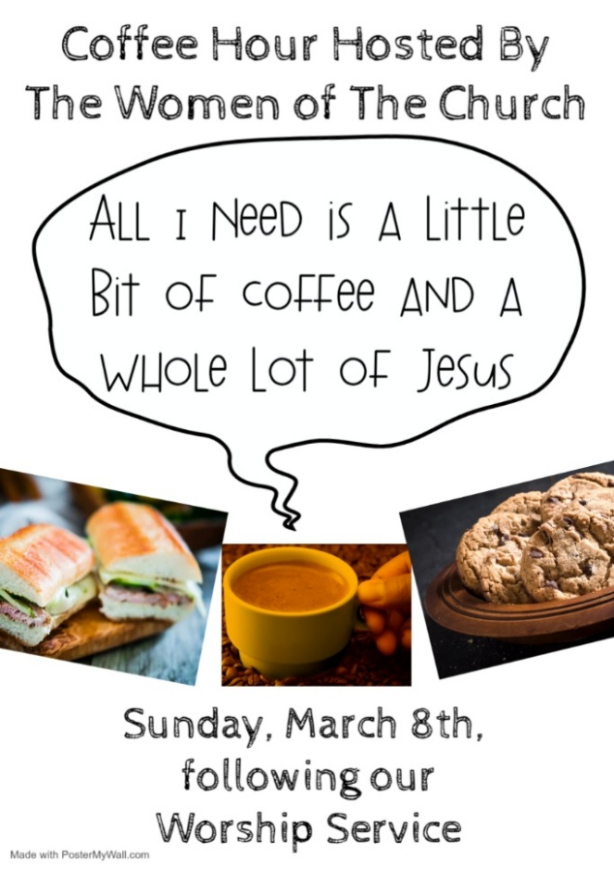

SUNDAY AT BROOKDALE
Vicar Vince will be preaching at Brookdale Senior Living in Cape May Court House, on Sunday, March 8th, at 1PM. Holy Communion will follow the service.

VICAR VINCE AT SEMINARY
TEEM Worship Class will be held in Gettysburg, PA on the Campus of United Lutheran Seminary from Wednesday, March 11th to Saturday, March 14th.

NEWSLETTER
Collect information, stories, pictures, and reports for our next publication. Everything needs submitted to Vicar Vince in-person or via email at vpie8282@gmail.com.
The deadline for information to be submitted for Spring is Sunday, March 15th.

CHURCH COUNCIL
Share your comments, concerns, questions, or joys with one of our Church Council Members who can bring them back to our meetings. Visitors are always welcome to attend and listen to what is going on in and around the church. Join us In- Person or on our Conference Call at our next Meeting on Tuesday, March 17th, at 6PM.

Our NJ Synod Assembly transitions back to a one-day event on Saturday, May 30th, 2026. Mary & Judy are considering attending with Vicar Vince.

TITHES, OFFERINGS, & ENVELOPES
We worship God with our tithes and offerings. We hear in scripture, “Each of you must give as you have made up your mind, not reluctantly or under compulsion, for God loves a cheerful giver.” (2 Corinthians 9:7) Envelopes can be dropped in the offering plate, mailed to the church, or dropped in the locked mailbox. Thanks for your support in the mission of our church, its ministries, the NJ Synod, etc!

SPACE AVAILABLE
​​​​​Interested in utilizing our Fellowship Hall for a Party or Event? There is a suggested $50 refundable security deposit, and it is $250 for facility use. No alcohol or games of chance permitted due to ELCA policy. Please contact Vicar Vince for more info.

ED GREEN CAPITAL IMPROVEMENT FUND
We are seeking out a new fundraiser at this time. We also have the donation bin in the back of the church and we have our Annual Church Rummage Sale to raise funds. Thanks for your continued donations, prayers, and support!

HOME COMMUNION MINISTRY
A Minister is available if you have a loved one, or if you desire services. We look forward in sharing the Word and Holy Communion! Please inform Vicar Vince, Kathy, or the Church Office so plans can be made for visits.

PRAYER SHAWL MINISTRY
Prayer Shawls, Lap Quilts, Scarves, and other items have been made with love. Blessed items are located in the Narthex, and are free for anyone. Members of the group continue working at home on new stitches and patterns. We are blessed to be able to continue collecting new items. We have a donation station of yarn and other items located in the Narthex. You can find some new supplies for your next creation!
PRAYER LIST
Our Prayer List continues to lengthen and we realize the important need for prayers and healing. Sometimes the unfortunate result is that someone has passed away, and the words “The Family & Friends of” appear before someone’s name. However, sometimes we forget names are still on the list and their health has improved and they can be removed. Please share various stories as we continue to pray for strength and healing. Names can be added or removed from the list on the clipboard in the Narthex prior to the Worship Service, by calling the church office, or addressing it on the Conference Call. Please let us know the relation to the person(s) you listed so we can be more mindful with our prayers.

LIBRARY
New books are added to our library from time to time. Several are borrowed and read and exchanged. Who knows, you might find one particularly interesting and share that with someone as well. Reading is a great way to pass spare time, learn, and explore. You may find some fresh ideas for prayer, ways to grow more spiritually, ways to grow closer to God, or some opportunities to understand our faith more. We also have an extended library located in Vicar Vince’s office. There are Bibles of various translations, books from his personal collection, books inherited from Pastor Leah, movies, past Bible Study Curriculums, and more. Visit the library between the church offices, or just ask to be able to check things out.

FAVORITE HYMNS
Carol is willing to play some of your favorite hymns for the Prelude & Postlude each Sunday during our Worship Service. Feel free to let her know of your suggestions.

INTERESTED IN BECOMING A NEW MEMBER
Have you been attending our church for a while? Have you just recently returned to church after being away for a bit? Maybe you transitioned from another church,
or just started to recently attend our church. We are glad to have you, and would love to have you as a member of our Congregation. See Vicar Vince for more info.

BAPTISM
We are a church whose unity is in Jesus Christ, who gathers us around word and water, wine and bread. Baptism is a significant part of our faith journey as we come from the baptismal waters to live a new life as children of God. Our baptism sets us out on a lifelong journey that is characterized by our relationship to God, our relationship to our faith community, our relationships in our community and the wider world. Living our baptismal covenant means living a life of growth in the faith practices of discipleship. Please see Vicar Vince for more information.
FIRST COMMUNION
Although no particular age for first communion is prescribed by The Use of the Means of Grace, one guideline is offered. Because admission to the Sacrament is by invitation of the Lord to the baptized, "baptized children begin to commune on a regular basis at a time determined through mutual conversation that includes the pastor/vicar, the child, and the parents or sponsors involved, within the accepted practices of the congregation.” Each congregation is encouraged to ask the question of readiness for first communion, establish their own policies regarding age and practice, and accompany that practice with catechesis appropriate to the age of the communicant. If anyone has questions, please see Vicar Vince.

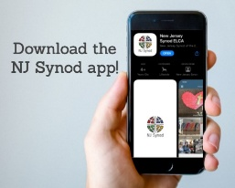
There is a weekly e-newsletter connecting our synod together with weekly prayer, upcoming events, synod and churchwide activities, mission stories, congregational activities, & more. Sign up at www.njsynod.org/stay-connected or download the app.

VICE PASTOR UPDATE
Pastor William Hodgetts continues to attend our Church Council Meetings
and provides Supervision and Support to Vicar Vince.

VICAR APPOINTMENT ON MARCH 19TH, 2023
A Memorandum of Understanding on the Matter of Pastoral Appointment
In Theological Education for Emerging Ministries (TEEM) Candidacy
TO: Congregation Council, Holy Spirit Lutheran Church, Villas
FROM: The Rev. Tracie L. Bartholomew, Bishop, New Jersey Synod

Dear Brother and Sisters in Christ,
This memorandum is in support of your discussions with Vincent Piekarski as pastor of Holy Spirit, Villas. Because this is not the usual pattern for completing the educational and candidacy requirements for ordination, it is my hope that this memorandum will both provide guidelines and engage in conversation with those who are invested in this process.

I would say at the outset that because Vincent is an outstanding candidate for the Ministry of Word and Sacrament, we will all want to do whatever is necessary to assure that his placement serves the mission of the church in the best possible fashion.

The following notes reflect my own understanding of this matter:
(1) The appointment for Vincent will begin on April 1, 2023. At this time, Vincent
will assume all responsibilities of a regularly called pastor, including presiding at
the Sacrament of Holy Communion and Baptism at Holy Spirit, Villas.
(2) A pastoral appointment in the TEEM process is an option for completing
seminary educational requirements and the steps of the candidacy process.
Upon completion of the candidacy process and seminary education, the
candidate may receive and accept a call to ordained ministry from the
congregation where the appointment is being served.
(3) This appointment is jointly supervised by the Office of the Bishop and the TEEM
pastor’s seminary. A mentoring relationship with a local pastor is required for the
length of this appointment.
(4) The synod of candidacy origin will be responsible for the approval process.
(5) Upon approval for ordination, the congregation would be expected to extend a
call to the pastoral appointee.
(6) Compensation for the TEEM pastor will be according to the guidelines of the New
Jersey Synod. All normal forms of compensation should be in place for the term
of the appointment, including stipulation that base salary and housing shall be in
accord with synod guidelines for first call at time of ordination.
(7) The ELCA Portico benefit plan for lay persons in full-time church service should
be used for the pastoral appointee up to the time of ordination, whereupon the
benefit package is to be converted to the plan for ELCA clergy.
(8) A decision for Pastoral Appointment is made with the agreement of a synod and
its candidacy committee, and the ELCA, normally represented by the regional
staff person of each in consultation with the seminary and its Director for
Contextual Education.
(9) Pastoral Appointment in a TEEM Candidacy is an option that is to serve the
mission of the Church in a particular and vital way and is not to be viewed or
used as a means to circumvent the normal candidacy process and/or first call
placement process.

In the specific case of Vincent, the New Jersey Synod remains responsible for the candidacy and approval process, and has agreed to this proposal for Appointment at Holy Spirit, Villas.

Continued blessings to both Holy Spirit and Vincent Piekarski as you embark on this journey of mutual ministry. As partners in ministry, we walk with you and rejoice in this new relationship.

VICAR VINCE’S DAY OF REST
A day of rest can have physical, mental, and spiritual benefits. “Mittwoch,” German for mid-week, or Wednesday, is the day that Vicar Vince will use to recharge and do some other things. Please do not hesitate to reach out if there is an emergency!

2026 FINANCIAL STANDING
JANUARY INCOME | $2,910.00
JANUARY SPENDING | $5,867.90
JANUARY GAIN OR (LOSS) | ($2,957.90)
2026 INCOME | $2,910.00
2026 SPENDING | $5,867.90
2026 GAIN OR (LOSS) | ($2,957.90)
ED GREEN CAPITAL IMPROVEMENT FUND | $2,458.55
FOOD PANTRY FUND (SOCIAL MINISTRY) | $13,657.94
CD | $26,414.45

WHAT IS THE EVANGELICAL LUTHERAN CHURCH IN AMERICA?
The ELCA was formed in 1987 by the merger of three Lutheran Church bodies –
the ALC (American Lutheran Church), the LCA (Lutheran Church in America), and the AELC (Association of Evangelical Lutheran Churches). Learn more at elca.org.

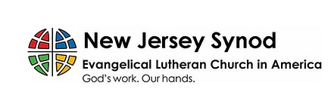
The New Jersey Synod is a geographical grouping of Evangelical Lutheran Church in America (ELCA) congregations that share the mission and ministry of the Church on the New Jersey territory. It is one of 65 synods in the ELCA. The NJ Synod is comprised of 143 congregations, which include over 45,000 baptized members.

TRUE DELIVERANCE PRAISE & WORSHIP CENTER
TDPWC utilizes our facilities from 1-4PM on Sundays. TDPWC hosts or assists with other events. TDPWC hosts a Prayer Line on Mondays, Wednesdays, & Fridays at 5PM on the Conference Call 1-657-390-7957; & Bible Study on Thursdays at 6:30PM on Zoom. See Rev. Brooks for more information.

JUST FRIENDS
The group promotes a spirit of fellowship among adults 50 years and older. Bring your own lunch, beverages and deserts are provided. Everyone is welcome. The group meets in Our Lady Star of The Sea Parish Hall on the last Wednesday of the month from 12Noon to 2PM from September through May. For information, please call Martine Simonis 609-884-5312 x 110.
ADDITIONAL OFFERINGS FROM OUR FRIENDS & NEIGHBORS
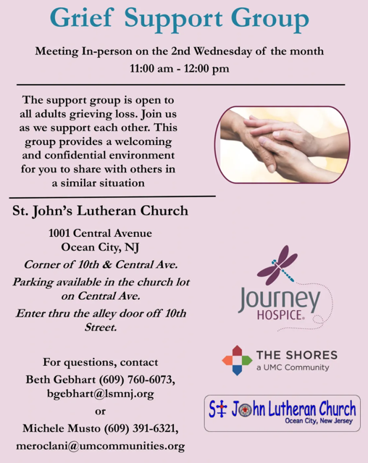

CHURCH STAFF & VOLUNTEERS
VICAR
Vicar Vince Piekarski
VICE PASTOR
Pastor William Hodgetts
ORGANIST & PIANIST
Carol Amundsen
CHURCH OFFICE, SUNDAY SCHOOL, & FOOD PANTRY
Heather Piekarski
CHURCH COUNCIL PRESIDENT & CHURCH PROPERTY
Wayne Rand
CHURCH COUNCIL VICE PRESIDENT & WOMEN OF THE CHURCH
Judy Brannan
CHURCH COUNCIL TREASURER
Bonnie Millard
CHURCH COUNCIL SECRETARY
Vicki Rinier

