Salko Farm and Stable
Lesson Packet

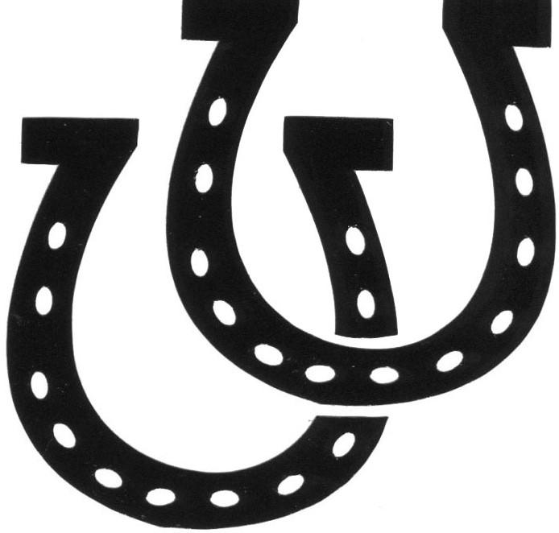

Includes:
-Waiver
-Medical Form
-Rate Sheet/Guidelines

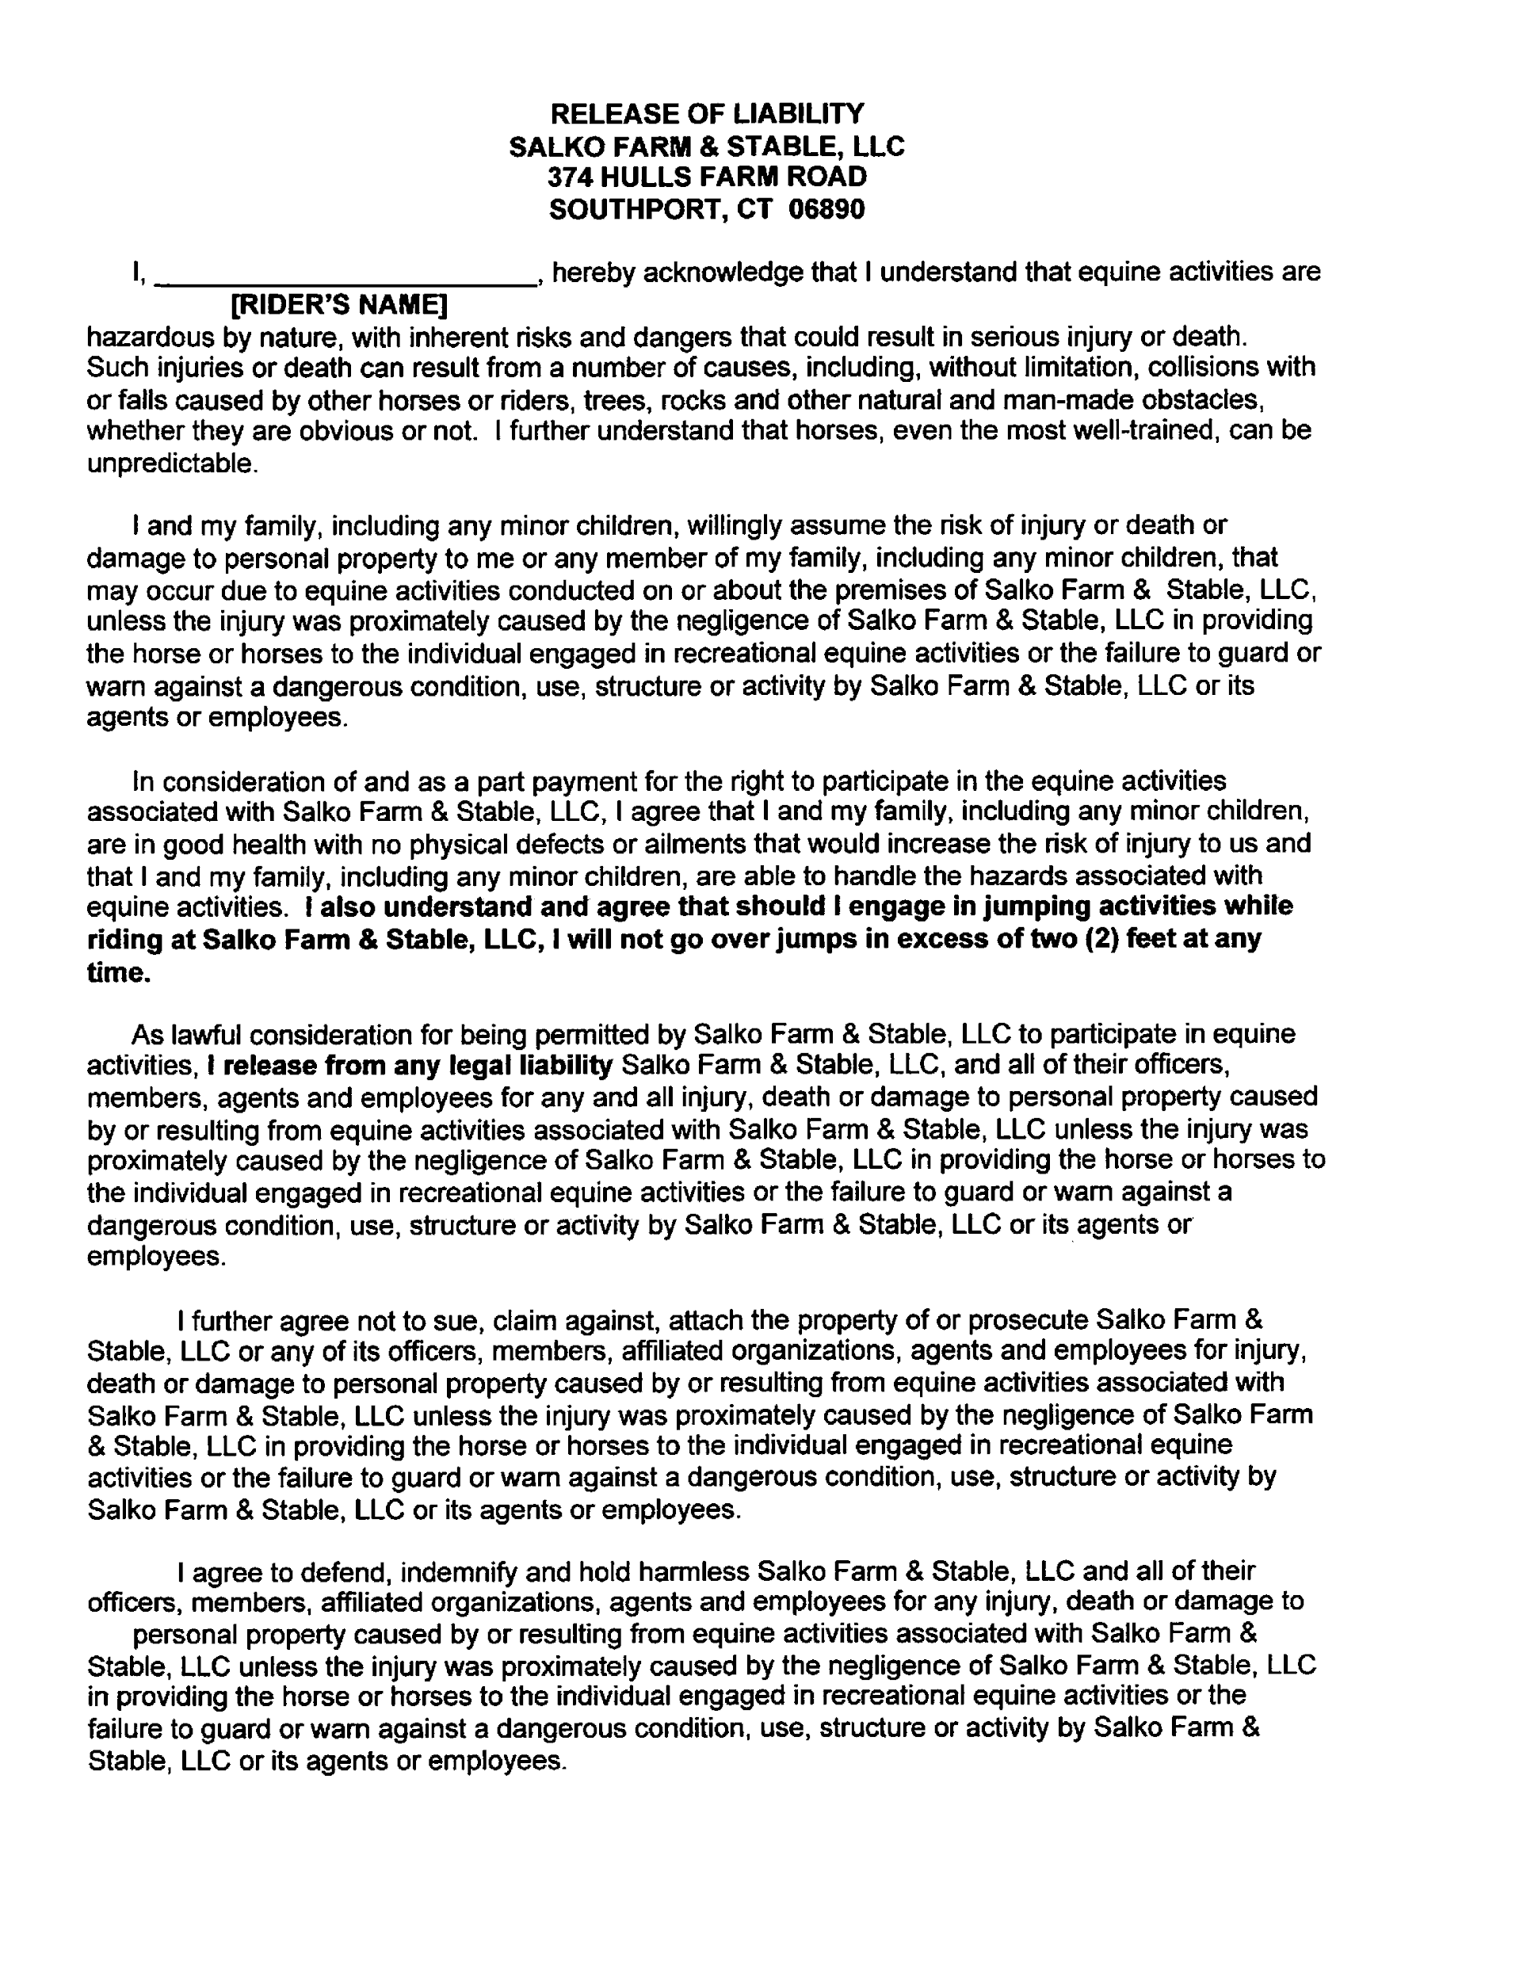
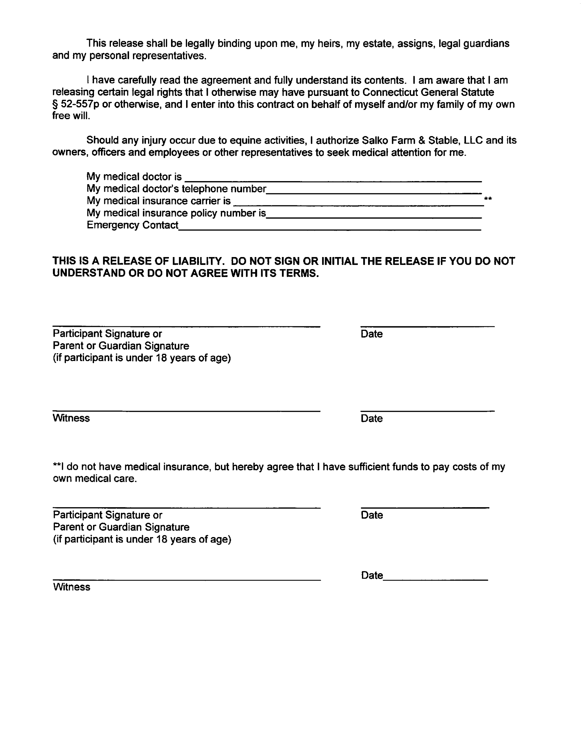

Emergency Contact
Child’s Name |  |  |  | Date of Birth
Parent’s/Guardian’s Name |  |  |  | Parent’s/Guardian’s Name
Home Phone |  | Work Phone |  | Home Phone |  |  |  | Work Phone
Cell Phone |  |  |  | Cell Phone
E-Mail |  |  |  | E-Mail
Address

City, ST ZIP Code |  |  |  | City, ST ZIP Code

Alternative Emergency Contacts
Primary Emergency Contact |  |  |  | Secondary Emergency Contact
Home Phone |  | Work Phone |  | Home Phone |  |  |  | Work Phone
Address |  |  |  | Address
City, ST ZIP Code |  |  |  | City, ST ZIP Code

Medical Information
Physician’s Name |  |  |  |  |  | Phone Number
Insurance Company |  |  |  |  |  | Policy Number
Allergies/Special Health Considerations
I authorize all medical and surgical treatment, X-ray, laboratory, anesthesia, and other medical and/or hospital procedures as may be performed or prescribed by the attending physician and/or paramedics for my child and waive my right to informed consent of treatment. This waiver applies only in the event that neither parent/guardian can be reached in the case of an emergency.
Parent’s/Guardian’s Signature |  |  |  |  |  | Date

Salko Farm & Stable LLC
374 Hulls Farm Road
Southport, CT 06890
203.255.5092
www.salkofarmandstable.com
email: salkofarmandstable@hotmail.com

1. Please email salkofarmandstable@hotmail.com to schedule a day and time for your lesson. This will be your time every week.

2. We strictly enforce a 24 hour cancellation policy – ESPECIALLY DURING SCHOOL BREAKS – since we have so many riders from so many different schools, it is up to each parent to cancel during their school breaks – NO EXCEPTIONS!!!!! Additionally, a rider is only allowed 2 cancellations every 6 months, otherwise we can not hold your weekly lesson time.

3. THE ONLY WAY TO CANCEL A LESSON IS TO EMAIL salkofarmandstable@hotmail.com. NO OTHER CANCELLATIONS WILL BE ACCEPTED – NO EXCEPTIONS!!! DO NOT TELL YOUR INSTRUCTOR OR CHRIS -- if you do so, you will be charged for the lesson.

4. We require that everyone pay per session (cash or check). All lessons MUST be used within the session dates. If lessons are not made-up within the session all remaining lessons will be forfeited.

Please Note: If a rider's payment is 3 lessons late, they will be taken off the schedule and lose their lesson time. Their time will be offered to a person on the Wait List.

5. After a session is completed, the majority of our students ride all year long, so we will assume that you are keeping your lesson time. BUT, if you do stop riding you must notify by email, otherwise you will continue to be charged. Our spaces are limited; so should you decide to stop riding we cannot guarantee that your riding time, if any, will be available at a later date.

Our rates are as follows:

Lesson Type | Price per Lesson | Price Per Session (12 Lessons)
Private ½ hour | $85 | $960
Semi-Private 1 hour | $105 | $1200
Private 1 hour | $150 | $1740
Group 1 hour | $85 | $960
Intro to Riding (3-5 yr olds only) | $65 | $720
(***PLEASE NOTE THERE IS A $35 RETURNED CHECK CHARGE)
8. All riders must wear an ASTM approved safety helmet, long pants or chaps and hard shoes (ankle paddock boots or field/dress boots). Sneakers and Hiking Boots are not permitted. These rules are strictly for safety, as it is far too dangerous to ride without proper footwear and helmet.

9. We are closed on major holidays, i.e., New Years Day, Easter, Memorial Day, 4th of July, Labor Day, Thanksgiving and Christmas. All dates are listed on our website salkofarmandstable.com

10. The barn is open Monday, Tuesday, Wednesday, Thursday, and Saturday. No Lessons are held on Friday or Sunday

