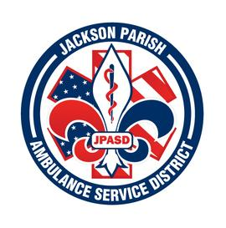
Jackson Parish Ambulance Service District
115 Watts Street
Jonesboro, LA 71251
Office: (318)-259-2877 Fax: (318)-259-2099
jacksonparishambulance@jpasd.com
Aaron K. Johnson, Jr. Paula Parkerson,MD
EMS Director Medical Director
Governing Board: Joe Vail, Allen Lindsay, Alma Williams, Conchita Doyle, Deidre Hollis

Meeting Minutes for Regular Scheduled Board Meeting: Thursday, May 11, 2023 @ 12:00 noon

Meeting CANCELLED

Next Regular Board Meeting will be held:
Thursday, June 8, 2023 @ 12:00 noon
Thursday, July 13, 2023 @ 12:00 noon Aaron Johnson /Secretary-Treasurer
@ JPASD – 115 Watts Street – Jonesboro, LA Unofficial Minutes

