The First Congregational Church and Society
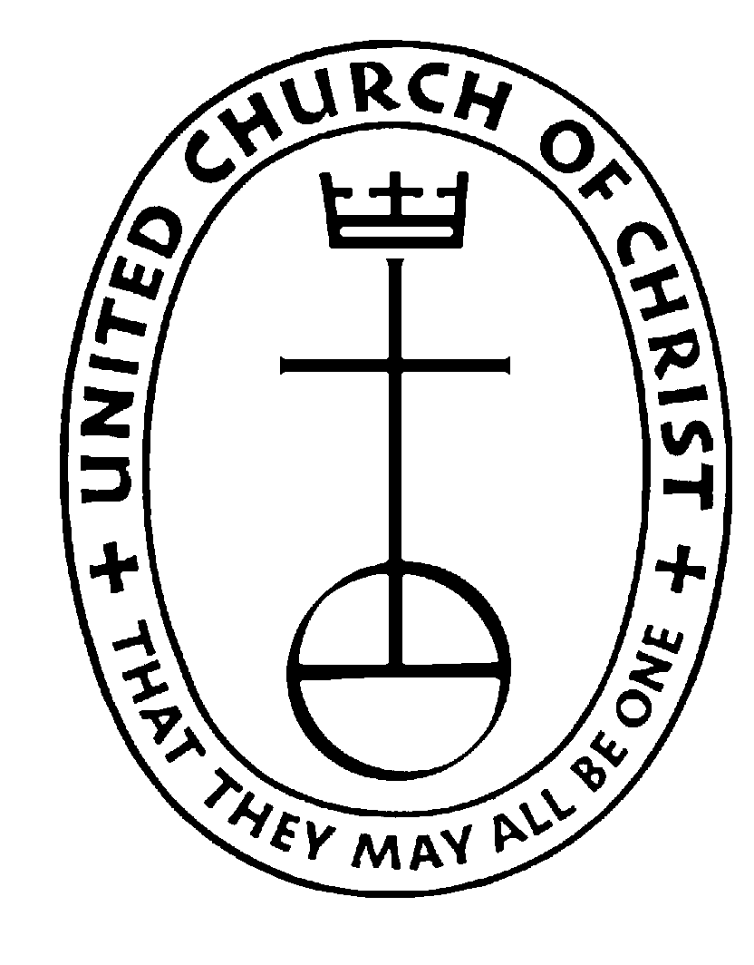

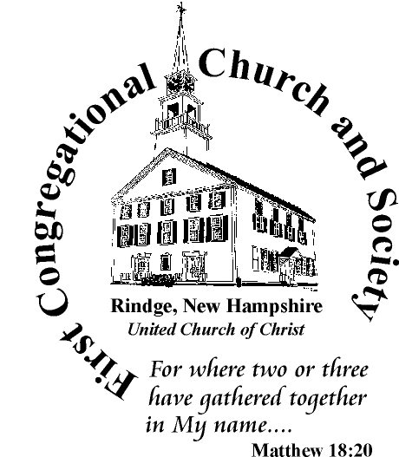

(United Church of Christ)

Rindge, New Hampshire

FY 2022-23 Nomination Slate

Position | Nominee | Term  Starts* | Current Term Ends*
Moderator | Marcie Miller | 2022 (2) | 2024
Vice Moderator
Treasurer | Lydia Hatch | 2021 (2) | 2023
Membership Secretary/Clerk | Gary Beaton | 2021 (2) | 2023
Communications Secretary | Maura Kegan | 2021 (2) | 2023
Spirituality Co-leader (1) | Susan Schenck | 2022 (1) | 2024
Spirituality Co-leader (2)
MLC Co-leader (1)
MLC Co-leader (2)
Operations Co-leader (1) | Jack Cantin | 2021 (2) | 2023
Operations Co-leader (2)
Outreach Co-leader (1) | Becky Beaton | 2022 (2) | 2024
Outreach Co-leader (2)
Community Care Co-leader (1) | Sue Chatwin | 2021 (2) | 2023
Community Care Co-Leader (2) | Cindy Cantin | 2021 (2) | 2023

*Terms are for 2 years, renewable twice, for a maximum of 3 terms. Terms start on the first day of the fiscal year (June 1) and ends on the last day of the fiscal year (May 31).
Rev. 4/4//2022

